1.1 Physical quantities and measurement techniques: Cambridge IGCSE Physics worksheet
1. What volume of liquid is shown in the measuring cylinder?
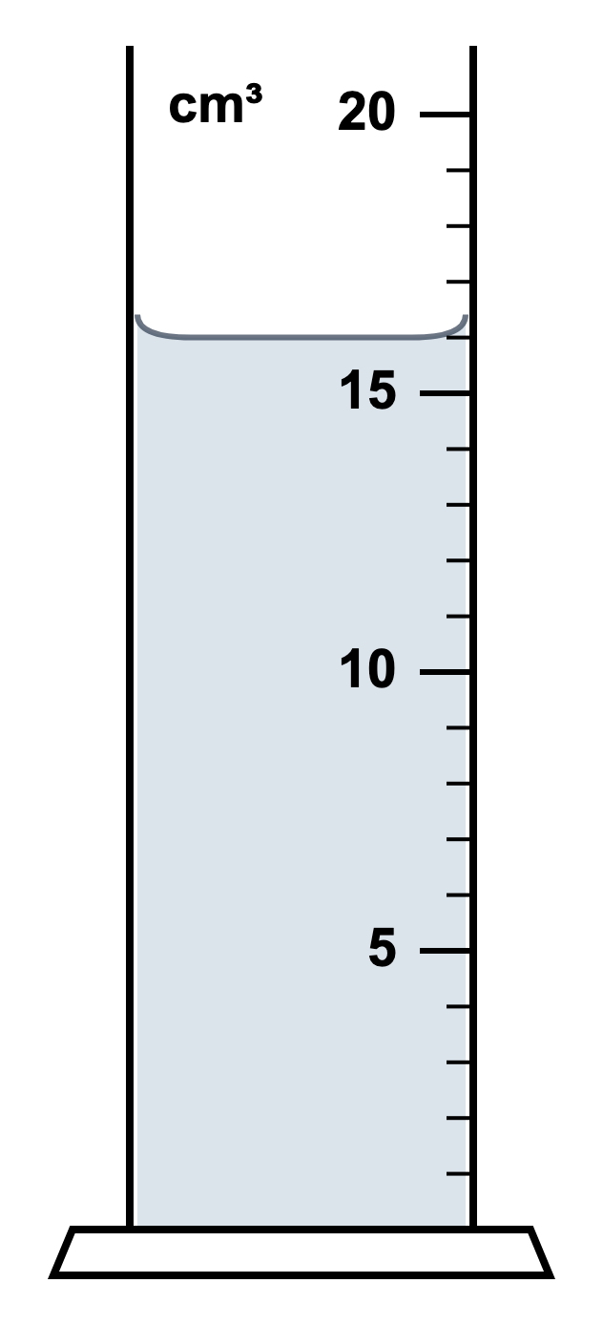
A 14 cm³
B 16 cm³
C 18 cm³
D 20 cm³
(1 mark)
2. Which method can be used to find the volume of a small irregular stone that sinks in water?
A Submerge it in water in a measuring cylinder and find the increase in the reading.
B Measure its greatest length with a ruler and cube this value.
C Measure its mass on a balance and record the value in cm³.
D Place it beside a thermometer and read the scale.
(1 mark)
3. A runner completes one full lap of a 400 m running track and finishes at the starting line. Which row gives the distance travelled and the displacement of the runner?
 | Distance travelled | Displacement
A | 0 | 0
B | 0 | 400 m
C | 400 m | 0
D | 400 m | 400 m

(1 mark)
4. The spring and ruler show its unloaded length and its length with a load attached.
What is the extension of the spring?
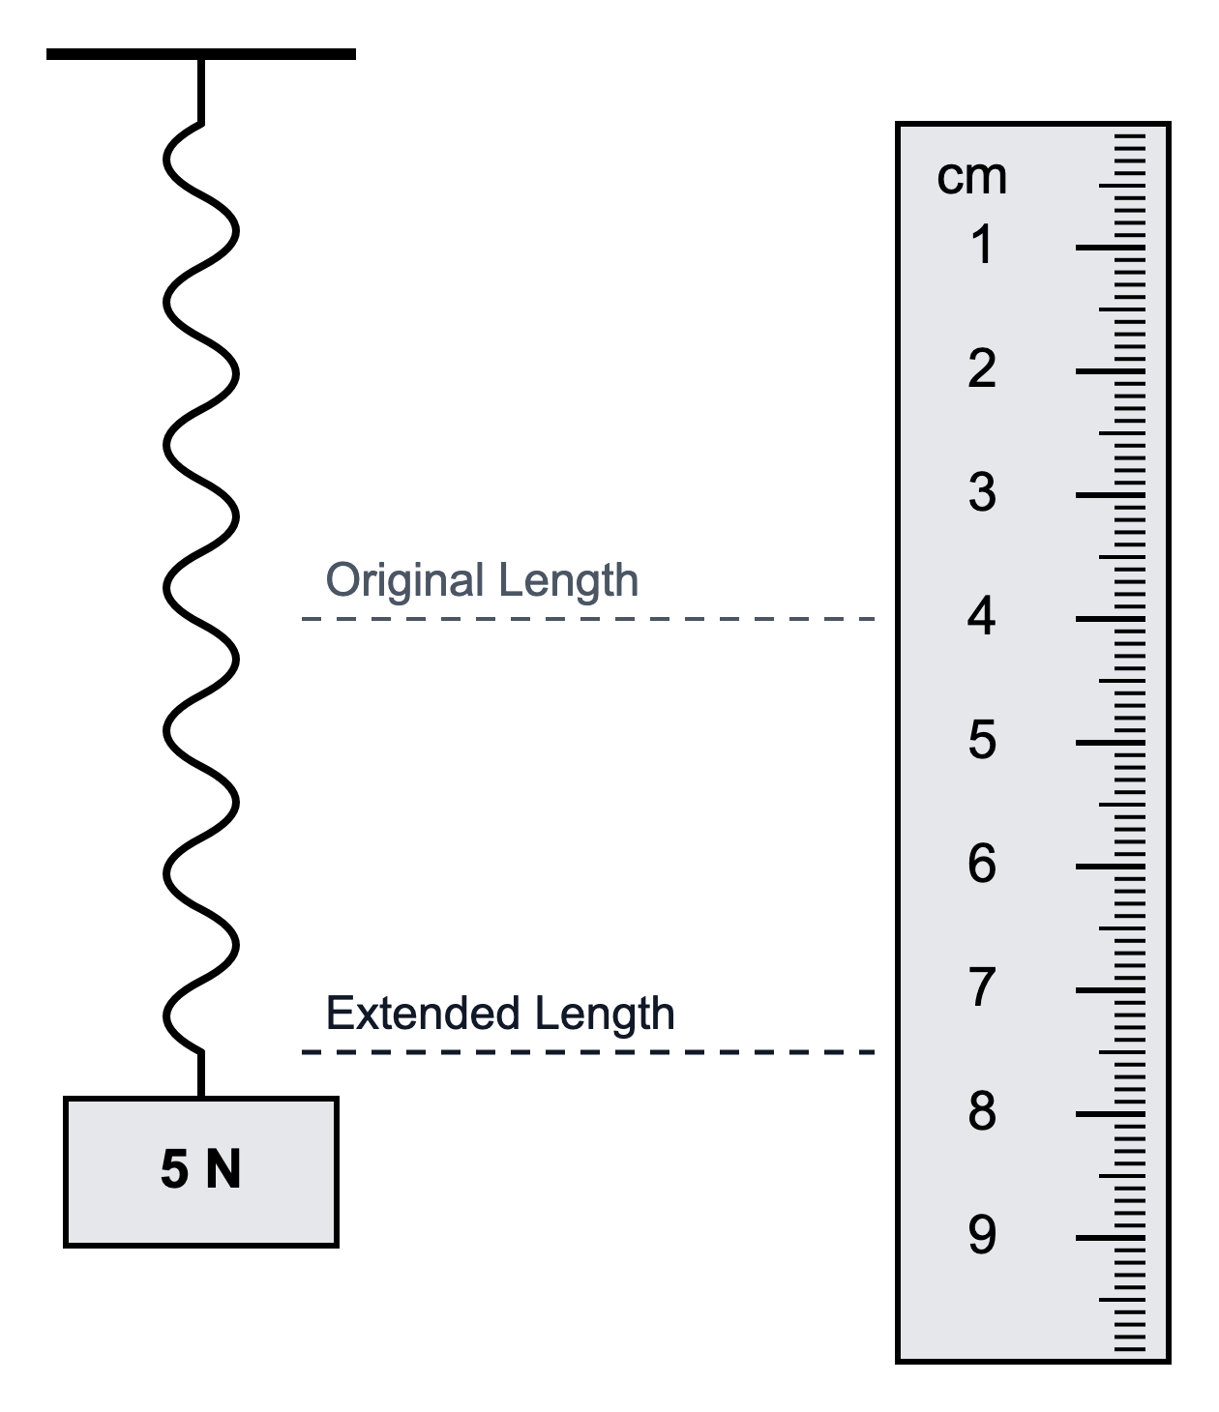
A 11.5 cm
B 7.5 cm
C 1.9 cm
D 3.5 cm
(1 mark)
5. A robot moves 60 m east and then 20 m west. Which row gives its total distance travelled and its final displacement from the start?
 | Distance / m | Displacement
A | 40 | 80 m east
B | 80 | 40 m west
C | 80 | 40 m east
D | 40 | 40 m east

(1 mark)
6. Two forces are added graphically by drawing their arrows tip to tail. Which arrow represents the resultant force?
A from the tail of the first arrow to the tip of the second arrow
B from the tip of the first arrow to the tail of the second arrow
C from the tip of the second arrow to the tail of the first arrow
D from the tip of the first arrow to the tip of the second arrow
(1 mark)
7. A student has a metre rule and several identical small spheres. Which method gives the best estimate of the diameter of one sphere?
A Measure one sphere once and record the nearest centimetre.
B Measure the circumference of one sphere and use it as the diameter.
C Place 10 spheres in a straight touching row, measure the row and divide by 10.
D Place the spheres at random positions on the rule and calculate their mean position.
(1 mark)
8. Which procedure gives the most reliable value for the period of a pendulum when using a handheld stopwatch?
A Time half an oscillation and multiply the result by two.
B Time 20 complete oscillations and divide the result by 20.
C Time one oscillation and record only the stopwatch's last digit.
D Count 20 oscillations but stop the watch after the first one.
(1 mark)
9. The stopwatch shows the time taken for a pendulum to complete 20 oscillations. What is the period of the pendulum?
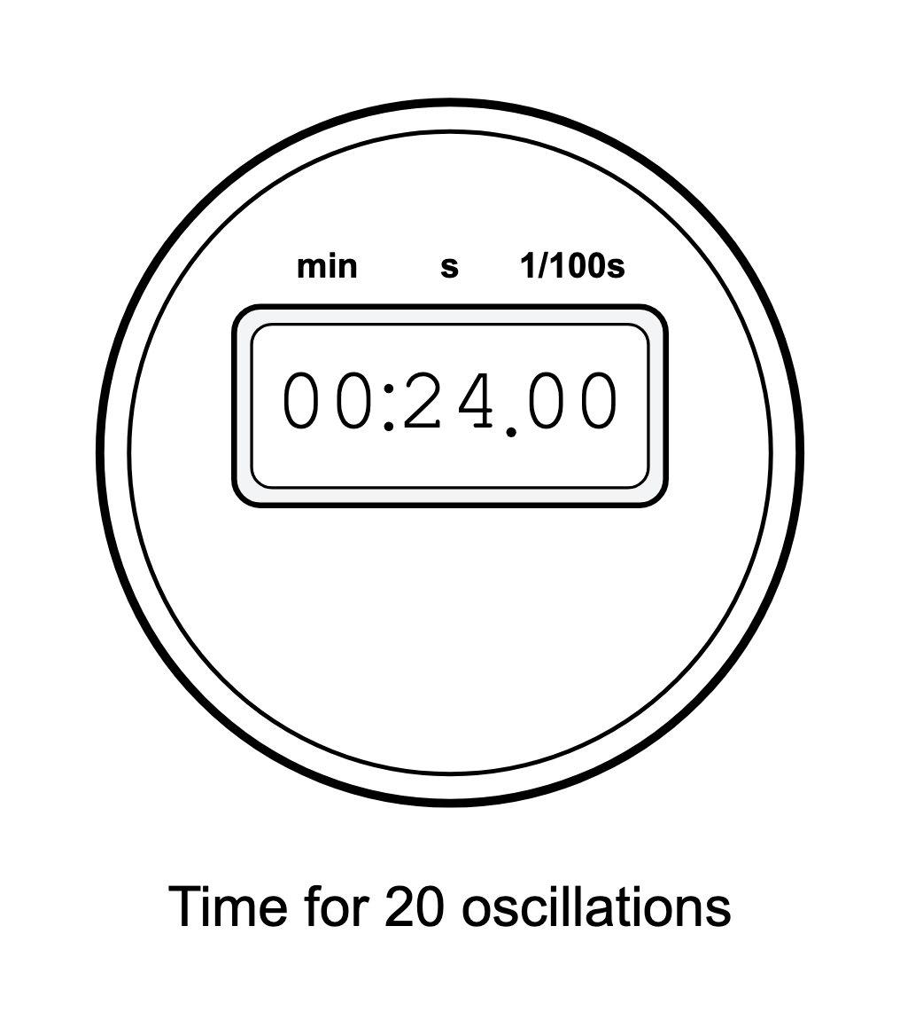
A 0.050 s
B 0.83 s
C 1.20 s
D 24.0 s
(1 mark)
10. In which row are the quantities correctly sorted into scalar quantities and vector quantities?
 | Scalar quantities | Vector quantities
A | speed and distance | force and temperature
B | mass and time | velocity and momentum
C | energy and weight | acceleration and distance
D | velocity and energy | speed and force

(1 mark)
11. Two forces act on an object at right angles to each other, as shown in the diagram.
What is the magnitude of the resultant force?
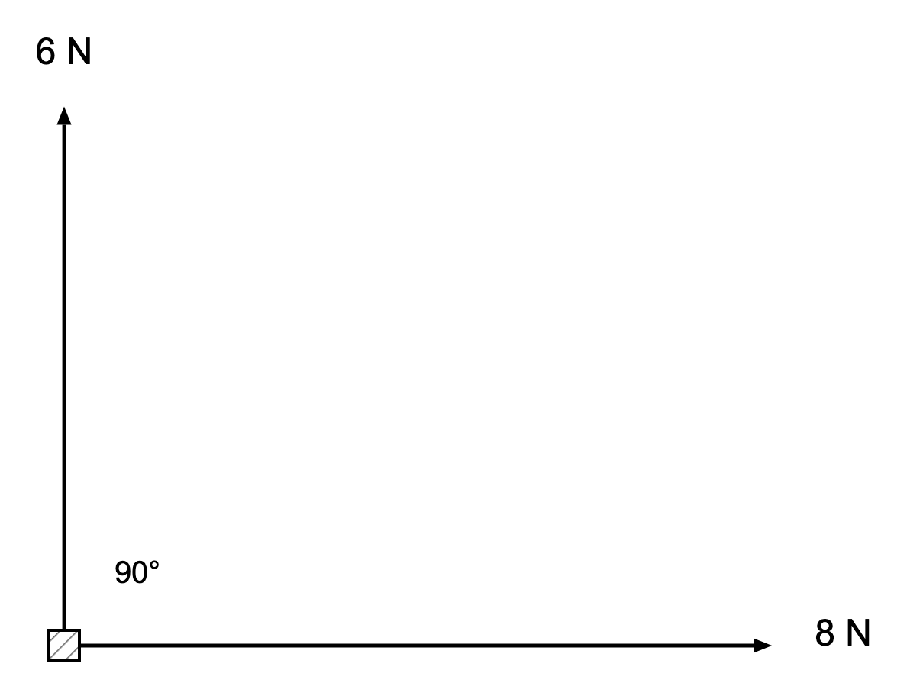
A 2 N
B 7 N
C 10 N
D 14 N
(1 mark)
12. Two forces of 3 N and 4 N act on an object. Which of these cannot be the resultant of the two forces?
A 1 N
B 5 N
C 7 N
D 9 N
(1 mark)
13. Give one reason why the resultant of the two velocities shown is not 11 m/s.
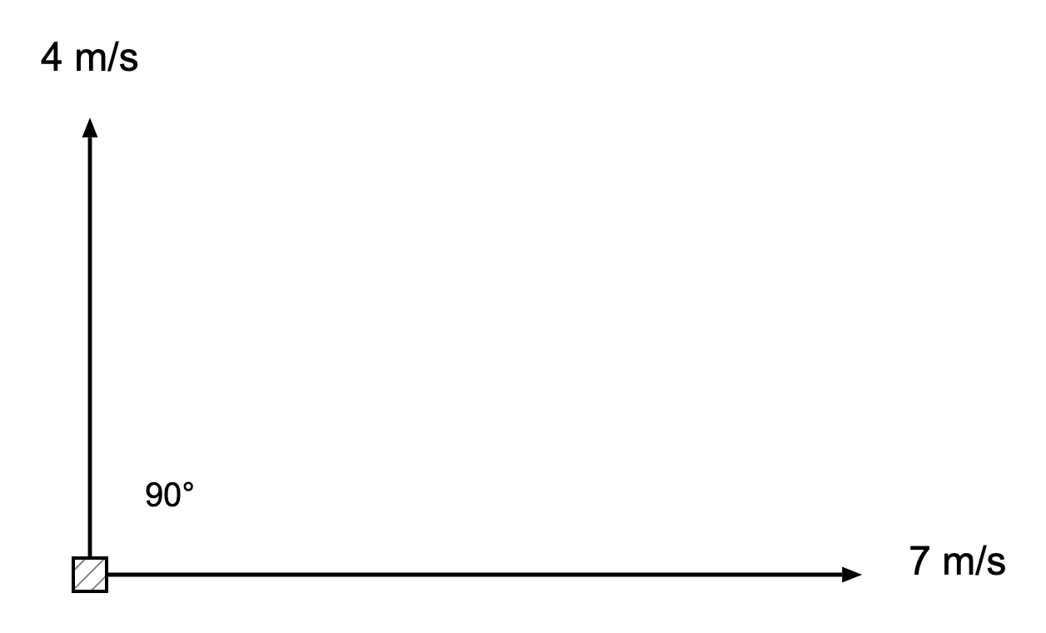
.....................................................................................................
.....................................................................................................
(1 mark)
14. The reading on each stopwatch is shown. Record both times, giving the shorter time first.
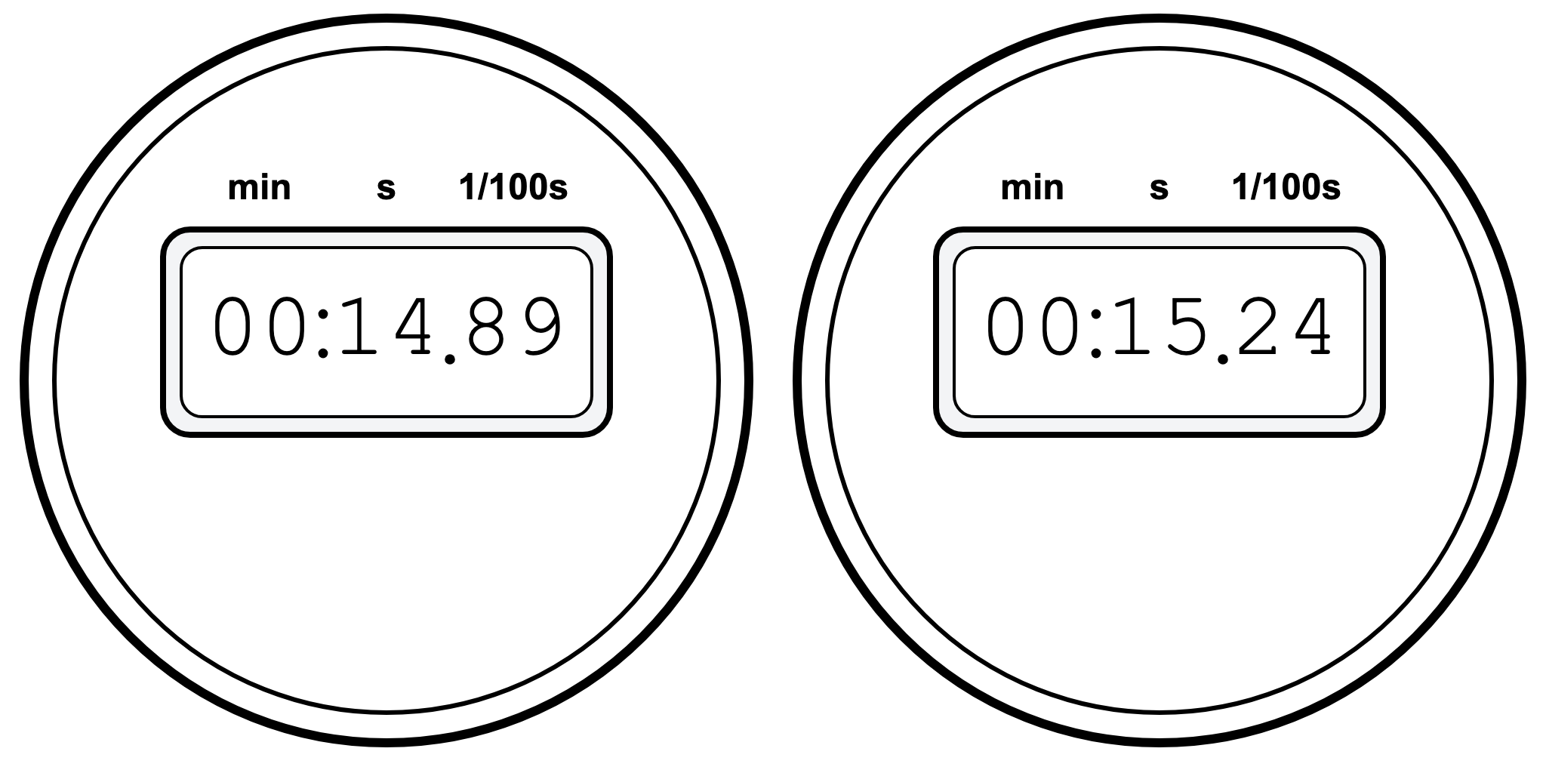
.....................................................................................................
.....................................................................................................
.....................................................................................................
.....................................................................................................
(2 marks)
15. An arrow represents a force on a scale diagram. State the two features of the force that the arrow shows, and state how the arrow shows each one.
.....................................................................................................
.....................................................................................................
.....................................................................................................
.....................................................................................................
(2 marks)
16. The diagram shows two forces acting at right angles. Describe how a scale drawing can be used to find the resultant of these two forces.
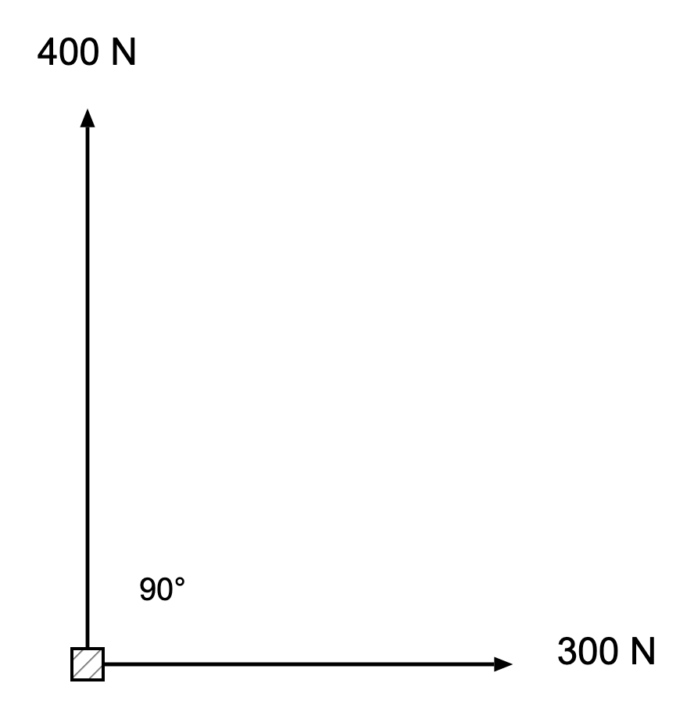
.....................................................................................................
.....................................................................................................
.....................................................................................................
.....................................................................................................
(2 marks)
17. Two liquid levels are shown. Calculate the increase in volume.
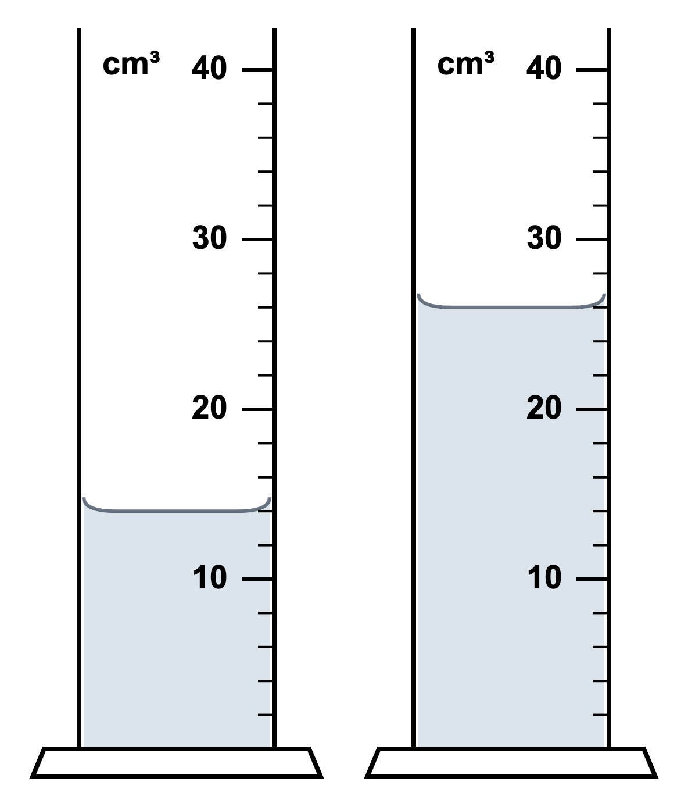
.....................................................................................................
.....................................................................................................
.....................................................................................................
.....................................................................................................
(2 marks)
18. On a scale diagram drawn with the scale 1 cm = 50 N, the resultant arrow is measured to be 9.5 cm long. Determine the resultant force. Give your answer with a unit.
.....................................................................................................
.....................................................................................................
.....................................................................................................
.....................................................................................................
(2 marks)
19. State two differences between distance and displacement.
.....................................................................................................
.....................................................................................................
.....................................................................................................
.....................................................................................................
(2 marks)
20. Describe a method for measuring the period of a pendulum more reliably than timing one oscillation.
.....................................................................................................
.....................................................................................................
.....................................................................................................
.....................................................................................................
(2 marks)
21. A student is planning measurements for a practical lesson.
(a) Choose a suitable instrument for each measurement.
Measurement | Suitable instrument
length of a laboratory bench
volume of water in a beaker
time for 20 oscillations of a pendulum
mass of a small block

(4 marks)
(b) A stack of 80 sheets of paper has a thickness of 6.4 mm. Calculate the thickness of one sheet of paper.
.....................................................................................................
.....................................................................................................
.....................................................................................................
.....................................................................................................
(2 marks)
(c) Explain why measuring the thickness of 80 sheets is better than measuring one sheet directly with a ruler.
.....................................................................................................
.....................................................................................................
(1 mark)
(d) State one possible systematic error when measuring length with a ruler.
.....................................................................................................
.....................................................................................................
(1 mark)
22. A student walks 12 m east, then 5 m north, then 12 m west.
(a) Calculate the total distance walked.
.....................................................................................................
.....................................................................................................
.....................................................................................................
.....................................................................................................
(2 marks)
(b) State the student's final displacement from the starting point. Include the direction.
.....................................................................................................
.....................................................................................................
.....................................................................................................
.....................................................................................................
(2 marks)
(c) Explain why distance is a scalar but displacement is a vector.
.....................................................................................................
.....................................................................................................
.....................................................................................................
.....................................................................................................
(2 marks)
(d) The walk takes 10 s. Calculate the student's average speed.
.....................................................................................................
.....................................................................................................
.....................................................................................................
.....................................................................................................
(2 marks)
23. A student places five identical spheres in a straight line between two blocks. The spheres touch each other.
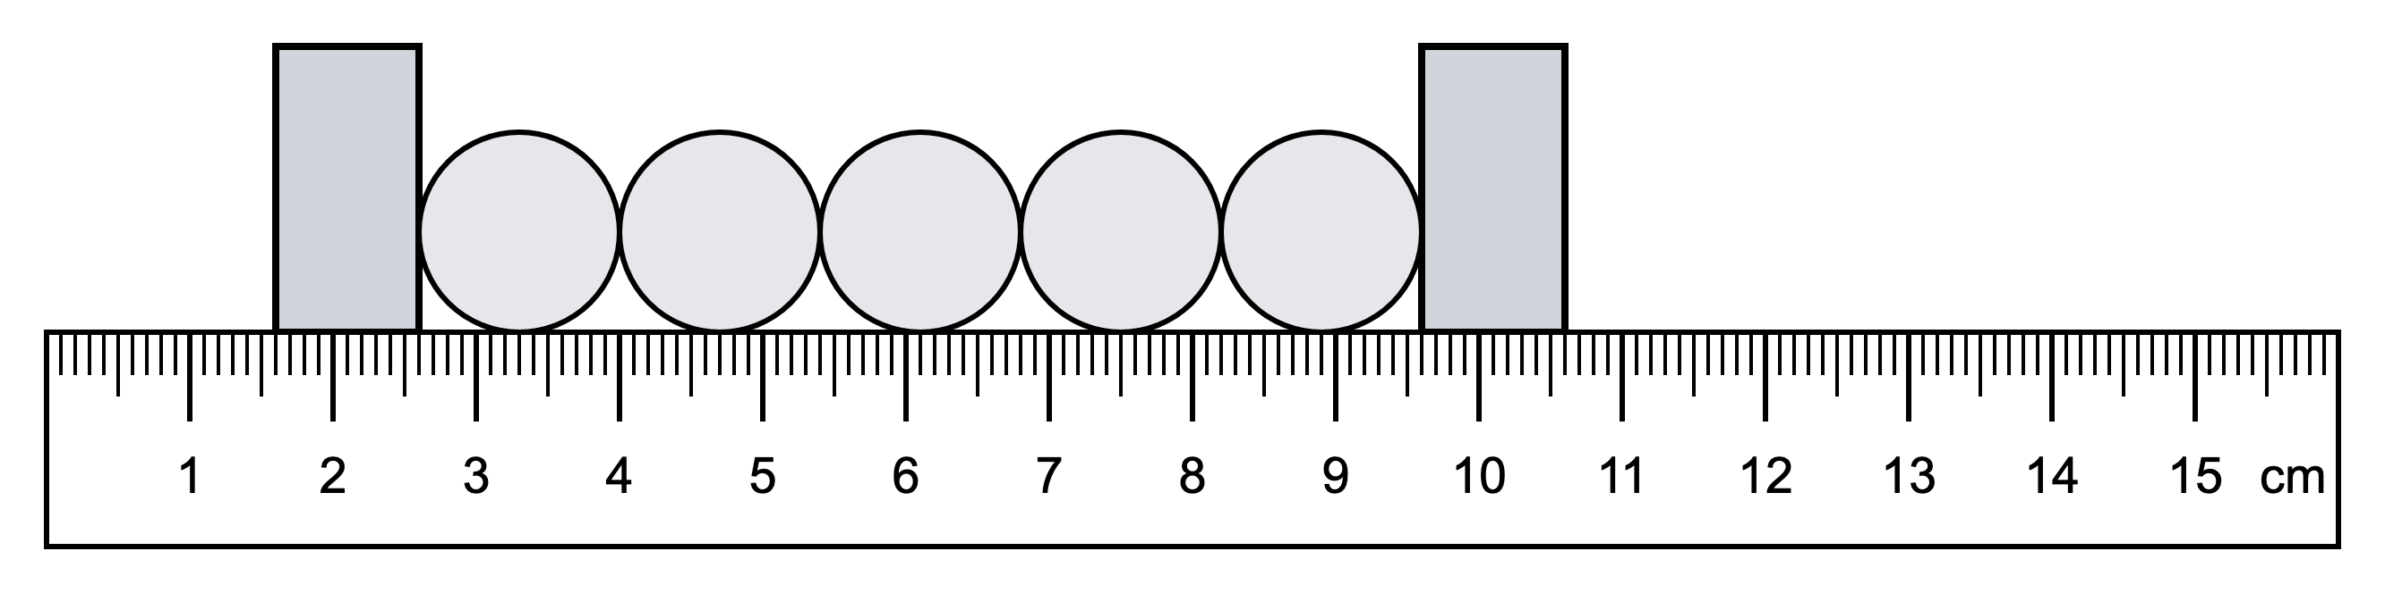
(a) State the ruler reading at the left side of the first sphere.
.....................................................................................................
.....................................................................................................
(1 mark)
(b) State the ruler reading at the right side of the fifth sphere.
.....................................................................................................
.....................................................................................................
(1 mark)
(c) Calculate the diameter of one sphere.
.....................................................................................................
.....................................................................................................
.....................................................................................................
.....................................................................................................
.....................................................................................................
(3 marks)
(d) Explain why measuring five spheres together gives a more accurate value for the diameter than measuring one sphere.
.....................................................................................................
.....................................................................................................
(1 mark)
(e) State why the blocks are useful in this measurement.
.....................................................................................................
.....................................................................................................
(1 mark)

