1.2 Motion: Cambridge IGCSE Physics worksheet
1. A graph of distance against time is drawn for a moving object. What does the gradient of the graph represent?
A acceleration
B distance
C time
D speed
(1 mark)
2. Which row correctly compares speed and velocity?
 | Speed | Velocity
A | Includes direction | Includes direction
B | No direction | Includes direction
C | Includes direction | No direction
D | No direction | No direction

(1 mark)
3. A train travels at a constant speed of 6 m/s for 8 s. How far does it travel?
A 0.75 m
B 14 m
C 48 m
D 96 m
(1 mark)
4. A distance-time graph has a horizontal section. What is the object doing during this section?
A Accelerating
B Moving at constant speed
C Moving back towards the starting point
D Remaining stationary
(1 mark)
5. An object changes from initial velocity u to final velocity v in time t. Which equation gives its acceleration a?
A $a=\frac{t}{v−u}$
B $a=\frac{v+u}{t}$
C $a=\frac{u−v}{t}$
D $a=\frac{v−u}{t}$
(1 mark)
6. Which distance-time graph represents an object whose speed is increasing?
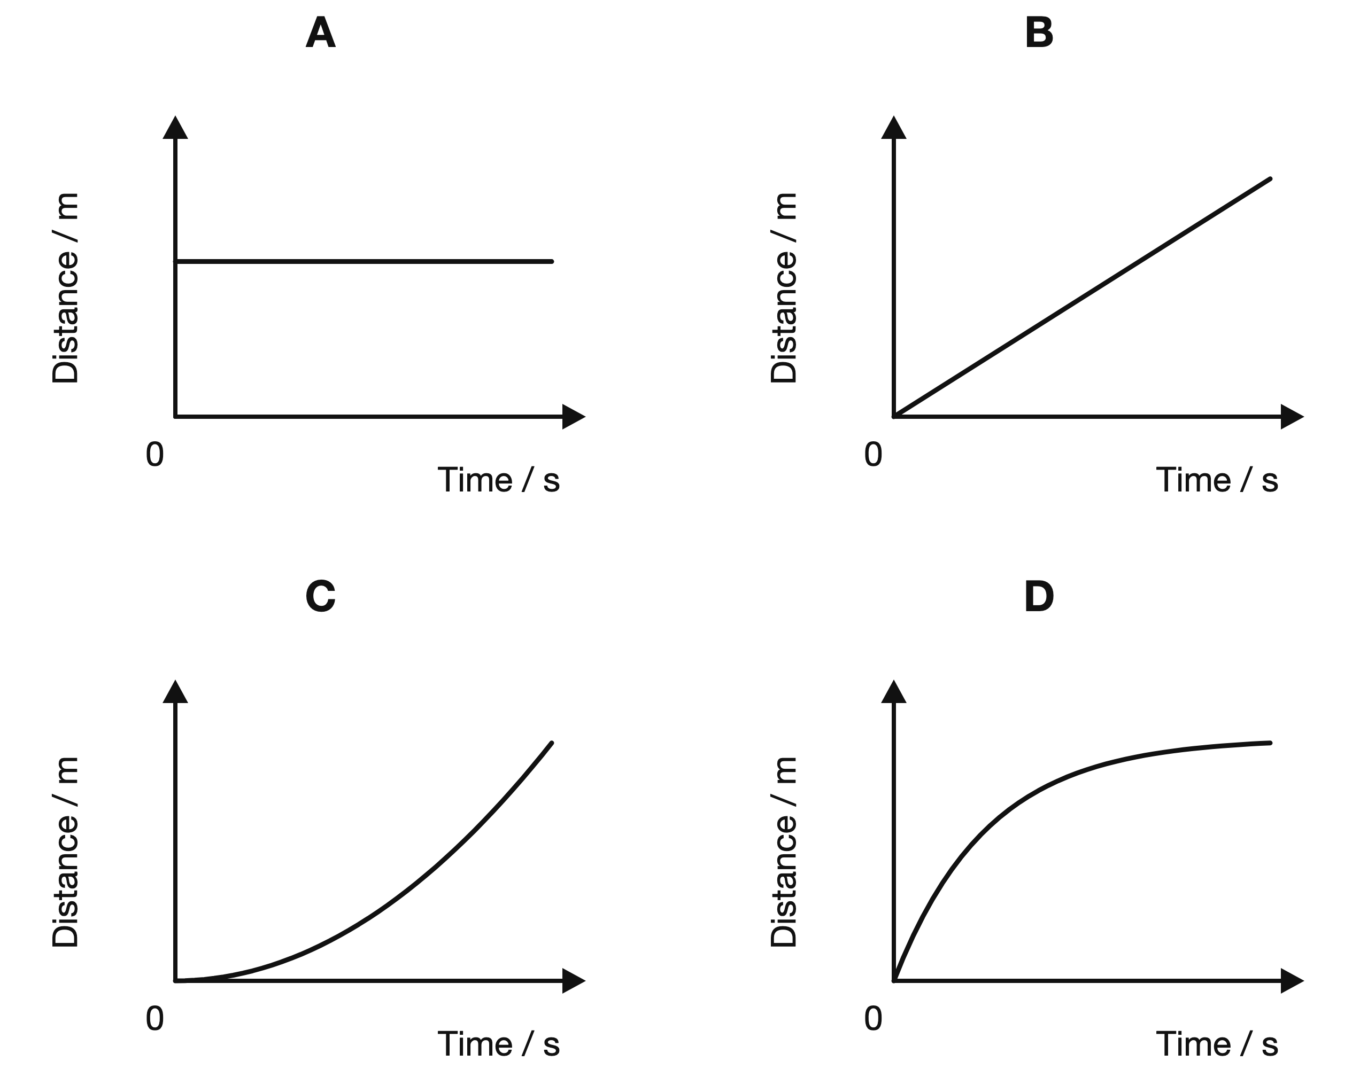
(1 mark)
7. An object completes one circular revolution of radius 5.0 m in 10 s. What is its speed? Use the circumference $2πr$.
A 3.1 m/s
B 0.50 m/s
C 2.0 m/s
D 31 m/s
(1 mark)
8. A parachutist is falling vertically at terminal velocity. Which statement is correct?
A The parachutist has no weight.
B Air resistance equals weight, so the speed is constant.
C Air resistance is greater than weight, so the speed is constant.
D Weight is greater than air resistance, so the speed is constant.
(1 mark)
9. The speed of an object increases uniformly from 0 m/s to 12 m/s in 5 s. What distance does it travel during this time?
A 12 m
B 17 m
C 60 m
D 30 m
(1 mark)
10. A trolley travels 80 m in 10 s, remains stationary for 5 s, and then travels 40 m in 5 s. What is its average speed for the complete journey?
A 12 m/s
B 8 m/s
C 2.0 m/s
D 6 m/s
(1 mark)
11. A car travels around a roundabout at a steady 20 km/h. Which statement about the car is correct?
A Its speed and its velocity both stay constant.
B Its speed is constant but its velocity changes.
C Its velocity is constant but its speed changes.
D Its speed and its velocity both change.
(1 mark)
12. The graph shows how the speed of a trolley changes with time.
What is the total distance travelled by the trolley in the 10 s shown?
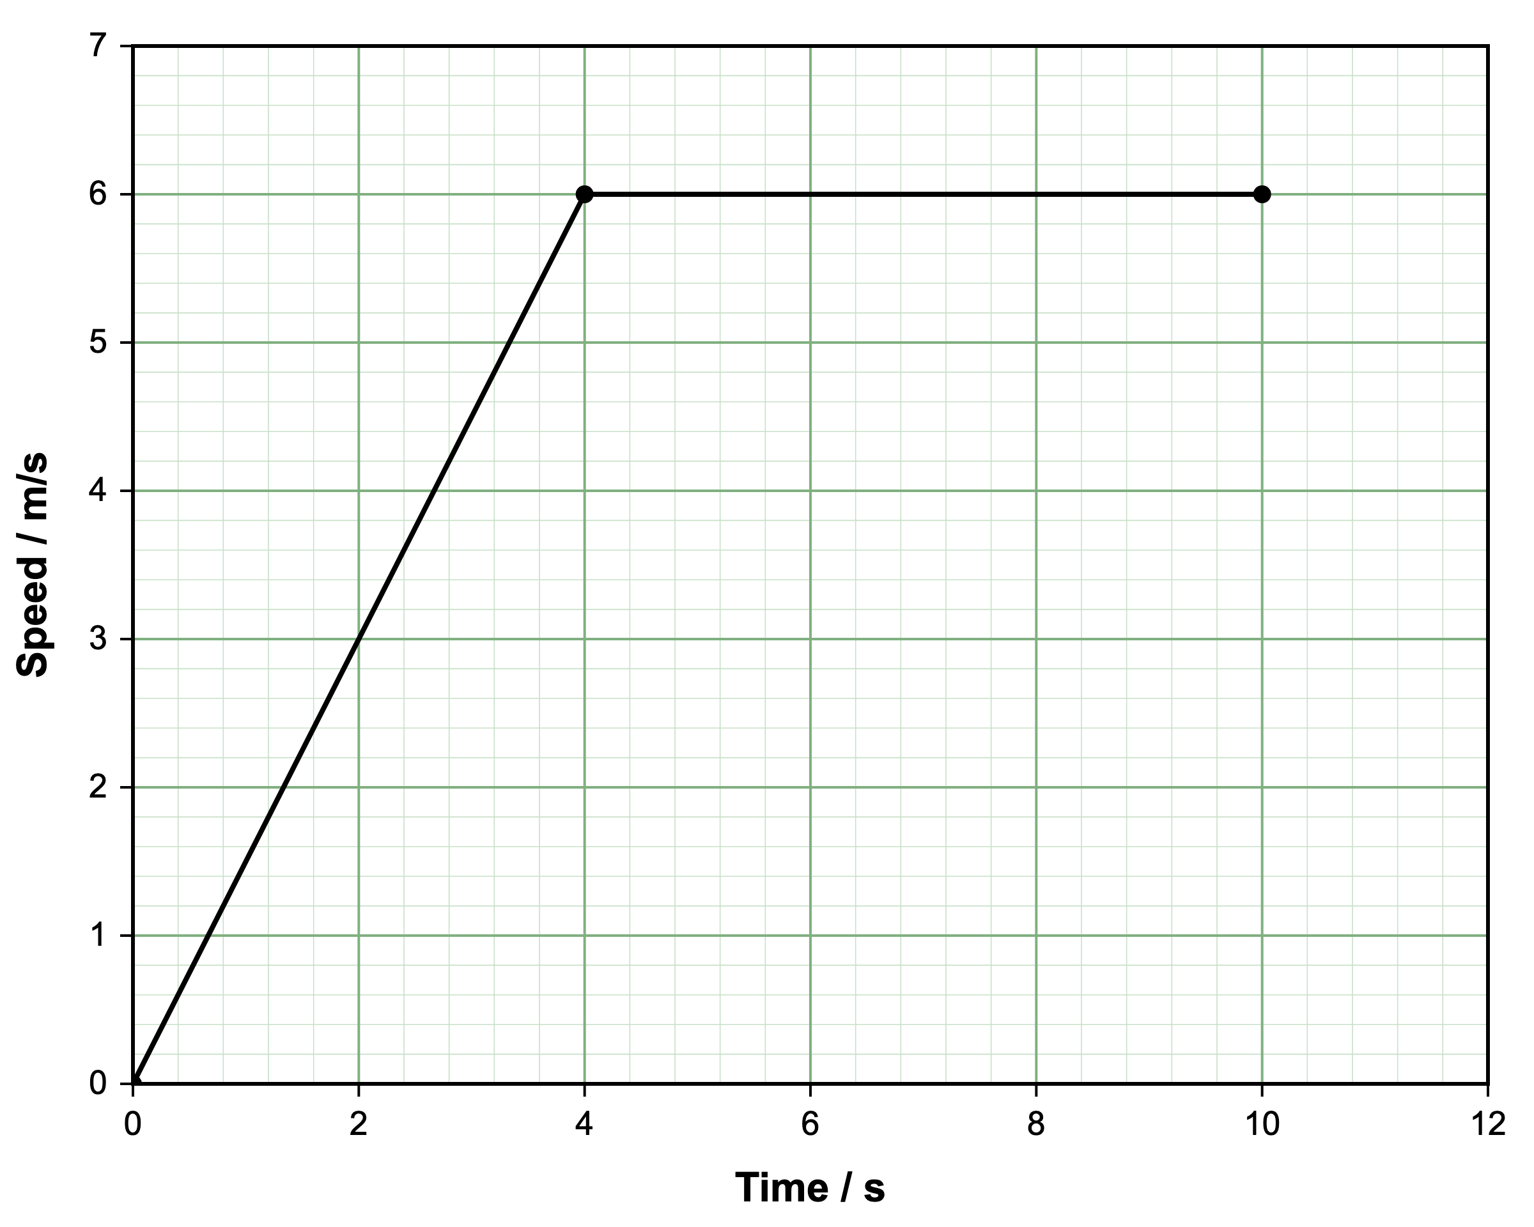
A 12 m
B 36 m
C 48 m
D 60 m
(1 mark)
13. Define the term speed.
.....................................................................................................
.....................................................................................................
(1 mark)
14. State the approximate acceleration of free fall near the Earth's surface.
.....................................................................................................
.....................................................................................................
(1 mark)
15. Define velocity.
.....................................................................................................
.....................................................................................................
(1 mark)
16. State the SI unit of acceleration.
.....................................................................................................
.....................................................................................................
(1 mark)
17. The gradient of a straight distance-time graph is 4 m/s. State the physical quantity represented by the gradient.
.....................................................................................................
.....................................................................................................
(1 mark)
18. A straight line on a distance-time graph passes through the points (2 s, 6 m) and (8 s, 24 m). Determine the gradient of the line.
.....................................................................................................
.....................................................................................................
.....................................................................................................
.....................................................................................................
(2 marks)
19. The Moon moves at constant speed in the orbit shown. Explain why its velocity is not constant.
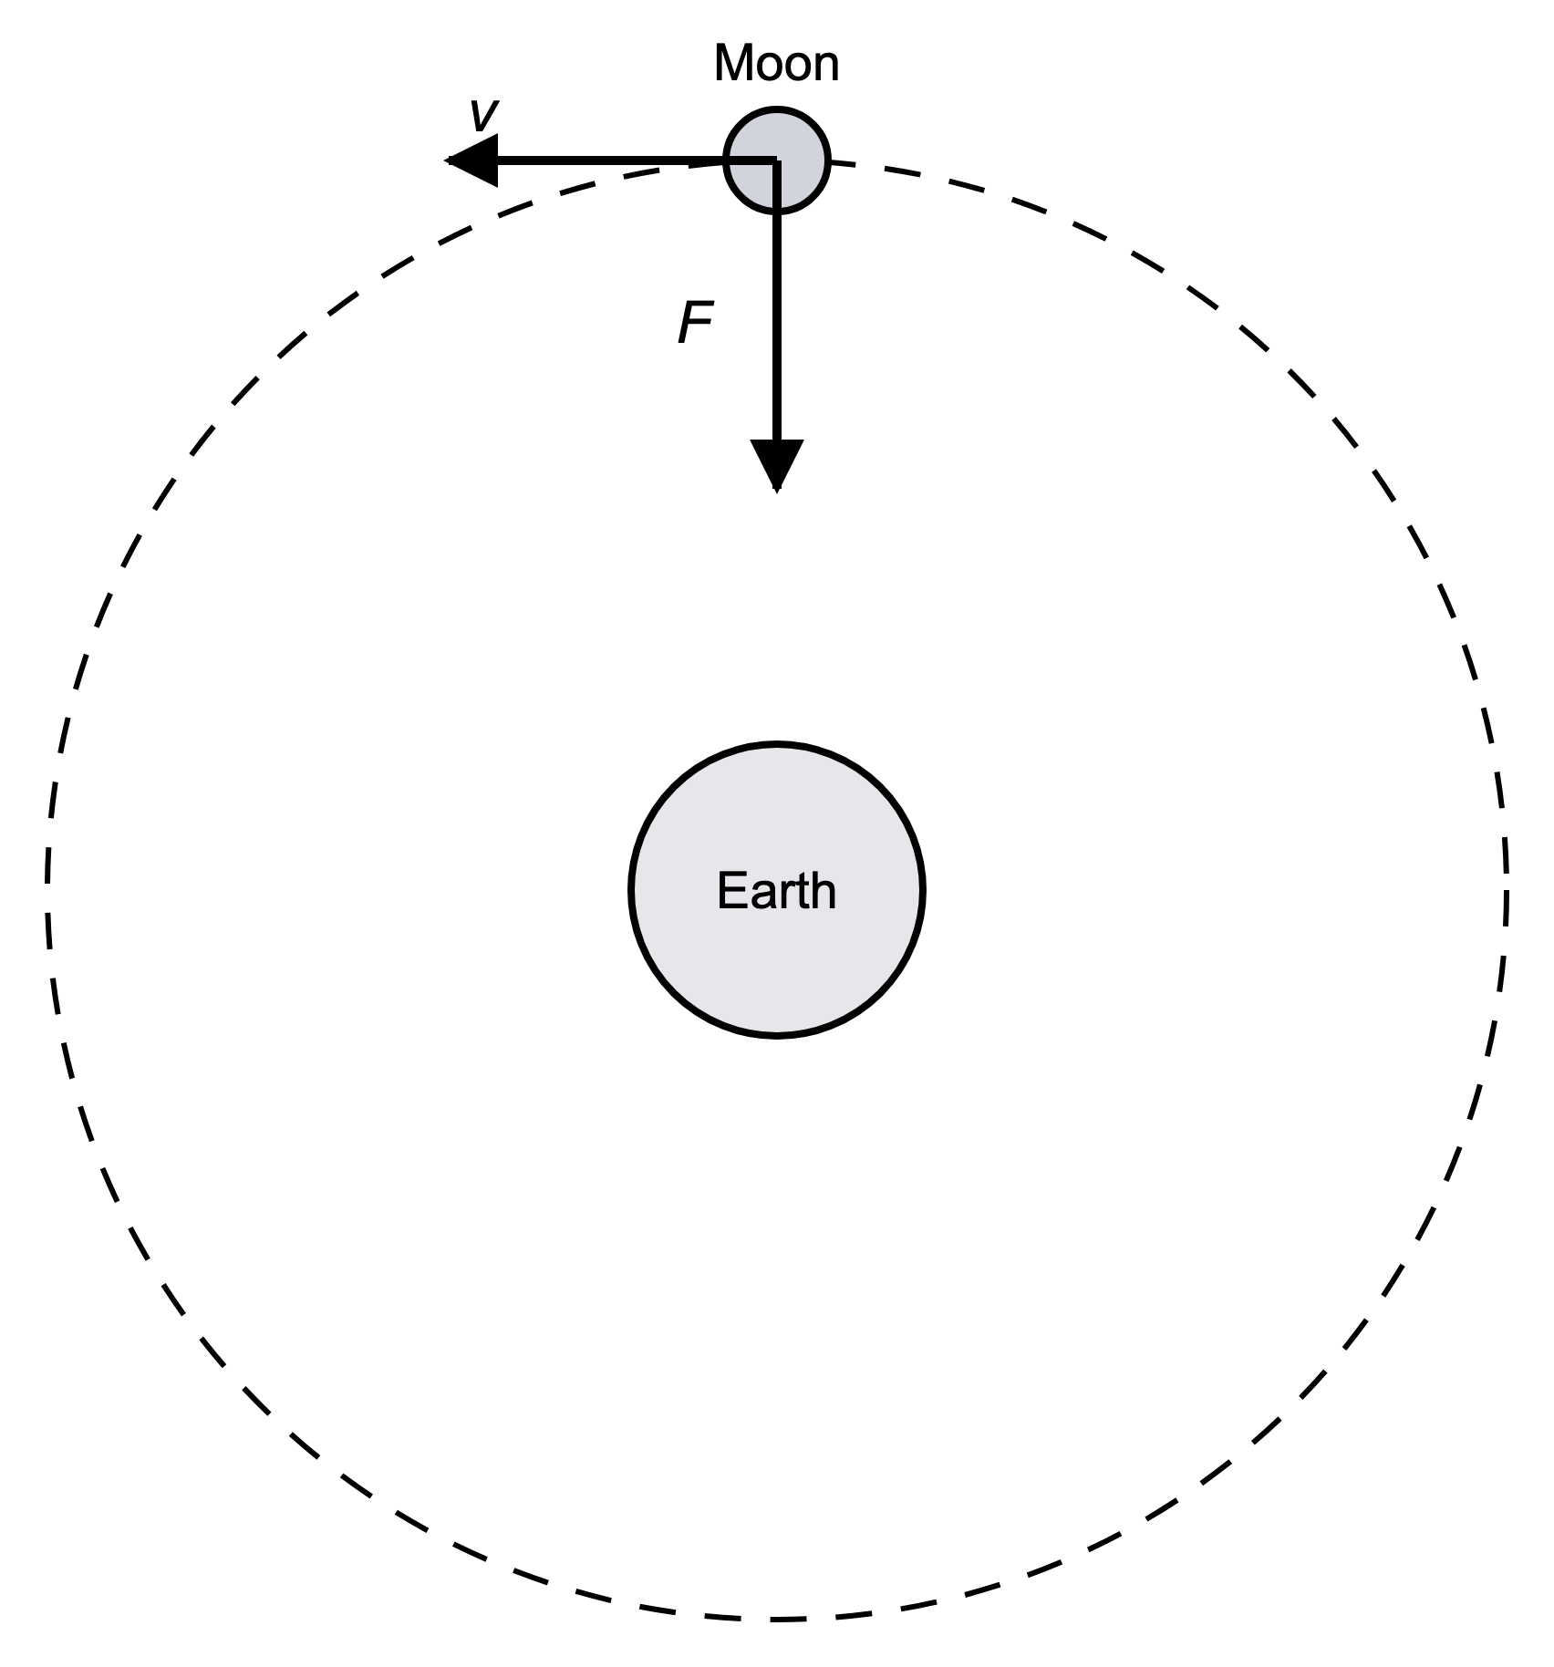
.....................................................................................................
.....................................................................................................
.....................................................................................................
.....................................................................................................
(2 marks)
20. A skydiver is already falling and the air resistance equals the weight. Describe the skydiver's motion.
.....................................................................................................
.....................................................................................................
(1 mark)
21. A speed-time graph has a gradient of -2 m/s² while the object is moving forwards. State what the negative sign shows.
.....................................................................................................
.....................................................................................................
(1 mark)
22. Convert 72 km/h into m/s.
.....................................................................................................
.....................................................................................................
.....................................................................................................
.....................................................................................................
(2 marks)
23. A satellite follows a circular orbit of radius 7.0 × 10⁶ m in a period of 6000 s. Calculate its average orbital speed.
.....................................................................................................
.....................................................................................................
.....................................................................................................
.....................................................................................................
(2 marks)
24. A technician measures a trolley moving in a straight line along a bench. The trolley travels 2.0 m east in 0.50 s.
(a) Calculate the speed of the trolley.
.....................................................................................................
.....................................................................................................
.....................................................................................................
.....................................................................................................
(2 marks)
(b) State the velocity of the trolley.
.....................................................................................................
.....................................................................................................
(1 mark)
(c) Explain why the answers to parts (a) and (b) are not the same type of quantity.
.....................................................................................................
.....................................................................................................
.....................................................................................................
.....................................................................................................
(2 marks)
(d) Suggest why repeating the timing and taking an average would improve the result if the journey lasted only 0.20 s.
.....................................................................................................
.....................................................................................................
.....................................................................................................
.....................................................................................................
(2 marks)
25. A trolley travels 12.6 m along a straight track. The stopwatch reading below was recorded for the journey.
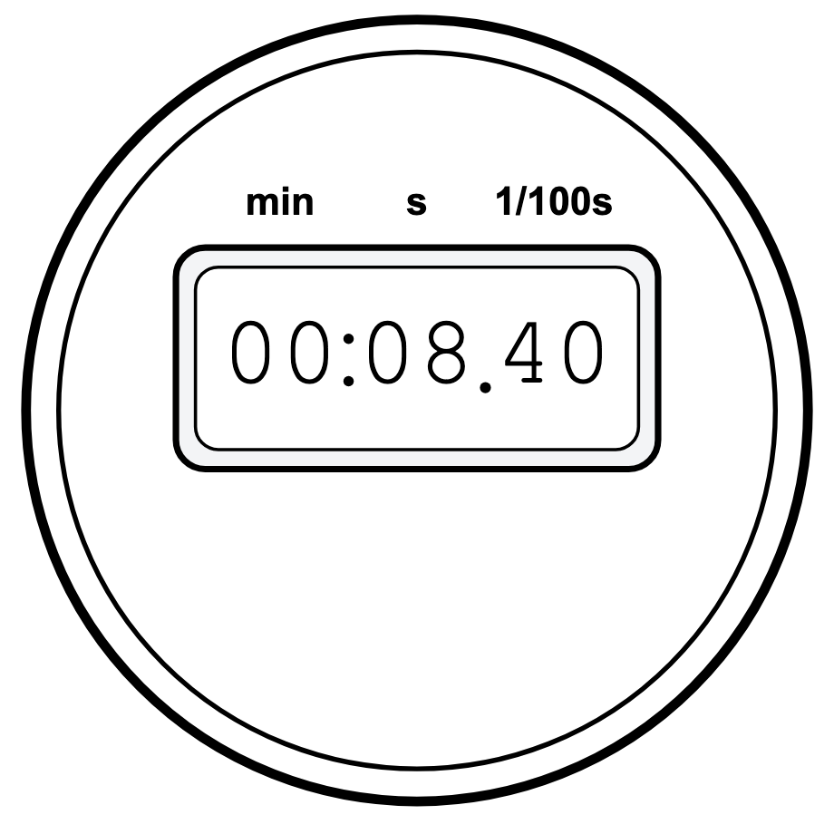
(a) State the equation linking speed, distance and time.
.....................................................................................................
.....................................................................................................
(1 mark)
(b) Use the stopwatch reading below to calculate the speed of the trolley.
.....................................................................................................
.....................................................................................................
.....................................................................................................
.....................................................................................................
.....................................................................................................
(3 marks)
(c) Explain why the value calculated in part (b) is an average speed.
.....................................................................................................
.....................................................................................................
.....................................................................................................
.....................................................................................................
(2 marks)
(d) Suggest one way to reduce the percentage uncertainty in the time measurement.
.....................................................................................................
.....................................................................................................
(1 mark)
26. A skydiver of mass 80 kg has just jumped from a plane and is falling downward. The diagram below shows the vertical forces acting on the skydiver at one instant during the fall.
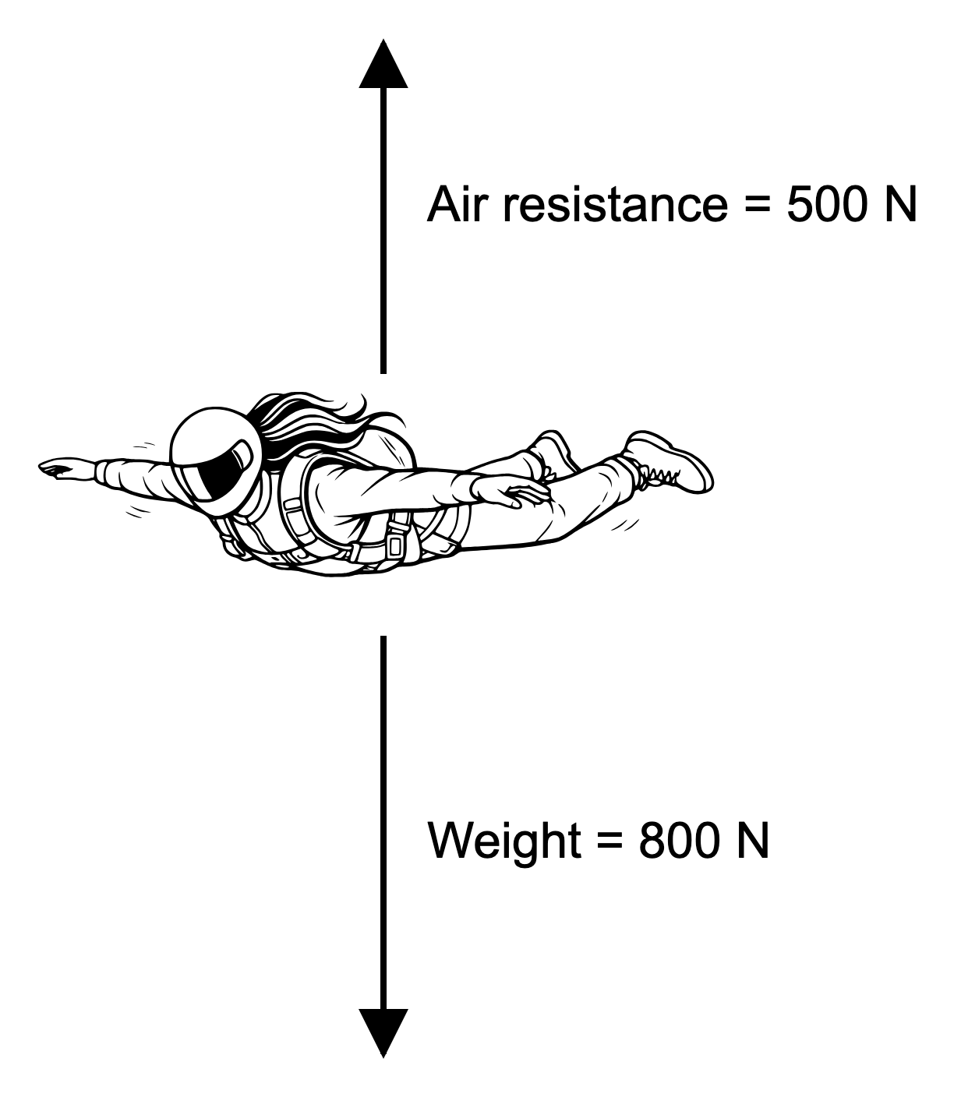
(a) Calculate the resultant force on the skydiver. Give the direction of this force.
.....................................................................................................
.....................................................................................................
.....................................................................................................
.....................................................................................................
(2 marks)
(b) Calculate the acceleration of the skydiver at this instant.
.....................................................................................................
.....................................................................................................
.....................................................................................................
.....................................................................................................
(2 marks)
(c) Describe how the air resistance on the skydiver changes as the skydiver's speed increases, and explain why.
.....................................................................................................
.....................................................................................................
.....................................................................................................
.....................................................................................................
(2 marks)
(d) The skydiver eventually reaches terminal velocity. Compare the forces acting on the skydiver at terminal velocity and explain why the velocity is now constant.
.....................................................................................................
.....................................................................................................
.....................................................................................................
.....................................................................................................
.....................................................................................................
(3 marks)

