1.3 Mass and weight: Cambridge IGCSE Physics worksheet
1. Which equation is used to calculate the weight of an object?
A $W=\frac{g}{m}$
B $W=\frac{m}{g}$
C $W=m+g$
D $W=mg$
(1 mark)
2. Which statement about mass and weight is correct?
A Mass is a force, and weight is the amount of matter in an object.
B Mass changes with location, but weight is constant.
C Mass is the amount of matter in an object, and weight is the gravitational force on it.
D Mass and weight are both forces.
(1 mark)
3. Which row correctly matches each instrument to the quantity it measures?
 | Balance | Newton meter
A | mass | weight
B | weight | mass
C | mass | mass
D | weight | weight

(1 mark)
4. A package has a mass of 15 kg. The gravitational field strength on the Moon is 1.6 N/kg.
What is the weight of the package on the Moon?
A 9.4 N
B 16.6 N
C 150 N
D 24 N
(1 mark)
5. A newton meter reads 18 N when an object hangs at rest from it. The gravitational field strength is 10 N/kg.
What is the mass of the object?
A 0.56 kg
B 1.8 kg
C 8.0 kg
D 180 kg
(1 mark)
6. An object is taken from Earth to the Moon, where the gravitational field is weaker.
How do its mass and weight on the Moon compare with their values on Earth?
 | Mass on the Moon | Weight on the Moon
A | smaller | smaller
B | larger | smaller
C | unchanged | unchanged
D | unchanged | smaller

(1 mark)
7. The same object is placed at P and at Q. The gravitational field strength is 3.0 N/kg at P and 12 N/kg at Q.
What is the ratio of the weight at P to the weight at Q?
A 4 : 1
B 1 : 1
C 1 : 4
D 3 : 4
(1 mark)
8. An electronic balance gives a reading of 2.40 kg for an object. The gravitational field strength is 10 N/kg.
What is the weight of the object?
A 0.240 N
B 2.40 N
C 24.0 N
D 240 N
(1 mark)
9. A satellite is moved from a lower circular orbit to a higher circular orbit around Earth.
How do its mass and the gravitational force on it change?
 | Mass | Gravitational force
A | decreases | decreases
B | unchanged | unchanged
C | increases | decreases
D | unchanged | decreases

(1 mark)
10. Object X has a mass of 4.0 kg in a gravitational field of strength 10 N/kg. Object Y is in a field of strength 8.0 N/kg and has the same weight as X.
What is the mass of Y?
A 5.0 kg
B 3.2 kg
C 4.0 kg
D 12 kg
(1 mark)
11. Which graph shows how weight varies with mass at a location where gravitational field strength is constant?
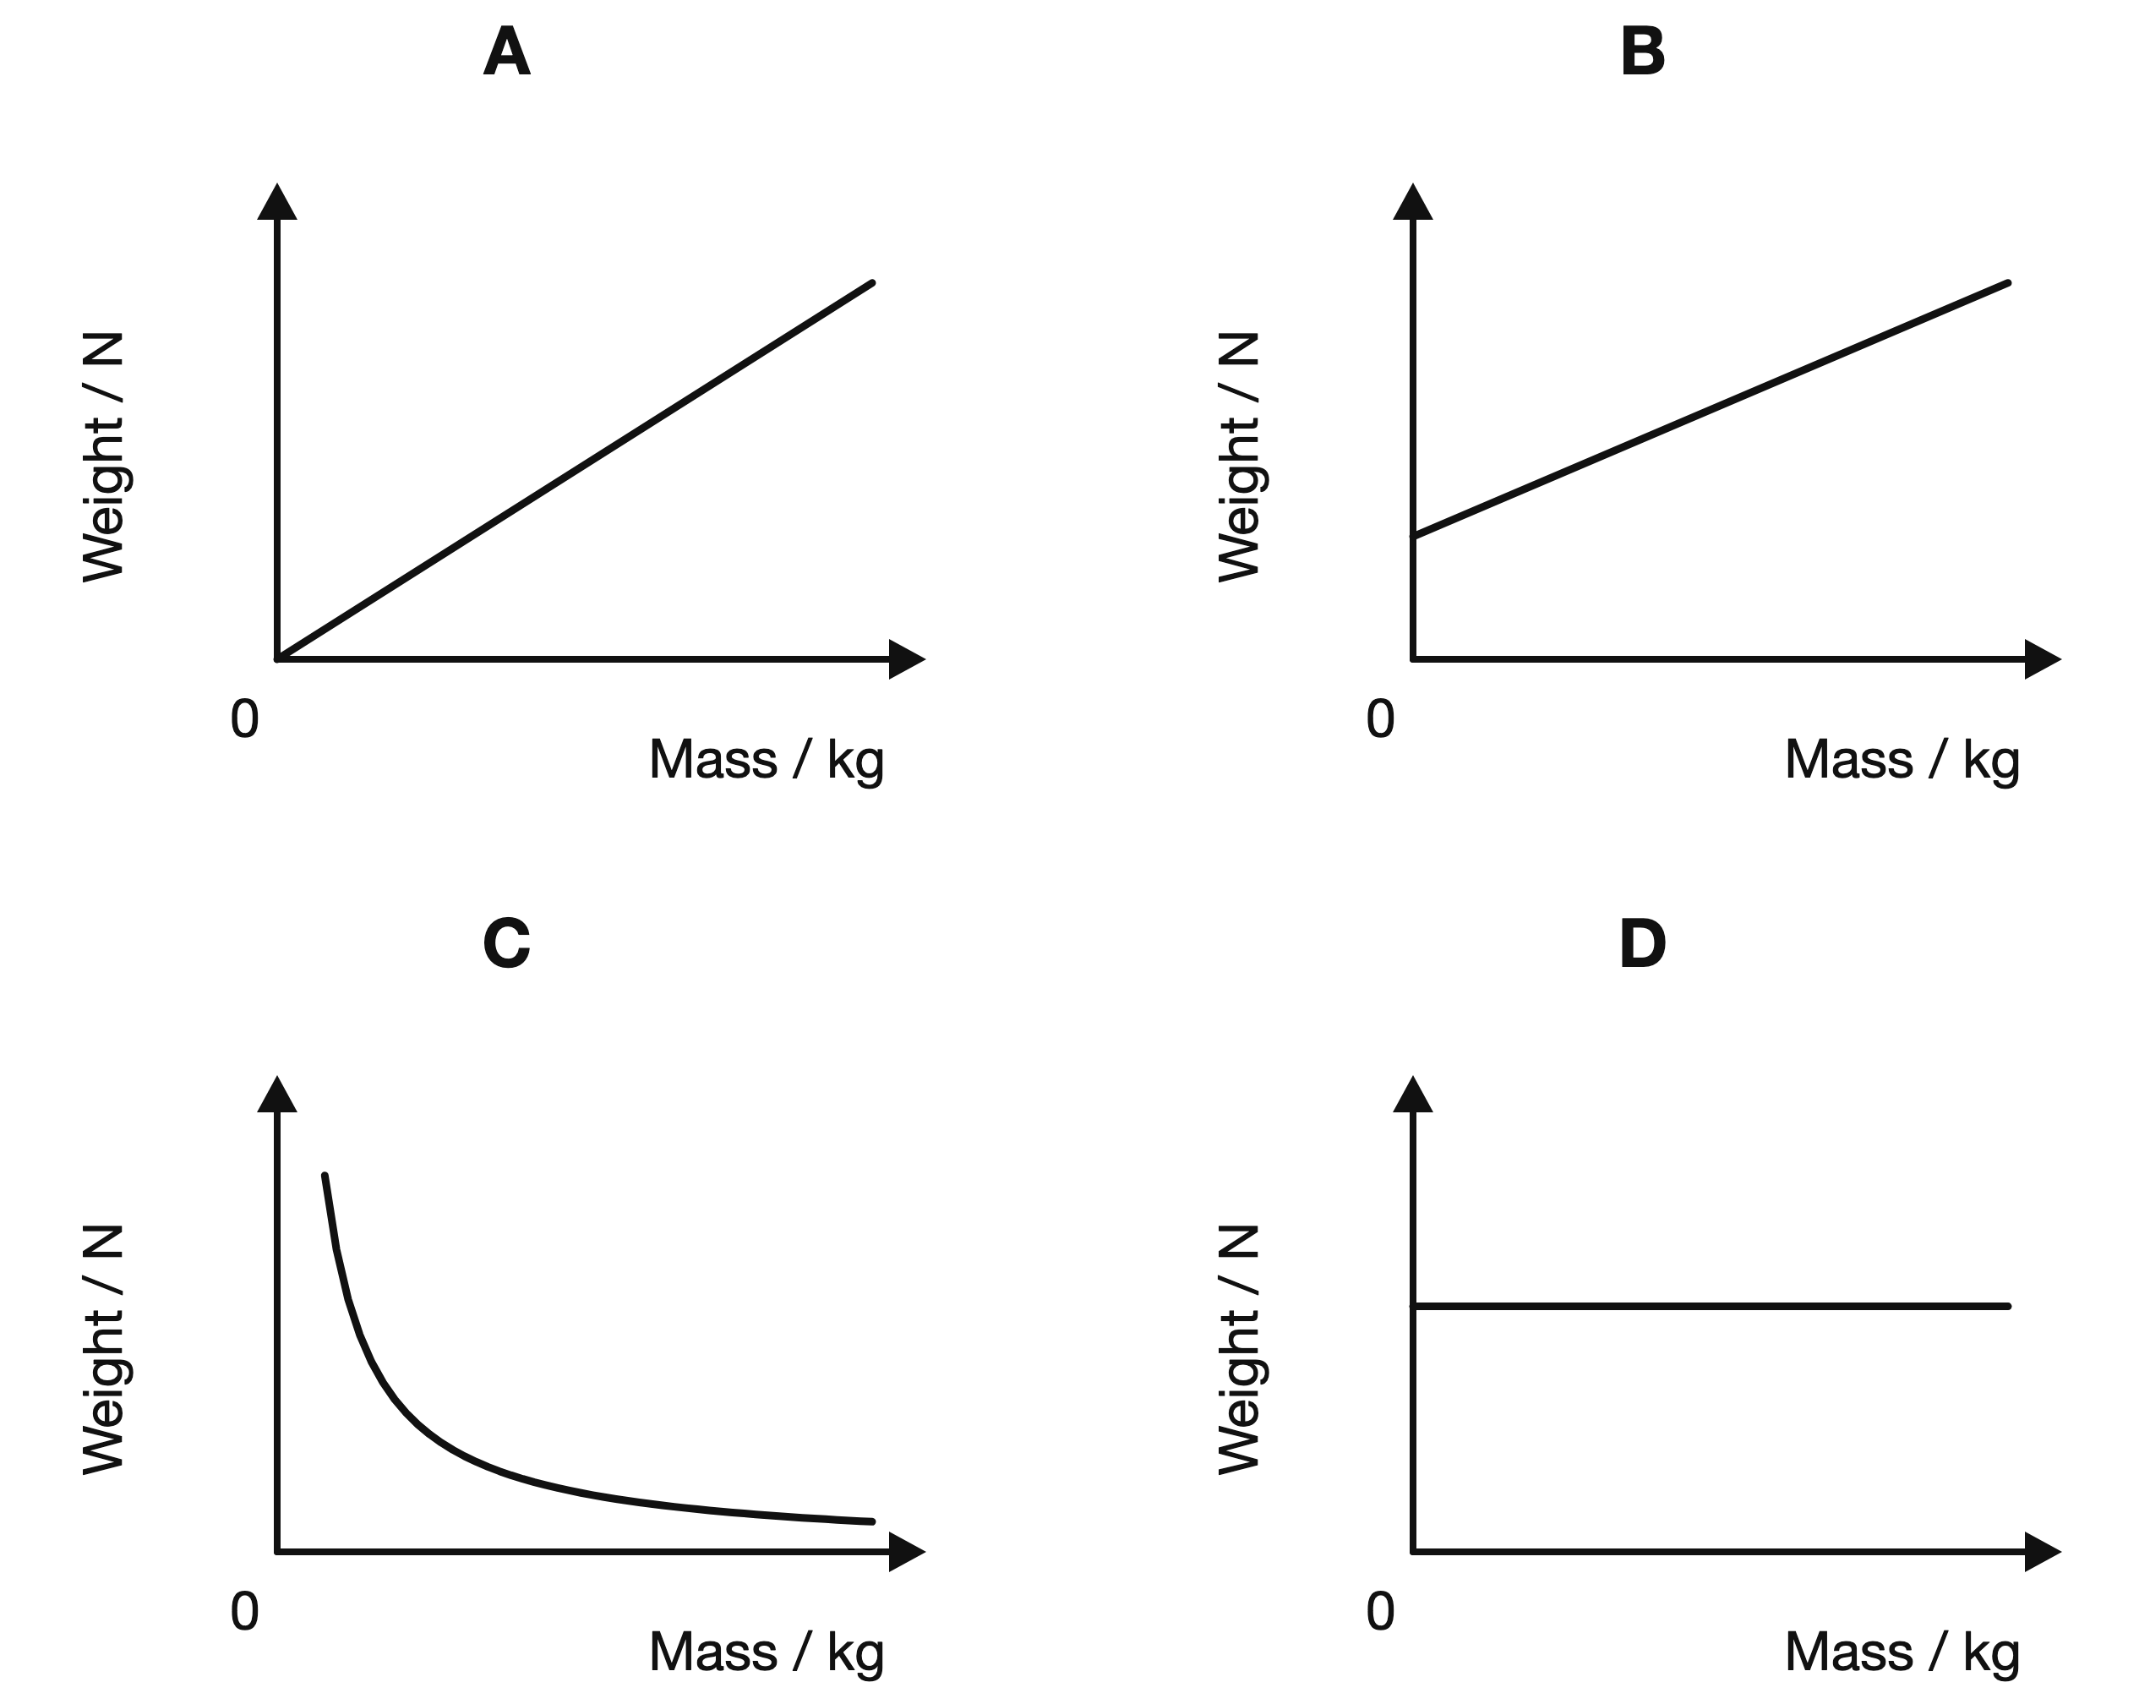
(1 mark)
12. At one location, a 3.0 kg object weighs 24 N. A second object at the same location weighs 40 N.
What is the mass of the second object?
A 1.8 kg
B 5.0 kg
C 8.0 kg
D 15 kg
(1 mark)
13. In the equation $W=mg$, what does g represent, and what quantity is it equivalent to for an object in free fall?
.....................................................................................................
.....................................................................................................
.....................................................................................................
.....................................................................................................
(2 marks)
14. Convert 750 g into kilograms.
.....................................................................................................
.....................................................................................................
(1 mark)
15. A student says, "My weight is 60 kg." State why this is not accurate physics wording.
.....................................................................................................
.....................................................................................................
.....................................................................................................
.....................................................................................................
(2 marks)
16. Use the mass reading in the diagram to find the block's weight when $g=10 N/kg$.
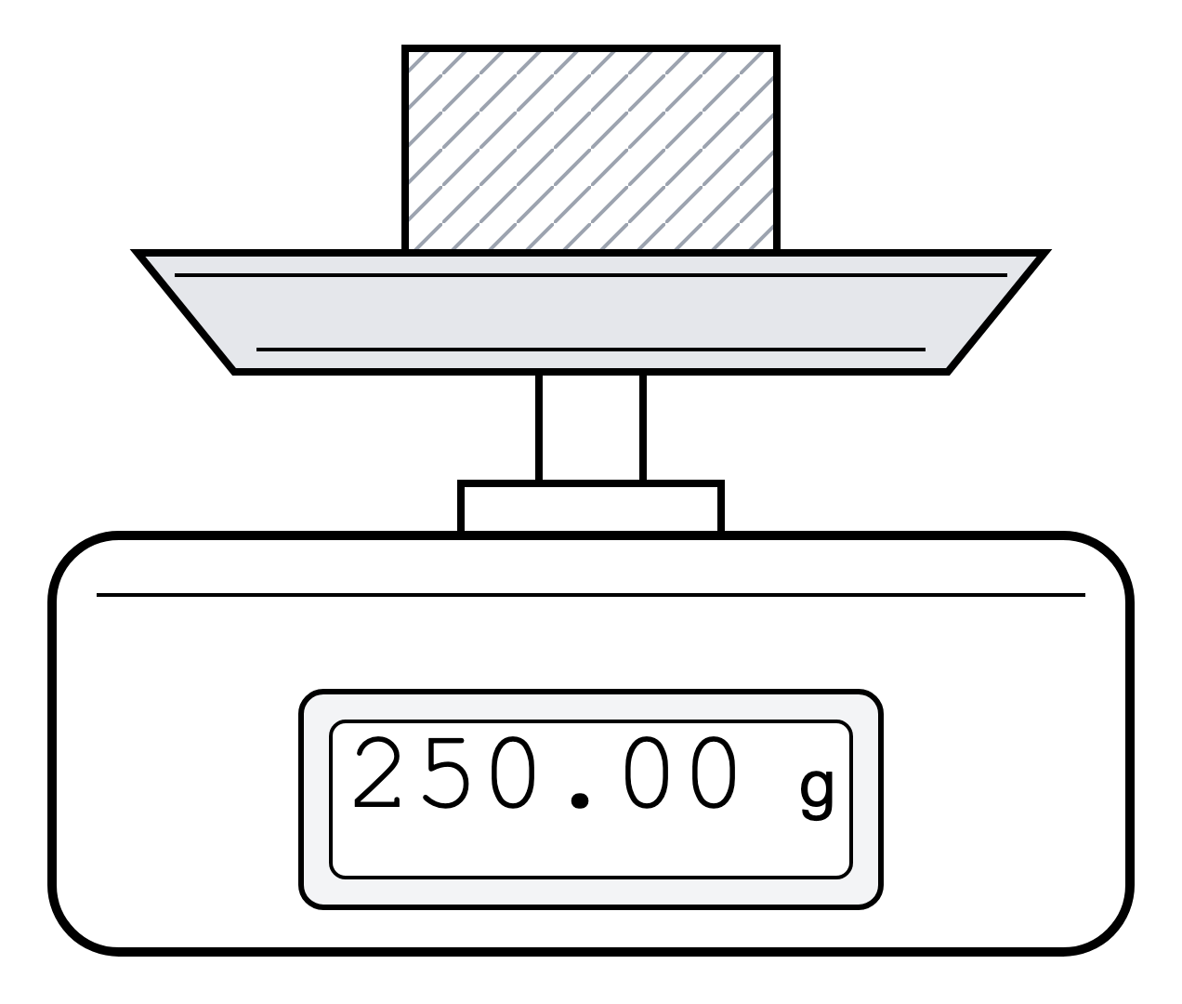
.....................................................................................................
.....................................................................................................
.....................................................................................................
.....................................................................................................
(2 marks)
17. The diagram shows two blocks on digital mass scales. Which block has the greater weight on Earth? Give a reason for your answer.
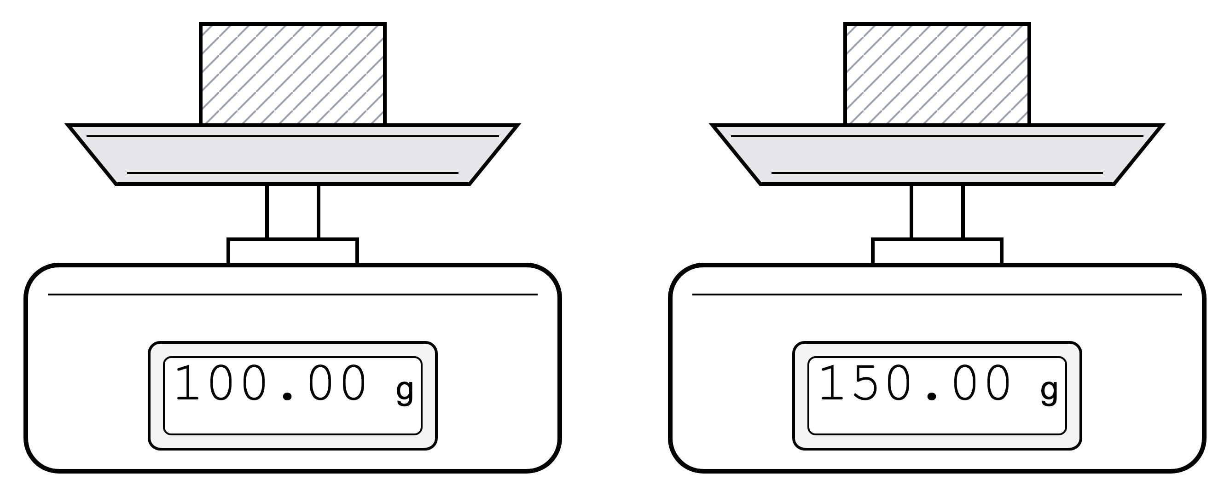
.....................................................................................................
.....................................................................................................
.....................................................................................................
.....................................................................................................
(2 marks)
18. A student writes: mass = 5 N. Explain why this unit is wrong and give a correct unit for mass.
.....................................................................................................
.....................................................................................................
.....................................................................................................
.....................................................................................................
(2 marks)
19. Use the two balance displays to calculate the mean mass of the sample.
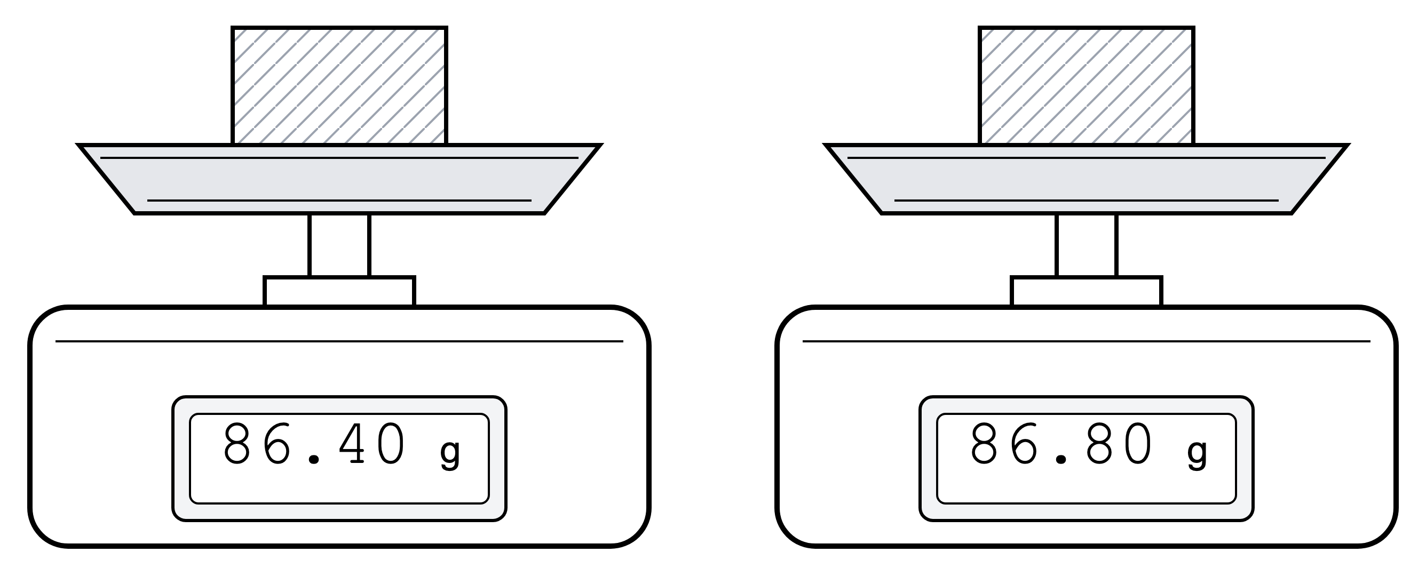
.....................................................................................................
.....................................................................................................
.....................................................................................................
.....................................................................................................
(2 marks)
20. Use the diagram to name the downward force and the forces acting along the two ropes.
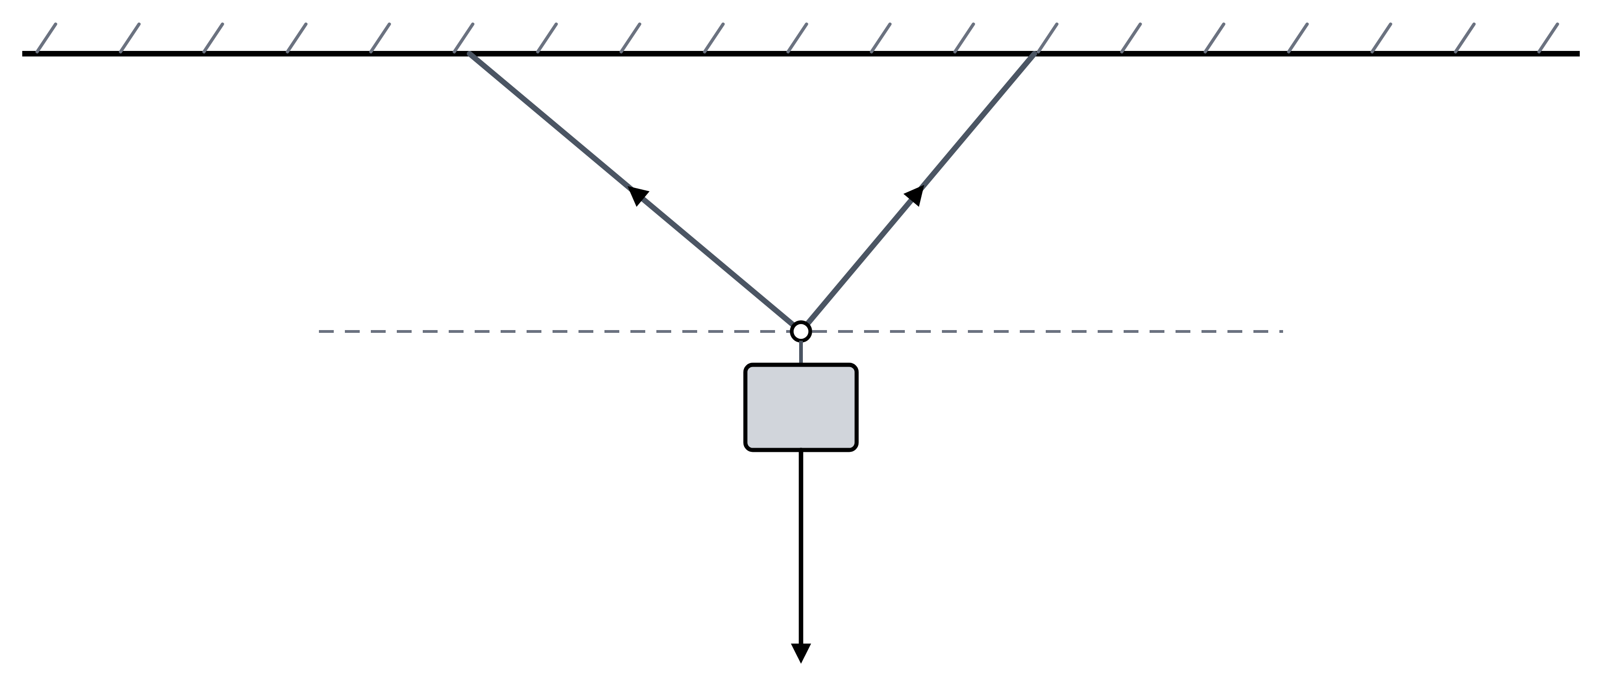
.....................................................................................................
.....................................................................................................
.....................................................................................................
.....................................................................................................
(2 marks)
21. The diagram below shows a small metal cube on a digital mass scale. Use $g=10 N/kg$.
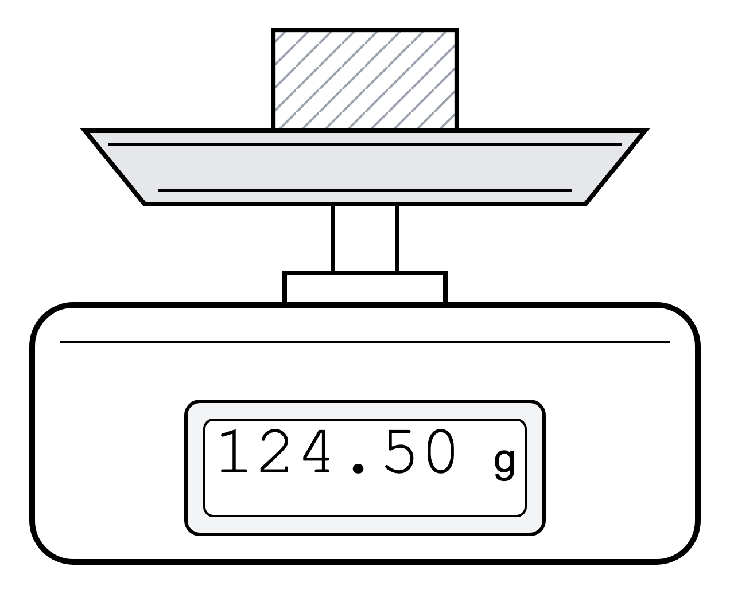
(a) State what is meant by mass.
.....................................................................................................
.....................................................................................................
(1 mark)
(b) State what is meant by weight.
.....................................................................................................
.....................................................................................................
(1 mark)
(c) State the SI unit for mass and the SI unit for weight.
.....................................................................................................
.....................................................................................................
.....................................................................................................
.....................................................................................................
(2 marks)
(d) Convert the mass shown in the diagram into kilograms.
.....................................................................................................
.....................................................................................................
(1 mark)
(e) Calculate the weight of the metal cube on Earth.
.....................................................................................................
.....................................................................................................
.....................................................................................................
.....................................................................................................
(2 marks)
22. A technician uses a force sensor to measure the weight of calibration masses in a laboratory on Earth. Use the table and graph grid below.
Mass / kg | Weight / N
0.00 | 0.00
0.20 | 1.94
0.40 | 3.95
0.60 | 5.86
0.80 | 7.88
1.00 | 9.79

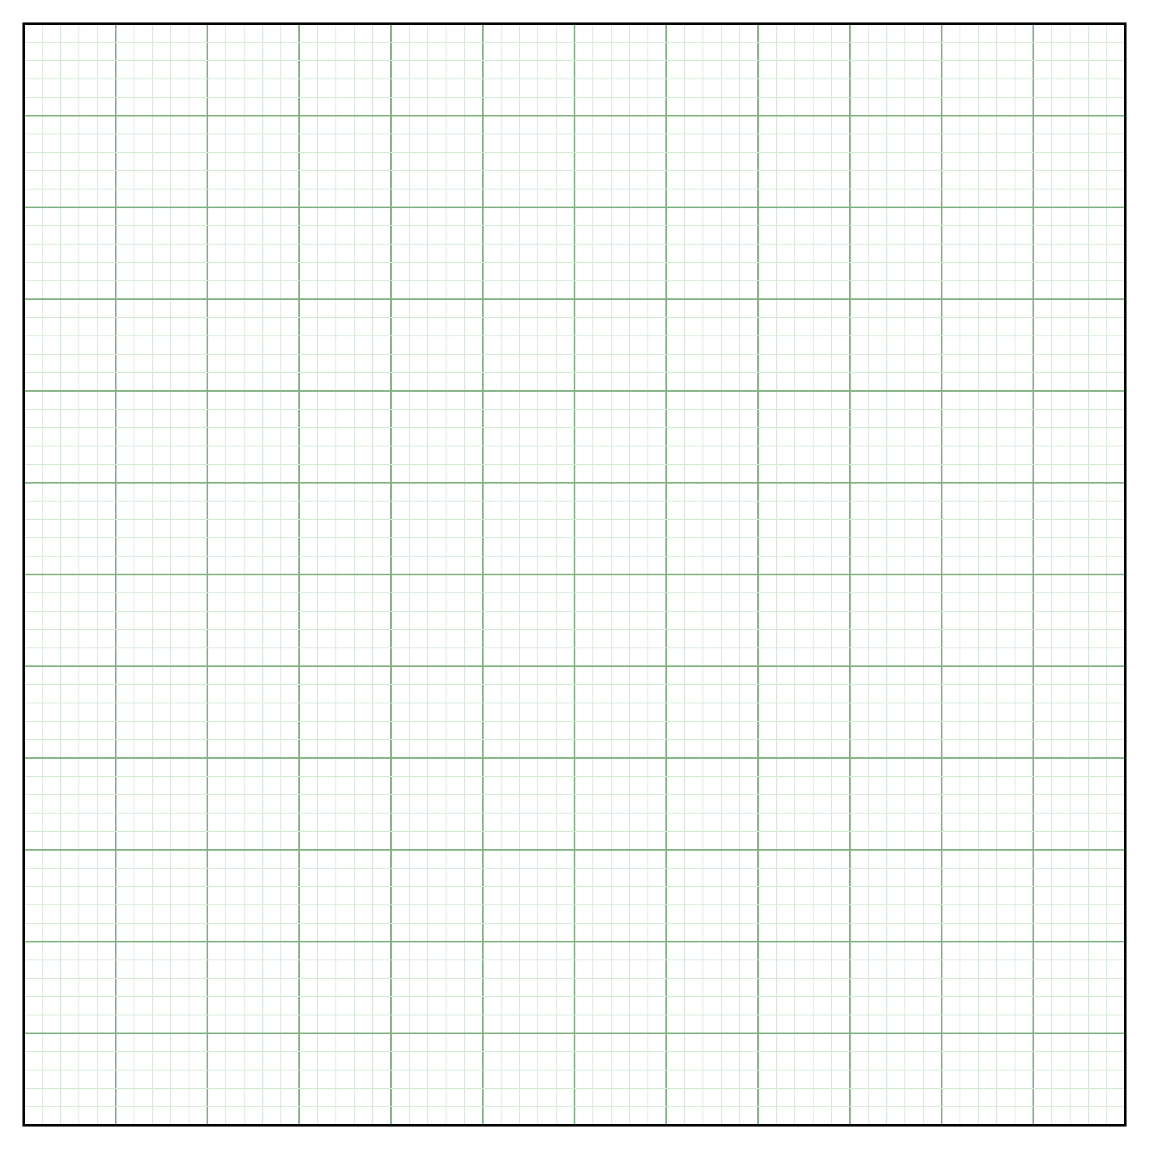
(a) State what is meant by the weight of an object.
.....................................................................................................
.....................................................................................................
(1 mark)
(b) Construct a graph of weight in N against mass in kg on the graph grid. Draw a best-fit line.
​
​
​
​
​
​
​
​
​
​
​
​
(4 marks)
(c) Determine the gravitational field strength in the laboratory using the gradient of the best-fit line. Give your answer in N/kg. ​
.....................................................................................................
.....................................................................................................
.....................................................................................................
.....................................................................................................
.....................................................................................................
(3 marks)
23. The diagram below shows a beaker containing water on a digital mass scale. The empty beaker has a mass of 80 g. The scale reading includes the mass of the beaker and the water. Use $g=9.8 N/kg$.
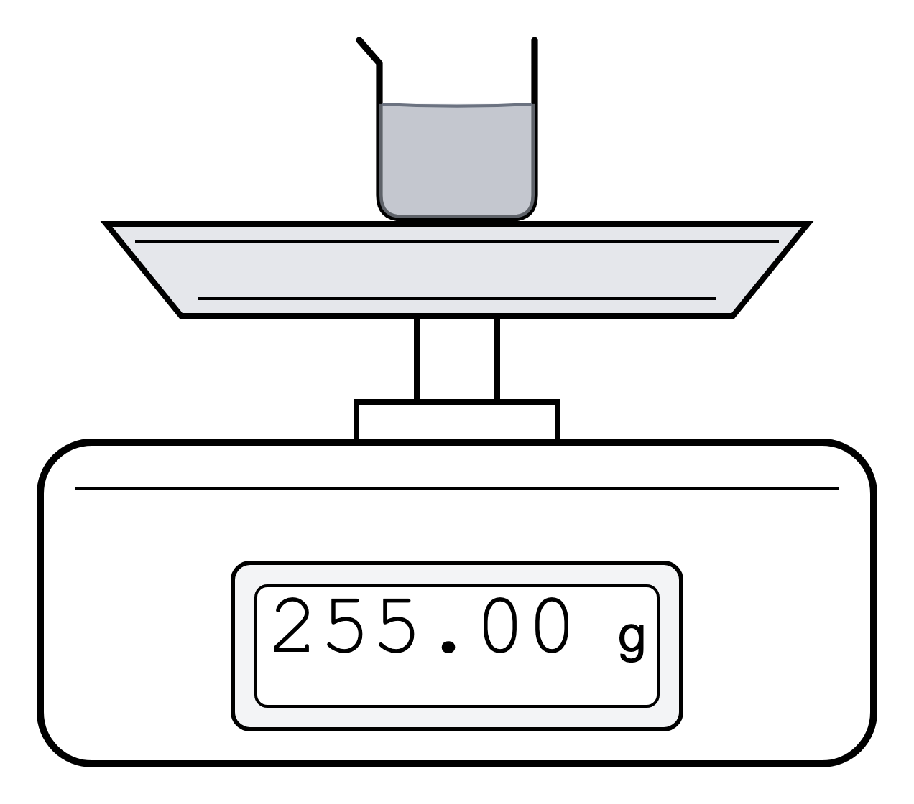
(a) State the total mass shown by the scale.
.....................................................................................................
.....................................................................................................
(1 mark)
(b) Calculate the mass of the water in grams.
.....................................................................................................
.....................................................................................................
.....................................................................................................
.....................................................................................................
(2 marks)
(c) Convert the mass of the water into kilograms.
.....................................................................................................
.....................................................................................................
(1 mark)
(d) Calculate the weight of the water.
.....................................................................................................
.....................................................................................................
.....................................................................................................
.....................................................................................................
(2 marks)
(e) The scale gives its reading in grams. Explain why a reading in grams is not a measurement of weight.
.....................................................................................................
.....................................................................................................
.....................................................................................................
.....................................................................................................
(2 marks)

