1.4 Density: Cambridge IGCSE Physics worksheet
1. Four solid samples have equal volumes. Which sample has the greatest density?
A the sample with the smallest surface area
B the sample with the lowest temperature
C the sample with the greatest mass
D the sample with the greatest surface area
(1 mark)
2. Which equation defines density $ρ$, in terms of mass $m$ and volume $V$?
A $ρ=\frac{m}{V}$
B $ρ=mV$
C $ρ=\frac{V}{m}$
D $ρ=m+V$
(1 mark)
3. Samples are cut from one uniform material at constant temperature.
Which graph shows how mass varies with volume?
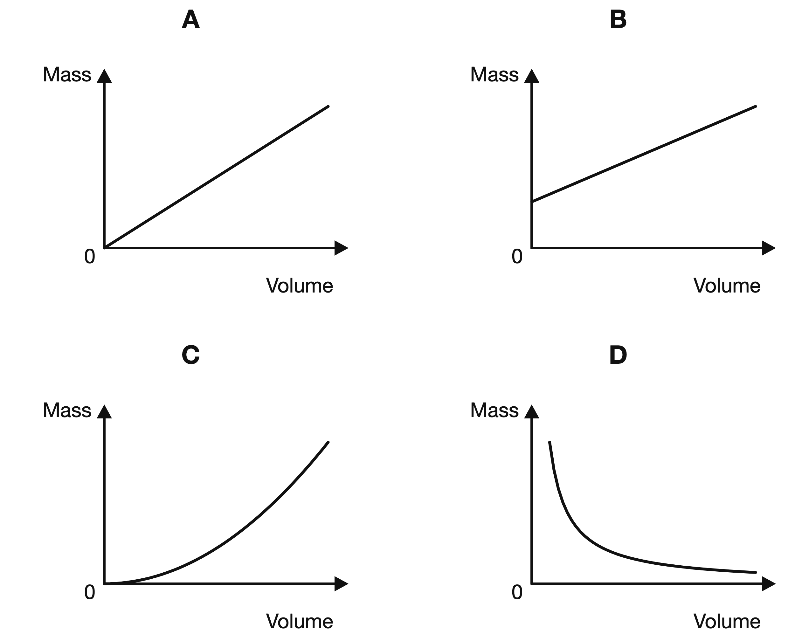
(1 mark)
4. A uniform block floats at rest with part of it above the surface of water.
How does the average density of the block compare with the density of water?
A It must be zero.
B It is equal to the density of water.
C It is less than the density of water.
D It is greater than the density of water.
(1 mark)
5. A solid has a mass of 216 g and a volume of 80.0 cm³.
What is the density of the solid?
A 0.370 g/cm³
B 2.70 g/cm³
C 136 g/cm³
D 17 280 g/cm³
(1 mark)
6. Which pair of instruments is needed to determine the density of an irregular stone that sinks in water?
A a metre rule and a stopwatch
B a newton meter and a thermometer
C a measuring cylinder and a stopwatch
D a balance and a measuring cylinder
(1 mark)
7. Which procedure gives the density of a liquid using a balance and a measuring cylinder?
A Find the liquid's mass by subtraction, then divide this mass by its measured volume.
B Divide the mass of the cylinder and liquid by the liquid's measured volume.
C Find the liquid's mass by subtraction, then divide its volume by this mass.
D Multiply the mass of the liquid by its measured volume.
(1 mark)
8. Which method can be used to find the volume of a small irregular stone that sinks in water?
A Submerge it in water in a measuring cylinder and find the increase in the reading.
B Measure its greatest length with a ruler and cube this value.
C Measure its mass on a balance and record the value in cm³.
D Place it beside a thermometer and read the scale.
(1 mark)
9. Which row describes the sample with the greatest density?
 | Mass / g | Volume / cm³
A | 40 | 20
B | 75 | 25
C | 96 | 24
D | 140 | 40

(1 mark)
10. An irregular solid has a mass of 72 g. The water level in a measuring cylinder rises from 35 cm³ to 59 cm³ when the solid is fully submerged.
What is the density of the solid?
A 0.33 g/cm³
B 1.2 g/cm³
C 2.1 g/cm³
D 3.0 g/cm³
(1 mark)
11. A rectangular block has dimensions 5.0 cm by 4.0 cm by 3.0 cm and a mass of 300 g.
What is the density of the block?
A 0.200 g/cm³
B 0.0250 g/cm³
C 25.0 g/cm³
D 5.0 g/cm³
(1 mark)
12. A graph of mass on the vertical axis against volume on the horizontal axis is a straight line through the origin for samples of one material.
What does the gradient of the line represent?
A volume
B density
C mass
D the reciprocal of density
(1 mark)
13. An empty bottle has a mass of 120 g. Its mass is 320 g when it contains 250 cm³ of a liquid.
What is the density of the liquid?
A 0.480 g/cm³
B 0.80 g/cm³
C 1.28 g/cm³
D 1.60 g/cm³
(1 mark)
14. Sample P has a mass of 100 g and a volume of 40 cm³. Sample Q is made from the same uniform material and has a mass of 250 g.
What is the volume of sample Q?
A 100 cm³
B 16 cm³
C 40 cm³
D 625 cm³
(1 mark)
15. A student finds the volume of a stone by fully submerging it in water. An air bubble is trapped against the stone.
How does this affect the calculated density of the stone?
A It is too high because the measured volume is too small.
B It is unchanged because the stone's mass is unchanged.
C It is too high because the measured volume is too large.
D It is too low because the measured volume is too large.
(1 mark)
16. An object has a density of 0.85 g/cm³. Water has a density of 1.00 g/cm³. State whether the object floats or sinks in water and give a reason.
.....................................................................................................
.....................................................................................................
.....................................................................................................
.....................................................................................................
(2 marks)
17. The two blocks have equal volumes. Use the balance readings to identify the denser block and give a reason.
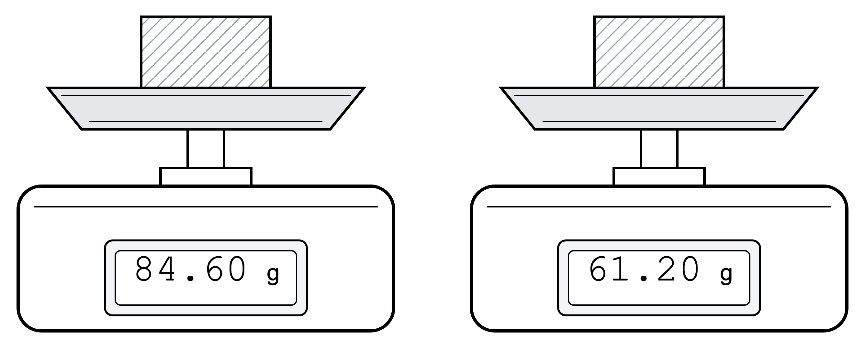
.....................................................................................................
.....................................................................................................
.....................................................................................................
.....................................................................................................
(2 marks)
18. A fixed mass of gas expands to occupy a greater volume. State what happens to its density and give a reason.
.....................................................................................................
.....................................................................................................
.....................................................................................................
.....................................................................................................
(2 marks)
19. State the SI unit of density.
.....................................................................................................
.....................................................................................................
(1 mark)
20. In the equation $ρ=\frac{m}{V}$, state the quantities represented by m and V.
.....................................................................................................
.....................................................................................................
.....................................................................................................
.....................................................................................................
(2 marks)
21. Read the mass of the material from the balance. Its density is 1.20 g/cm³. Determine its volume.
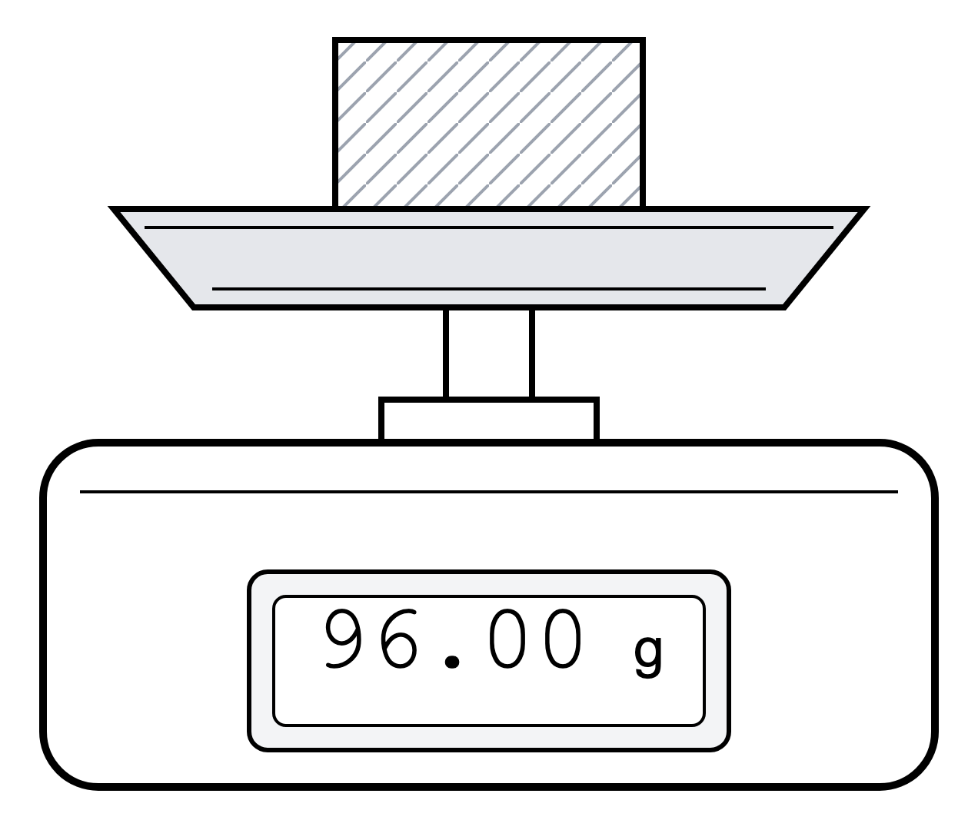
.....................................................................................................
.....................................................................................................
.....................................................................................................
.....................................................................................................
(2 marks)
22. Two liquids do not mix. Liquid P has a density of 0.78 g/cm³ and liquid Q has a density of 1.15 g/cm³. State which liquid forms the upper layer and give a reason.
.....................................................................................................
.....................................................................................................
.....................................................................................................
.....................................................................................................
(2 marks)
23. A 15 cm³ component is made from a metal alloy of density 8.0 g/cm³. What is the mass of the component?
.....................................................................................................
.....................................................................................................
.....................................................................................................
.....................................................................................................
(2 marks)
24. The mass scales below show two liquids in identical beakers. Each empty beaker has mass 50 g. Each beaker contains 50 cm³ of liquid. The left-hand beaker contains liquid A and the right-hand beaker contains liquid B. Liquid A and liquid B do not mix.
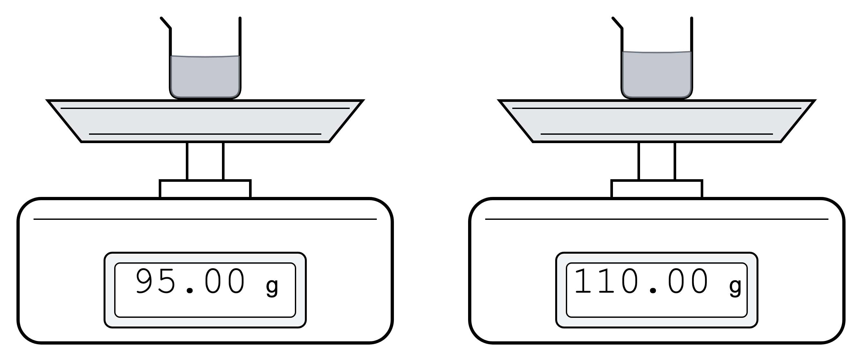
(a) Calculate the density of liquid A in g/cm³.
.....................................................................................................
.....................................................................................................
.....................................................................................................
.....................................................................................................
(2 marks)
(b) Calculate the density of liquid B in g/cm³.
.....................................................................................................
.....................................................................................................
.....................................................................................................
.....................................................................................................
(2 marks)
(c) If the liquids are poured into the same test tube, state which liquid forms the top layer. Explain your answer.
.....................................................................................................
.....................................................................................................
.....................................................................................................
.....................................................................................................
(2 marks)
(d) A small bead has density 1.10 g/cm³. It is dropped into the test tube containing both liquids. Explain where the bead settles.
.....................................................................................................
.....................................................................................................
.....................................................................................................
.....................................................................................................
.....................................................................................................
(3 marks)
(e) Explain why mass alone is not usually enough to decide which liquid floats.
.....................................................................................................
.....................................................................................................
(1 mark)
25. The diagram below shows a measuring cylinder setup with two states of the water level. One cylinder contains only water. The other cylinder contains two identical marbles immersed in the water. The cross-sectional area of the measuring cylinder is 8.0 cm². The density of water is 1000 kg/m³. A small pressure sensor is fixed to the side of the cylinder near the bottom.
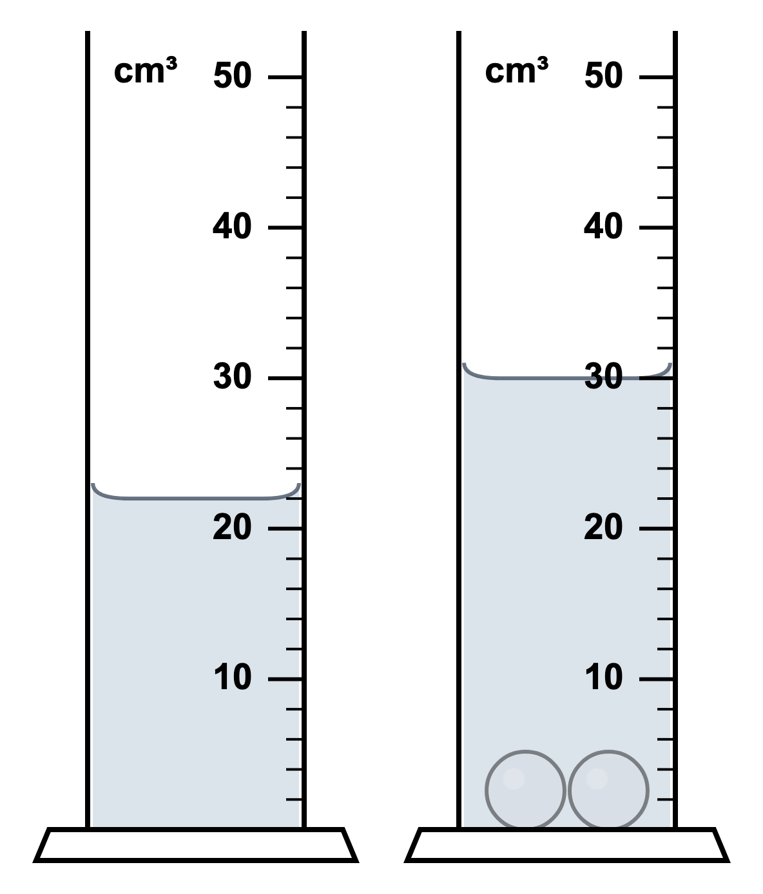
(a) Calculate the total volume of the two marbles.
.....................................................................................................
.....................................................................................................
(1 mark)
(b) Calculate the volume of one marble.
.....................................................................................................
.....................................................................................................
(1 mark)
(c) Calculate the increase in water height in cm and then in m.
.....................................................................................................
.....................................................................................................
.....................................................................................................
.....................................................................................................
(2 marks)
(d) Calculate the increase in pressure at the sensor due to the increased water height.
.....................................................................................................
.....................................................................................................
.....................................................................................................
.....................................................................................................
.....................................................................................................
(3 marks)
(e) Explain why the pressure at the sensor increases after the marbles are added.
.....................................................................................................
.....................................................................................................
.....................................................................................................
.....................................................................................................
(2 marks)
(f) A student says, "The pressure at the sensor would increase by the same amount if the marbles were added to a wider cylinder of water." Explain why this statement is not correct.
.....................................................................................................
.....................................................................................................
(1 mark)

