1.5 Forces: Cambridge IGCSE Physics worksheet
1. A falling object has a weight of 50 N. Air resistance on the object is 20 N upward. What is the resultant force?
A 30 N downward
B 30 N upward
C 70 N downward
D 70 N upward
(1 mark)
2. Which graph shows the relationship between extension and applied force for a spring that obeys Hooke's law?
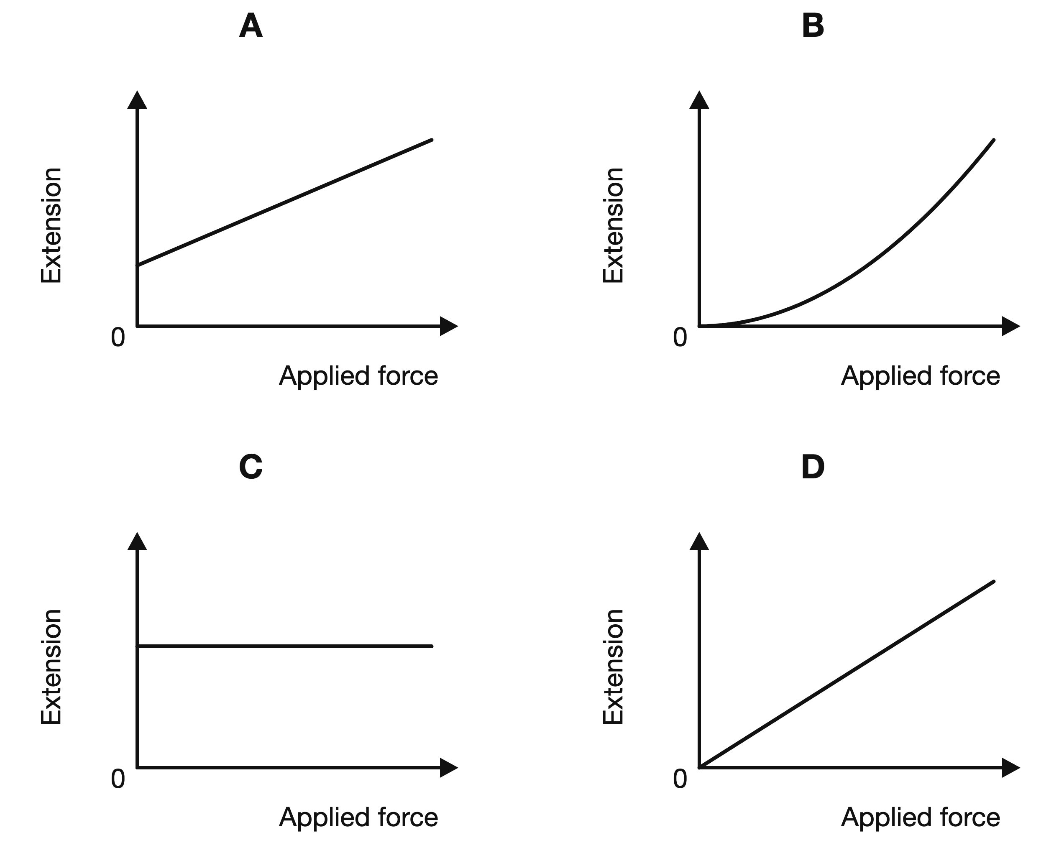
(1 mark)
3. Which equation gives the moment of a force about a pivot?
A $M=Fd$
B $M=\frac{F}{d}$
C $M=\frac{d}{F}$
D $M=F+d$
(1 mark)
4. The same resultant force acts separately on two trolleys. One trolley has a greater mass and gains a smaller acceleration. Which statement best explains this?
A The greater-mass trolley has less inertia.
B The greater-mass trolley has greater inertia.
C Both trolleys must have the same acceleration.
D The force on the greater-mass trolley must be larger.
(1 mark)
5. A resultant force of 15 N acts on an object of mass 5 kg. What is the acceleration of the object?
A 3 m/s²
B 10 m/s²
C 20 m/s²
D 75 m/s²
(1 mark)
6. A student suspends an irregular lamina from several points and draws a vertical line from each suspension point. What identifies the centre of gravity of the lamina?
A the lowest suspension point
B the midpoint of the longest vertical line
C the point halfway between the suspension points
D the point where the vertical lines intersect
(1 mark)
7. A force of 3.6 N is applied to a spring with a spring constant of 120 N/m.
What is the extension of the spring?
A 0.030 cm
B 0.30 cm
C 3.0 cm
D 33 cm
(1 mark)
8. The same force extends spring P by 2.0 cm and spring Q by 4.0 cm. Both springs obey Hooke's law.
Which statement is correct?
A P has a greater spring constant and is stiffer than Q.
B Q has a greater spring constant because it extends more.
C P and Q have the same spring constant because the forces are equal.
D The spring constants cannot be compared without knowing the natural lengths.
(1 mark)
9. Which change makes an object more stable?
A raising its centre of gravity and narrowing its base
B lowering its centre of gravity and widening its base
C raising its centre of gravity and widening its base
D lowering its centre of gravity and narrowing its base
(1 mark)
10. The diagram shows a conical pendulum moving in a horizontal circle. Which statement explains the inward resultant force on the pendulum bob?
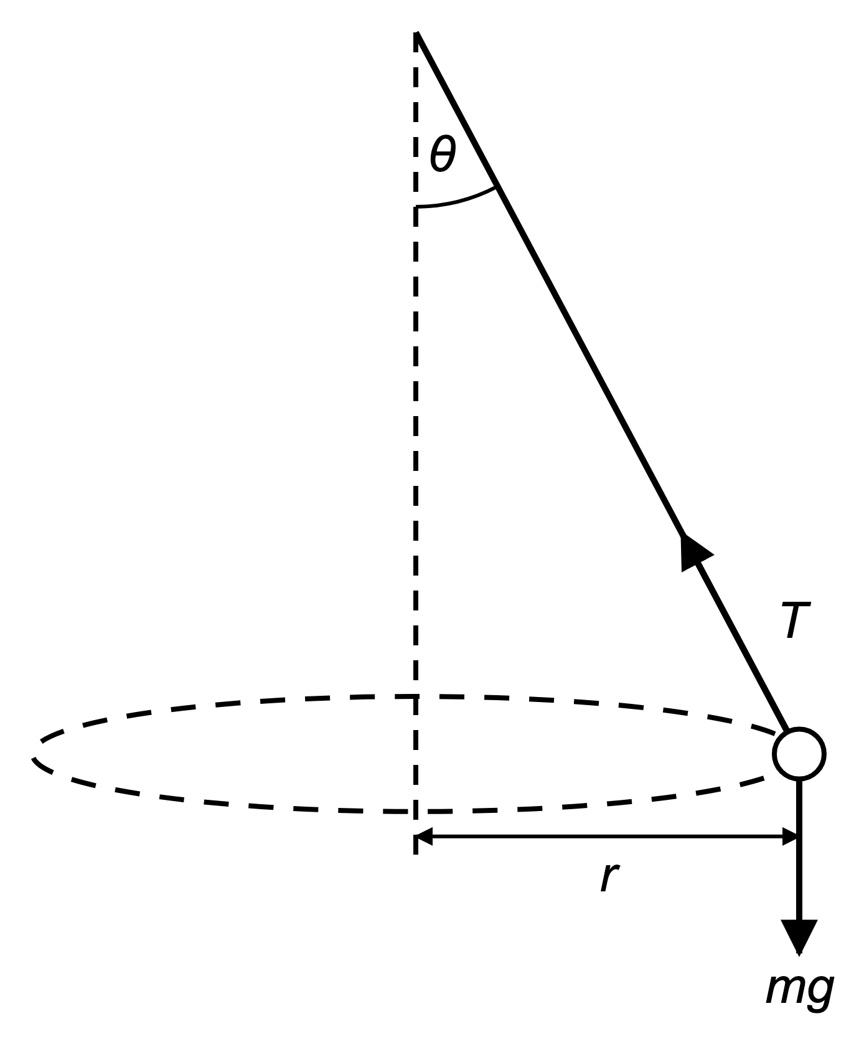
A The weight acts horizontally towards the centre.
B The vertical component of the tension acts towards the centre.
C The tension and weight are equal and opposite.
D The horizontal component of the tension acts towards the centre.
(1 mark)
11. A graph of extension against force is a straight line through the origin with a gradient of 0.0040 m/N.
What is the spring constant?
A 0.0040 N/m
B 250 N/m
C 4.0 N/m
D 2500 N/m
(1 mark)
12. A lift and its load have a total mass of 600 kg and a total weight of 6000 N. The lift accelerates upward at 2 m/s². What is the tension in the lift cable?
A 1200 N
B 4800 N
C 7200 N
D 12 000 N
(1 mark)
13. A force of 30 N acts at a perpendicular distance of 25 cm from a pivot. Calculate the moment in N m.
.....................................................................................................
.....................................................................................................
.....................................................................................................
.....................................................................................................
(2 marks)
14. Two forces of 6 N and 4 N both act to the right on an object. Calculate the resultant force.
.....................................................................................................
.....................................................................................................
(1 mark)
15. One force produces a clockwise moment of 12 N m. Another force produces an anticlockwise moment of 15 N m. State whether the object is balanced and explain your answer.
.....................................................................................................
.....................................................................................................
.....................................................................................................
.....................................................................................................
(2 marks)
16. A force of 14 N acts to the right and a force of 9 N acts to the left. Calculate the resultant force.
.....................................................................................................
.....................................................................................................
.....................................................................................................
.....................................................................................................
(2 marks)
17. A cyclist of mass 75 kg increases speed from 4 m/s to 6 m/s in 2 s. Calculate the resultant force on the cyclist.
.....................................................................................................
.....................................................................................................
.....................................................................................................
.....................................................................................................
(2 marks)
18. A student says, "If an object is moving, there must be a forward resultant force acting on it." Is the student correct? Explain your answer.
.....................................................................................................
.....................................................................................................
.....................................................................................................
.....................................................................................................
(2 marks)
19. Use the ruler shown to record the original length and the loaded length of the spring.
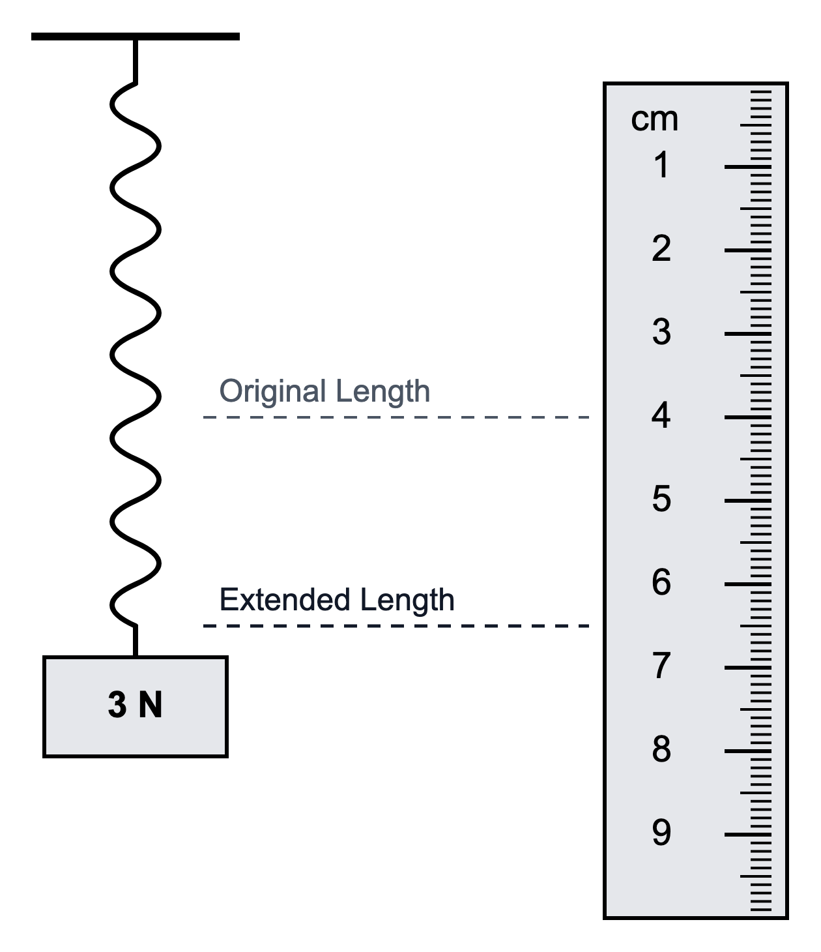
.....................................................................................................
.....................................................................................................
.....................................................................................................
.....................................................................................................
(2 marks)
20. A 12 kg cart has a 30 N forward force and a 6 N backward force acting on it. Calculate the acceleration of the cart.
.....................................................................................................
.....................................................................................................
.....................................................................................................
.....................................................................................................
(2 marks)
21. The diagram below shows a car moving round a bend.
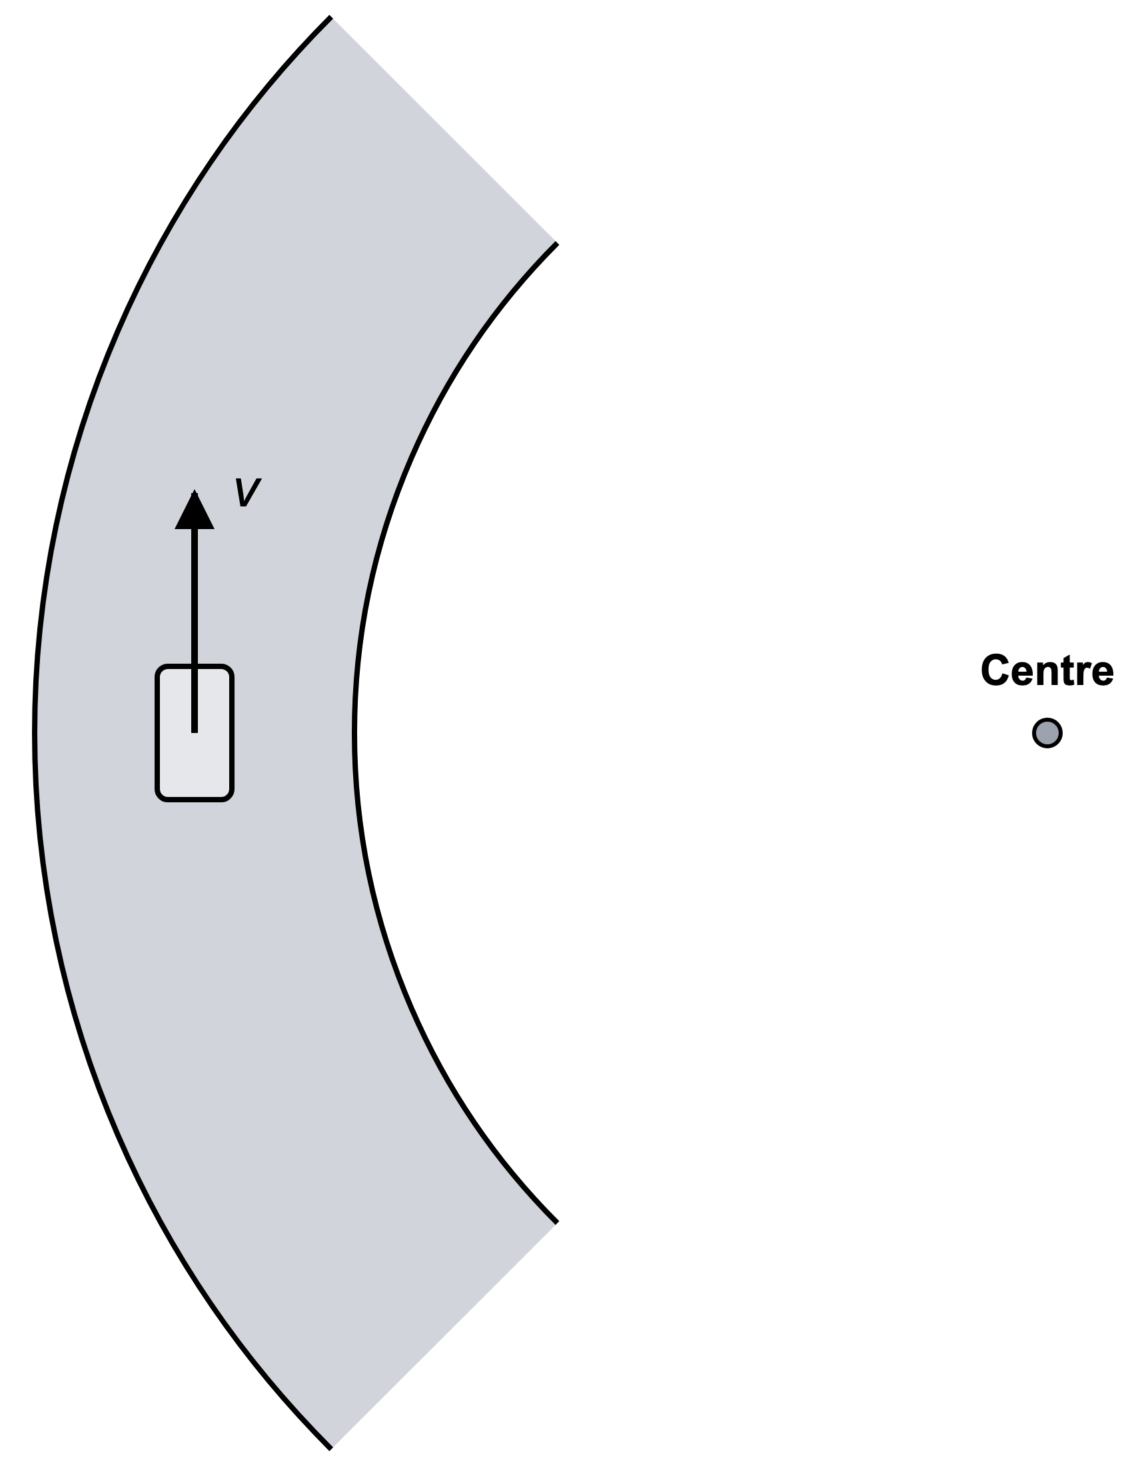
(a) For the car moving round the bend, complete the missing force arrow on the diagram.
(1 mark)
(b) Explain why the car can move at constant speed even though its velocity changes.
.....................................................................................................
.....................................................................................................
.....................................................................................................
.....................................................................................................
(2 marks)
(c) For the car moving round the bend, state the direction of the acceleration.
.....................................................................................................
.....................................................................................................
(1 mark)
22. The diagram shows the horizontal forces on a cyclist.
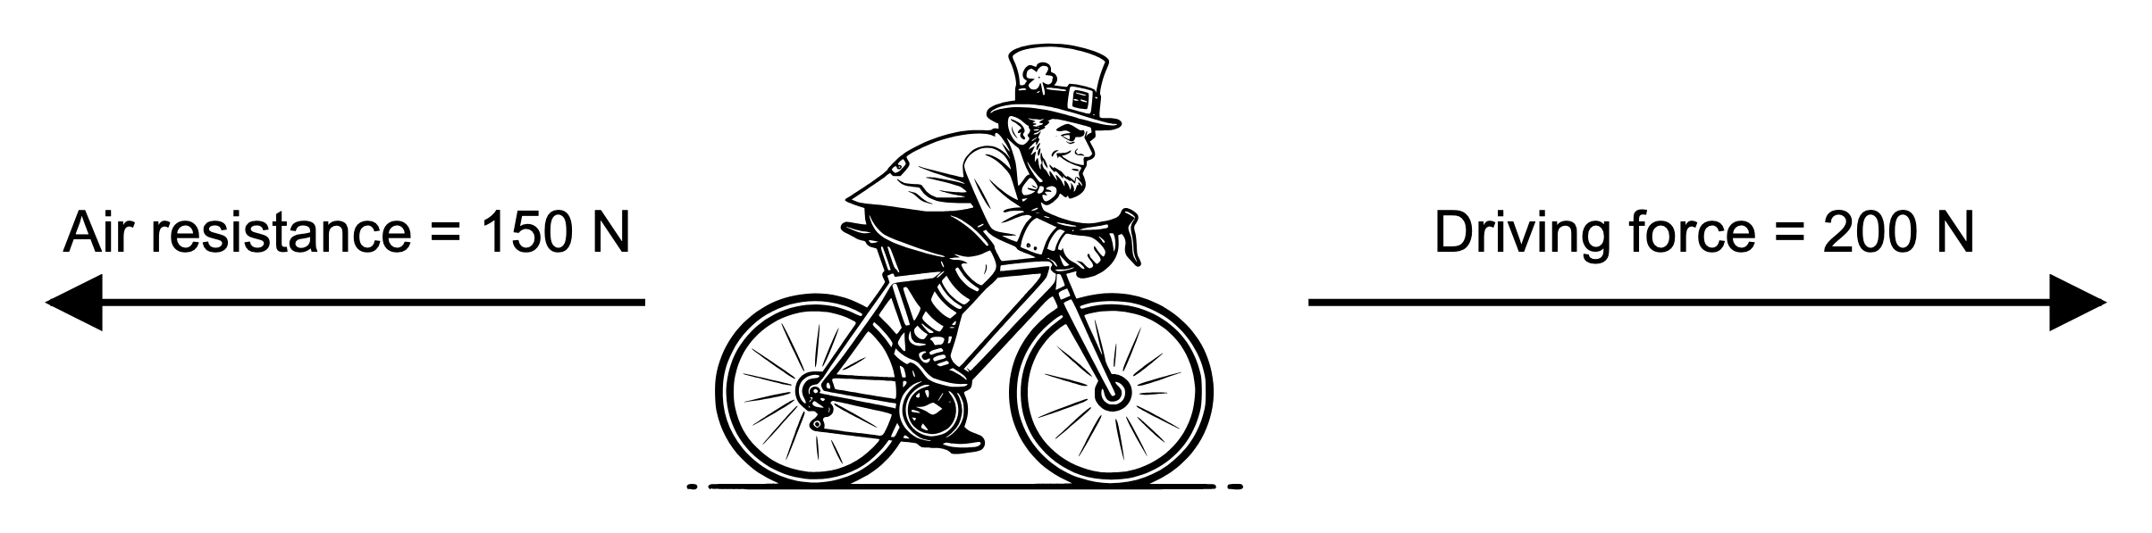
(a) Name the force that opposes the motion of the cyclist.
.....................................................................................................
.....................................................................................................
(1 mark)
(b) Calculate the resultant horizontal force on the cyclist. Give the direction.
.....................................................................................................
.....................................................................................................
.....................................................................................................
.....................................................................................................
(2 marks)
(c) Describe the effect of this resultant force on the cyclist's velocity.
.....................................................................................................
.....................................................................................................
.....................................................................................................
.....................................................................................................
(2 marks)
(d) State why force is a vector quantity.
.....................................................................................................
.....................................................................................................
(1 mark)
23. A student sets up the apparatus shown in the diagram below to investigate the relationship between force and extension for a spring.
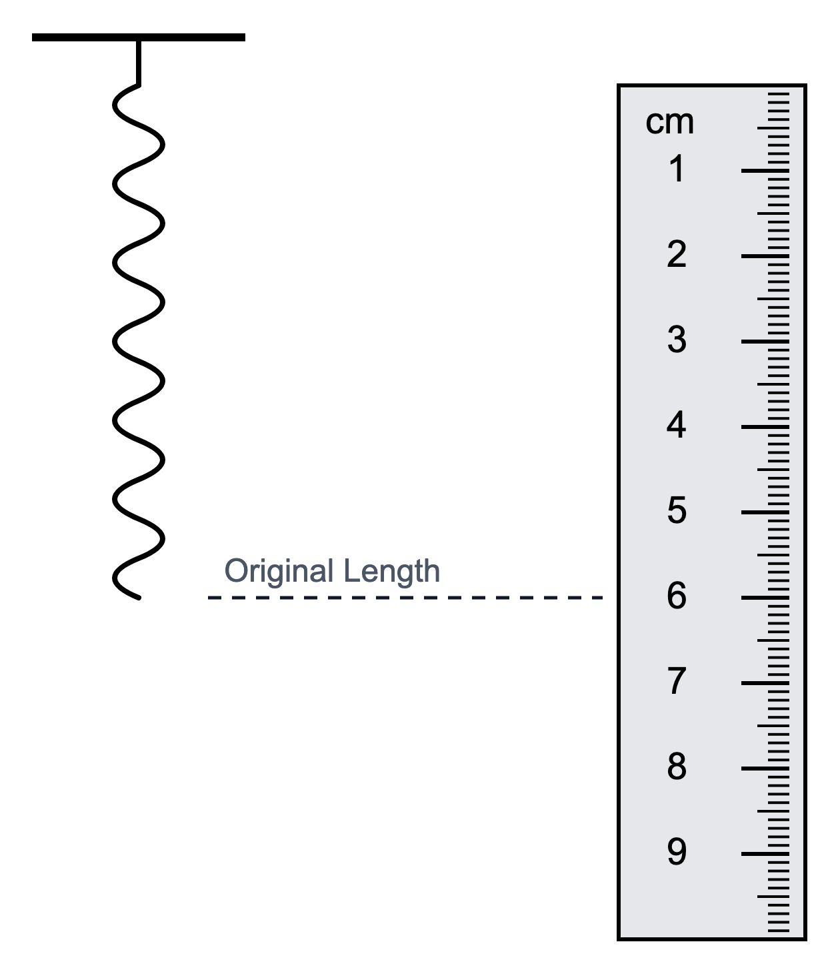
(a) State the name of the quantity measured from the ruler before any load is added.
.....................................................................................................
.....................................................................................................
(1 mark)
(b) Describe how the student should use this apparatus to obtain a full set of results for a force-extension investigation.
.....................................................................................................
.....................................................................................................
.....................................................................................................
.....................................................................................................
.....................................................................................................
(4 marks)
(c) State the independent variable and the dependent variable in this investigation.
.....................................................................................................
.....................................................................................................
.....................................................................................................
.....................................................................................................
(2 marks)
24. The diagram shows a beam in equilibrium.
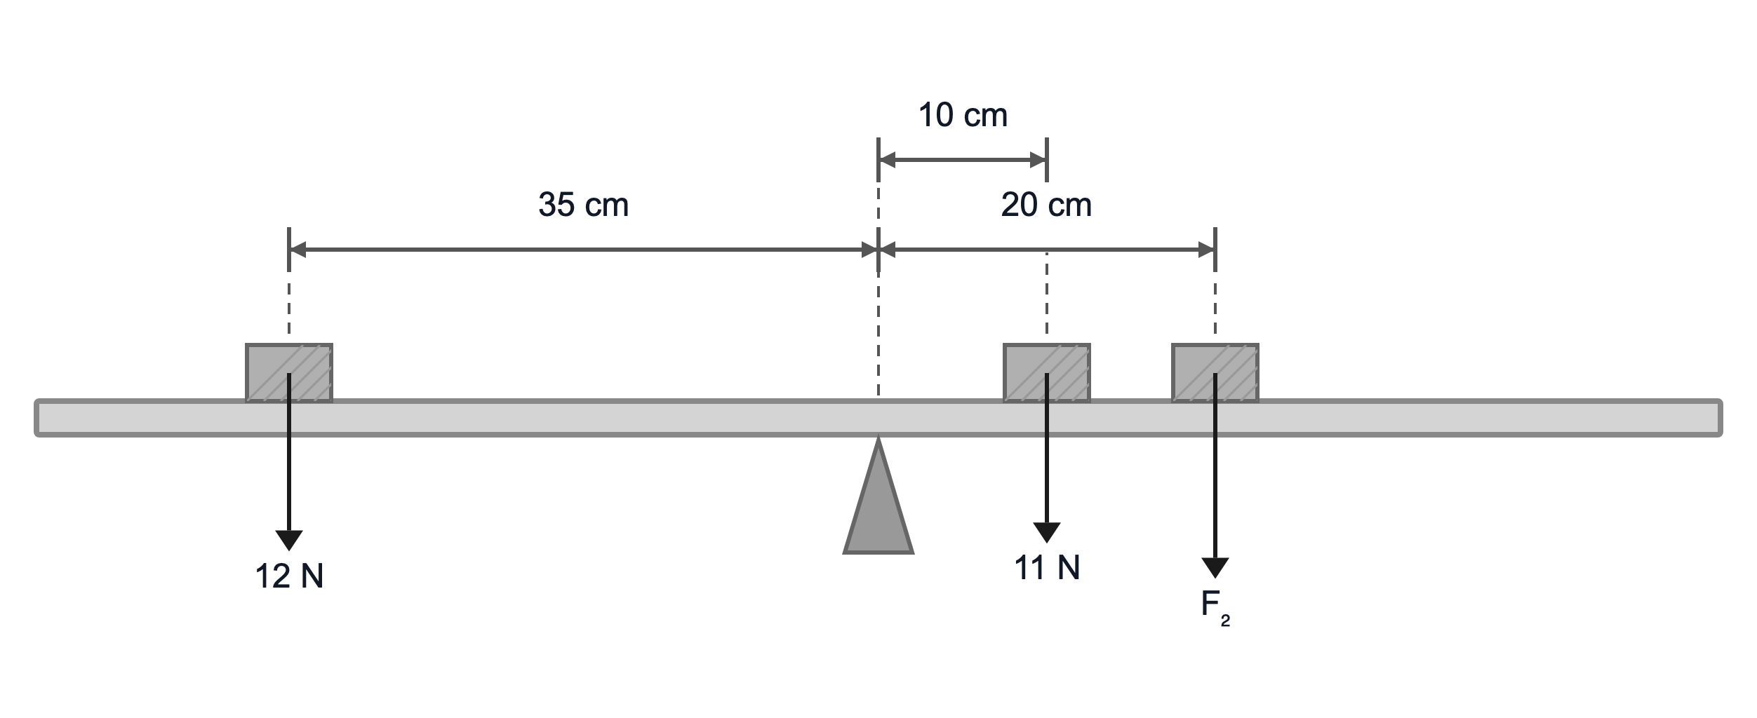
(a) Calculate the anticlockwise moment due to the left-hand load in N cm.
.....................................................................................................
.....................................................................................................
.....................................................................................................
.....................................................................................................
(2 marks)
(b) Calculate the value of F₂.
.....................................................................................................
.....................................................................................................
.....................................................................................................
.....................................................................................................
.....................................................................................................
(3 marks)
(c) Convert the total clockwise moment into N m.
.....................................................................................................
.....................................................................................................
(1 mark)

