1.6 Momentum: Cambridge IGCSE Physics worksheet
1. Which equation defines the momentum $p$ of an object of mass $m$ moving with velocity $v$?
A $p=\frac{m}{v}$
B $p=mv$
C $p=\frac{v}{m}$
D $p=m+v$
(1 mark)
2. Which row gives an object with momentum 12 kg m/s?
 | Mass / kg | Speed / m/s
A | 1.0 | 6.0
B | 2.0 | 3.0
C | 3.0 | 4.0
D | 4.0 | 2.0

(1 mark)
3. During a collision, an airbag increases the time taken for a passenger's momentum to fall to zero. The change in momentum is unchanged. Why does this reduce the average force on the passenger?
A The passenger's mass increases.
B The passenger's change in momentum increases.
C The passenger's initial momentum becomes zero.
D The rate of change of momentum decreases.
(1 mark)
4. For which system is total momentum conserved during an interaction?
A a system with a resultant external force
B a system in which every object has constant speed
C a system with no resultant external force
D a system in which kinetic energy is constant
(1 mark)
5. A graph shows how the resultant force on an object varies with time. What does the area under the graph represent?
A the acceleration of the object
B the impulse on the object
C the resultant force on the object
D the rate of change of momentum
(1 mark)
6. The mass and the speed of a moving object are both doubled without changing its direction. How does its momentum change?
A It is unchanged.
B It is doubled.
C It is tripled.
D It is quadrupled.
(1 mark)
7. Which equation gives the resultant force on an object in terms of its change in momentum $Δp$ during a time interval $Δt$?
A $F=\frac{Δp}{Δt}$
B $F=Δp×Δt$
C $F=\frac{Δt}{Δp}$
D $F=Δp+Δt$
(1 mark)
8. A car undergoes the same change in momentum in two tests. It stops in 0.050 s without a crumple zone and in 0.20 s with a crumple zone. How does the average resultant force with the crumple zone compare with the force without it?
A It is one-quarter as large.
B It is one-half as large.
C It is four times as large.
D It is unchanged.
(1 mark)
9. The momentum of a ball increases from 2.0 kg m/s to 8.0 kg m/s in 0.15 s. What is the average resultant force on the ball?
A 0.90 N
B 6.0 N
C 53 N
D 40 N
(1 mark)
10. An object moves with a constant velocity to the east. What is the direction of its momentum?
A vertically downwards
B vertically upwards
C west
D east
(1 mark)
11. A stationary 3.0 kg launcher fires a 0.020 kg projectile horizontally at 300 m/s. What is the recoil velocity of the launcher?
A 2.0 m/s opposite to the projectile
B 2.0 m/s in the projectile's direction
C 4.5 m/s opposite to the projectile
D 300 m/s opposite to the projectile
(1 mark)
12. A 0.50 kg trolley moves right at 6.0 m/s and collides with a 0.50 kg trolley moving left at 2.0 m/s. The trolleys stick together. What is their velocity immediately after the collision?
A 4.0 m/s to the right
B 2.0 m/s to the left
C 2.0 m/s to the right
D 4.0 m/s to the left
(1 mark)
13. What is the momentum of a stationary 900 kg car?
.....................................................................................................
.....................................................................................................
(1 mark)
14. Car airbags increase the time taken for a passenger to stop. Explain why this reduces the force on the passenger.
.....................................................................................................
.....................................................................................................
.....................................................................................................
.....................................................................................................
(2 marks)
15. A 3.0 kg trolley moving at 5.0 m/s collides with a stationary trolley. They stick together and move off at 1.5 m/s. Calculate the mass of the second trolley.
.....................................................................................................
.....................................................................................................
.....................................................................................................
.....................................................................................................
(2 marks)
16. What is meant by a closed system in momentum calculations?
.....................................................................................................
.....................................................................................................
(1 mark)
17. State the SI unit of momentum.
.....................................................................................................
.....................................................................................................
(1 mark)
18. State one unit of impulse.
.....................................................................................................
.....................................................................................................
(1 mark)
19. A 2.5 kg scooter moves at 4.0 m/s. Calculate its momentum.
.....................................................................................................
.....................................................................................................
.....................................................................................................
.....................................................................................................
(2 marks)
20. Two trolleys start at rest and then push apart on a low-friction track. Explain why their total momentum after they separate is zero.
.....................................................................................................
.....................................................................................................
.....................................................................................................
.....................................................................................................
(2 marks)
21. Define momentum.
.....................................................................................................
.....................................................................................................
(1 mark)
22. A student says, "A heavier object must always have more momentum." Give one reason why this statement can be wrong.
.....................................................................................................
.....................................................................................................
.....................................................................................................
.....................................................................................................
(2 marks)
23. The diagram shows a 0.20 kg rubber ball colliding with a wall. The ball is in contact with the wall for 0.12 s. Take motion towards the wall as positive.
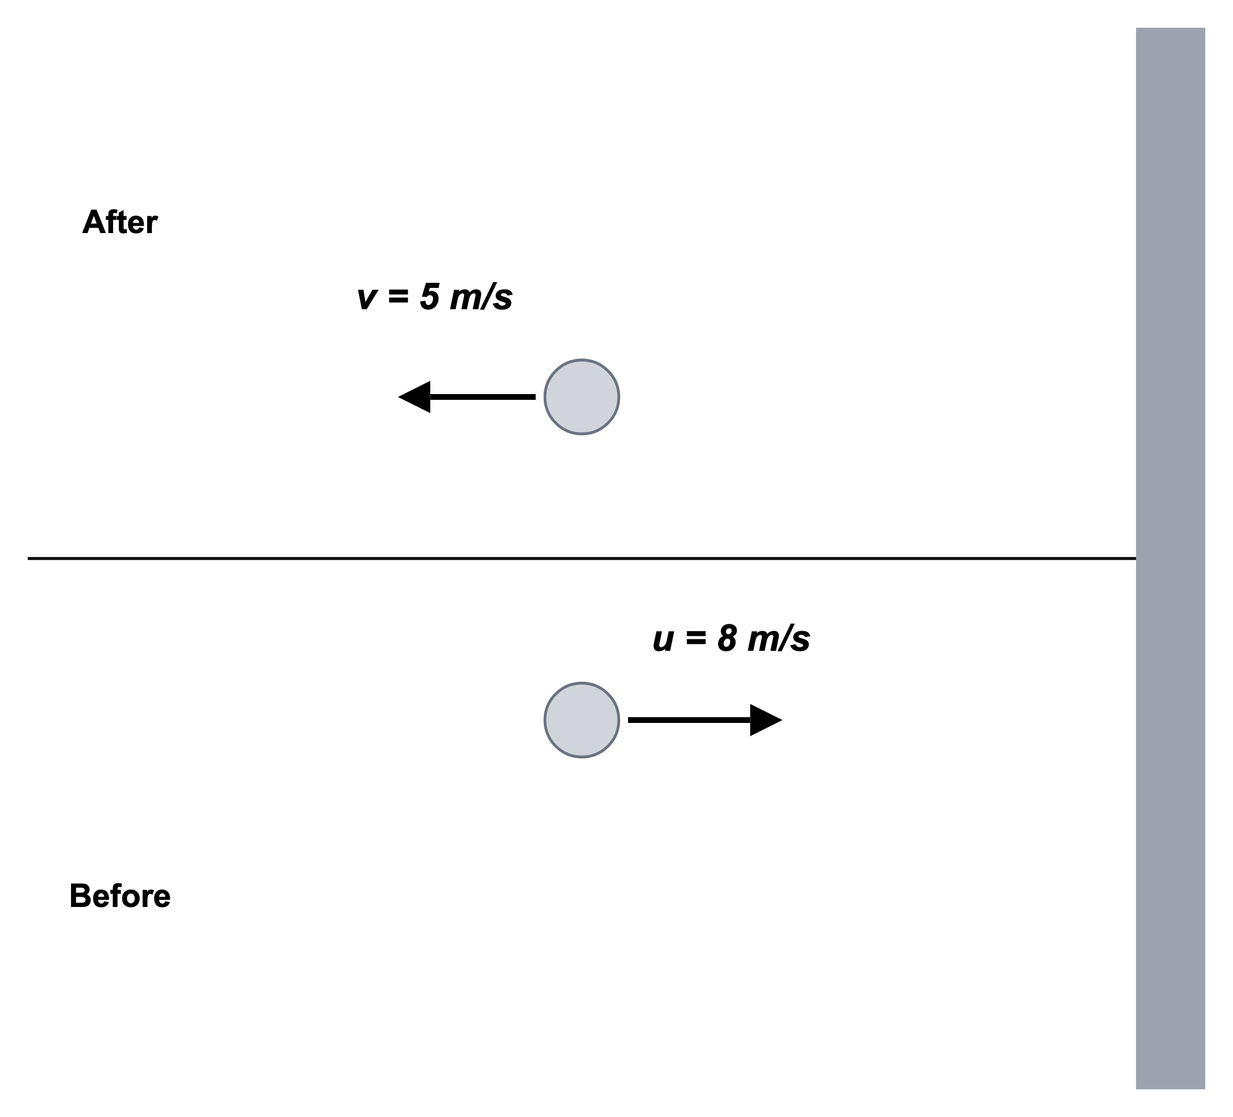
(a) Calculate the initial momentum of the ball.
.....................................................................................................
.....................................................................................................
.....................................................................................................
.....................................................................................................
(2 marks)
(b) Calculate the final momentum of the ball.
.....................................................................................................
.....................................................................................................
.....................................................................................................
.....................................................................................................
(2 marks)
(c) Calculate the size of the change in momentum of the ball.
.....................................................................................................
.....................................................................................................
.....................................................................................................
.....................................................................................................
(2 marks)
(d) State the direction of the impulse on the ball.
.....................................................................................................
.....................................................................................................
(1 mark)
(e) Calculate the magnitude of the average force on the ball.
.....................................................................................................
.....................................................................................................
.....................................................................................................
.....................................................................................................
(2 marks)
24. The diagram shows a cyclist and bicycle of total mass 90 kg moving to the right at 12 m/s. The driving force is 150 N to the right and the drag force is 250 N to the left. These forces act for 5.0 s.
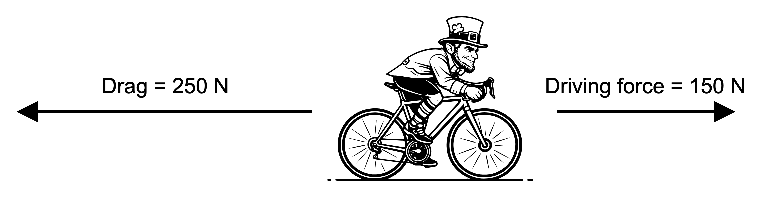
(a) Use the diagram to determine the resultant horizontal force on the cyclist.
.....................................................................................................
.....................................................................................................
.....................................................................................................
.....................................................................................................
(2 marks)
(b) Calculate the change in momentum of the cyclist in the 5.0 s interval.
.....................................................................................................
.....................................................................................................
.....................................................................................................
.....................................................................................................
.....................................................................................................
(3 marks)
(c) Calculate the speed of the cyclist after 5.0 s.
.....................................................................................................
.....................................................................................................
.....................................................................................................
.....................................................................................................
.....................................................................................................
(3 marks)
(d) Later, the driving force increases to 250 N while the drag force stays at 250 N. State what happens to the cyclist's speed then.
.....................................................................................................
.....................................................................................................
(1 mark)
25. A wicketkeeper catches a 0.15 kg cricket ball travelling at 20 m/s. The ball comes to rest in the gloves.
(a) Calculate the momentum of the ball just before it is caught.
.....................................................................................................
.....................................................................................................
.....................................................................................................
.....................................................................................................
(2 marks)
(b) Calculate the magnitude of the change in momentum of the ball.
.....................................................................................................
.....................................................................................................
.....................................................................................................
.....................................................................................................
(2 marks)
(c) The ball is brought to rest in 0.050 s. Calculate the average force on the ball.
.....................................................................................................
.....................................................................................................
.....................................................................................................
.....................................................................................................
(2 marks)
(d) The wicketkeeper moves the hands backwards so the stopping time becomes 0.20 s. Calculate the new average force on the ball.
.....................................................................................................
.....................................................................................................
.....................................................................................................
.....................................................................................................
(2 marks)
(e) Explain why moving the hands backwards reduces the risk of injury.
.....................................................................................................
.....................................................................................................
.....................................................................................................
.....................................................................................................
(2 marks)

