1.7 Energy, work and power: Cambridge IGCSE Physics worksheet
1. Which equation relates power P, energy transferred E and time t?
A $P=Et$
B $P=\frac{t}{E}$
C $P=E−t$
D $P=\frac{E}{t}$
(1 mark)
2. What is the function of a moderator in a nuclear fission reactor?
A to absorb all the neutrons
B to cool the steam leaving the turbine
C to prevent nuclei from absorbing neutrons
D to slow down neutrons
(1 mark)
3. Some fossil fuels contain sulfur impurities.
Which environmental problem can result when these fuels are burned?
A radioactive waste
B flooding of valleys
C changes to tidal times
D acid rain
(1 mark)
4. An object with weight 200 N falls vertically through 4.0 m.
How much work is done on the object by its weight?
A 800 J
B 50 J
C 2000 J
D 0 J
(1 mark)
5. A force does 480 J of work while moving a box 8.0 m in the direction of the force.
What is the force?
A 0.017 N
B 60 N
C 472 N
D 3840 N
(1 mark)
6. A device receives 2500 J of energy and is 40% efficient.
What is its useful energy output?
A 1000 J
B 62.5 J
C 1500 J
D 6250 J
(1 mark)
7. A heater transfers 900 J of energy in 30 s.
What is the power of the heater?
A 0.033 W
B 30 W
C 930 W
D 27 000 W
(1 mark)
8. The Sankey diagram shows the energy transfers in a motor.
What is the useful energy output?
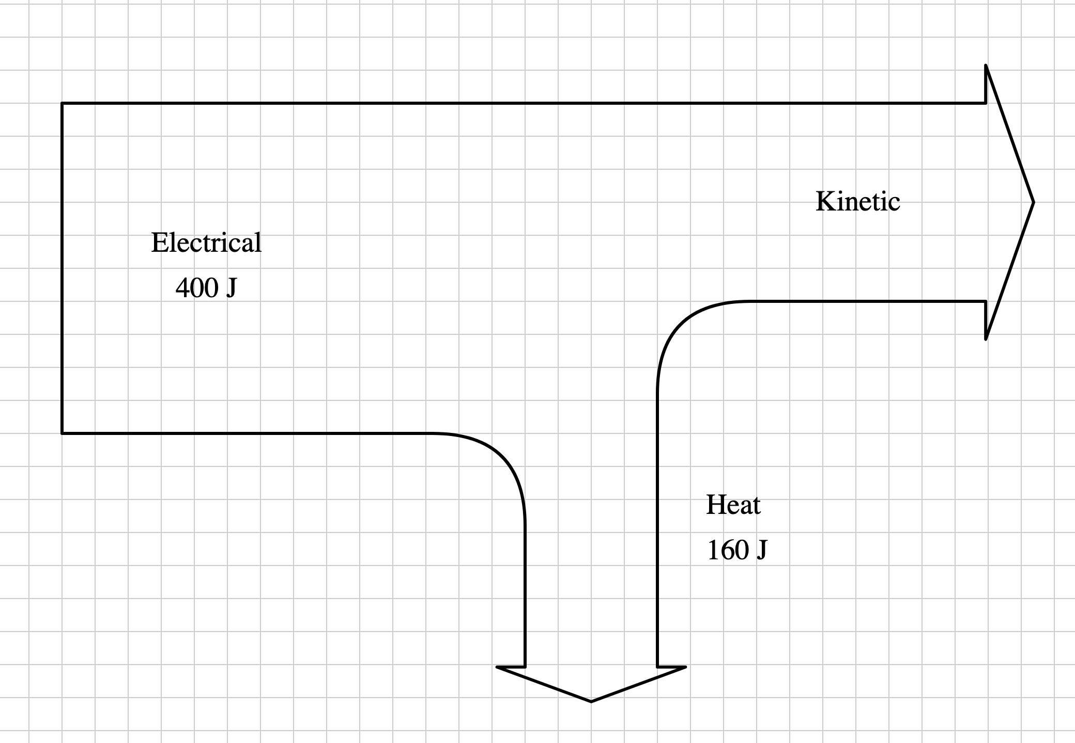
A 160 J
B 240 J
C 400 J
D 560 J
(1 mark)
9. A rope pulls a sledge with a force of 40 N. The horizontal component of the force is 25 N. The sledge moves 8.0 m horizontally.
How much work is done by the pulling force?
A 320 J
B 200 J
C 15 J
D 3.1 J
(1 mark)
10. An object of mass 4.0 kg has 72 J of kinetic energy.
What is its speed?
A 3.0 m/s
B 6.0 m/s
C 18 m/s
D 36 m/s
(1 mark)
11. A 50 kg climber gains 1500 J of gravitational potential energy. The gravitational field strength is 10 N/kg.
What vertical height does the climber gain?
A 3.0 m
B 30 m
C 300 m
D 0.30 m
(1 mark)
12. The time taken for an energy transfer is constant.
Which graph shows how power varies with the energy transferred?
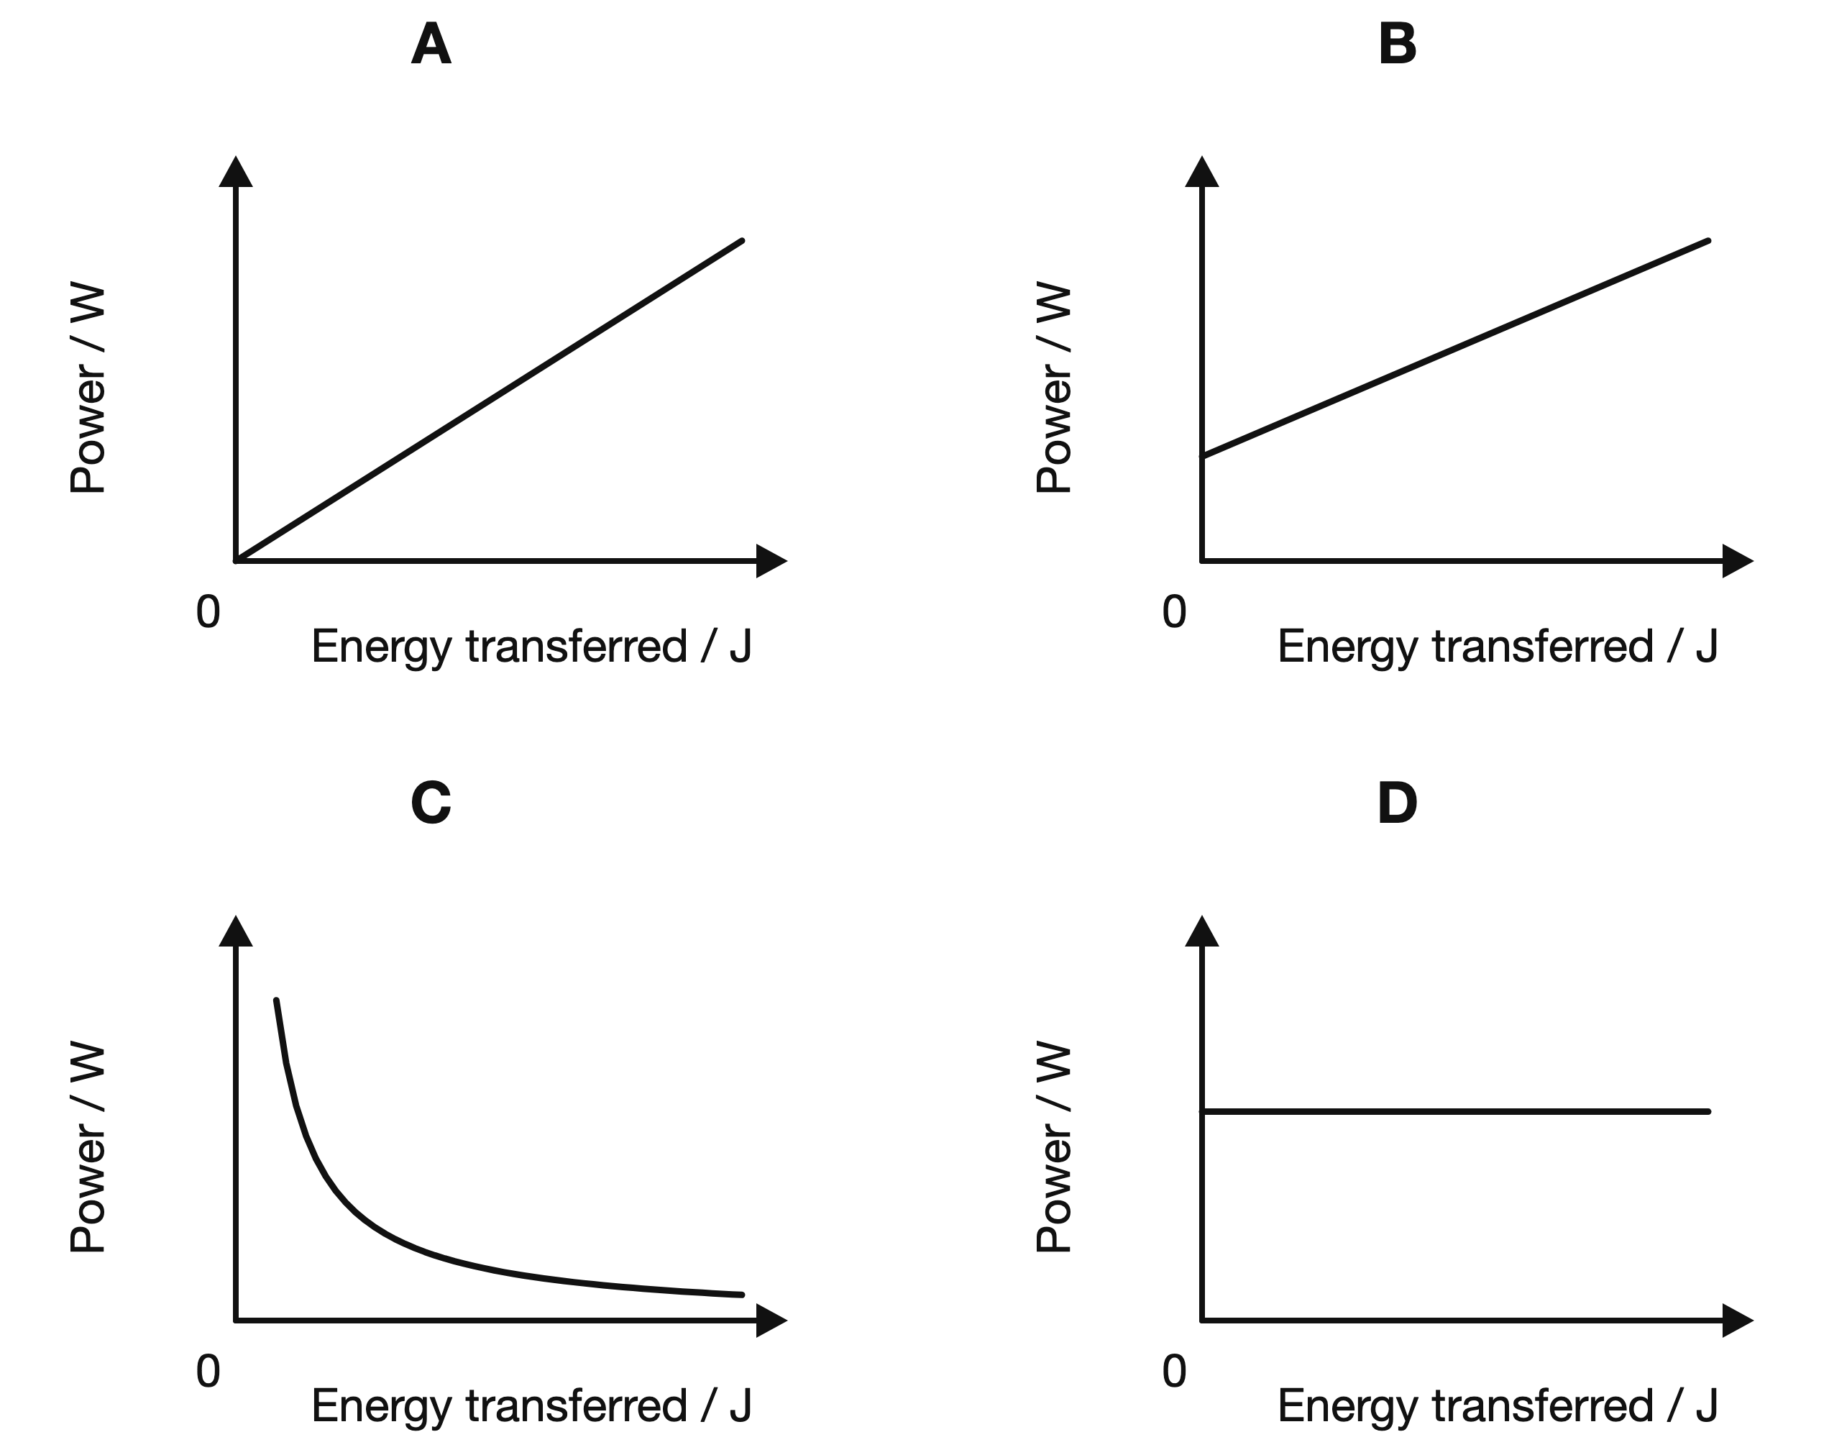
(1 mark)
13. The work done against gravity as a rollercoaster car moves from A to B is 150 kJ. Use the height shown to determine the car's weight.
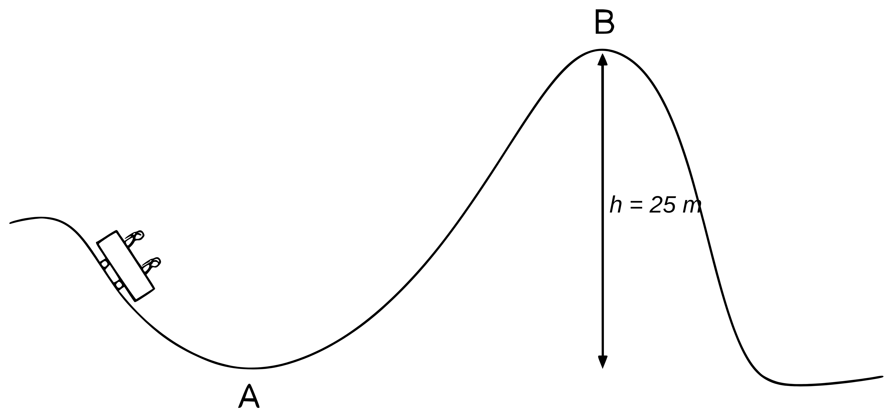
.....................................................................................................
.....................................................................................................
.....................................................................................................
.....................................................................................................
(2 marks)
14. Use the energy values shown for the speaker to calculate the percentage of the input energy that is wasted.
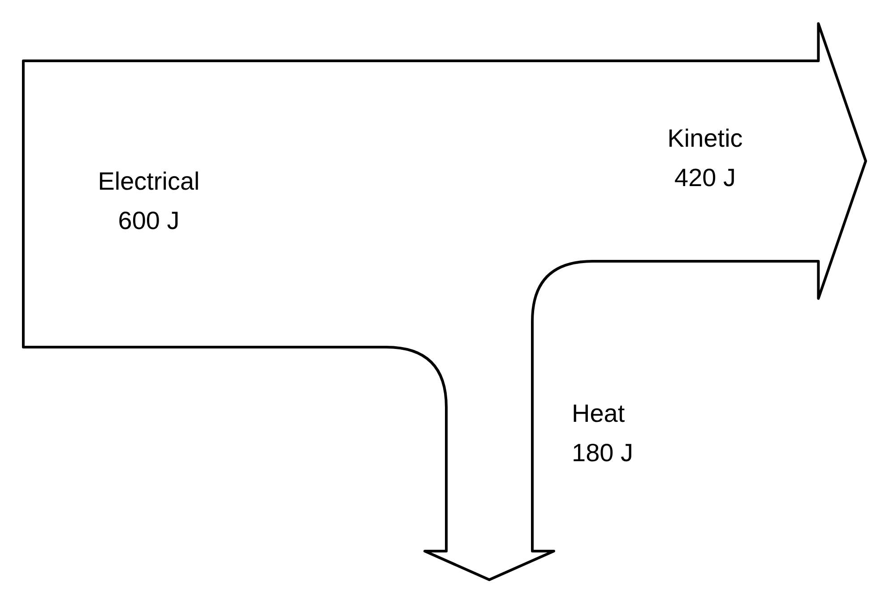
.....................................................................................................
.....................................................................................................
.....................................................................................................
.....................................................................................................
(2 marks)
15. Ignoring friction, determine the lowest speed at A that allows the car to reach B. Use a gravitational field strength of 10 N/kg.
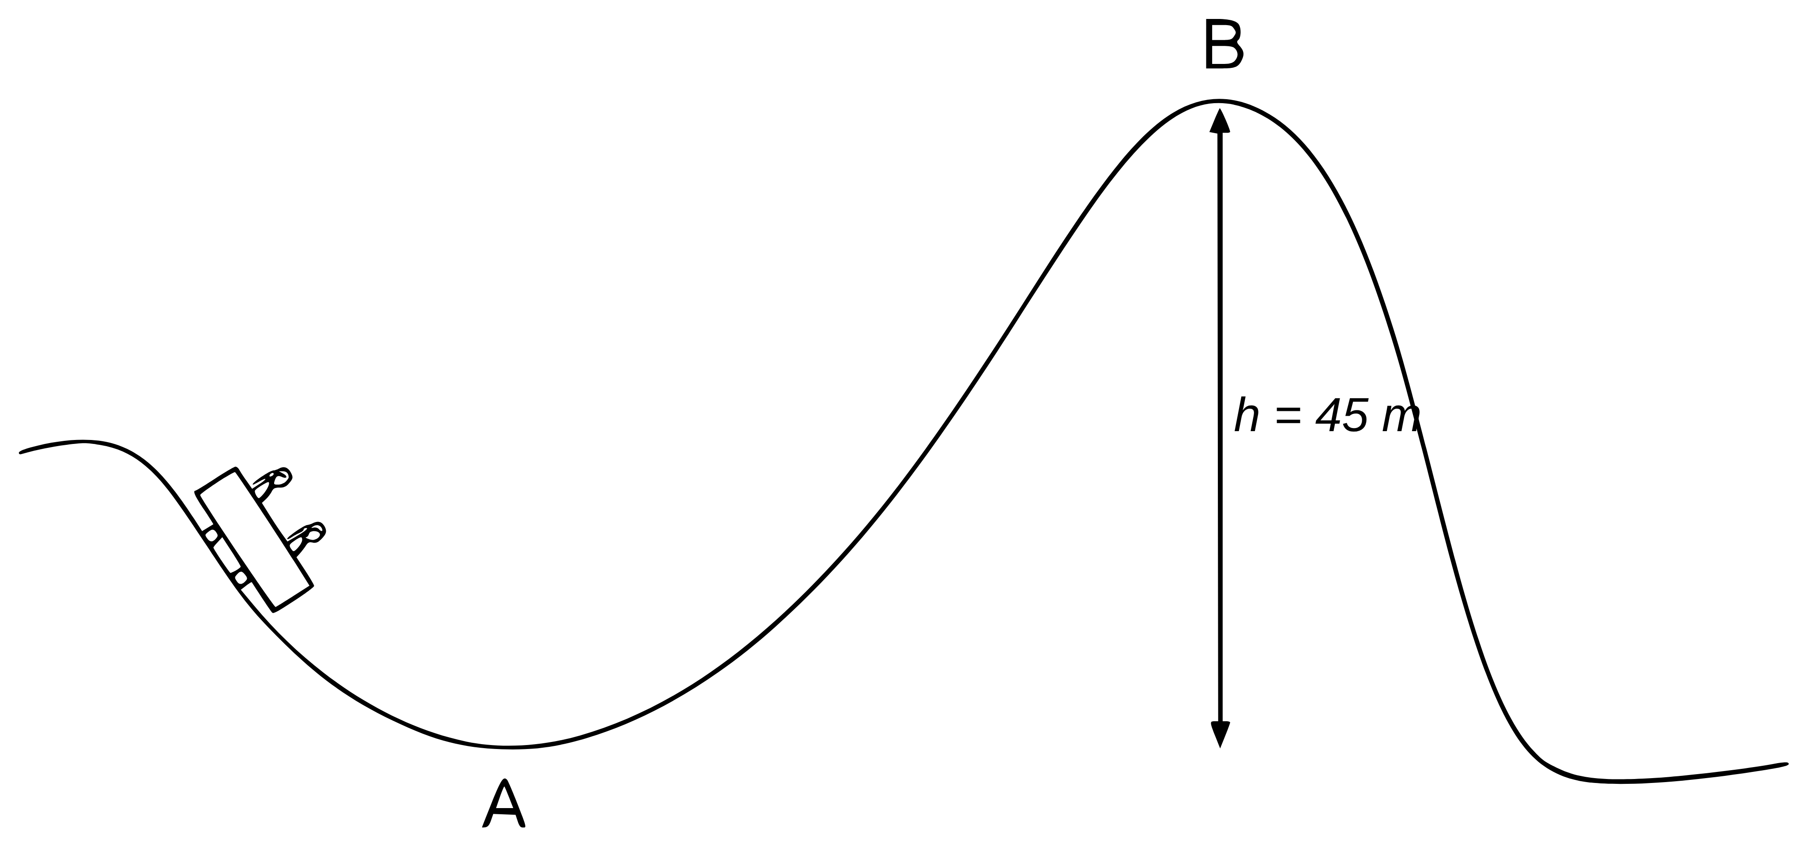
.....................................................................................................
.....................................................................................................
.....................................................................................................
.....................................................................................................
(2 marks)
16. Calculate the elastic potential energy stored in the spring. Use $E=\frac{1}{2}Fx$.
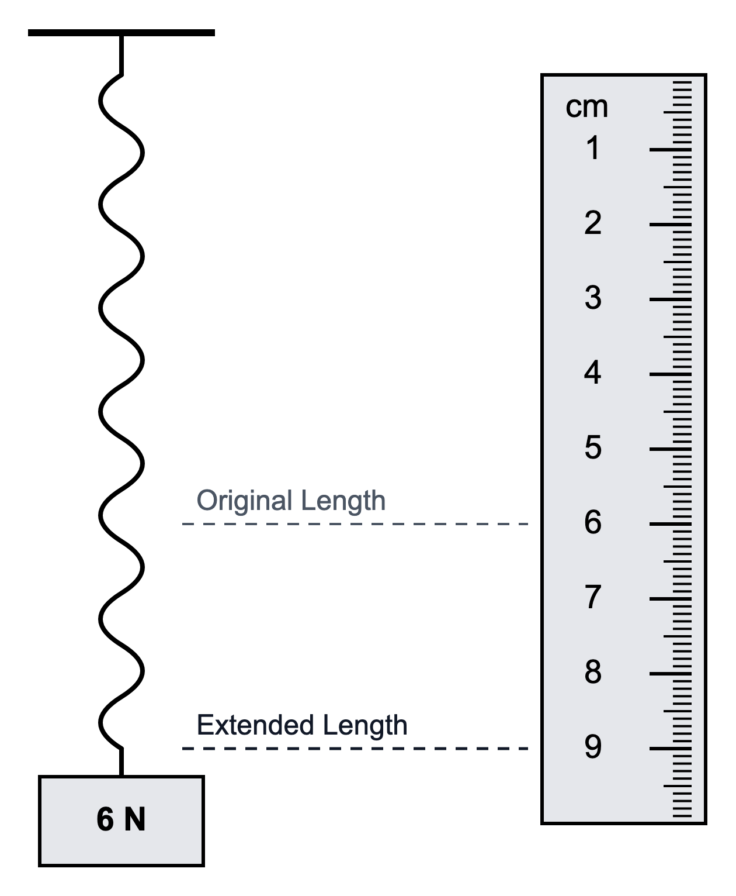
.....................................................................................................
.....................................................................................................
.....................................................................................................
.....................................................................................................
(2 marks)
17. A television transfers 360 kJ of energy in 30 minutes. Calculate its power.
.....................................................................................................
.....................................................................................................
.....................................................................................................
.....................................................................................................
(2 marks)
18. Classify coal and nuclear fuel as renewable or non-renewable resources.
.....................................................................................................
.....................................................................................................
.....................................................................................................
.....................................................................................................
(2 marks)
19. State where nuclear fusion occurs naturally on a very large scale.
.....................................................................................................
.....................................................................................................
(1 mark)
20. Use the coal-fired power station shown. State the energy transfer in the boiler and the energy transfer in the generator.
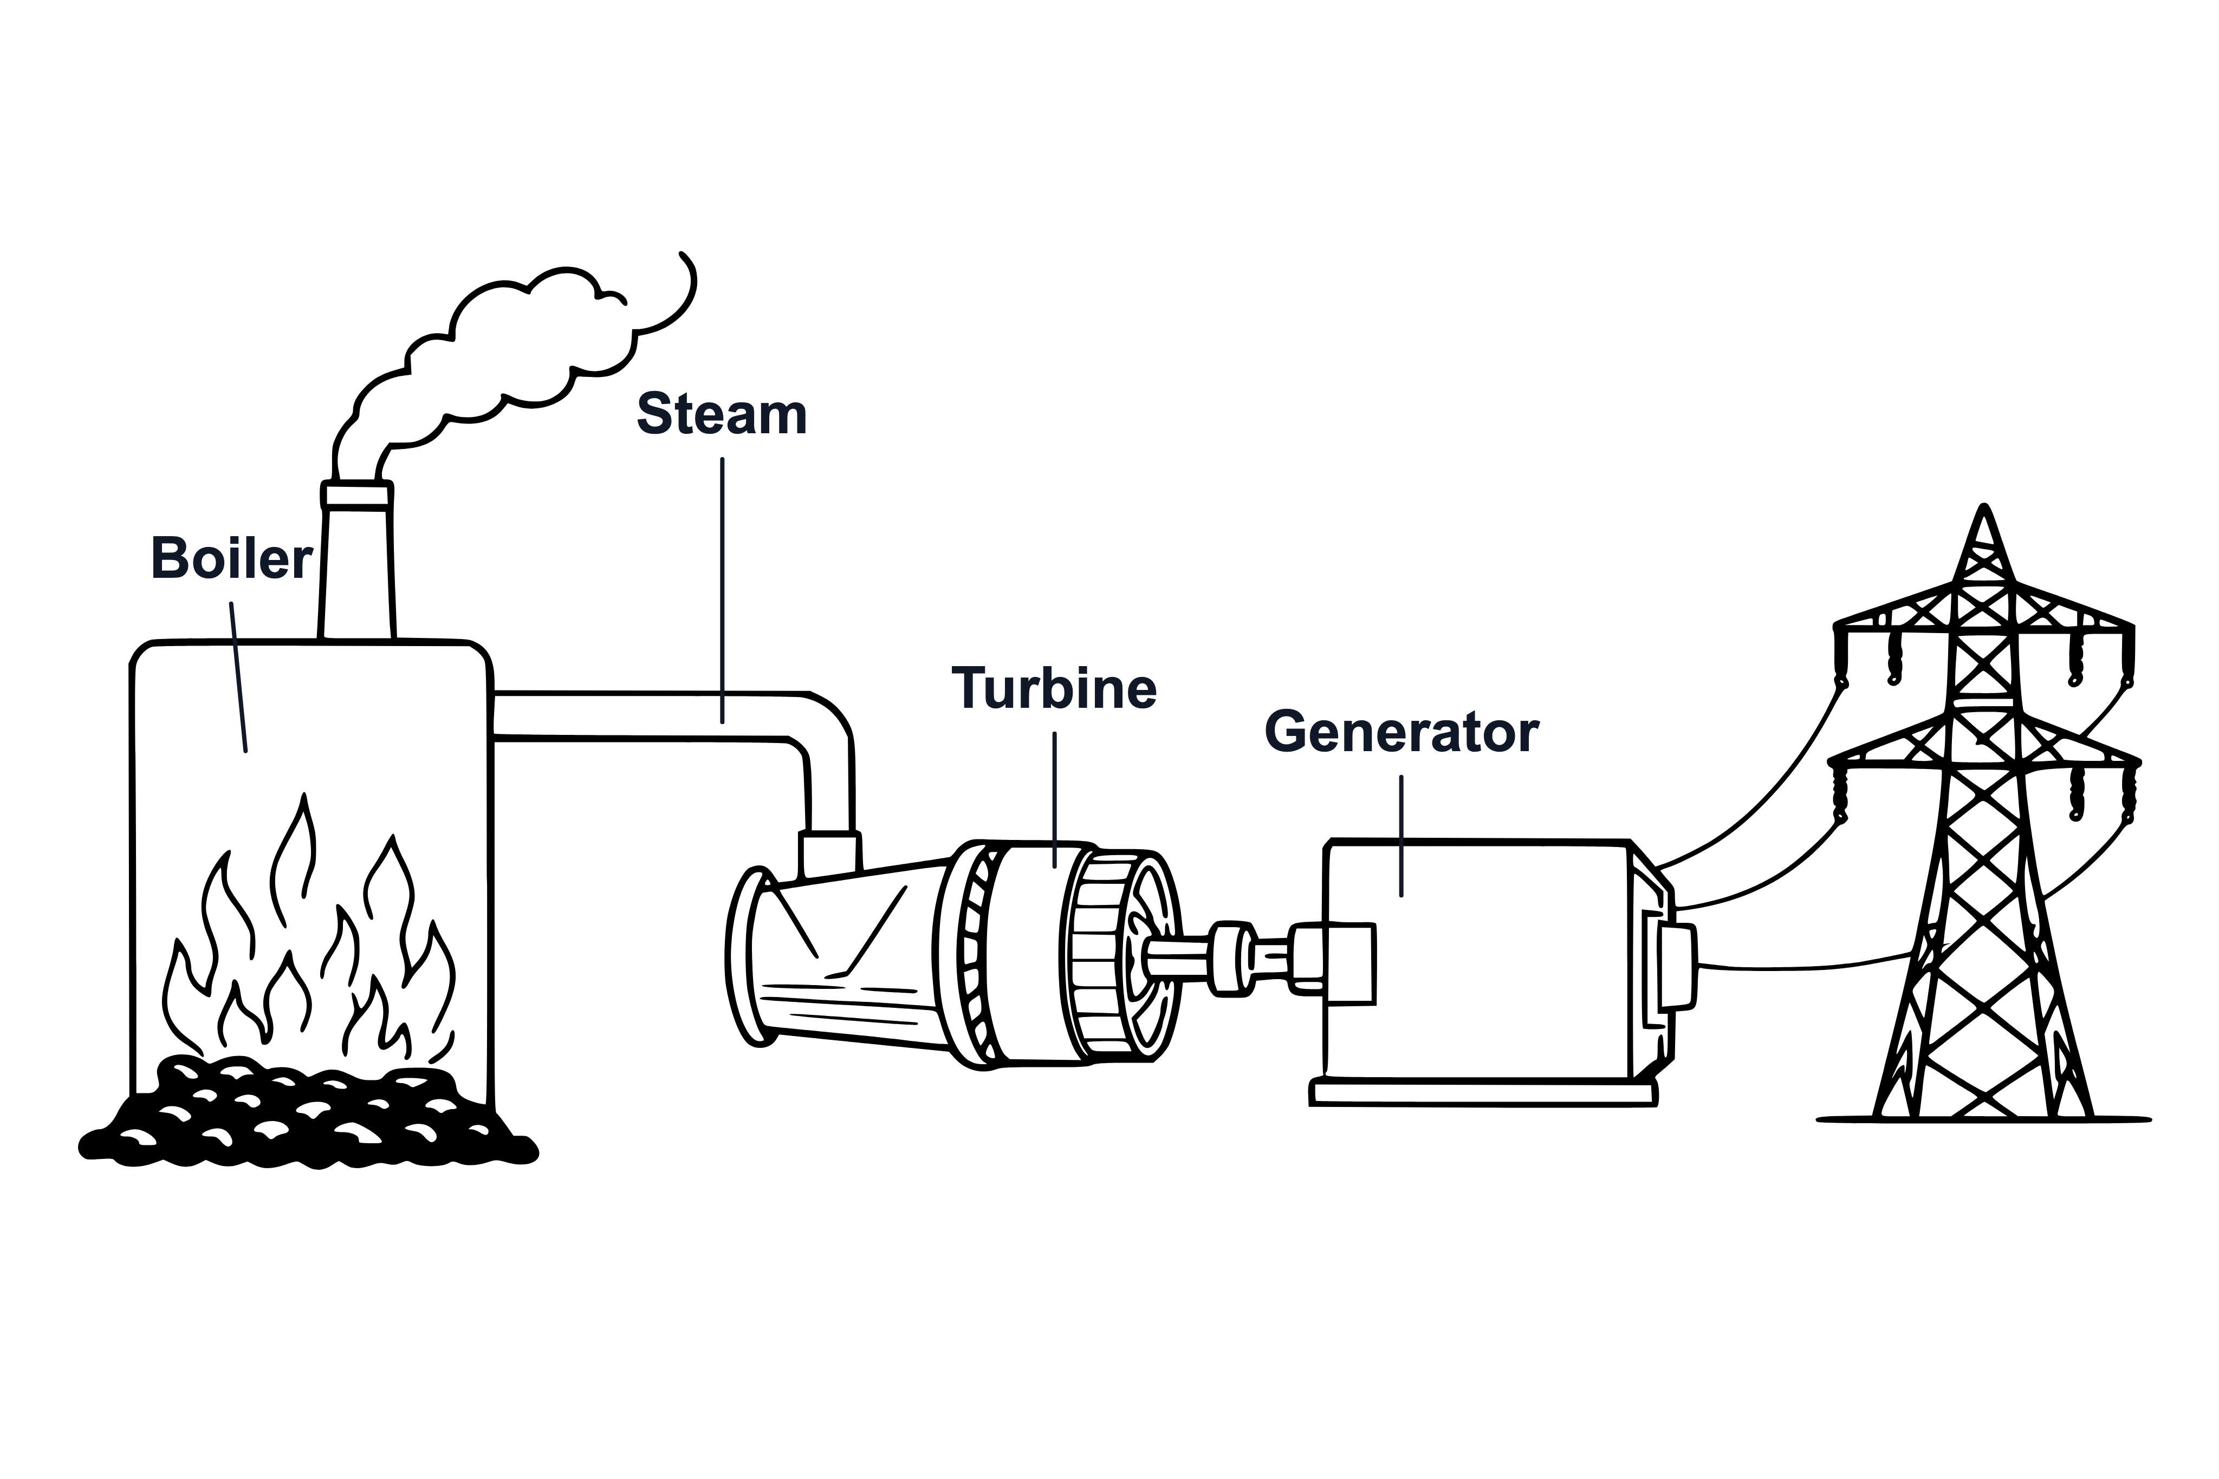
.....................................................................................................
.....................................................................................................
.....................................................................................................
.....................................................................................................
(2 marks)
21. The diagram below shows a pendulum at positions A, B and C.
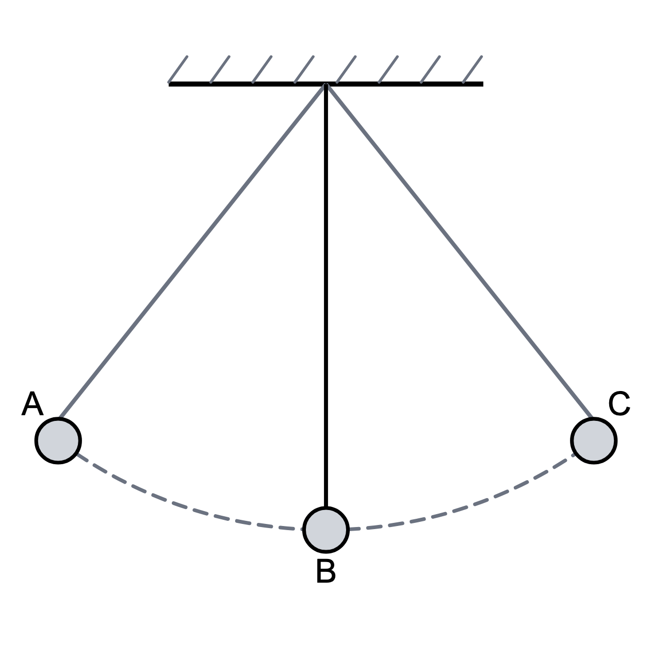
(a) State the position at which the kinetic energy of the bob is greatest.
.....................................................................................................
.....................................................................................................
(1 mark)
(b) State the positions at which the gravitational potential energy is greatest.
.....................................................................................................
.....................................................................................................
(1 mark)
(c) Explain your answer to (a).
.....................................................................................................
.....................................................................................................
.....................................................................................................
.....................................................................................................
(2 marks)
22. The diagram below shows the height from which a ball is dropped. A ball of mass 0.60 kg is held at the height shown in the diagram. The ball is then dropped. Use $g=10 N/kg$.
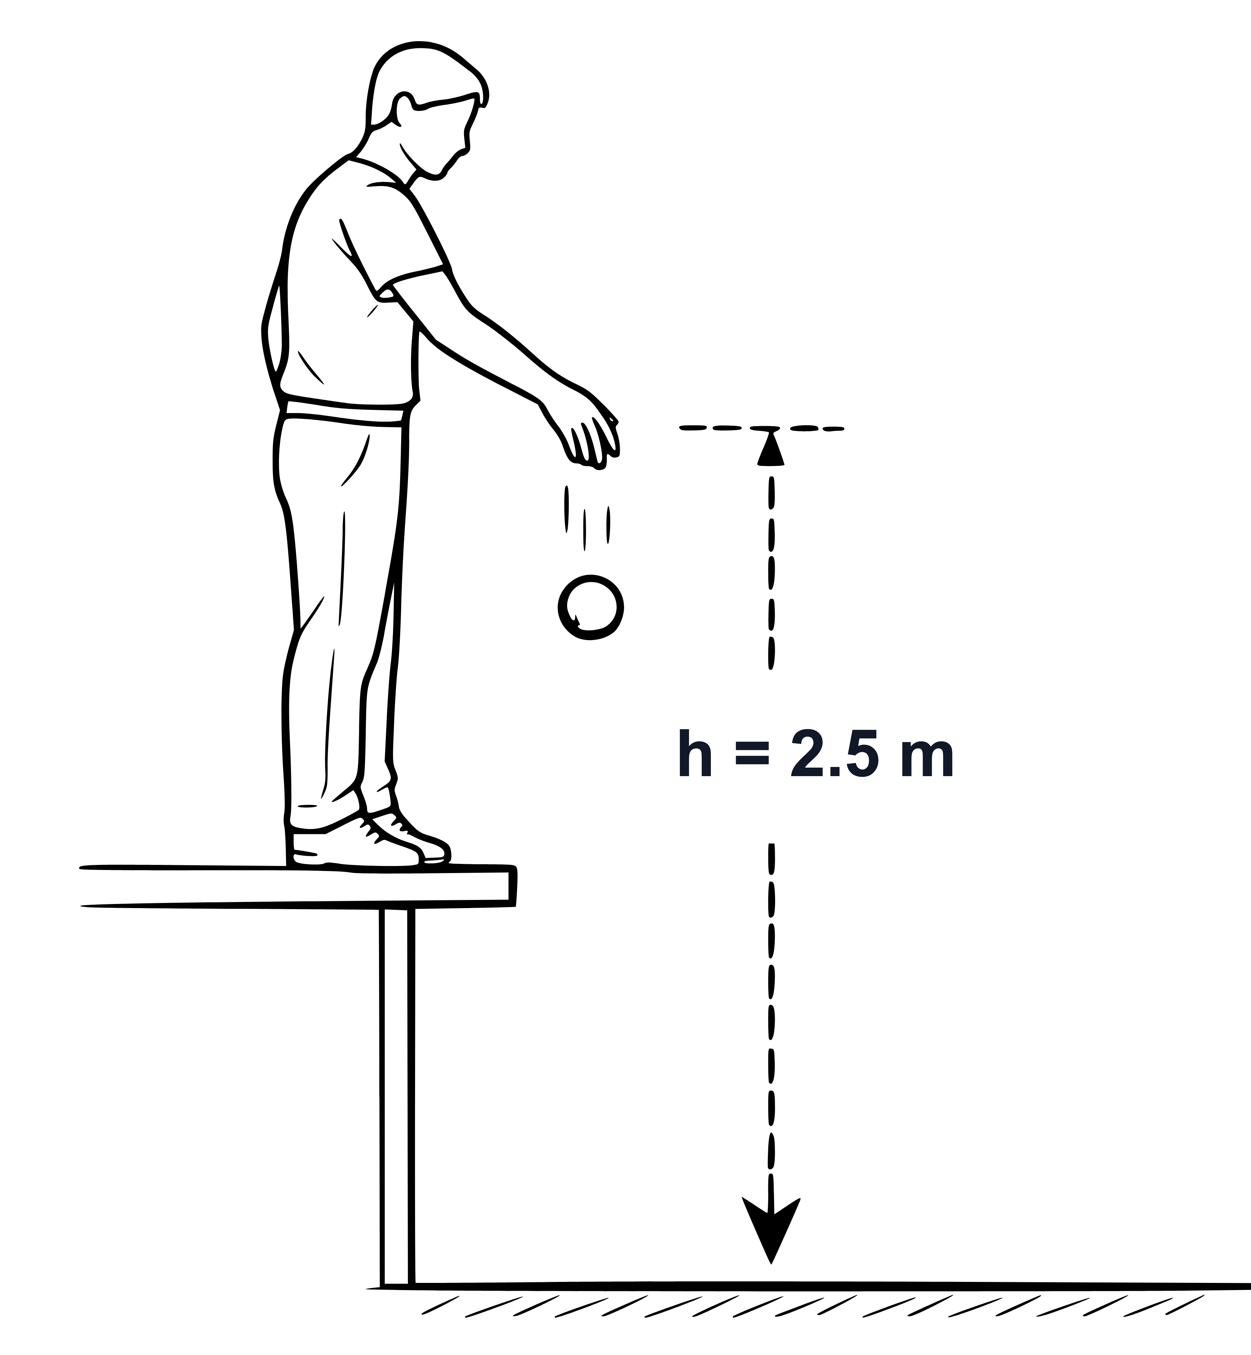
(a) Calculate the weight of the ball.
.....................................................................................................
.....................................................................................................
.....................................................................................................
.....................................................................................................
(2 marks)
(b) Calculate the change in gravitational potential energy of the ball as it falls to the floor.
.....................................................................................................
.....................................................................................................
.....................................................................................................
.....................................................................................................
.....................................................................................................
(3 marks)
(c) Ignore air resistance. State the kinetic energy of the ball just before it reaches the floor.
.....................................................................................................
.....................................................................................................
(1 mark)
(d) Calculate the speed of the ball just before it reaches the floor.
.....................................................................................................
.....................................................................................................
.....................................................................................................
.....................................................................................................
.....................................................................................................
(3 marks)
(e) In practice, the ball reaches the floor at a lower speed than your answer to part (d). Explain why.
.....................................................................................................
.....................................................................................................
.....................................................................................................
.....................................................................................................
(2 marks)
23. A student lists four situations.
1. A suitcase is pulled horizontally with a force of 60 N for 15 m.
2. A tray is carried horizontally for 15 m while the student pushes upward on the tray.
3. A heavy box is held still above the floor for 20 s.
4. A shopping trolley is pushed forward and moves forward.
(a) Calculate the work done on the suitcase in situation 1.
.....................................................................................................
.....................................................................................................
.....................................................................................................
.....................................................................................................
(2 marks)
(b) Explain why the upward force on the tray in situation 2 does no work on the tray as it moves horizontally.
.....................................................................................................
.....................................................................................................
.....................................................................................................
.....................................................................................................
(2 marks)
(c) Explain why no work is done on the heavy box in situation 3, even though the student becomes tired.
.....................................................................................................
.....................................................................................................
.....................................................................................................
.....................................................................................................
(2 marks)
(d) State which situation does not give enough information to calculate the work done. Give a reason for your answer.
.....................................................................................................
.....................................................................................................
.....................................................................................................
.....................................................................................................
(2 marks)

