1.8 Pressure: Cambridge IGCSE Physics worksheet
1. Two points are at the same depth in the same stationary liquid.
How do the pressures caused by the liquid at the two points compare?
A The pressure is greater at the point nearer the side of the container.
B The pressures are equal.
C The pressure is greater at the point nearer the centre of the container.
D The pressures are both zero.
(1 mark)
2. In a constant gravitational field, which two quantities determine the pressure caused by a liquid at a point below its surface?
A depth and liquid density
B depth and container area
C liquid density and container shape
D container area and container shape
(1 mark)
3. Why is the wall of a water dam made thicker near the bottom than near the top?
A Water density increases with depth.
B Gravitational field strength increases with depth.
C Water pressure decreases with depth.
D Water pressure increases with depth.
(1 mark)
4. Oil has a density of 800 kg/m³ and water has a density of 1000 kg/m³. Points in the two liquids are at the same depth.
How does the pressure caused by the oil compare with the pressure caused by the water?
A It is 0.20 times as large.
B It is 1.0 times as large.
C It is 1.25 times as large.
D It is 0.80 times as large.
(1 mark)
5. Three differently shaped open containers hold the same liquid to the same depth.
How does the pressure caused by the liquid at the bottom of each container compare?
A It is greatest in the container with the largest base area.
B It is greatest in the container holding the most liquid.
C It is the same in all three containers.
D It is greatest in the narrowest container.
(1 mark)
6. A pressure of 25 000 Pa acts normally on an area of 0.0080 m².
What force acts on this area?
A 200 N
B 20 N
C 3 125 000 N
D 2000 N
(1 mark)
7. Blocks P and Q exert equal normal forces on a floor. The contact area of P is 0.020 m² and the contact area of Q is 0.040 m².
How does the pressure exerted by P compare with the pressure exerted by Q?
A It is one-quarter as large.
B It is half as large.
C It is twice as large.
D It is the same.
(1 mark)
8. Why does a person wearing wide snowshoes sink less into soft snow?
A The snowshoes increase the person's weight.
B The snowshoes increase the contact area.
C The snowshoes decrease the contact area.
D The snowshoes increase the density of the snow.
(1 mark)
9. At a fixed location, the pressure caused by a liquid at a point depends on the liquid density and the depth of the point. Which changes leave this pressure unchanged?
 | Liquid density | Depth
A | doubled | unchanged
B | doubled | halved
C | halved | halved
D | unchanged | doubled

(1 mark)
10. A constant normal force acts on different contact areas.
Which graph shows how pressure varies with contact area?
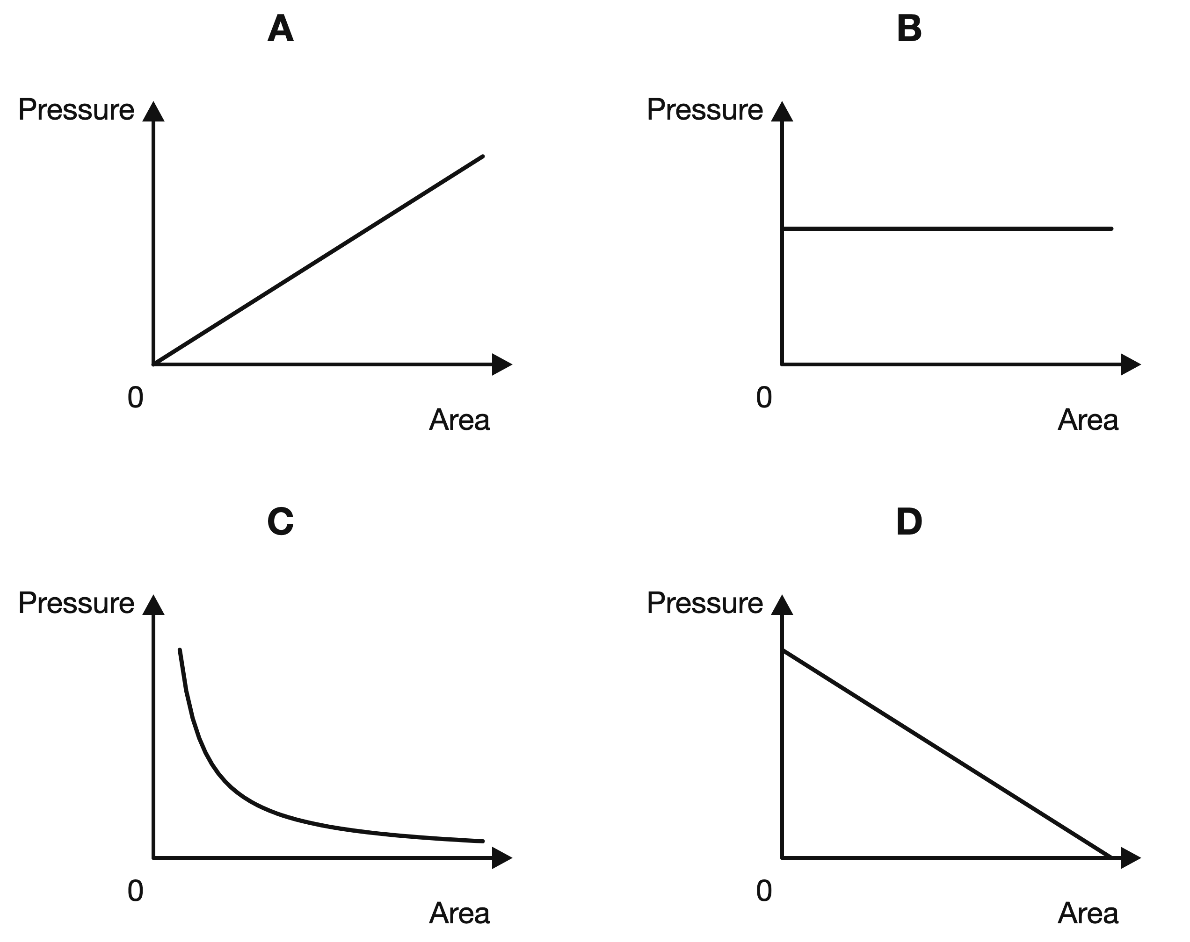
(1 mark)
11. A liquid has a density of 1200 kg/m³. Use a gravitational field strength of 10 N/kg.
At what depth does the liquid cause a pressure of 36 000 Pa?
A 3.0 m
B 0.30 m
C 30 m
D 300 m
(1 mark)
12. A tool exerts a normal force of 180 N through a contact area of 15 cm².
What pressure does the tool exert?
A 12 Pa
B 1200 Pa
C 12 000 Pa
D 120 000 Pa
(1 mark)
13. Give one suitable unit for pressure.
.....................................................................................................
.....................................................................................................
(1 mark)
14. In the equation $p=\frac{F}{A}$, state the SI unit for force and the SI unit for area.
.....................................................................................................
.....................................................................................................
.....................................................................................................
.....................................................................................................
(2 marks)
15. Write the equation for pressure difference in a liquid and state the unit of density.
.....................................................................................................
.....................................................................................................
.....................................................................................................
.....................................................................................................
(2 marks)
16. State the SI unit of pressure and give the equivalent unit in newtons and metres.
.....................................................................................................
.....................................................................................................
.....................................................................................................
.....................................................................................................
(2 marks)
17. A diver is 1.5 m below the surface of fresh water. The density of the water is 1000 kg/m³. Calculate the pressure difference between the diver and the surface. Use $g=10 N/kg$.
.....................................................................................................
.....................................................................................................
.....................................................................................................
.....................................................................................................
(2 marks)
18. Write the equation linking pressure, force and area.
.....................................................................................................
.....................................................................................................
(1 mark)
19. A machine part experiences a pressure of 4000 Pa over a surface area of 0.20 m². Calculate the normal force on the surface.
.....................................................................................................
.....................................................................................................
.....................................................................................................
.....................................................................................................
(2 marks)
20. Explain why the sharp point of a drawing pin can be pushed into a board more easily than the flat head.
.....................................................................................................
.....................................................................................................
.....................................................................................................
.....................................................................................................
(2 marks)
21. A force keeps the same size but is spread over a smaller area. What happens to the pressure?
.....................................................................................................
.....................................................................................................
(1 mark)
22. The diagrams below show two cylinders containing liquid.
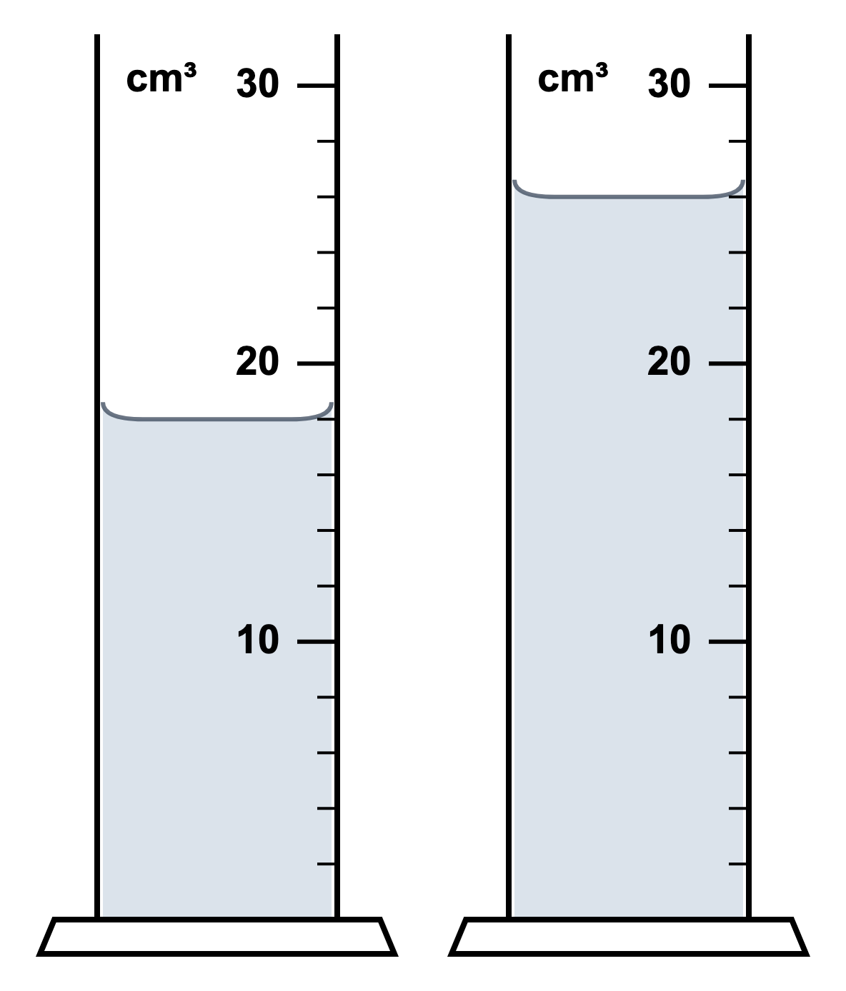
(a) State which cylinder would have the greater pressure at its base.
.....................................................................................................
.....................................................................................................
(1 mark)
(b) Explain your answer.
.....................................................................................................
.....................................................................................................
(1 mark)
(c) State what else would have to stay the same for this comparison to be valid.
.....................................................................................................
.....................................................................................................
(1 mark)
23. An uncooked chicken egg is dropped from a ship into the Mariana Trench and sinks to the seabed, 10,900 m below the surface. The egg is completely full of liquid white and yolk, and its shell is porous. The density of the seawater is 1030 kg/m³. The gravitational field strength is $g=10 N/kg$.
(a) Calculate the pressure due to the seawater at the seabed.
.....................................................................................................
.....................................................................................................
.....................................................................................................
.....................................................................................................
.....................................................................................................
(3 marks)
(b) Calculate the force the seawater exerts on a 1.0 cm² patch of the shell.
.....................................................................................................
.....................................................................................................
.....................................................................................................
.....................................................................................................
(2 marks)
(c) The egg is not crushed. Explain why.
.....................................................................................................
.....................................................................................................
.....................................................................................................
.....................................................................................................
.....................................................................................................
(3 marks)
(d) A sealed plastic bottle full of air is dropped at the same time. Explain why the bottle is crushed.
.....................................................................................................
.....................................................................................................
.....................................................................................................
.....................................................................................................
(2 marks)
24. A U-tube manometer contains a liquid of density 800 kg/m³. One side is connected to a gas supply. The other side is open to the atmosphere. The liquid level on the gas side is 6.0 cm lower than the liquid level on the open side. Atmospheric pressure is 1.01 × 10⁵ Pa.
(a) State what the difference in liquid levels shows about the gas pressure compared with atmospheric pressure.
.....................................................................................................
.....................................................................................................
(1 mark)
(b) Calculate the pressure difference between the gas and the atmosphere.
.....................................................................................................
.....................................................................................................
.....................................................................................................
.....................................................................................................
.....................................................................................................
(3 marks)
(c) Calculate the pressure of the gas.
.....................................................................................................
.....................................................................................................
.....................................................................................................
.....................................................................................................
(2 marks)
(d) The same gas pressure is measured using a narrower U-tube containing the same liquid. State and explain what happens to the height difference between the liquid levels. Ignore capillary effects.
.....................................................................................................
.....................................................................................................
.....................................................................................................
.....................................................................................................
(2 marks)

