2.1 Kinetic particle model of matter: Cambridge IGCSE Physics worksheet
1. Which statement about absolute zero is correct?
A It is 0 °C, when water freezes.
B It is 273 °C, when particle speed is greatest.
C It is 0 K, when all particle potential energy is zero.
D It is approximately −273 °C, the lowest possible temperature.
(1 mark)
2. What causes the pressure exerted by a gas on the walls of its container?
A Gas particles collide with the walls and exert forces on them.
B Gas particles repel the walls without touching them.
C Gas particles remain at rest against the walls.
D Gas particles are pulled downwards by gravity.
(1 mark)
3. A gas has a temperature of 27 °C.
What is its thermodynamic temperature?
A 300 K
B 246 K
C 27 K
D 327 K
(1 mark)
4. A fixed mass of gas is held at constant volume. Its pressure is 100 kPa at 300 K.
What is its pressure at 450 K?
A 66.7 kPa
B 150 kPa
C 250 kPa
D 450 kPa
(1 mark)
5. A fixed mass of gas is compressed at constant temperature from a volume of 600 cm³ to 200 cm³.
What happens to the gas pressure?
A It becomes three times as large.
B It becomes one-third as large.
C It becomes nine times as large.
D It remains unchanged.
(1 mark)
6. A sealed, rigid container holds a gas. The gas is heated.
Which statement explains why its pressure increases?
A The particles become larger and occupy more space.
B The particles move faster and collide with the walls more frequently and forcefully.
C The particles move more slowly and remain near the walls.
D More particles are created inside the container.
(1 mark)
7. Smoke particles illuminated in air are seen to move in an irregular, random way.
What causes this motion?
A The smoke particles repeatedly expand and contract.
B Convection currents push every smoke particle in the same direction.
C Air molecules collide unevenly with the smoke particles.
D Gravity pulls different smoke particles in random directions.
(1 mark)
8. Two identical rigid containers hold the same gas at the same temperature. Container X holds twice as many gas particles as container Y.
How does the pressure in X compare with the pressure in Y?
A It is half as large.
B It is the same.
C It is twice as large.
D It is four times as large.
(1 mark)
9. A fixed mass of gas remains at constant temperature.
Which graph shows how its pressure varies with volume?
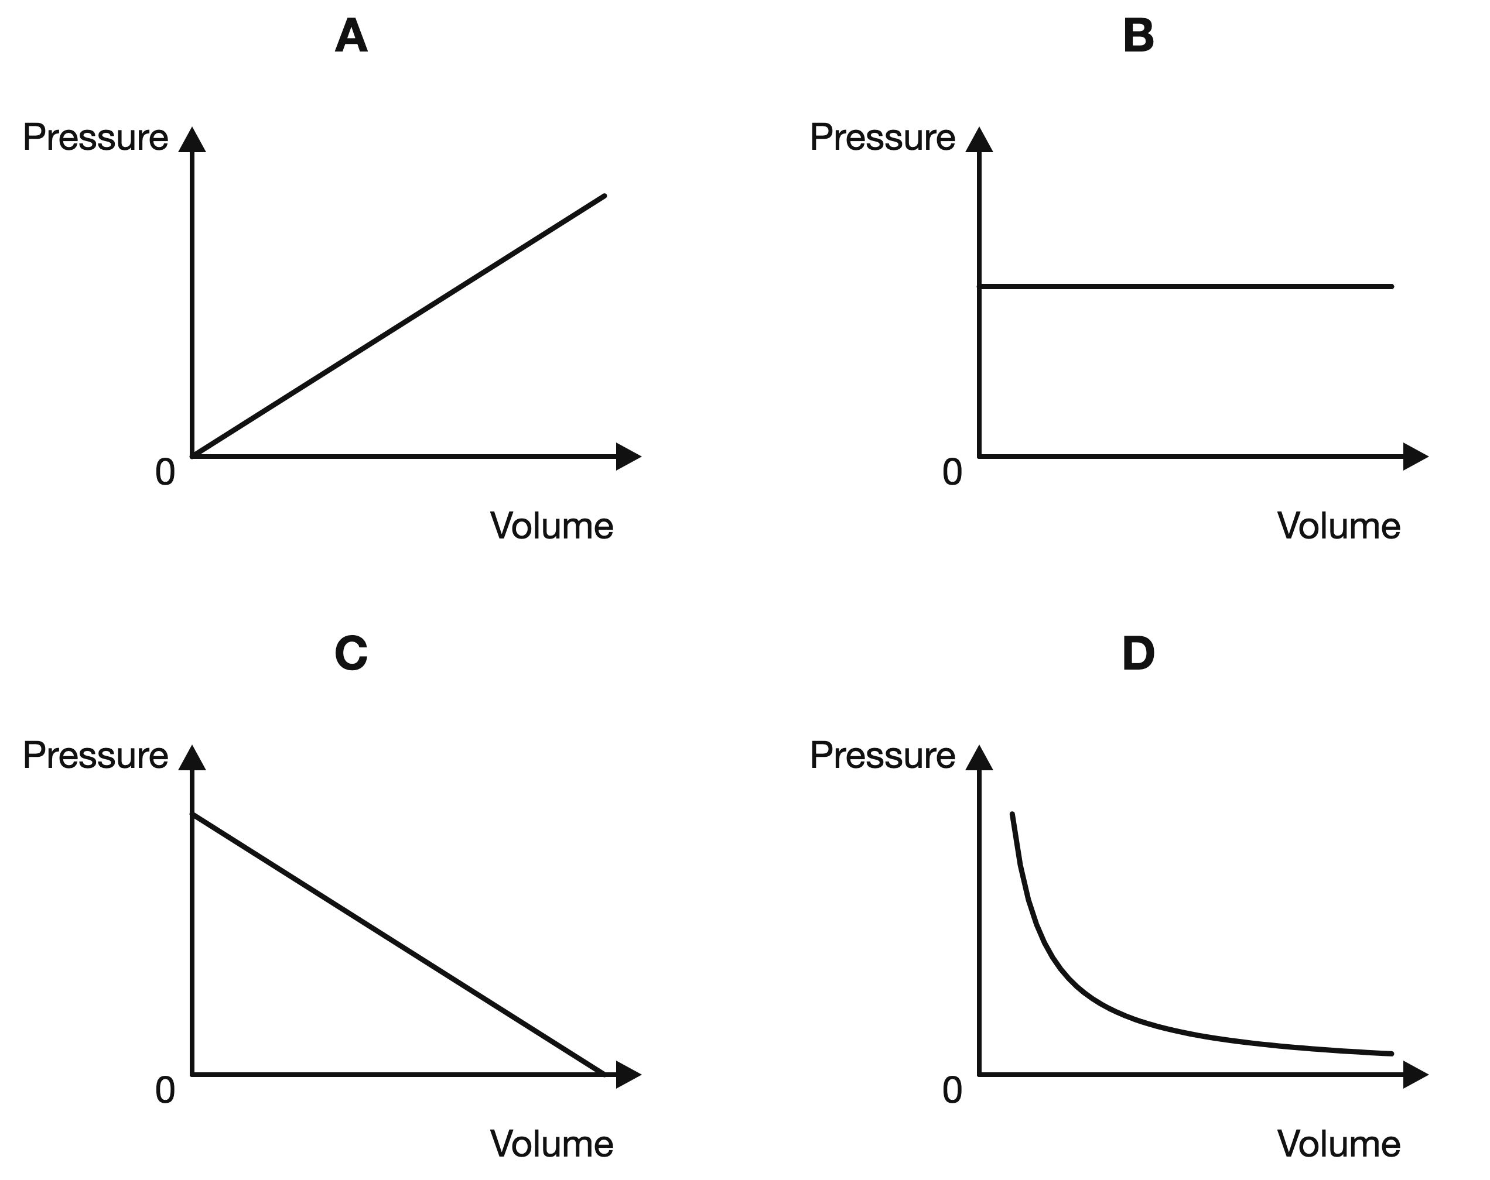
(1 mark)
10. A fixed mass of gas is kept at constant volume.
Which graph shows how its pressure varies with temperature in kelvin?
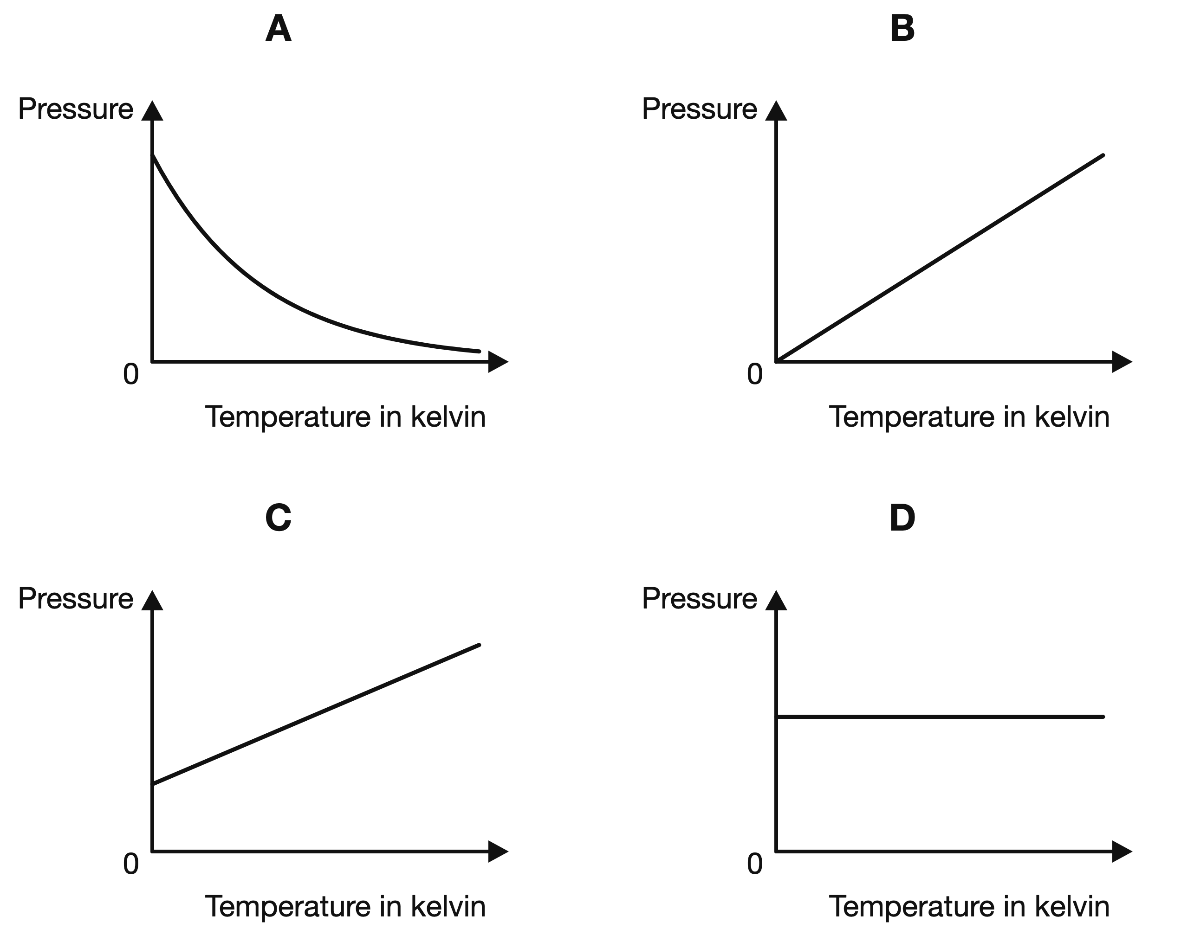
(1 mark)
11. State what happens to the kinetic energy of gas particles when the gas is heated.
.....................................................................................................
.....................................................................................................
(1 mark)
12. The diagram shows a piston setup used to investigate Boyle's Law. State Boyle's Law for a fixed mass of gas at constant temperature.

.....................................................................................................
.....................................................................................................
(1 mark)
13. Pure water at standard atmospheric pressure reaches the temperature shown. Name the change of state when the water changes from liquid to gas.
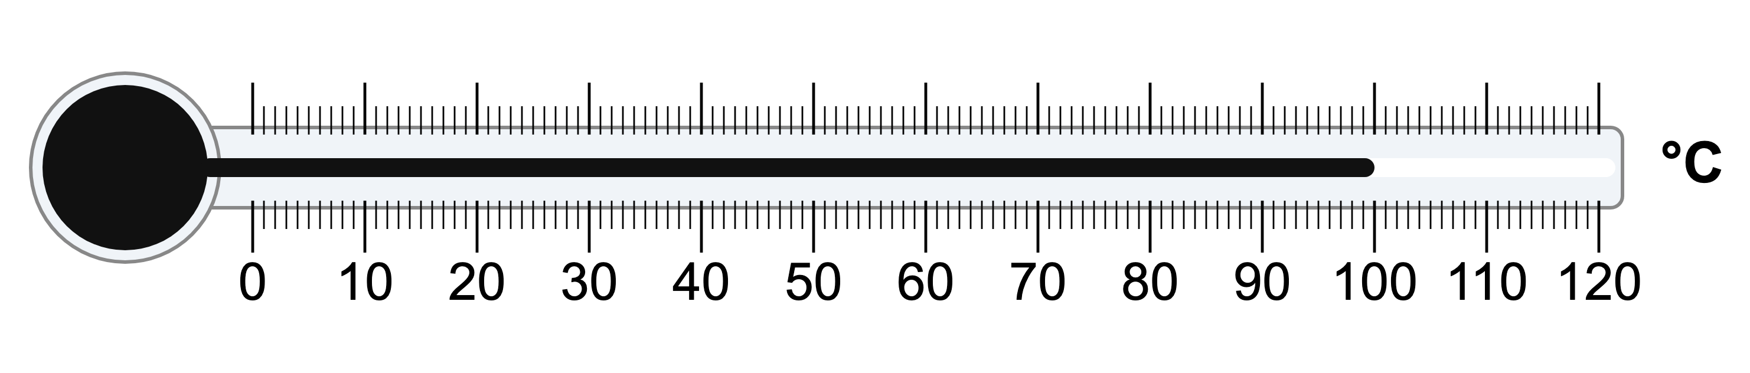
.....................................................................................................
.....................................................................................................
(1 mark)
14. A fixed mass of gas at constant temperature is compressed by a piston. Describe why the gas pressure increases.
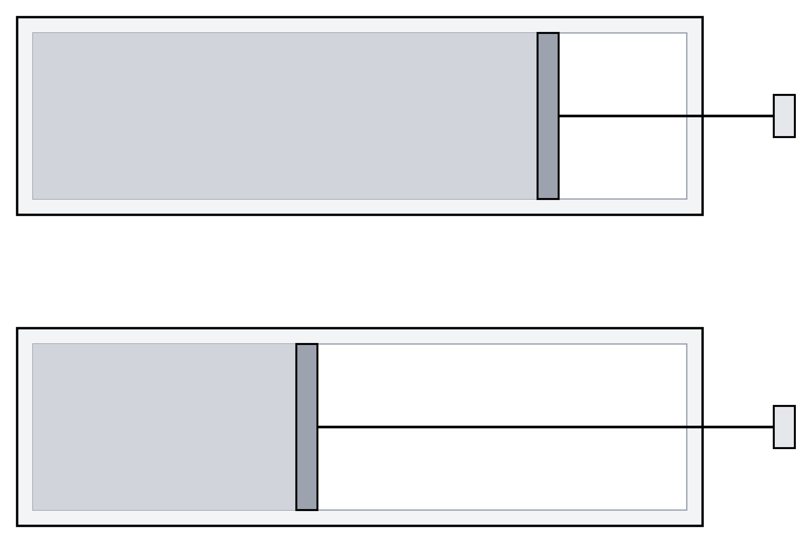
.....................................................................................................
.....................................................................................................
.....................................................................................................
.....................................................................................................
(2 marks)
15. The diagram shows a cylinder of gas with a movable piston. It has a volume of 10 cm³ at a pressure of 100 kPa. Calculate the pressure if the piston reduces the volume to 5 cm³ at constant temperature.
.....................................................................................................
.....................................................................................................
.....................................................................................................
.....................................................................................................
(2 marks)
16. A sample of one substance can exist as a solid, as a liquid or as a gas.
(a) Draw simple particle diagrams to show the arrangement of the particles in a solid, in a liquid and in a gas. Label each of the three diagrams.
​
​
​
​
​
​
​
​
​
​
​
​
(3 marks)
(b) Describe how the particles move in each of the three states.
.....................................................................................................
.....................................................................................................
.....................................................................................................
.....................................................................................................
.....................................................................................................
(3 marks)
(c) Explain, in terms of the forces between the particles, why a solid has a fixed shape but a liquid does not.
.....................................................................................................
.....................................................................................................
.....................................................................................................
.....................................................................................................
.....................................................................................................
(3 marks)
(d) Explain why a gas can be compressed into a much smaller volume but a liquid cannot.
.....................................................................................................
.....................................................................................................
.....................................................................................................
.....................................................................................................
(2 marks)
17. A gas thermometer contains a fixed volume of gas. It is moved from a cold room to a warm room. The thermometer readings are shown.
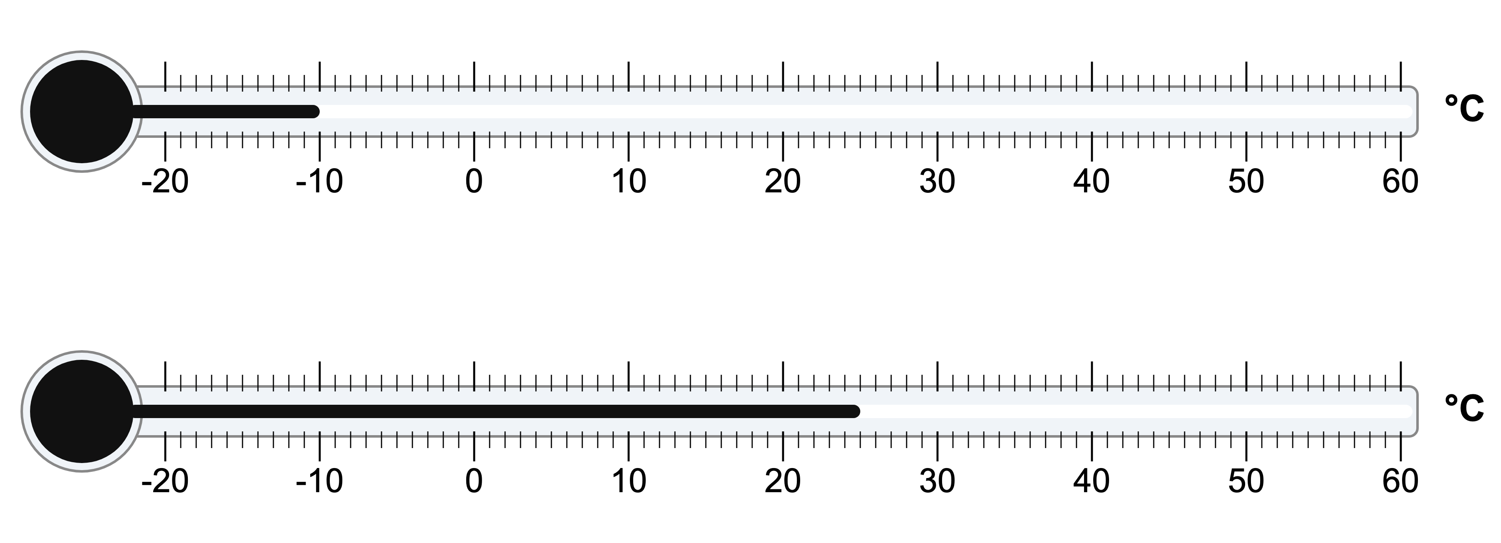
(a) Convert the readings on the thermometers from degrees Celsius to kelvin.
.....................................................................................................
.....................................................................................................
.....................................................................................................
.....................................................................................................
(2 marks)
(b) Describe how the average kinetic energy of the gas particles changes when the gas warms from -10 °C to 25 °C.
.....................................................................................................
.....................................................................................................
.....................................................................................................
.....................................................................................................
(2 marks)
(c) Explain what happens to the pressure of the gas if its volume is fixed. ​
.....................................................................................................
.....................................................................................................
.....................................................................................................
.....................................................................................................
.....................................................................................................
(3 marks)
18. A small glass cell is filled with smoke and lit brightly from one side. A student looks down at the smoke inside the cell through a microscope.
(a) Describe what the student sees through the microscope.
.....................................................................................................
.....................................................................................................
.....................................................................................................
.....................................................................................................
(2 marks)
(b) Explain why the smoke particles move in this way.
.....................................................................................................
.....................................................................................................
.....................................................................................................
.....................................................................................................
.....................................................................................................
(3 marks)
(c) The student says that the moving specks are the air molecules themselves. Explain why the student is wrong.
.....................................................................................................
.....................................................................................................
.....................................................................................................
.....................................................................................................
(2 marks)
(d) An air molecule has a far smaller mass than a smoke particle. Explain how such light molecules are able to move a smoke particle at all.
.....................................................................................................
.....................................................................................................
(1 mark)
(e) State what this experiment provides evidence for.
.....................................................................................................
.....................................................................................................
(1 mark)

