2.2 Thermal properties and temperature: Cambridge IGCSE Physics worksheet
1. Which particle property is related to the temperature of a substance?
A the average kinetic energy of the particles
B the total kinetic energy of all the particles
C the total mass of the particles
D the rate at which the particles gain energy
(1 mark)
2. What is meant by the internal energy of a substance?
A the total kinetic energy of the substance as a whole
B the total random kinetic and potential energies of its particles
C the energy transferred from the substance to its surroundings
D the gravitational potential energy of the substance
(1 mark)
3. Why is a small gap left between sections of a metal bridge?
A to increase conduction through the bridge
B to allow the metal to contract when its temperature increases
C to allow the metal to expand when its temperature increases
D to prevent the bridge from emitting infrared radiation
(1 mark)
4. A gas in a cylinder is heated. A movable piston keeps the gas pressure constant.
What happens to the volume of the gas?
A It decreases because the particles become smaller.
B It remains constant because the pressure is constant.
C It increases as the piston moves outwards.
D It becomes zero when the gas reaches thermal equilibrium.
(1 mark)
5. An object receives 12 000 J of energy and its temperature rises by 4.0 °C.
What is the heat capacity of the object?
A 3.0 J/°C
B 12 000 J/°C
C 48 000 J/°C
D 3000 J/°C
(1 mark)
6. Why does evaporation from the surface of a liquid cause the remaining liquid to cool?
A The highest-energy particles escape from the liquid.
B The escaping particles transfer energy to the liquid.
C The lowest-energy particles escape from the liquid.
D The mass of each remaining particle decreases.
(1 mark)
7. Which statement defines the specific heat capacity of a substance?
A the energy needed to raise the temperature of an object by 1 °C
B the energy needed to melt 1 kg of the substance
C the energy needed to raise the temperature of 1 kg of the substance by 1 °C
D the energy transferred by 1 kg of the substance each second
(1 mark)
8. Ice at its melting temperature is heated until some of it becomes water. Its temperature remains constant.
What happens to the internal energy of the ice-water mixture?
A It decreases because the temperature is constant.
B It remains constant because the temperature is constant.
C It first decreases and then increases.
D It increases because the potential energy of the particles increases.
(1 mark)
9. Two liquid-in-glass thermometers have identical bulbs and contain the same liquid. One thermometer has a narrower capillary tube.
Why is this thermometer more sensitive?
A The liquid expands through a smaller volume for each degree.
B The same volume expansion produces a larger movement along the tube.
C The liquid reaches thermal equilibrium more slowly.
D The glass expands much more than the liquid.
(1 mark)
10. The specific latent heat of fusion of a substance is 330 000 J/kg.
How much energy is needed to melt 0.20 kg of the substance at its melting temperature?
A 66 000 J
B 16 500 J
C 330 000 J
D 1650 J
(1 mark)
11. A pure solid is melting while energy is supplied at a constant rate. Its temperature remains constant until all the solid has melted.
What happens to the supplied energy during melting?
A It leaves the substance as thermal radiation.
B It decreases the kinetic energy of the particles.
C It changes the arrangement and separation of the particles.
D It increases the mass of the substance.
(1 mark)
12. A pure solid is melting at constant temperature.
Which row shows what happens to the average kinetic energy and the average potential energy of its particles?
 | Average kinetic energy | Average potential energy
A | decreases | increases
B | increases | remains unchanged
C | remains unchanged | increases
D | remains unchanged | decreases

(1 mark)
13. Equal masses of materials X and Y receive equal amounts of energy. The specific heat capacity of X is 900 J/kg °C and that of Y is 450 J/kg °C.
How does the temperature rise of Y compare with that of X?
A It is four times as large.
B It is half as large.
C It is the same.
D It is twice as large.
(1 mark)
14. A 2.0 kg metal block has a specific heat capacity of 500 J/kg °C. Its temperature rises by 6.0 °C.
How much energy is transferred to the block?
A 60 J
B 6000 J
C 3000 J
D 1500 J
(1 mark)
15. A 0.25 kg sample of water warms by 20 °C. The specific heat capacity of water is 4200 J/kg °C. Calculate the increase in thermal energy.
.....................................................................................................
.....................................................................................................
.....................................................................................................
.....................................................................................................
(2 marks)
16. Define specific heat capacity.
.....................................................................................................
.....................................................................................................
.....................................................................................................
.....................................................................................................
(2 marks)
17. During evaporation, state which liquid particles escape and the effect on the average kinetic energy of the particles left behind.
.....................................................................................................
.....................................................................................................
.....................................................................................................
.....................................................................................................
(2 marks)
18. State the freezing point of water.
.....................................................................................................
.....................................................................................................
(1 mark)
19. State how evaporation cools a liquid.
.....................................................................................................
.....................................................................................................
.....................................................................................................
.....................................................................................................
(2 marks)
20. State two particle-level changes when the temperature of a solid increases.
.....................................................................................................
.....................................................................................................
.....................................................................................................
.....................................................................................................
(2 marks)
21. The cylinder readings shown are for equal masses of the same liquid at 20 °C and 60 °C. State how the volume changes as the temperature rises and calculate the change.
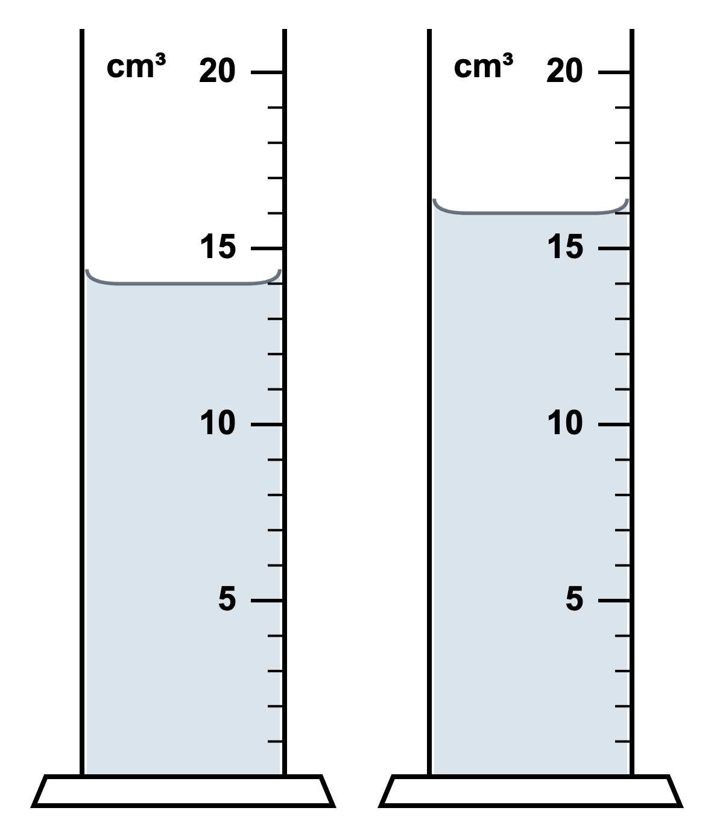
.....................................................................................................
.....................................................................................................
.....................................................................................................
.....................................................................................................
(2 marks)
22. Record the volume of oil shown. State how its volume changes as its temperature rises.
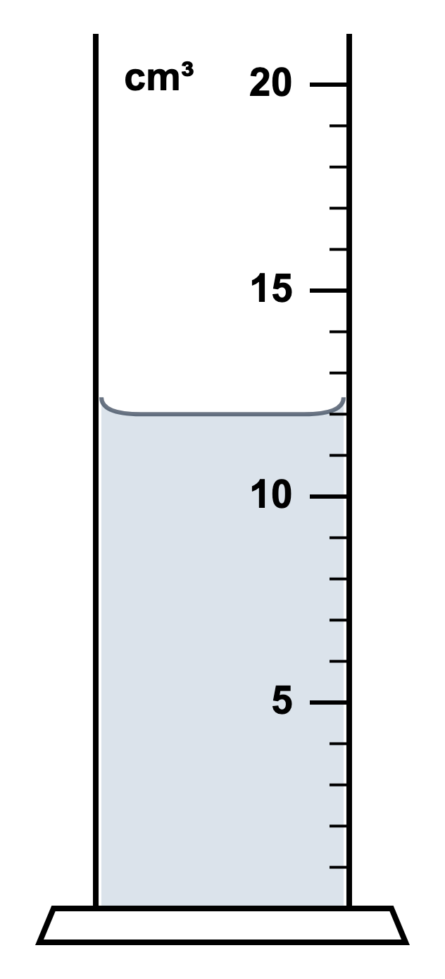
.....................................................................................................
.....................................................................................................
.....................................................................................................
.....................................................................................................
(2 marks)
23. A student wraps a small piece of wet cotton wool around the bulb of a thermometer. Some of the liquid evaporates. The thermometer readings before and after evaporation are shown.
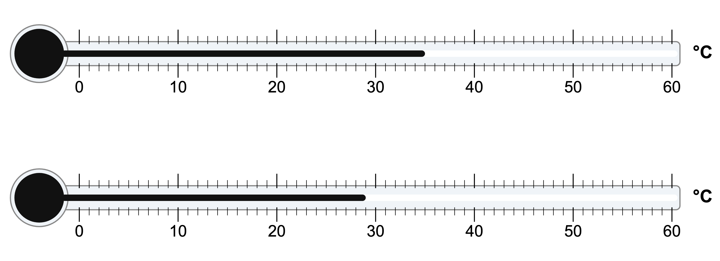
(a) Determine the decrease in temperature shown by the thermometers.
.....................................................................................................
.....................................................................................................
.....................................................................................................
.....................................................................................................
(2 marks)
(b) Explain, in terms of particles, why evaporation cools the thermometer bulb.
.....................................................................................................
.....................................................................................................
.....................................................................................................
.....................................................................................................
.....................................................................................................
(3 marks)
(c) Suggest one change to the experiment that would make the temperature of the thermometer bulb fall faster. Explain your answer.
.....................................................................................................
.....................................................................................................
.....................................................................................................
.....................................................................................................
(2 marks)
24. A student wraps the bulb of a thermometer in a small piece of wet cloth and stands the thermometer in a room. After a few minutes the reading has fallen below the temperature of the room.
(a) State what causes the reading to fall below the temperature of the room.
.....................................................................................................
.....................................................................................................
(1 mark)
(b) Explain, in terms of the particles in the water, why evaporation cools the liquid that is left behind.
.....................................................................................................
.....................................................................................................
.....................................................................................................
.....................................................................................................
.....................................................................................................
(3 marks)
(c) State three changes the student could make to increase the rate at which water evaporates from the cloth. Explain how each change increases the rate.
.....................................................................................................
.....................................................................................................
.....................................................................................................
.....................................................................................................
.....................................................................................................
.....................................................................................................
.....................................................................................................
.....................................................................................................
(6 marks)
(d) Explain why the thermometer bulb itself becomes cooler, and not only the water in the cloth.
.....................................................................................................
.....................................................................................................
.....................................................................................................
.....................................................................................................
(2 marks)
(e) State two differences between evaporation and boiling.
.....................................................................................................
.....................................................................................................
.....................................................................................................
.....................................................................................................
(2 marks)

