3.1 General properties of waves: Cambridge IGCSE Physics worksheet
1. A water wave crosses from deep water into shallow water. Its speed and wavelength both decrease.
What happens to its frequency?
A It decreases to zero.
B It decreases in the same ratio as the speed.
C It increases as the wavelength decreases.
D It remains unchanged.
(1 mark)
2. Sound travels through air at 340 m/s. A sound wave has frequency 170 Hz. What is its wavelength?
A 0.50 m
B 2.0 m
C 170 m
D 57 800 m
(1 mark)
3. The diagram shows plane wavefronts passing through a gap in a barrier.
Which change would produce more spreading of the wavefronts beyond the gap?

A Make the gap narrower while keeping the wavelength unchanged.
B Make the gap wider while keeping the wavelength unchanged.
C Increase the amplitude while keeping the gap unchanged.
D Decrease the amplitude while keeping the gap unchanged.
(1 mark)
4. Why can a wave change direction when it crosses a boundary at an angle?
A Its amplitude always becomes zero at the boundary.
B Its frequency changes when it enters the new medium.
C Its speed changes when it enters the new medium.
D Its energy changes into matter at the boundary.
(1 mark)
5. A sound wave has frequency 680 Hz and wavelength 0.50 m. What is its speed?
A 0.00074 m/s
B 1360 m/s
C 340 m/s
D 680 m/s
(1 mark)
6. Waves pass through a gap of fixed width. The wavelength is increased.
What happens to the diffraction of the waves?
A It decreases because the waves travel faster.
B It increases because the wavelength is closer to the gap width.
C It remains unchanged because the gap width is fixed.
D It stops because long waves cannot pass through a gap.
(1 mark)
7. The diagram shows wavefronts crossing from air into glass.
Which row compares the wave in glass with the wave in air?
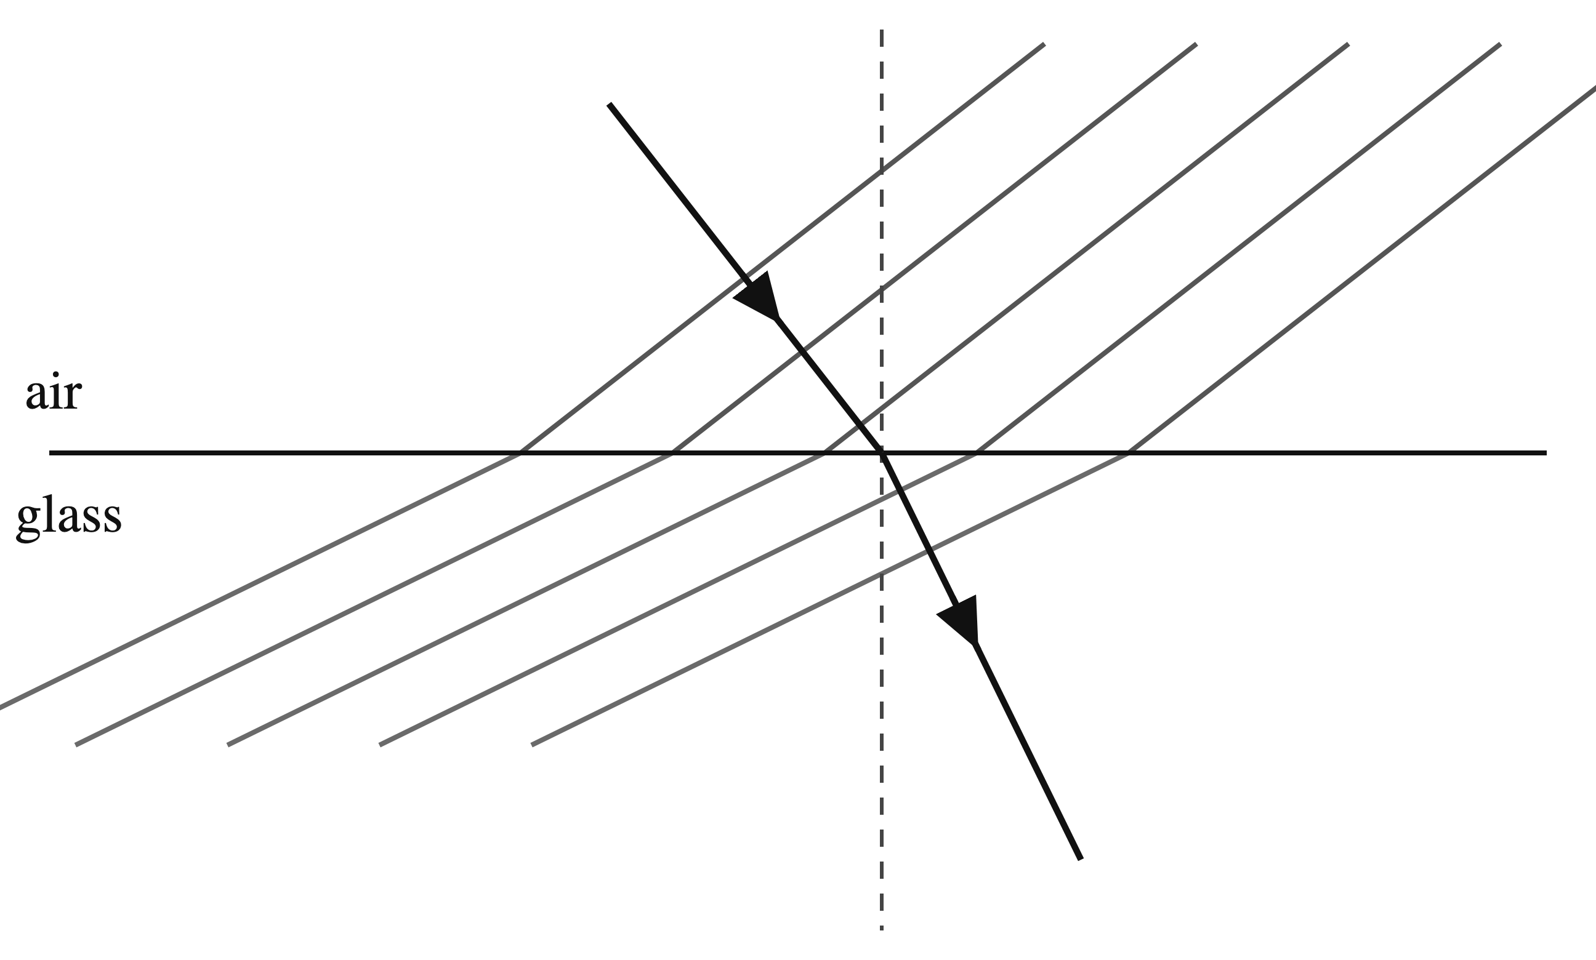
 | Wavelength in glass | Frequency in glass
A | greater | greater
B | greater | unchanged
C | smaller | unchanged
D | smaller | smaller

(1 mark)
8. A radio wave has a frequency of 1.0 × 10⁸ Hz. Its speed is 3.0 × 10⁸ m/s.
What is its wavelength?
A 0.33 m
B 3.0 m
C 3.0 × 10¹⁶ m
D 3.0 × 10⁸ m
(1 mark)
9. A radio receiver can detect a signal even when a hill blocks the direct path from the transmitter.
Which statement best explains this observation?
A The waves are refracted because they enter the hill.
B The waves are reflected only along the original straight path.
C The waves increase their frequency when they reach the hill.
D The waves diffract around the hill into the region beyond it.
(1 mark)
10. Infrared radiation has a wavelength of 2.0 × 10⁻⁶ m. Its speed is 3.0 × 10⁸ m/s.
What is its frequency?
A 6.0 × 10² Hz
B 1.5 × 10² Hz
C 6.0 × 10⁻¹⁴ Hz
D 1.5 × 10¹⁴ Hz
(1 mark)
11. A light wave enters glass from air. State what happens to its frequency and wavelength.
.....................................................................................................
.....................................................................................................
.....................................................................................................
.....................................................................................................
(2 marks)
12. Name the highest point and the lowest point on the wave profile shown.
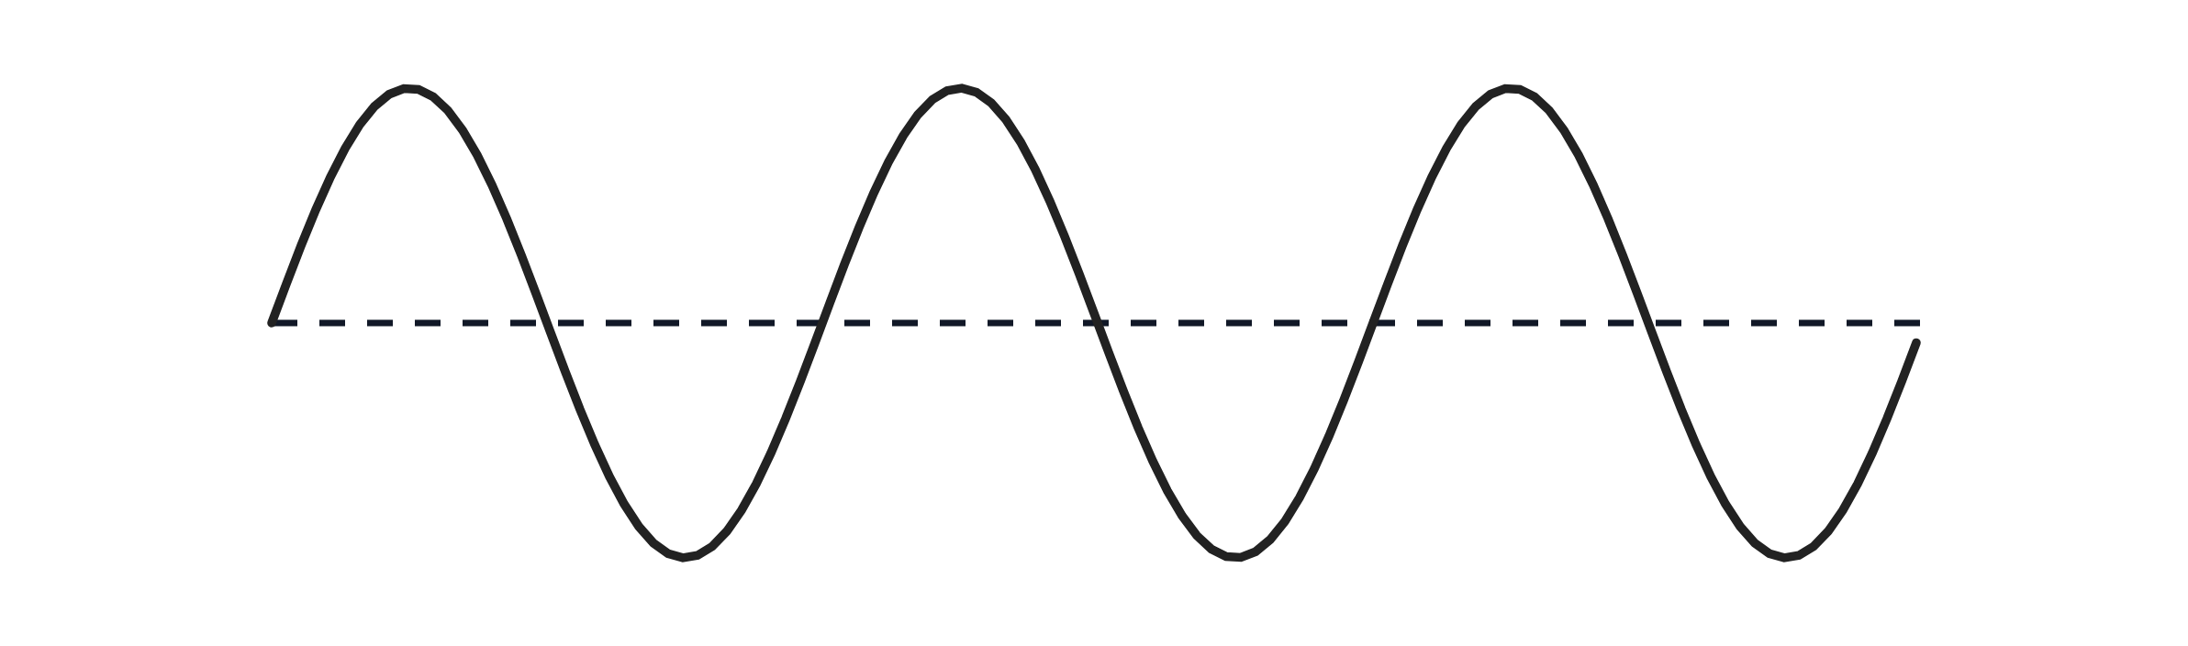
.....................................................................................................
.....................................................................................................
.....................................................................................................
.....................................................................................................
(2 marks)
13. A floating cork moves up and down as water waves pass. State what the waves transfer and what they do not transfer.
.....................................................................................................
.....................................................................................................
.....................................................................................................
.....................................................................................................
(2 marks)
14. Draw one arrow before the barrier and one arrow after the gap to show the direction in which the waves travel.

.....................................................................................................
.....................................................................................................
.....................................................................................................
.....................................................................................................
(2 marks)
15. Use the spacing of the incoming wavefronts. State how the gap width compares with the wavelength.
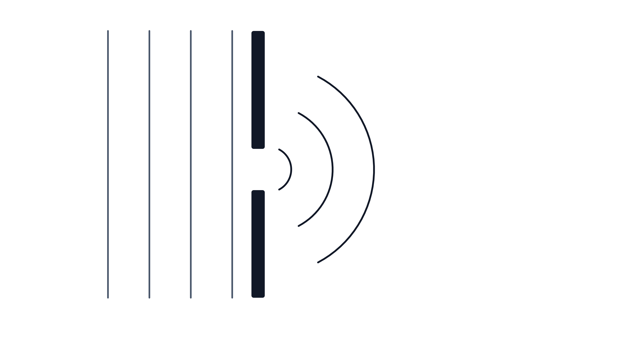
.....................................................................................................
.....................................................................................................
(1 mark)
16. State how the wavelength changes and whether the ray bends towards or away from the normal.
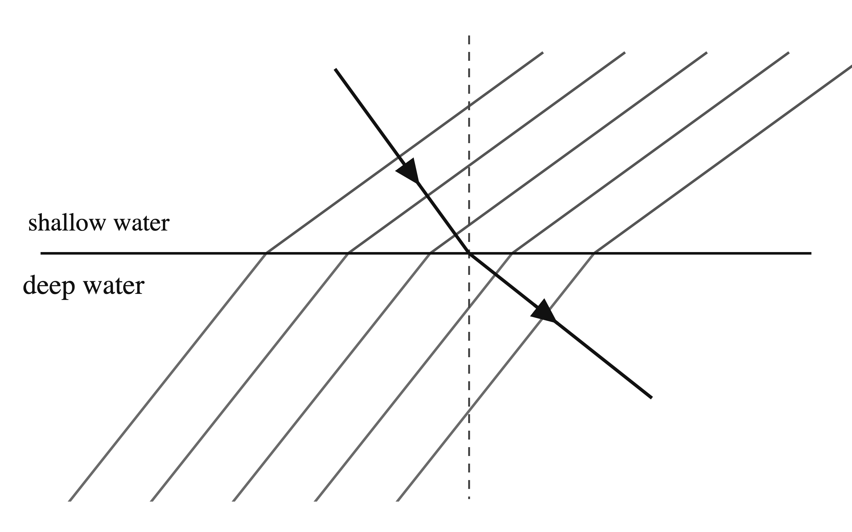
.....................................................................................................
.....................................................................................................
.....................................................................................................
.....................................................................................................
(2 marks)
17. State whether the waves in every region of the electromagnetic spectrum are transverse or longitudinal.
.....................................................................................................
.....................................................................................................
(1 mark)
18. The gap is much wider than the wavelength. Complete the diagram by drawing three diffracted wavefronts after the gap.

(2 marks)
19. One cycle of the oscilloscope trace spans 5.0 divisions. Use the displayed timebase to calculate the frequency of the sound.
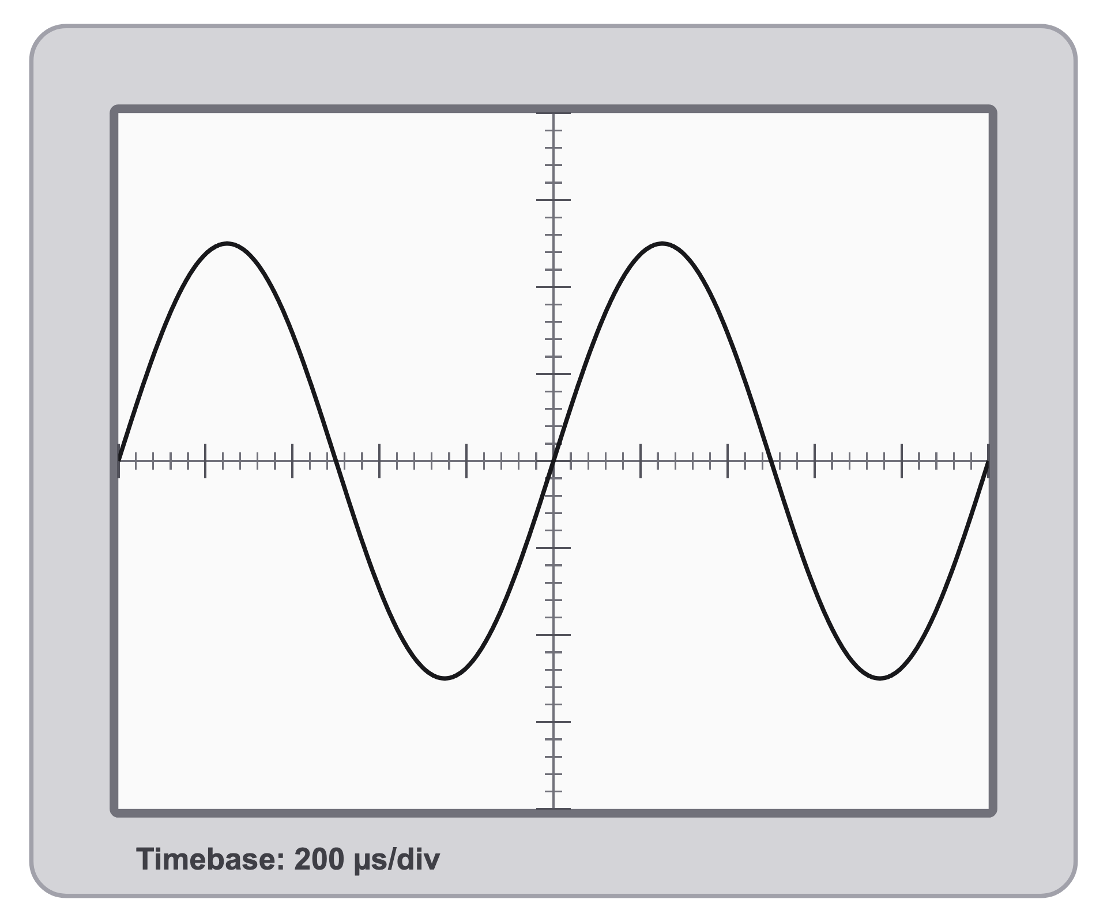
.....................................................................................................
.....................................................................................................
.....................................................................................................
.....................................................................................................
(2 marks)
20. A student ties one end of a long rope to a fixed post and holds the other end. The student moves their hand up and down at a steady rate, and a wave travels along the rope towards the post.​
(a) The diagram shows the shape of the rope at one moment. Name the features marked A and B.
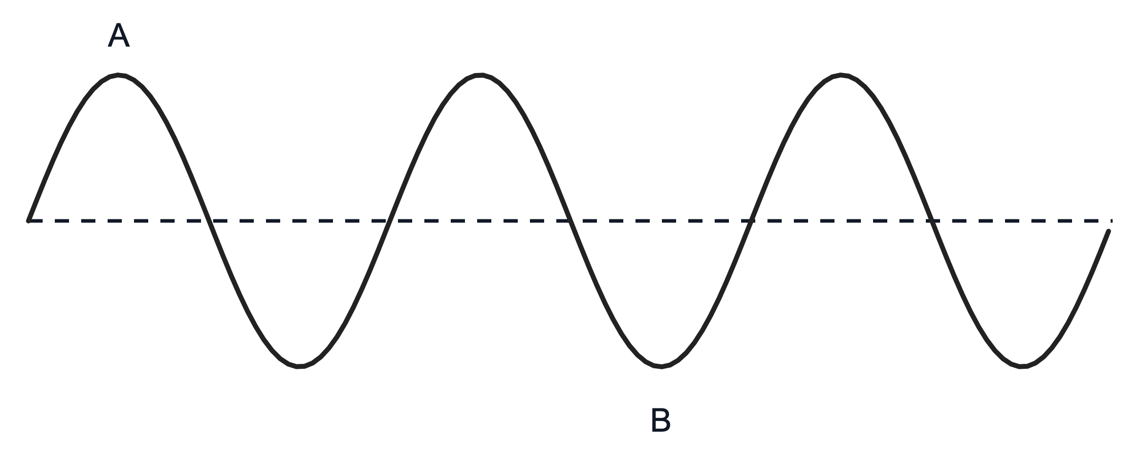
.....................................................................................................
.....................................................................................................
.....................................................................................................
.....................................................................................................
(2 marks)
(b) State the name given to a wave of the kind travelling along the rope. Give the reason for your answer.
.....................................................................................................
.....................................................................................................
.....................................................................................................
.....................................................................................................
(2 marks)
(c) The student now stretches a long spring along the floor and moves one end backwards and forwards along the length of the spring. The diagram shows the spring while the wave travels along it. Describe how the coils of the spring move, and state how their movement compares with the direction in which the wave travels.
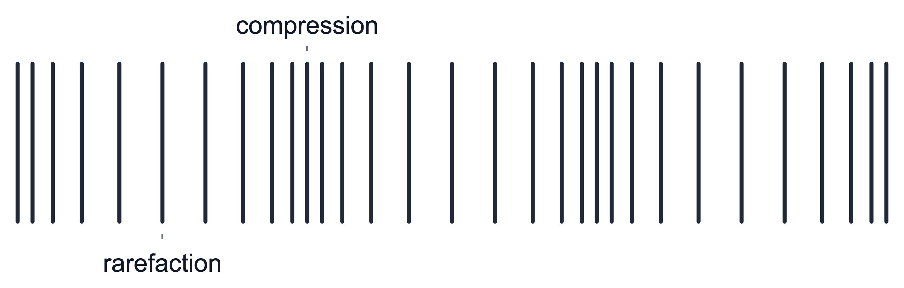
.....................................................................................................
.....................................................................................................
.....................................................................................................
.....................................................................................................
.....................................................................................................
(3 marks)
21. A student sends a longitudinal wave along a stretched spring.

(a) Name the regions in the pattern below where the coils are closest together.
.....................................................................................................
.....................................................................................................
(1 mark)
(b) On the pattern below, mark the distance of one wavelength between two successive compressions.
.....................................................................................................
.....................................................................................................
.....................................................................................................
.....................................................................................................
(2 marks)
(c) Explain why the wave in the spring is longitudinal.
.....................................................................................................
.....................................................................................................
.....................................................................................................
.....................................................................................................
(2 marks)
(d) The wave travels at 3.6 m/s and has a wavelength of 0.90 m. Calculate its frequency.
.....................................................................................................
.....................................................................................................
.....................................................................................................
.....................................................................................................
.....................................................................................................
(3 marks)
22. Water waves of wavelength 0.12 m travel towards a barrier with a wide gap. The frequency of the waves is 4.0 Hz.

(a) Describe how the wavefronts after the wide gap are different from wavefronts after a narrow gap.
.....................................................................................................
.....................................................................................................
.....................................................................................................
.....................................................................................................
.....................................................................................................
(3 marks)
(b) Explain the difference in the amount of diffraction that you described in part (a).
.....................................................................................................
.....................................................................................................
.....................................................................................................
.....................................................................................................
(2 marks)
(c) Calculate the speed of the water waves. ​
.....................................................................................................
.....................................................................................................
.....................................................................................................
.....................................................................................................
.....................................................................................................
(3 marks)

