3.2 Light: Cambridge IGCSE Physics worksheet
1. A ray of light strikes a plane mirror at an angle of incidence of 32°.
What is the angle of reflection?
A 16°
B 32°
C 58°
D 64°
(1 mark)
2. The diagram shows a light ray at a plane mirror. The two marked angles are measured between the rays and the normal.
Which equation must the angles obey?
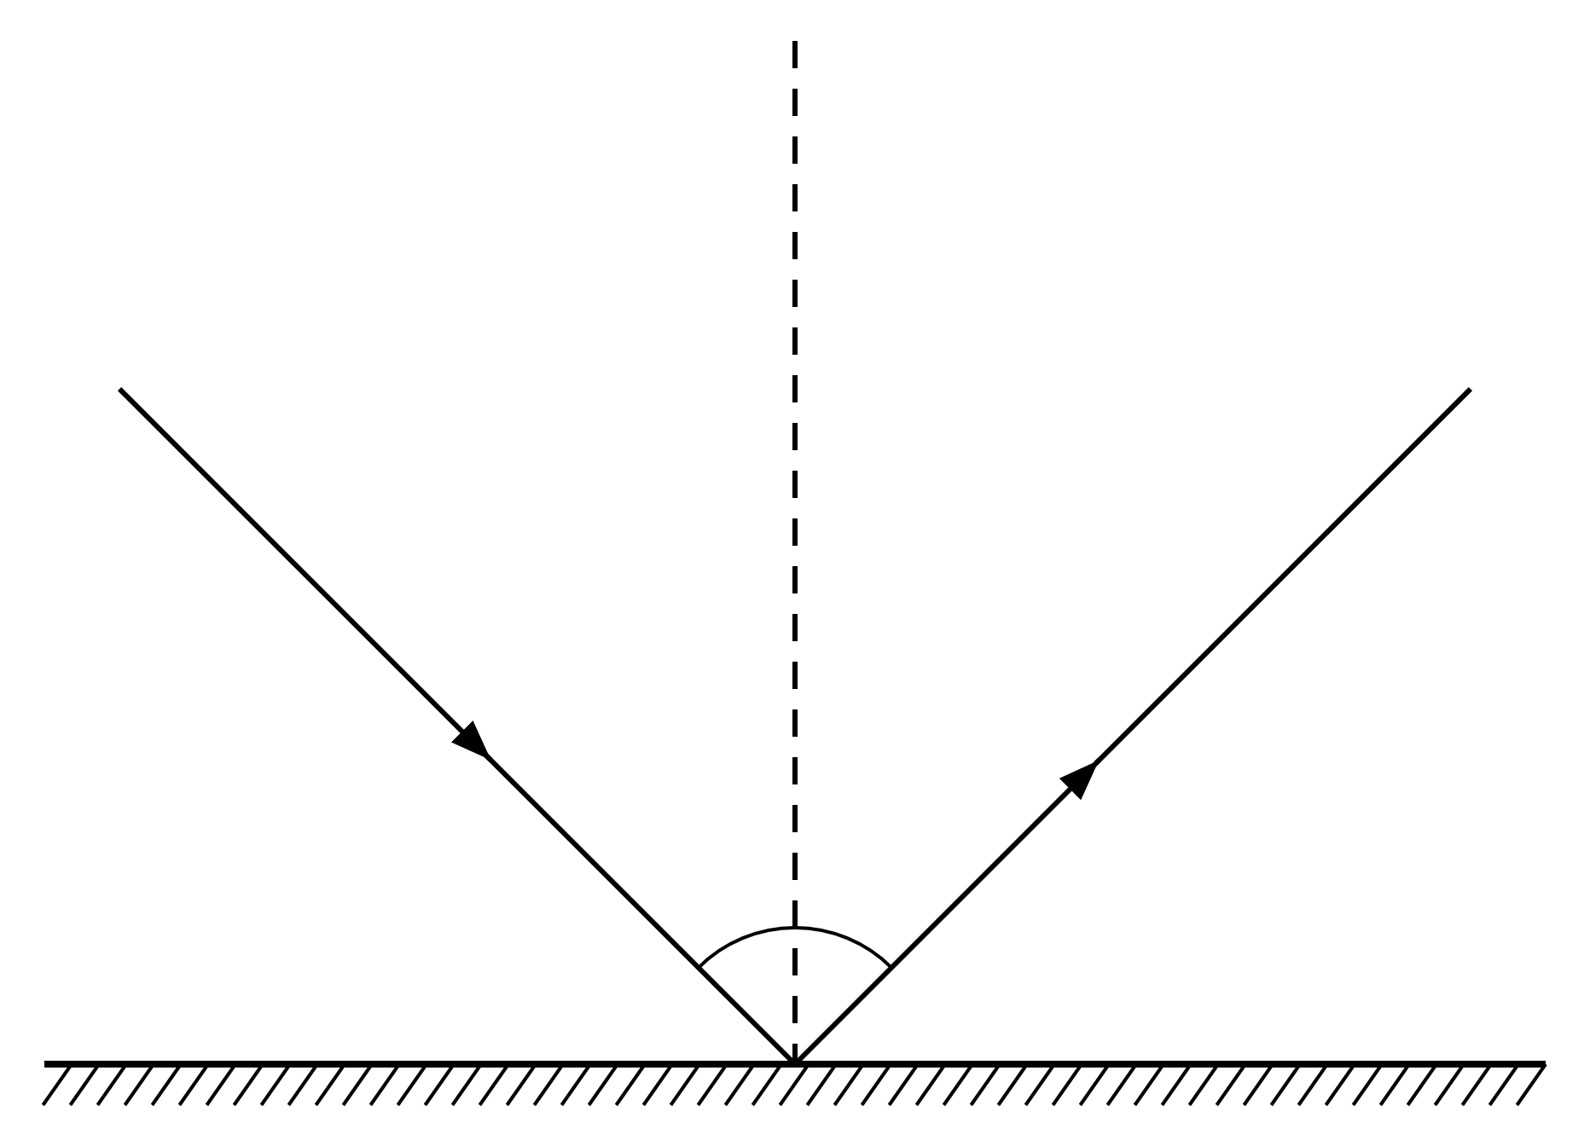
A $i=r$
B $i+r=90°$
C $i=2r$
D $r=180°−i$
(1 mark)
3. Why does a converging lens change the direction of light rays?
A The rays are reflected from both curved surfaces.
B The rays are refracted at the curved surfaces.
C The rays diffract around the edge of the lens.
D The lens absorbs the rays and emits them in new directions.
(1 mark)
4. The ray diagram shows an object in front of a diverging lens.
Which row gives the properties of the image?
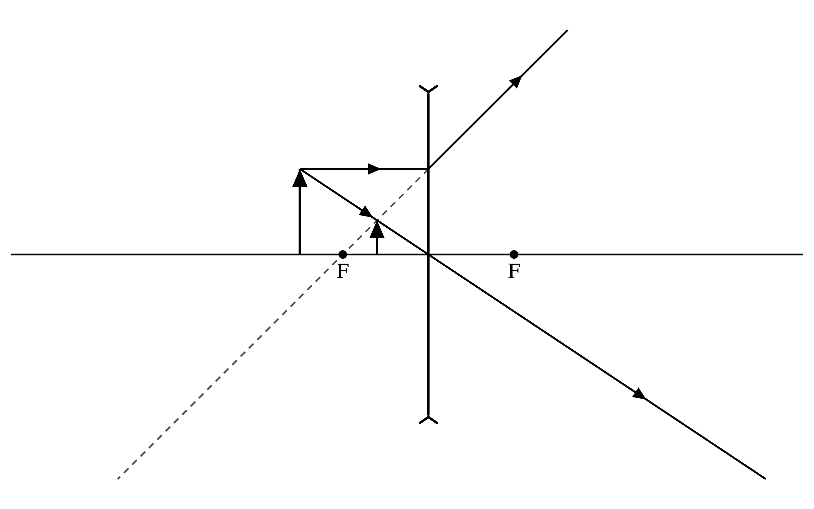
 | Orientation | Size | Type
A | inverted | diminished | real
B | upright | magnified | virtual
C | upright | diminished | virtual
D | inverted | magnified | real

(1 mark)
5. A student is short-sighted.
Where is the image of a distant object formed by the uncorrected eye, and which lens corrects the student's vision?
 | Image position | Correcting lens
A | behind the retina | diverging
B | in front of the retina | converging
C | in front of the retina | diverging
D | behind the retina | converging

(1 mark)
6. The diagram shows the complete path of a light ray through a rectangular glass block.
Which statement describes the emergent ray compared with the incident ray?
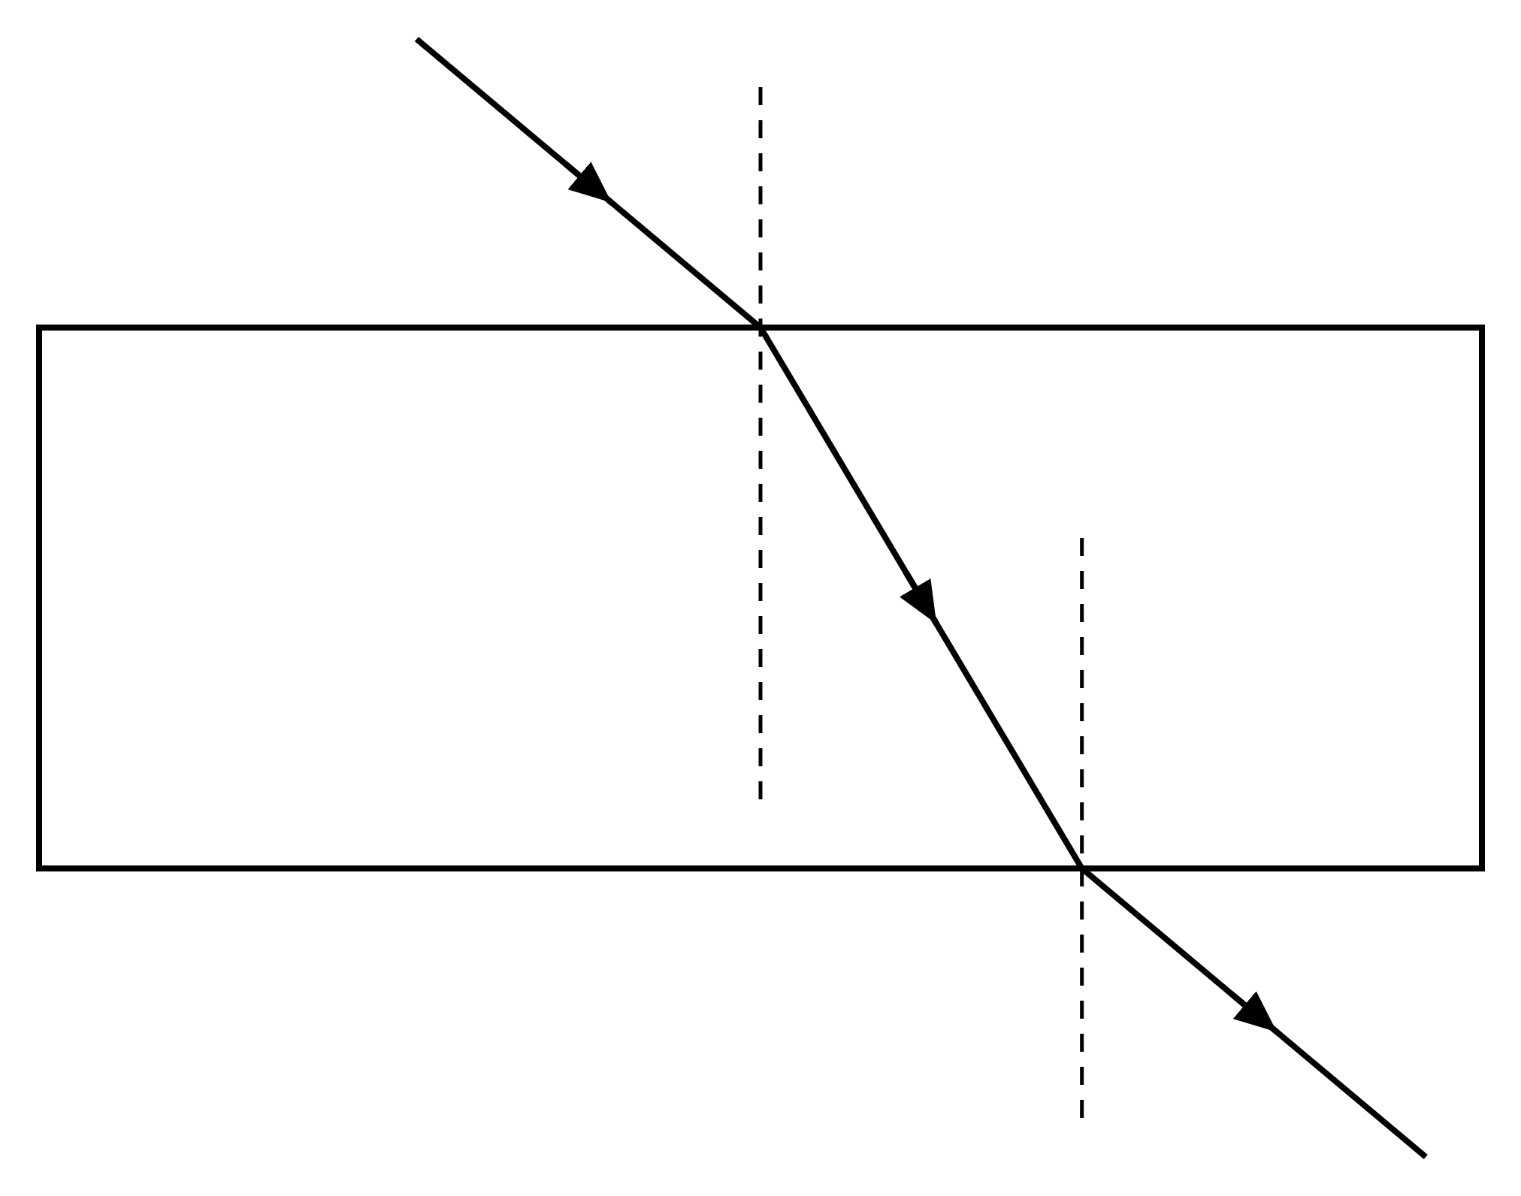
A It is perpendicular to the incident ray.
B It travels back along the incident path.
C It is parallel to the incident ray with no displacement.
D It is parallel to the incident ray and displaced sideways.
(1 mark)
7. A projector uses a converging lens to form a magnified real image of a slide on a screen.
Where is the slide placed?
A beyond 2F
B at 2F
C between the lens and F
D between F and 2F
(1 mark)
8. A ray of light is directed through the near principal focus before entering a converging lens.
Which path does the ray take after leaving the lens?
A It passes through the far principal focus.
B It continues through the optical centre.
C It bends back towards the object.
D It emerges parallel to the principal axis.
(1 mark)
9. The diagram shows light entering a glass block from air.
Which row describes the change at the first boundary?
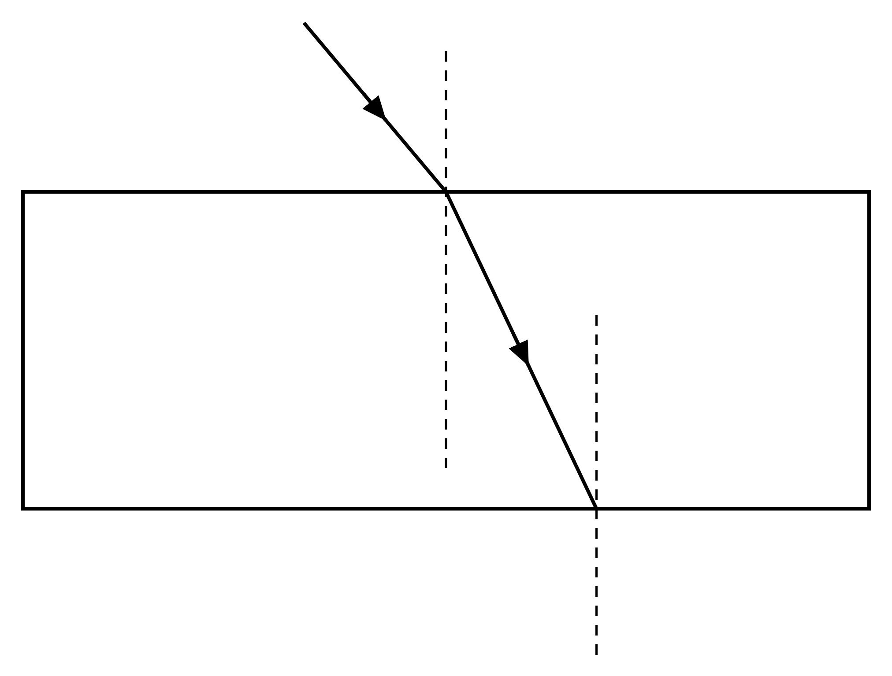
 | Speed in glass | Direction in glass
A | increases | bends away from normal
B | decreases | bends toward normal
C | unchanged | bends toward normal
D | decreases | bends away from normal

(1 mark)
10. Which row gives the two conditions required for total internal reflection?
 | Direction of light | Angle of incidence
A | more optically dense to less optically dense | greater than critical angle
B | more optically dense to less optically dense | less than critical angle
C | less optically dense to more optically dense | greater than critical angle
D | less optically dense to more optically dense | less than critical angle

(1 mark)
11. Which row explains how light is kept inside the core of an optical fibre?
 | Core refractive index | Incidence angle at boundary
A | less than cladding | greater than critical angle
B | greater than cladding | less than critical angle
C | equal to cladding | equal to critical angle
D | greater than cladding | greater than critical angle

(1 mark)
12. A ray inside glass of refractive index 1.50 reaches a glass-air boundary at an angle of incidence of 50°. The critical angle is 41.8°.
Which statement describes what happens at the boundary?
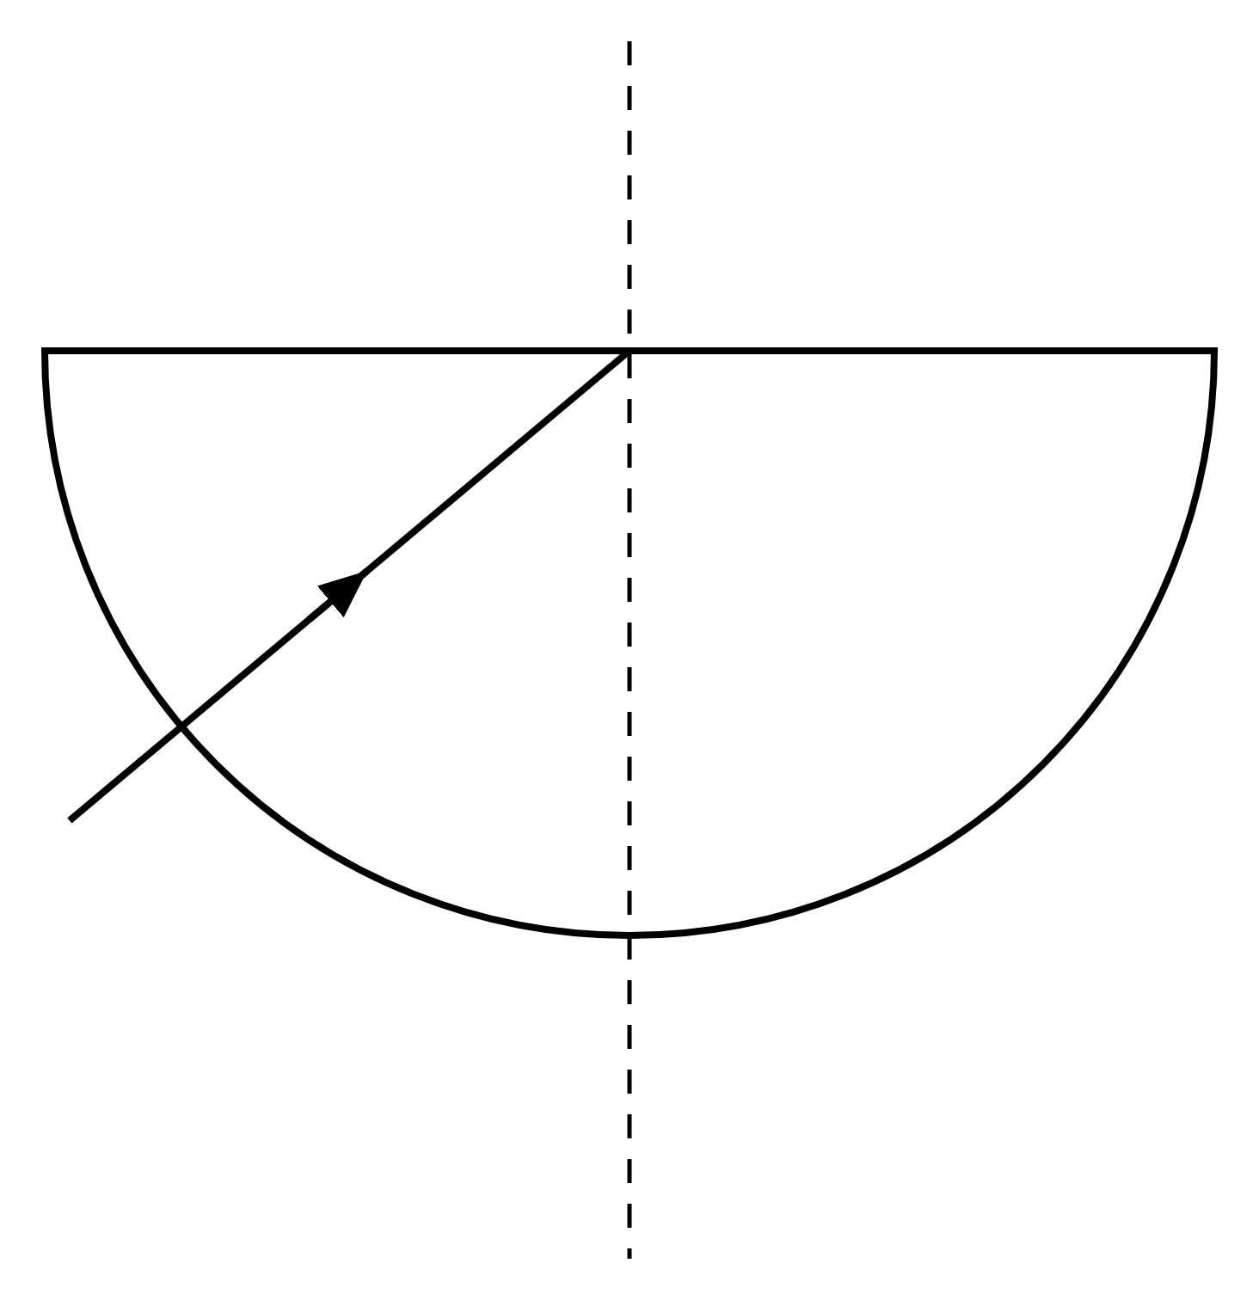
A The ray passes into the air without changing direction.
B The ray refracts into the air and bends toward the normal.
C The ray undergoes total internal reflection.
D The ray is absorbed completely at the boundary.
(1 mark)
13. State the seven colours of the visible spectrum in order of increasing wavelength.
.....................................................................................................
.....................................................................................................
.....................................................................................................
.....................................................................................................
(2 marks)
14. The refractive index of a transparent material is 1.60. Calculate its critical angle.
.....................................................................................................
.....................................................................................................
.....................................................................................................
.....................................................................................................
(2 marks)
15. Compare the direction and position of the emergent ray with the incident ray.
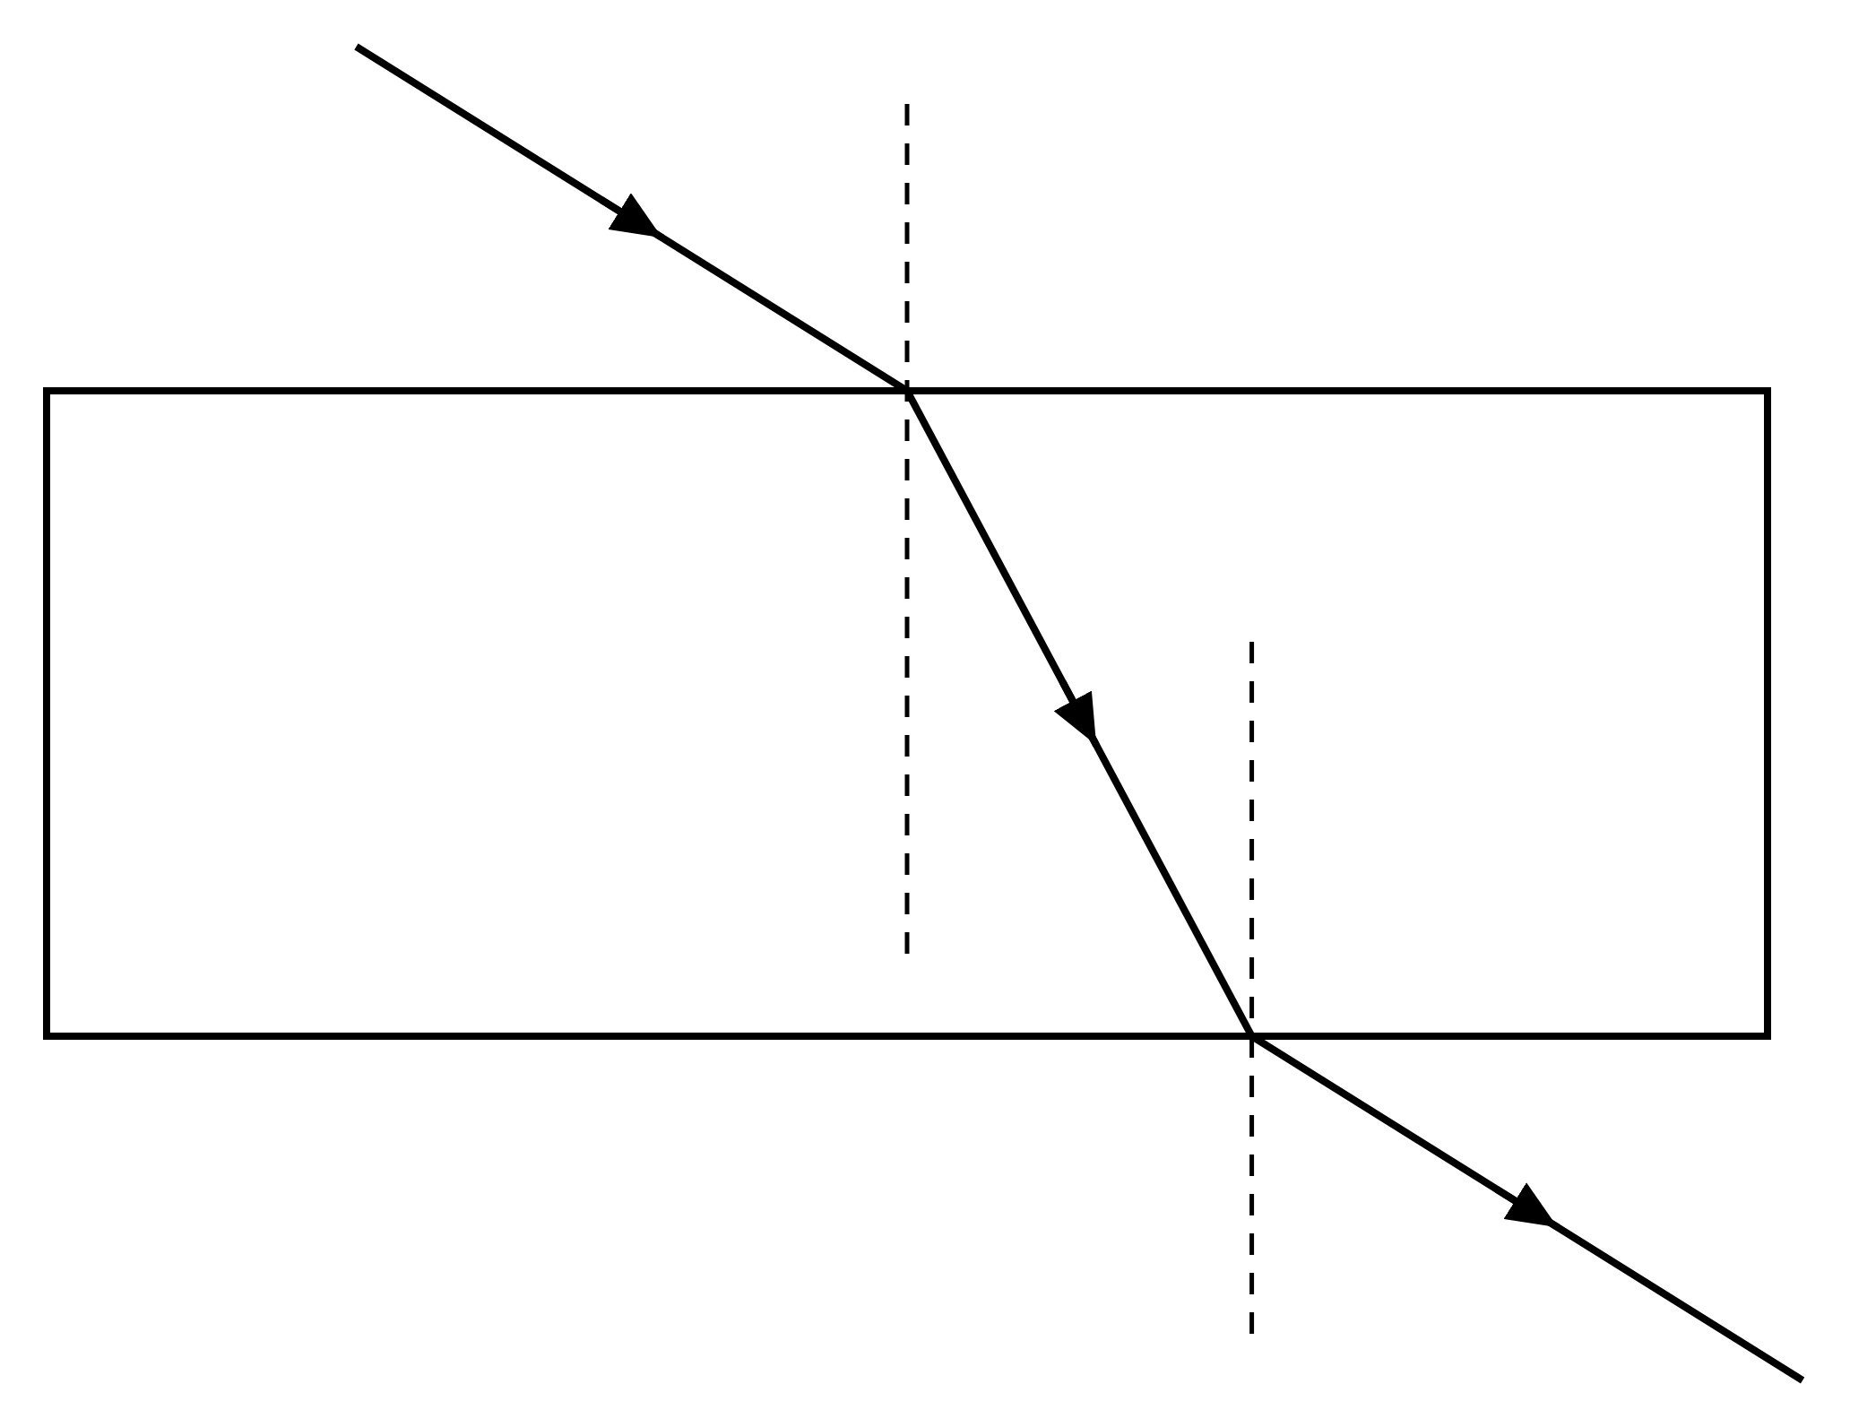
.....................................................................................................
.....................................................................................................
.....................................................................................................
.....................................................................................................
(2 marks)
16. A converging lens is used as a magnifying glass with the object between the focal point and the lens. Complete the diagram to show the image formed.
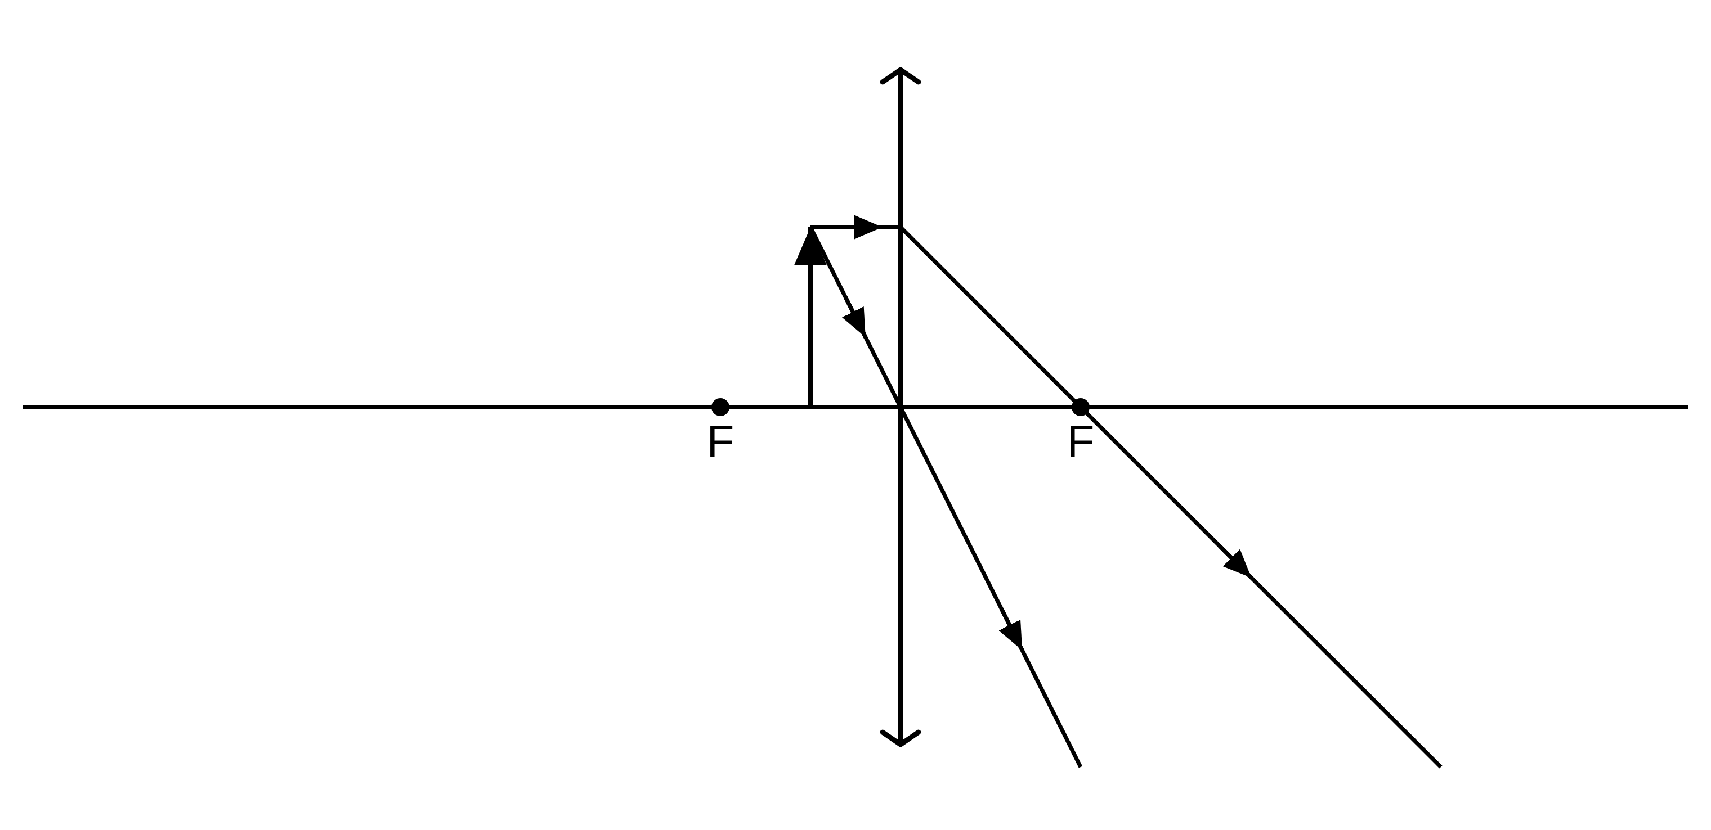
(2 marks)
17. State how the wavelength changes and whether the ray bends towards or away from the normal.
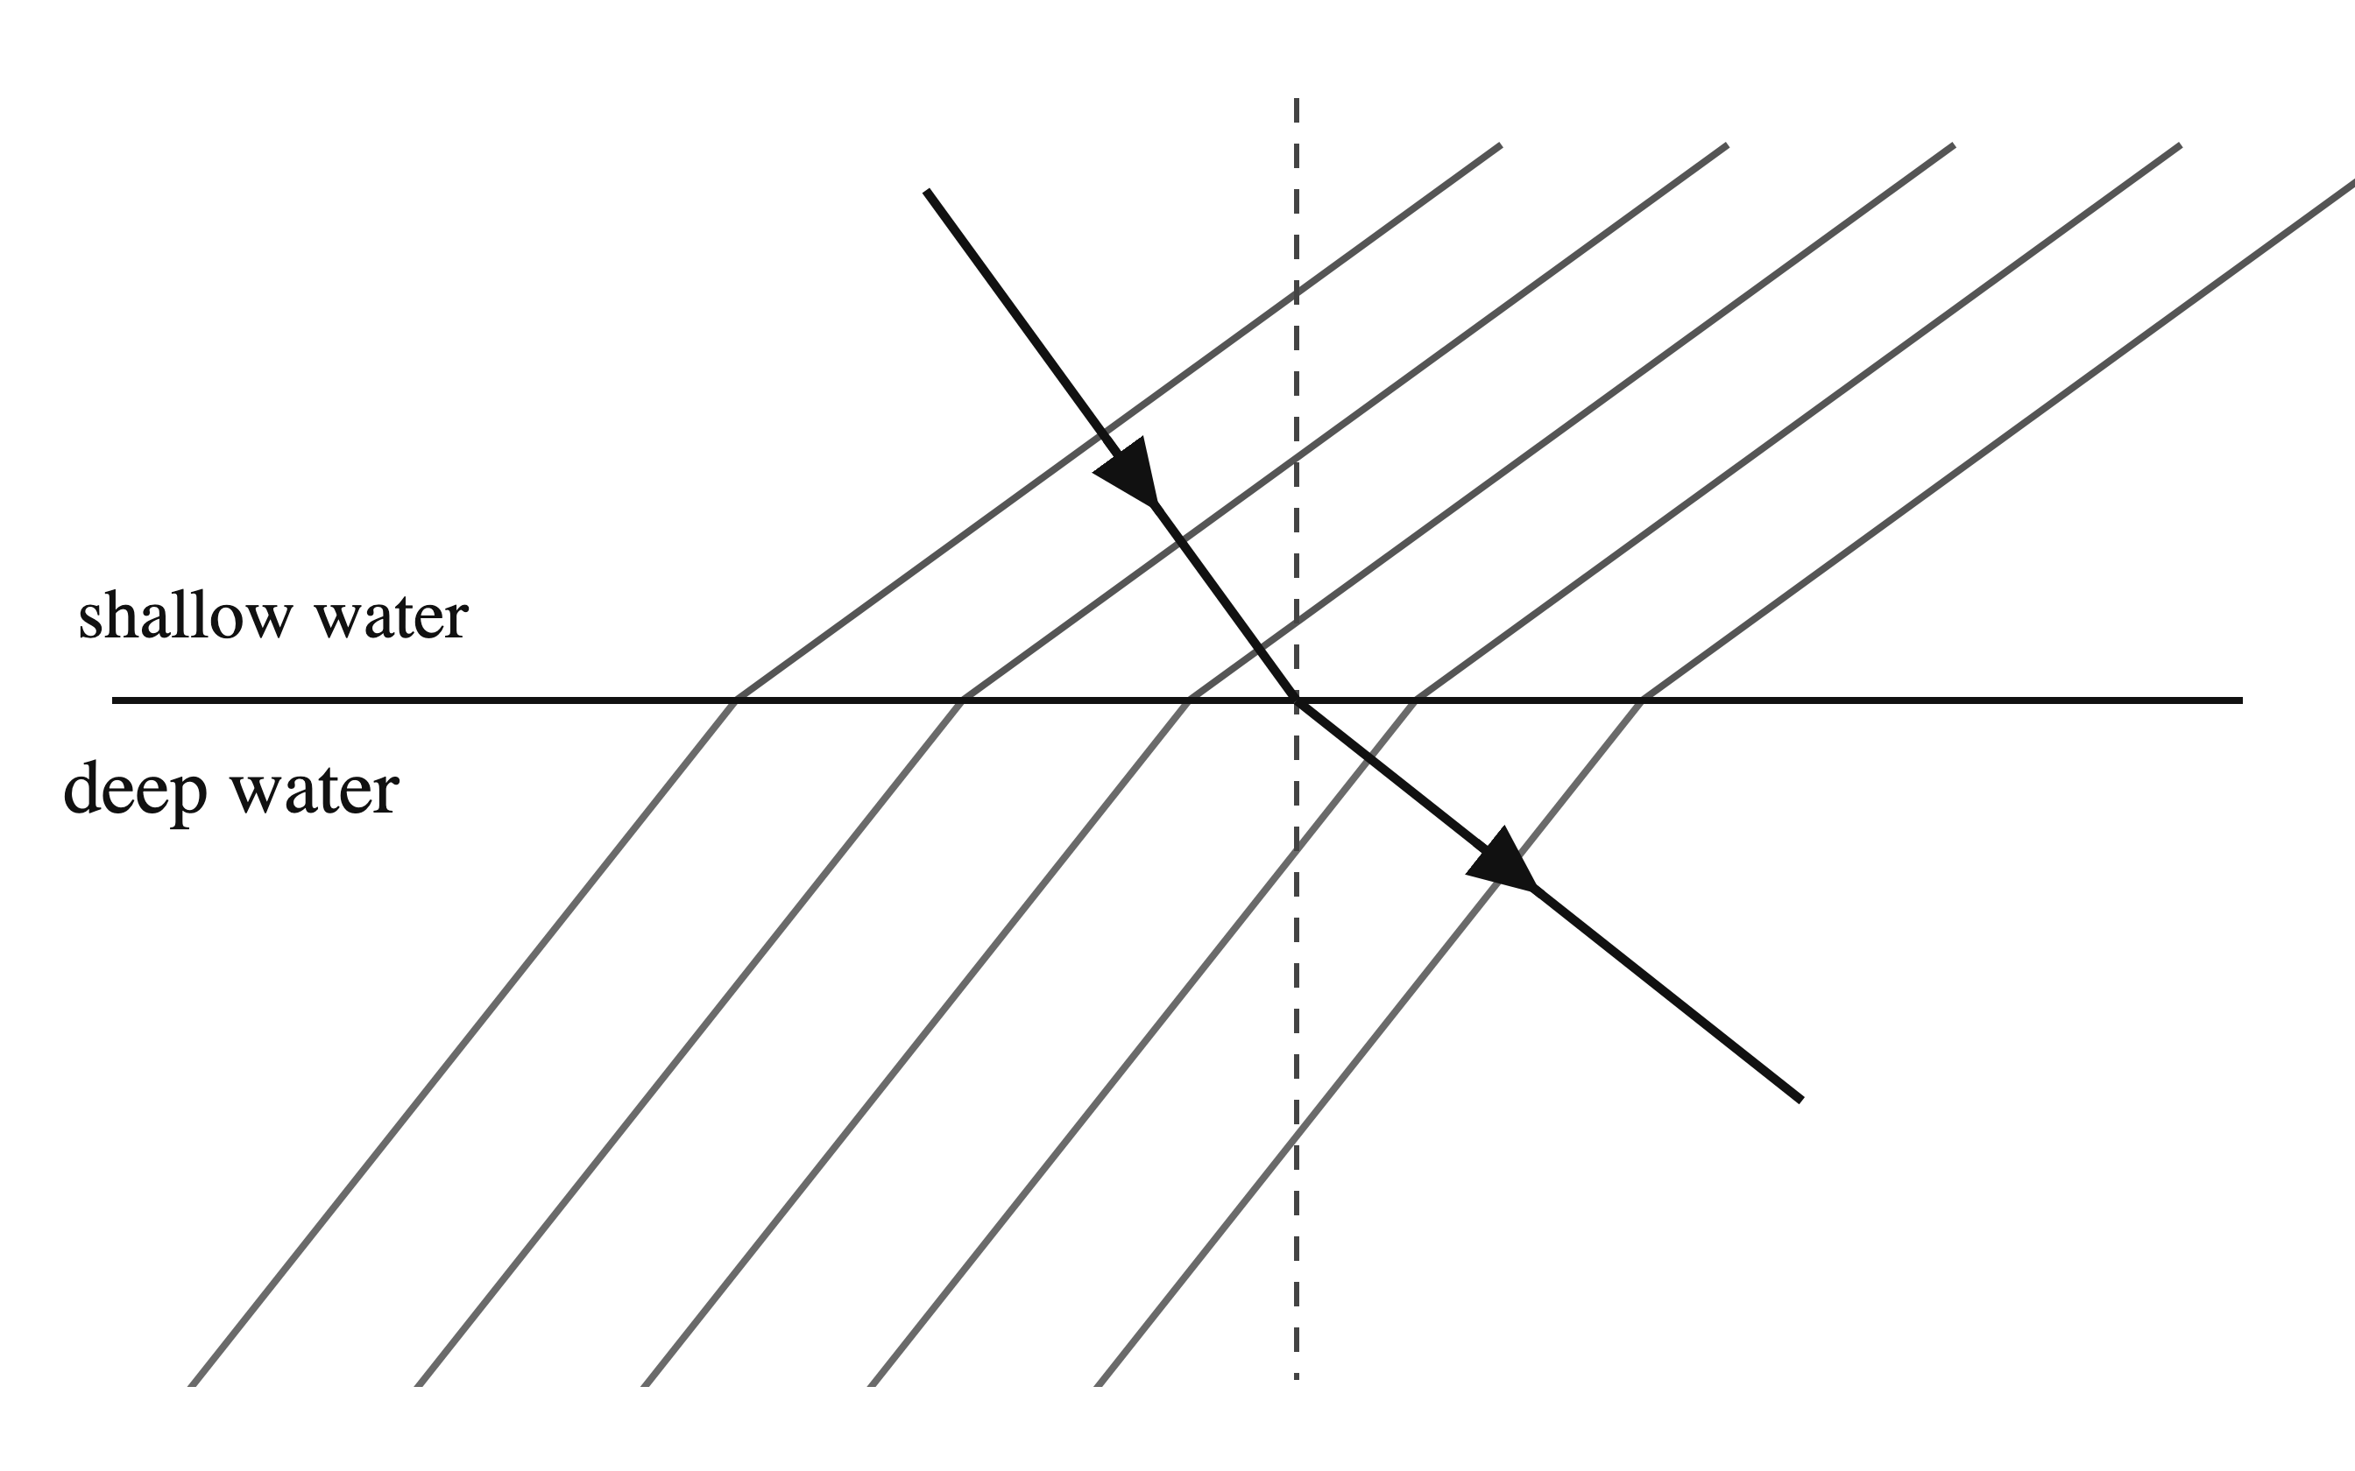
.....................................................................................................
.....................................................................................................
.....................................................................................................
.....................................................................................................
(2 marks)
18. The object is at the principal focus of the converging lens. Use the outgoing rays to state why no image can be formed on a screen.
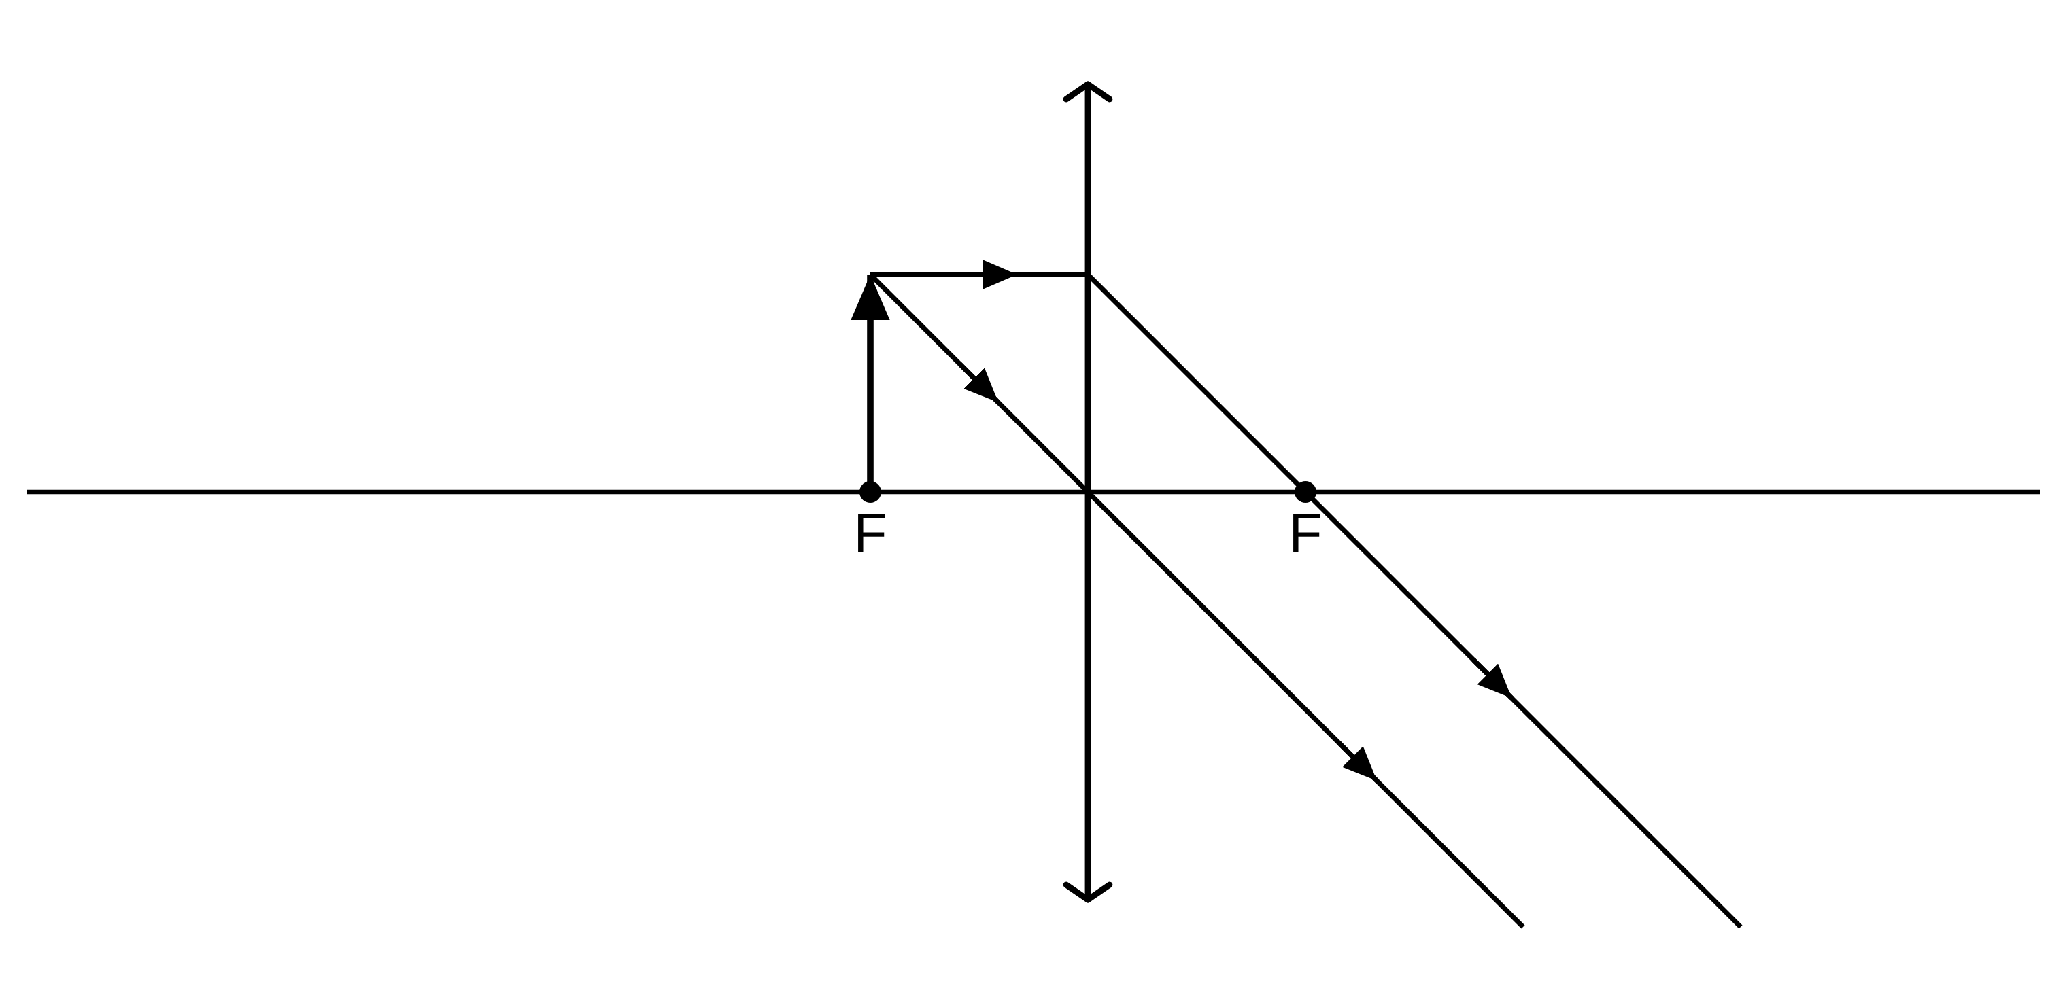
.....................................................................................................
.....................................................................................................
.....................................................................................................
.....................................................................................................
(2 marks)
19. A patient is long-sighted. Give the corrective lens and the change it produces in an incoming beam of light.
.....................................................................................................
.....................................................................................................
.....................................................................................................
.....................................................................................................
(2 marks)
20. A narrow beam of white light from a lamp is directed at one face of a triangular glass prism. A band of colours appears on a white screen placed beyond the prism.
(a) Name the effect that produces the band of colours on the screen.
.....................................................................................................
.....................................................................................................
(1 mark)
(b) Describe how the direction of the beam changes, relative to the normal, as it enters the glass prism and as it leaves the prism.
.....................................................................................................
.....................................................................................................
.....................................................................................................
.....................................................................................................
(2 marks)
(c) Name the colour in the band that has been deviated least by the prism. Name the colour that has been deviated most.
.....................................................................................................
.....................................................................................................
.....................................................................................................
.....................................................................................................
(2 marks)
(d) Explain why the white light produces a band of separate colours on the screen.
.....................................................................................................
.....................................................................................................
.....................................................................................................
.....................................................................................................
.....................................................................................................
(3 marks)
21. A ray of light travels inside a semicircular glass block towards the centre of the flat face. The student slowly increases the angle at which the ray meets the flat face and watches the light leaving the block.
(a) State what is meant by the critical angle.
.....................................................................................................
.....................................................................................................
.....................................................................................................
.....................................................................................................
(2 marks)
(b) At the angle shown, some of the light leaves the block. Describe how the light leaving the block changes as the angle of incidence is increased towards the critical angle.
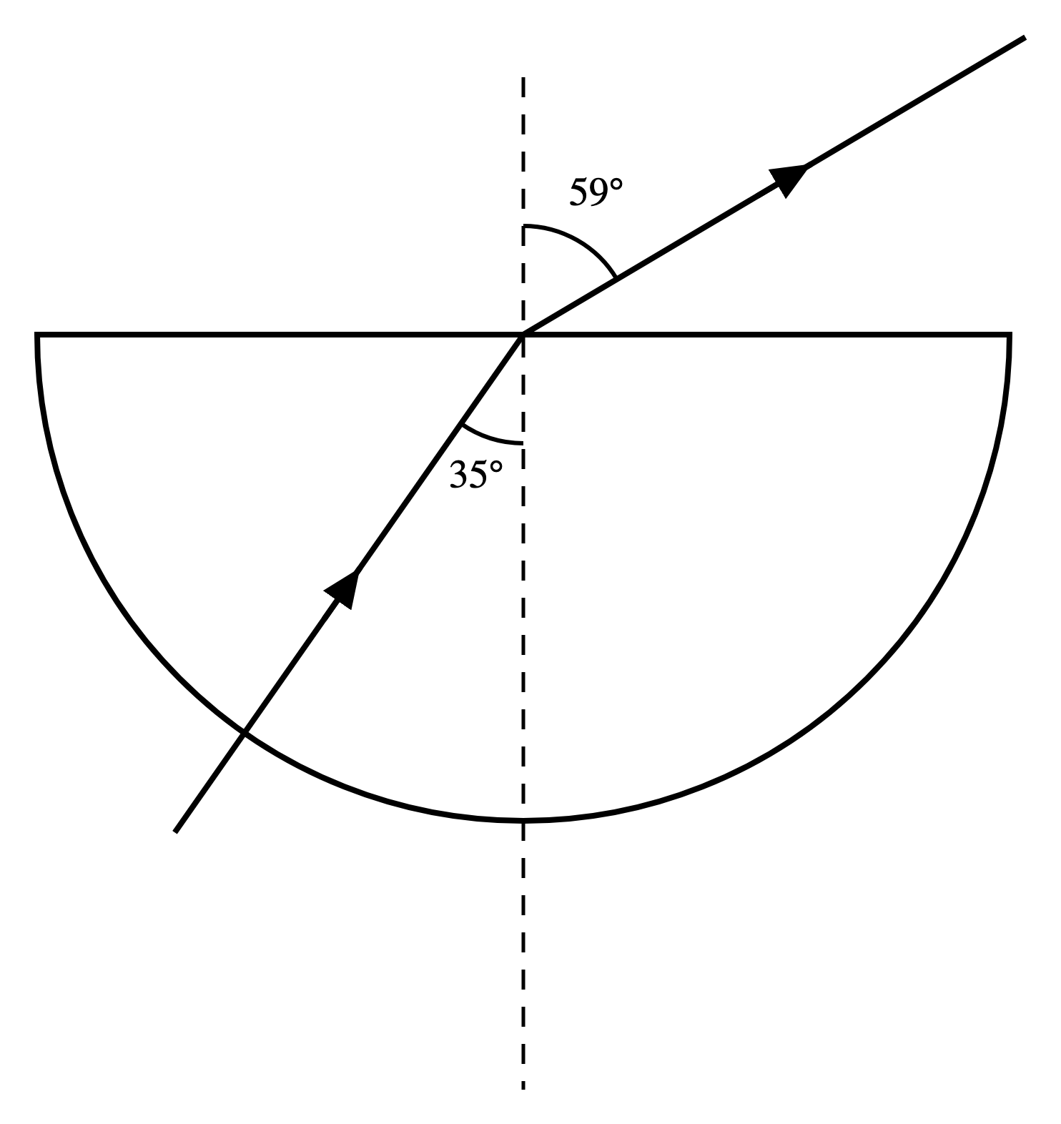
.....................................................................................................
.....................................................................................................
.....................................................................................................
.....................................................................................................
.....................................................................................................
(3 marks)
(c) The angle of incidence has been increased to 60°, which is greater than the critical angle for this glass. On the diagram, draw the path taken by the light after it reaches the flat surface.
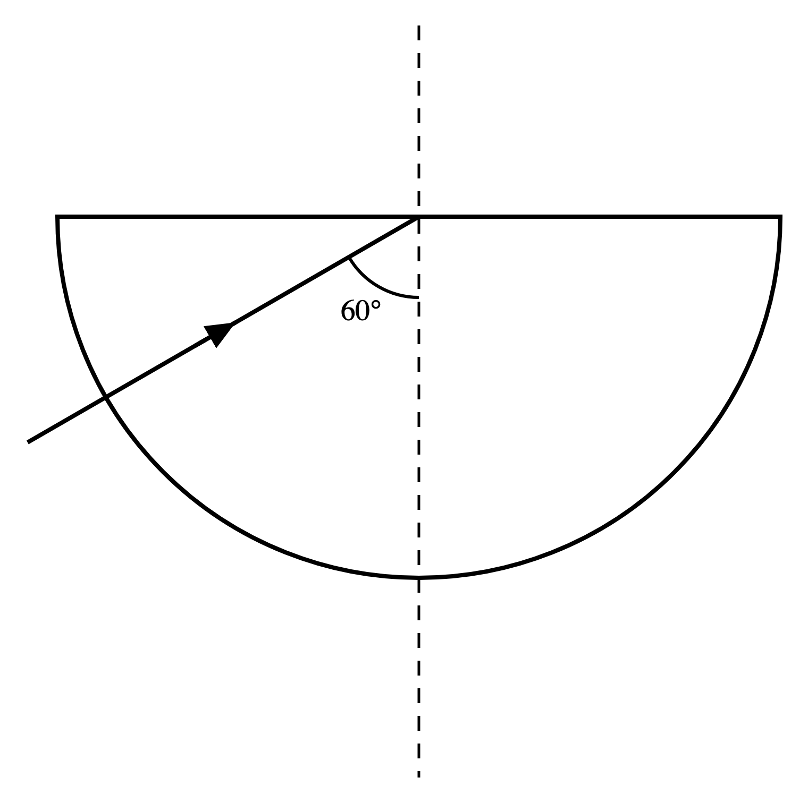
.....................................................................................................
.....................................................................................................
.....................................................................................................
.....................................................................................................
(2 marks)
22. The diagram below shows a ray of light passing through a rectangular glass block. The angles of incidence and refraction are labelled.
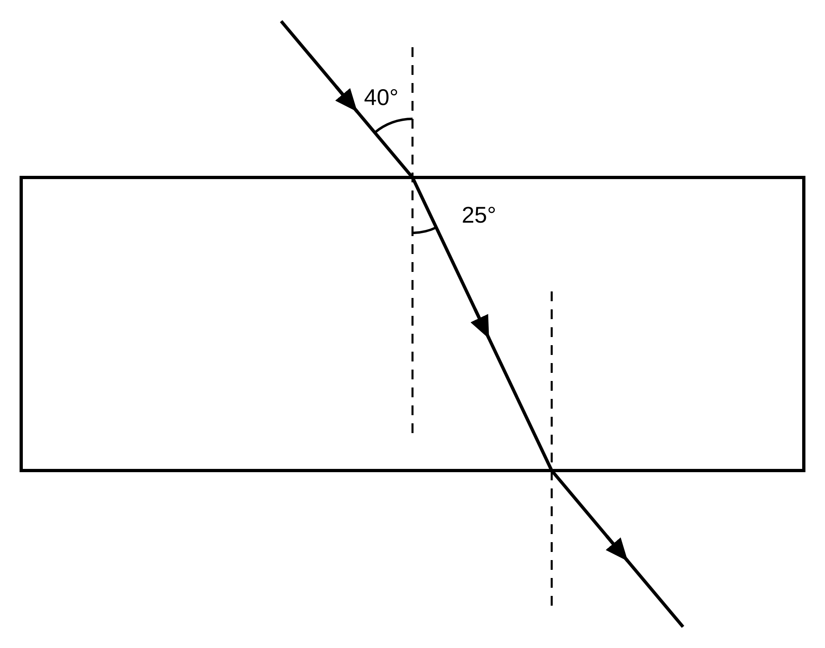
(a) Define the term 'normal'.
.....................................................................................................
.....................................................................................................
(1 mark)
(b) Define the term 'angle of refraction'.
.....................................................................................................
.....................................................................................................
(1 mark)
(c) Using the angle values shown in the diagram, calculate the refractive index of the glass. Give your answer to 2 significant figures.
.....................................................................................................
.....................................................................................................
.....................................................................................................
.....................................................................................................
.....................................................................................................
(3 marks)
(d) Explain why the ray bends towards the normal as it enters the glass block.
.....................................................................................................
.....................................................................................................
.....................................................................................................
.....................................................................................................
(2 marks)
(e) Some of the light is reflected at the top surface of the block rather than entering it. State the angle of reflection for this reflected ray.
.....................................................................................................
.....................................................................................................
(1 mark)

