3.3 Electromagnetic spectrum: Cambridge IGCSE Physics worksheet
1. Which row describes all electromagnetic waves?
 | Wave type | Travel through a vacuum | Speed in a vacuum
A | longitudinal | yes | different speeds
B | transverse | no | 3.0 × 10⁸ m/s
C | transverse | yes | 3.0 × 10⁸ m/s
D | longitudinal | no | different speeds

(1 mark)
2. A mark on a banknote is invisible in ordinary light but glows when illuminated by a detector lamp.
Which radiation does the lamp emit?
A microwaves
B infrared
C X-rays
D ultraviolet
(1 mark)
3. Which region of the electromagnetic spectrum is used for conventional radio broadcasting?
A radio waves
B gamma rays
C X-rays
D ultraviolet
(1 mark)
4. Which statement describes a digital signal?
A It has only two possible values, often called 0 and 1.
B It varies smoothly between its highest and lowest values.
C It has a higher frequency than any analogue signal.
D It can only be sent along a metal wire.
(1 mark)
5. Which is a benefit of transmitting data as a digital signal rather than as an analogue signal?
A More data can be transmitted each second.
B The signal does not become weaker as it travels.
C The signal needs no transmitter or receiver.
D The signal cannot pick up any noise.
(1 mark)
6. Why is prolonged exposure to ultraviolet radiation from the Sun harmful?
A It causes only surface heating and burns.
B It always causes immediate internal heating.
C It passes through the body without interacting.
D It can damage skin cells and eyes.
(1 mark)
7. A technician checks an operating circuit in darkness. The image must show which components have the highest surface temperatures.
Which radiation should the camera detect?
A radio waves
B ultraviolet
C infrared
D X-rays
(1 mark)
8. Which sequence is in order of increasing frequency?
A gamma rays, X-rays, ultraviolet
B infrared, microwaves, radio waves
C visible light, infrared, microwaves
D radio waves, microwaves, infrared
(1 mark)
9. A ground station sends a signal to a communications satellite. The signal must pass through the atmosphere and be directed in a narrow beam.
Which radiation is commonly used?
A ultraviolet
B infrared
C microwaves
D gamma rays
(1 mark)
10. Use the spectrum strip. Which pair gives the two missing region labels from left to right?
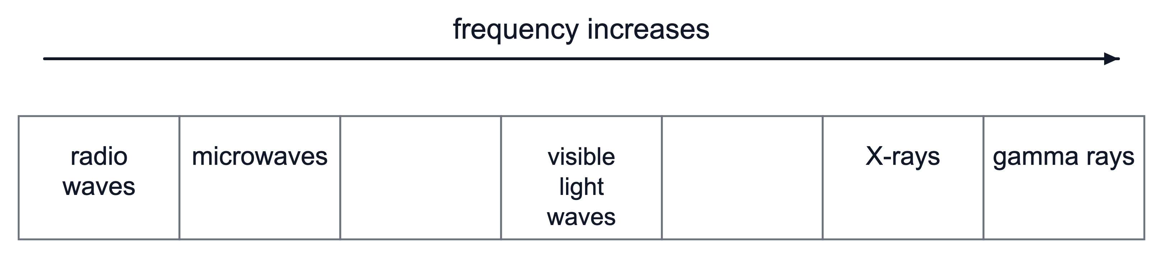
A infrared, ultraviolet
B ultraviolet, infrared
C radio waves, gamma rays
D microwaves, X-rays
(1 mark)
11. A sound is to be transmitted as a digital signal. The microphone produces an analogue signal.
Which device must the microphone signal pass through before it is transmitted?
A a loudspeaker
B an analogue-to-digital converter
C a digital-to-analogue converter
D an amplifier
(1 mark)
12. What is a possible harmful effect of excessive exposure to microwaves?
A internal heating of body tissue
B sunburn caused by ultraviolet exposure
C ionisation throughout the body
D no harmful effect because microwaves are invisible
(1 mark)
13. A digital signal that has become weak and noisy can be regenerated so that it is exactly the same as when it was transmitted.
Which feature of a digital signal makes this possible?
A It travels at the speed of light.
B It has only two states, so small changes caused by noise can be ignored and the states rebuilt.
C It has a larger amplitude than an analogue signal.
D It does not pick up any noise during transmission.
(1 mark)
14. A radio signal and a light signal set off together along a 300 km path through a vacuum. State which signal reaches the far end of the path first.
.....................................................................................................
.....................................................................................................
(1 mark)
15. Name each part of the electromagnetic spectrum in order of increasing frequency.

.....................................................................................................
.....................................................................................................
.....................................................................................................
.....................................................................................................
(2 marks)
16. A Bluetooth link keeps working between two devices that are in different rooms of a house. Give one reason why radio waves are suitable for this link.
.....................................................................................................
.....................................................................................................
(1 mark)
17. Digital signals can be sent over greater distances than analogue signals before the information becomes unclear. State the reason for this.
.....................................................................................................
.....................................................................................................
(1 mark)
18. The selected radiation is used to form an image of a broken bone. State why bone and soft tissue appear different in the image.
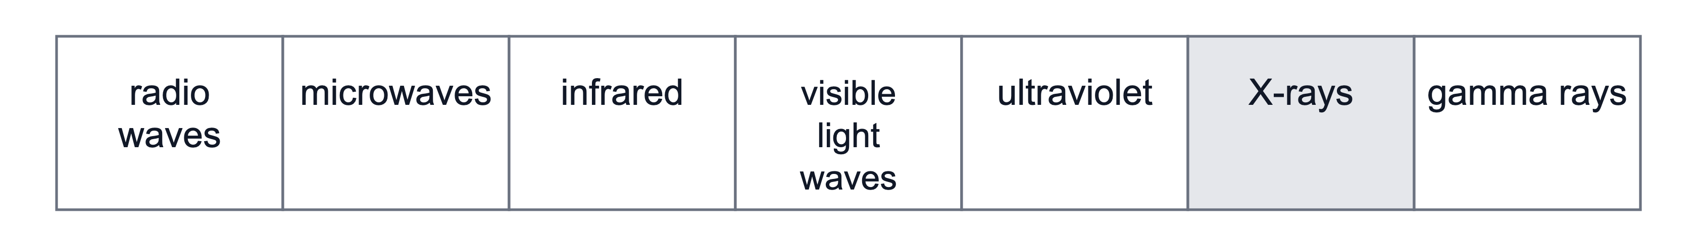
.....................................................................................................
.....................................................................................................
.....................................................................................................
.....................................................................................................
(2 marks)
19. State why a person cannot see infrared or ultraviolet radiation.
.....................................................................................................
.....................................................................................................
(1 mark)
20. A radio wave has a frequency of 100 MHz. Calculate its wavelength in a vacuum.
.....................................................................................................
.....................................................................................................
.....................................................................................................
.....................................................................................................
(2 marks)
21. An optical fibre is a long, thin thread of glass. State the property of glass that allows a signal to travel along the fibre.
.....................................................................................................
.....................................................................................................
(1 mark)
22. Name the two parts of the electromagnetic spectrum used to carry signals along an optical fibre.
.....................................................................................................
.....................................................................................................
(1 mark)
23. A wireless internet router stands in one room of a house. State the property of microwaves that allows a laptop in the next room to receive the signal.
.....................................................................................................
.....................................................................................................
(1 mark)
24. Compare the frequency and wavelength of gamma rays with those of radio waves.
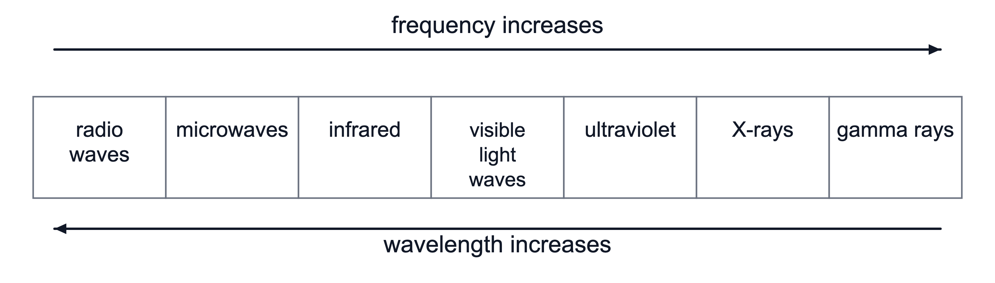
.....................................................................................................
.....................................................................................................
.....................................................................................................
.....................................................................................................
(2 marks)
25. The diagram shows the position of ultraviolet radiation in the electromagnetic spectrum.
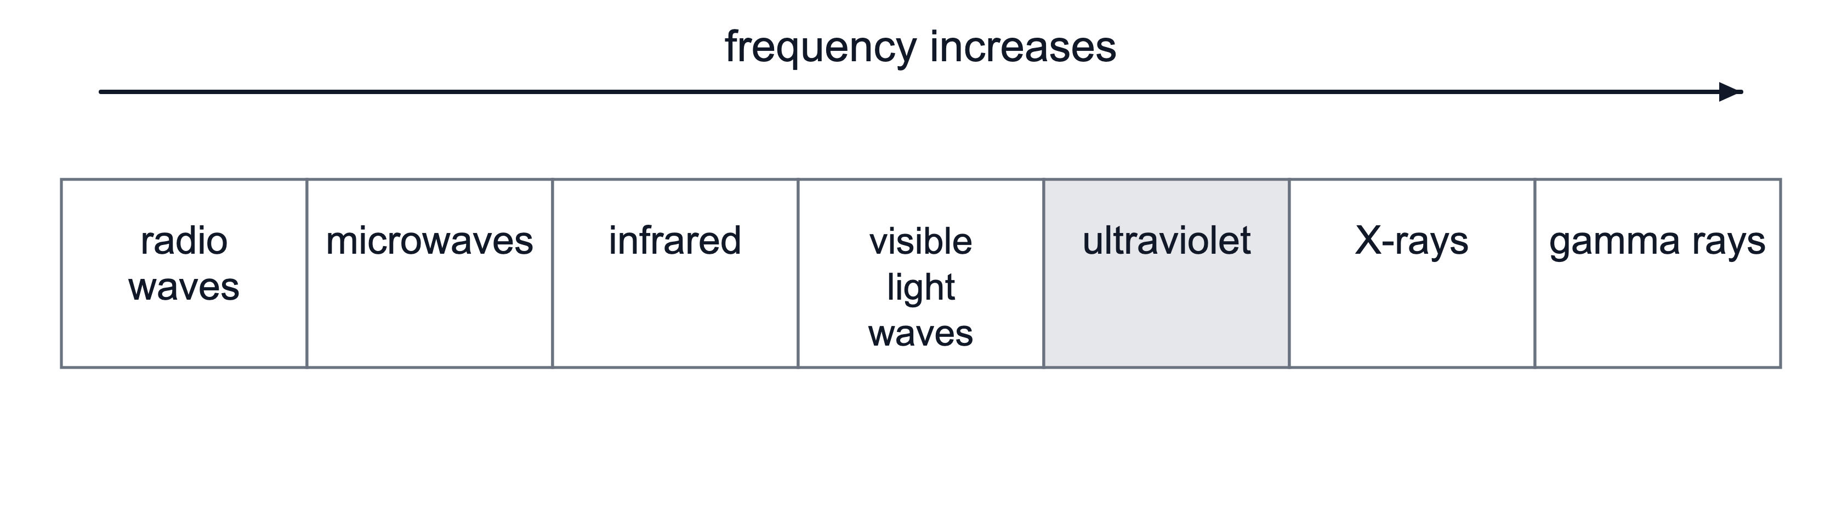
(a) Ultraviolet radiation is shown in the high-frequency part of the spectrum. Describe one useful application and one harmful effect of ultraviolet radiation.
.....................................................................................................
.....................................................................................................
.....................................................................................................
.....................................................................................................
(2 marks)
(b) Compare the dangers of ultraviolet, X-rays and gamma rays.
.....................................................................................................
.....................................................................................................
.....................................................................................................
.....................................................................................................
.....................................................................................................
(3 marks)
(c) Explain why radiographers use lead screens when working near X-ray sources.
.....................................................................................................
.....................................................................................................
.....................................................................................................
.....................................................................................................
.....................................................................................................
(3 marks)
26. A television company broadcasts its channels straight to homes from a satellite. A ground station sends each channel up to the satellite, and the satellite sends it back down over a wide area. The satellite stays above the same place on the Earth's surface, and each home receives the broadcast with a dish fixed to a wall.
(a) Name the part of the electromagnetic spectrum used to carry the signals between the ground station and the satellite.
.....................................................................................................
.....................................................................................................
(1 mark)
(b) State the name given to the orbit of this satellite. Explain why this orbit suits a receiving dish that is fixed to a wall. ​
.....................................................................................................
.....................................................................................................
.....................................................................................................
.....................................................................................................
(2 marks)
(d) The company considers changing the link to the satellite from microwaves to radio waves. State whether this change would alter the time a signal takes to reach the satellite. Explain your answer.
.....................................................................................................
.....................................................................................................
.....................................................................................................
.....................................................................................................
.....................................................................................................
(3 marks)
27. The diagram below shows the position of infrared radiation on the electromagnetic spectrum.
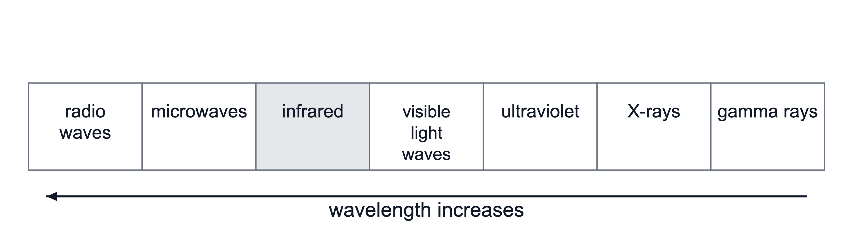
(a) Infrared radiation is used by the remote controller. Describe two other uses of infrared radiation.
.....................................................................................................
.....................................................................................................
.....................................................................................................
.....................................................................................................
(2 marks)
(b) Explain why warm objects can be detected using this radiation.
.....................................................................................................
.....................................................................................................
.....................................................................................................
.....................................................................................................
(2 marks)
(c) Compare infrared radiation with visible light.
.....................................................................................................
.....................................................................................................
.....................................................................................................
.....................................................................................................
.....................................................................................................
(3 marks)

