3.4 Sound: Cambridge IGCSE Physics worksheet
1. Which statement describes a compression in a sound wave travelling through air?
A Air particles are closer together than their normal spacing.
B Air particles have moved permanently in the direction of the wave.
C Air particles are farther apart than their normal spacing.
D Air particles stop moving.
(1 mark)
2. A sound has a greater frequency than another sound. How does its pitch compare?
A Its pitch is lower.
B Its pitch is unchanged.
C Its pitch is higher.
D Its pitch depends only on its amplitude.
(1 mark)
3. What causes a loudspeaker cone to produce a sound wave?
A The cone becomes electrically charged.
B The cone vibrates.
C The cone steadily increases the air temperature.
D The cone releases air from the loudspeaker.
(1 mark)
4. A microphone is moved farther from a stationary loudspeaker. The sound is displayed on an oscilloscope whose settings are unchanged. Which row describes the trace after the microphone is moved?
 | Amplitude | Period
A | increases | increases
B | increases | unchanged
C | decreases | unchanged
D | decreases | decreases

(1 mark)
5. Two microphones are 3.40 m apart and connected to an electronic timer. A sharp sound reaches the second microphone 0.010 s after it reaches the first. What value does the experiment give for the speed of sound?
A 0.034 m/s
B 340 m/s
C 34 m/s
D 680 m/s
(1 mark)
6. Why can reflected ultrasound pulses be used to locate a boundary inside an object?
A The pulses travel infinitely fast.
B The pulses change into visible light at the boundary.
C The pulses pass through every boundary without changing.
D The time taken for a reflected pulse to return can be measured.
(1 mark)
7. A source makes 120 complete oscillations in 0.40 s. What is the frequency of the sound produced?
A 48 Hz
B 300 Hz
C 120 Hz
D 3000 Hz
(1 mark)
8. Two sounds are displayed using the same oscilloscope settings. Trace X has five complete cycles and a peak amplitude of three divisions. Trace Y has three complete cycles and a peak amplitude of three divisions over the same time interval. Which comparison is correct?
 | Pitch of X compared with Y | Loudness of X compared with Y
A | lower | greater
B | lower | equal
C | higher | greater
D | higher | equal

(1 mark)
9. A person stands in front of a large wall and makes a short sound. The echo is heard 0.80 s later. The speed of sound is 340 m/s. How far is the person from the wall?
A 68 m
B 425 m
C 272 m
D 136 m
(1 mark)
10. An ultrasound pulse travels through water at 1500 m/s. The pulse returns from the bottom 0.12 s after it is sent. What is the depth of the water?
A 90 m
B 180 m
C 6250 m
D 12 500 m
(1 mark)
11. The trace is produced by a microphone connected to an oscilloscope. What is the frequency of the sound?
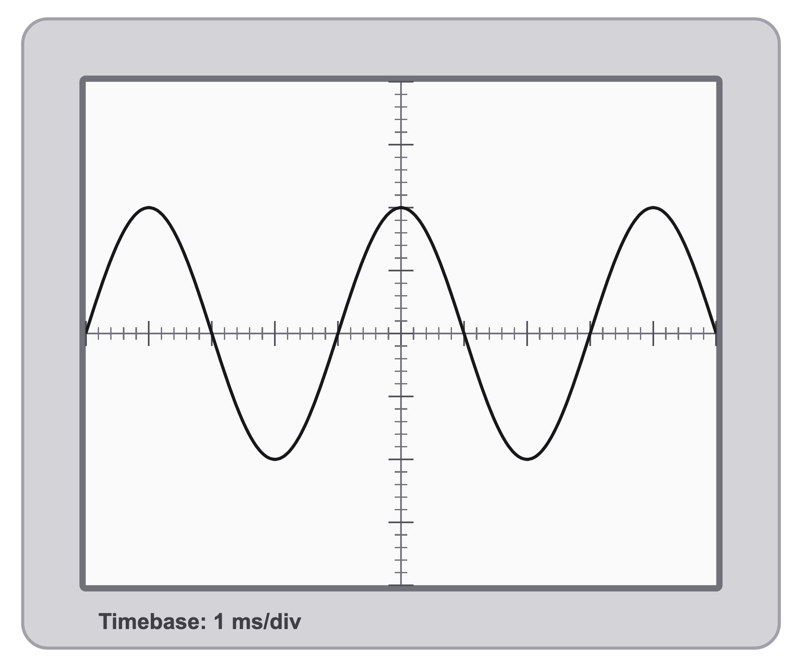
A 250 Hz
B 4 Hz
C 1000 Hz
D 4000 Hz
(1 mark)
12. A student measures the time between seeing two wooden blocks strike together at a distance and hearing the sound. Which change most directly reduces the percentage uncertainty in the measured sound travel time?
A Use blocks with a different colour.
B Stand closer to the blocks.
C Stand farther from the blocks.
D Use a quieter strike.
(1 mark)
13. Put solids, liquids and gases in order from the fastest to the slowest speed of sound.
.....................................................................................................
.....................................................................................................
.....................................................................................................
.....................................................................................................
(2 marks)
14. State whether sound can travel through a vacuum. Give a reason for your answer.
.....................................................................................................
.....................................................................................................
.....................................................................................................
.....................................................................................................
(2 marks)
15. State the approximate speed of sound in air.
.....................................................................................................
.....................................................................................................
(1 mark)
16. Define ultrasound.
.....................................................................................................
.....................................................................................................
(1 mark)
17. Sound travels at about 340 m/s in air and at about 1500 m/s in water. State what this shows about the speed of sound in a liquid compared with its speed in a gas.
.....................................................................................................
.....................................................................................................
(1 mark)
18. Name the regions of a sound wave where the particles of the medium are pushed close together.
.....................................................................................................
.....................................................................................................
(1 mark)
19. The regions marked A and B are shown on a longitudinal wave. Identify each region.
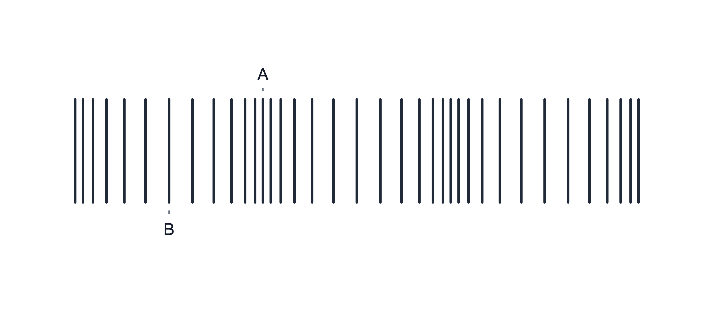
.....................................................................................................
.....................................................................................................
.....................................................................................................
.....................................................................................................
(2 marks)
20. A sound pulse travels 170 m from a starter pistol to a detector. Use the recorded time to calculate the speed of sound.
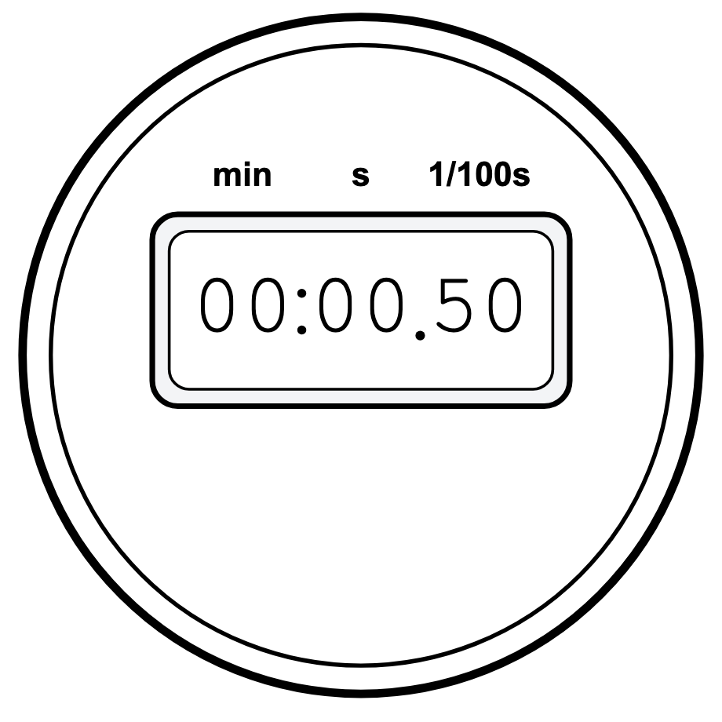
.....................................................................................................
.....................................................................................................
.....................................................................................................
.....................................................................................................
(2 marks)
21. Give one medical use of ultrasound.
.....................................................................................................
.....................................................................................................
(1 mark)
22. State what an object must do in order to produce a sound.
.....................................................................................................
.....................................................................................................
(1 mark)
23. State the direction in which the particles of the air vibrate, compared with the direction in which a sound wave travels.
.....................................................................................................
.....................................................................................................
(1 mark)
24. Two microphones are connected to an oscilloscope and placed 2.72 m apart. A sharp sound is made next to the first microphone. The first pulse shows the sound reaching the first microphone. The second pulse shows the sound reaching the second microphone.
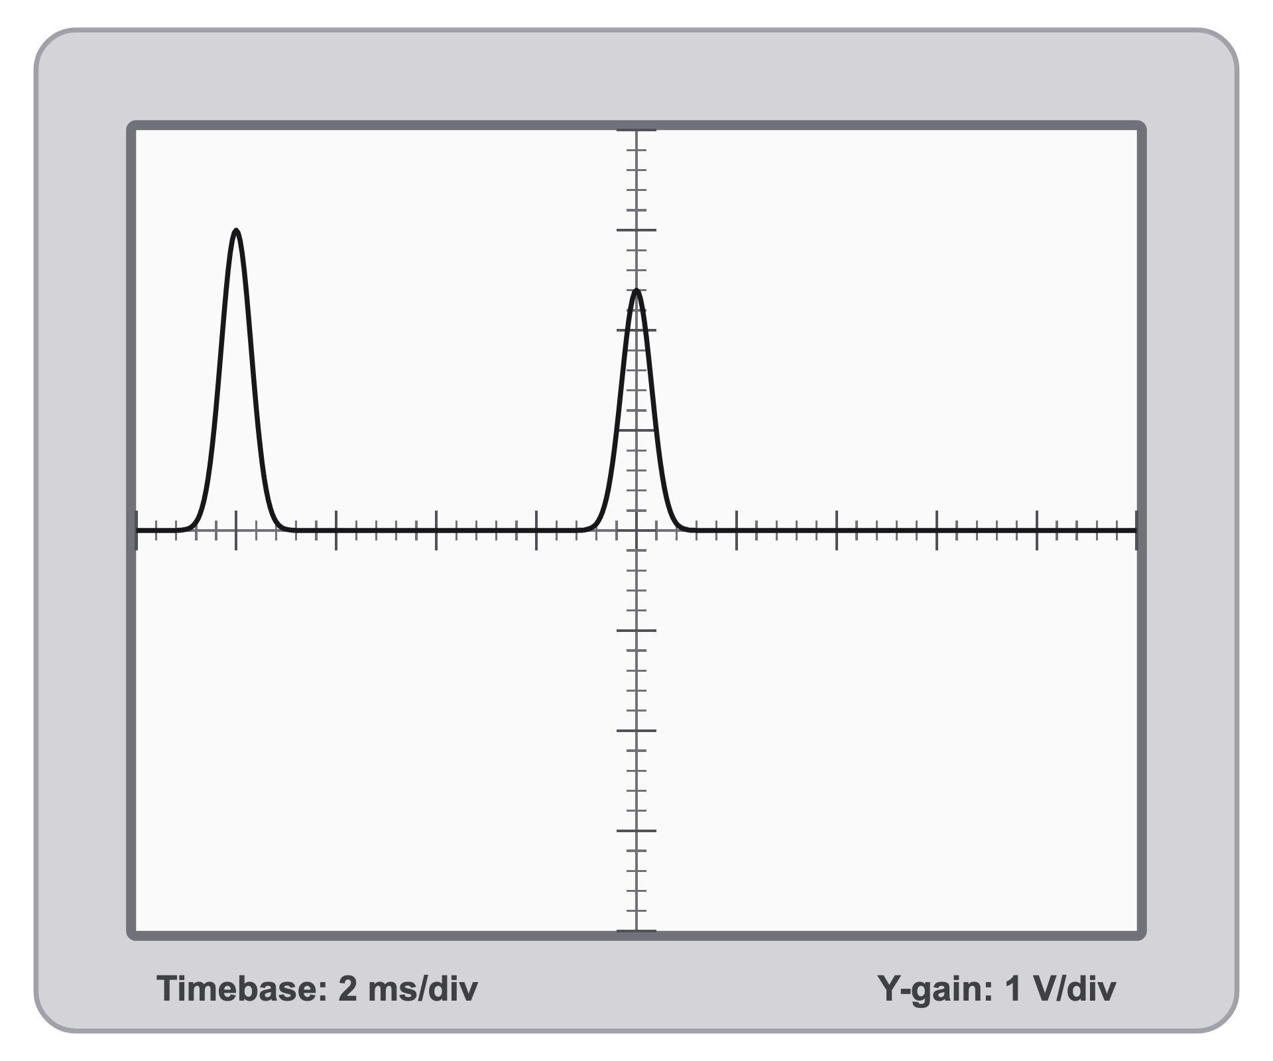
(a) Determine the time taken for the sound to travel from the first microphone to the second microphone.
.....................................................................................................
.....................................................................................................
.....................................................................................................
.....................................................................................................
(2 marks)
(b) Calculate the speed of sound in air using this result.
.....................................................................................................
.....................................................................................................
.....................................................................................................
.....................................................................................................
.....................................................................................................
(3 marks)
(c) Explain one reason why this method is more accurate than using a stopwatch to time a clap over a short distance. ​
.....................................................................................................
.....................................................................................................
.....................................................................................................
.....................................................................................................
(2 marks)
25. A ship uses sonar to measure the depth of water. The first pulse on the oscilloscope is the transmitted ultrasound pulse. The second pulse is the echo from the seabed. The speed of sound in seawater is 1500 m/s.
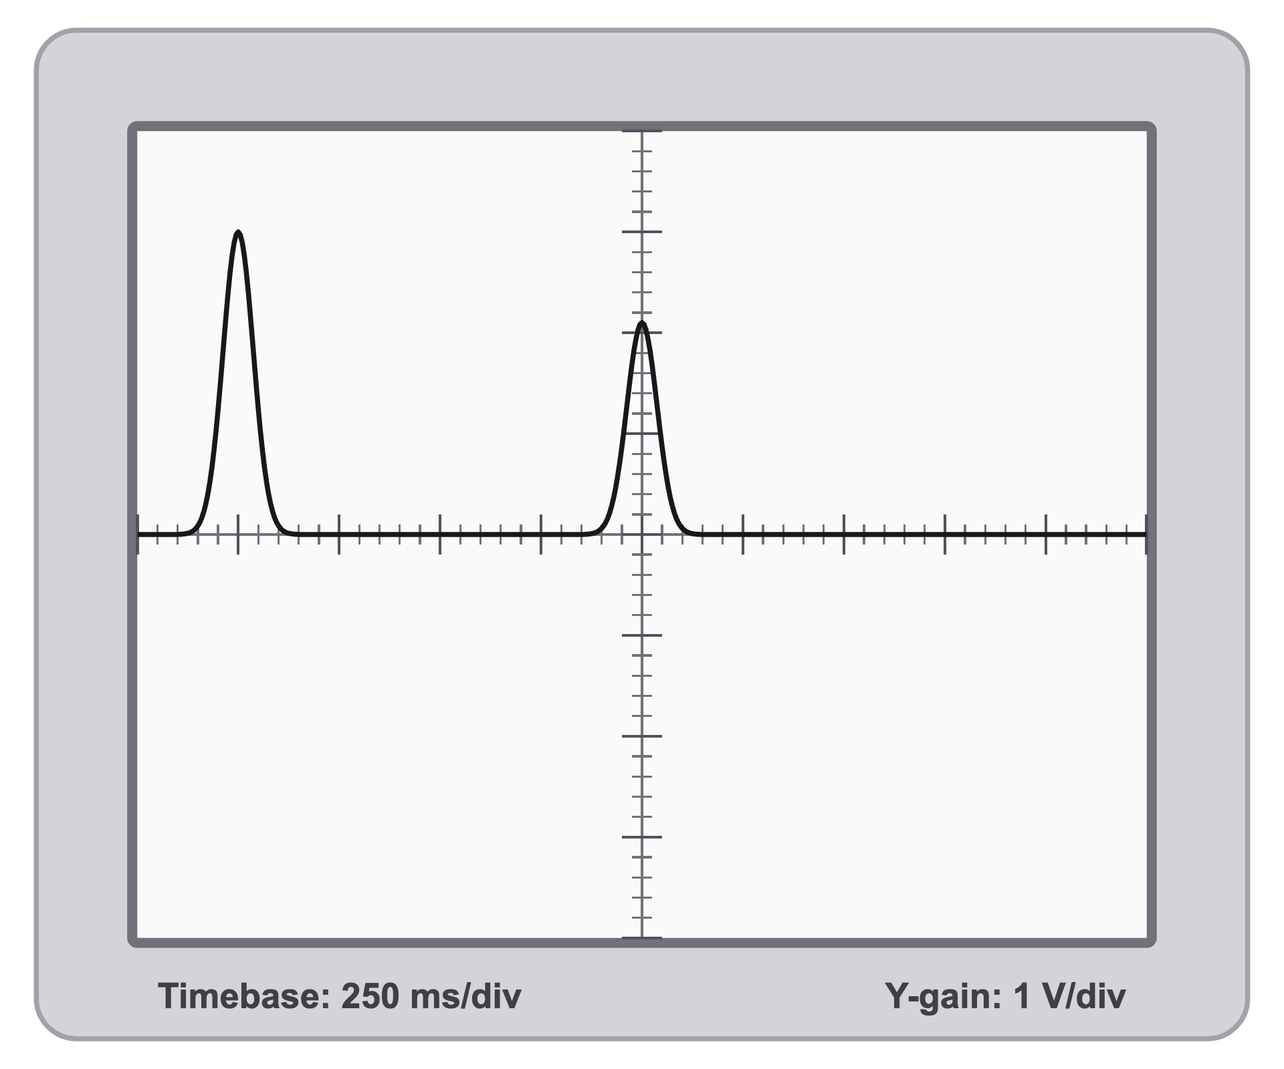
(a) Describe how sonar uses ultrasound to measure the depth of water.
.....................................................................................................
.....................................................................................................
.....................................................................................................
.....................................................................................................
(2 marks)
(b) Determine the time between the transmitted pulse and the echo.
.....................................................................................................
.....................................................................................................
.....................................................................................................
.....................................................................................................
(2 marks)
(c) Calculate the depth of the water.
.....................................................................................................
.....................................................................................................
.....................................................................................................
.....................................................................................................
.....................................................................................................
(3 marks)
(d) Explain why high-frequency sound is useful for detecting objects or boundaries underwater.
.....................................................................................................
.....................................................................................................
.....................................................................................................
.....................................................................................................
(2 marks)
26. A long steel water pipe runs across a field. A worker taps one end of the pipe once with a hammer. A second worker at the far end of the pipe, 1200 m away, hears two separate sounds a short time apart. Sound travels at about 340 m/s in air and at about 5000 m/s in steel.
(a) State which of the two sounds reaches the second worker first.
.....................................................................................................
.....................................................................................................
(1 mark)
(b) Explain why the single tap produces two sounds that arrive at different times.
.....................................................................................................
.....................................................................................................
.....................................................................................................
.....................................................................................................
(2 marks)
(c) Calculate the time between the two sounds arriving at the second worker.
.....................................................................................................
.....................................................................................................
.....................................................................................................
.....................................................................................................
.....................................................................................................
(3 marks)
(d) Sound travels at about 1500 m/s in water. State where the speed of sound in a liquid fits in relation to its speed in solids and in gases.
.....................................................................................................
.....................................................................................................
(1 mark)

