4.2 Electrical quantities: Cambridge IGCSE Physics worksheet
1. Use the meter connections shown. Which component has its potential difference measured by the voltmeter?
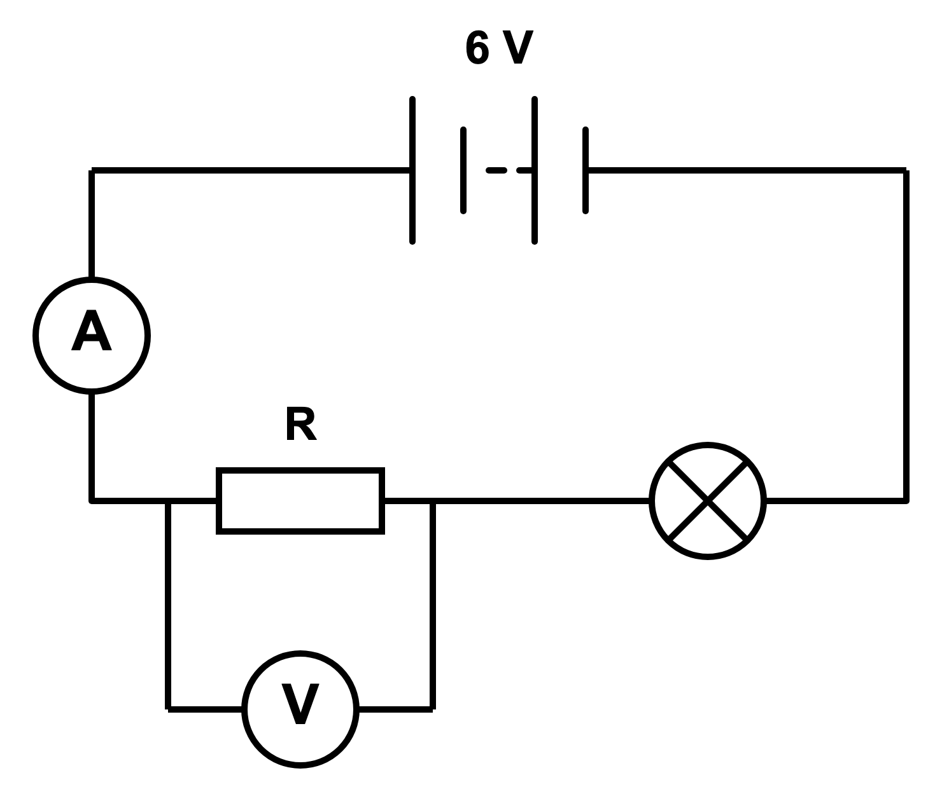
A the battery
B the lamp
C the resistor
D the ammeter
(1 mark)
2. What is electric current?
A energy transferred per unit charge
B force acting per unit charge
C charge passing a point per unit time
D resistance opposing each unit of charge
(1 mark)
3. Which equation links charge Q, current I and time t?
A $Q=It$
B $Q=\frac{I}{t}$
C $Q=\frac{t}{I}$
D $Q=I+t$
(1 mark)
4. A variable resistor is connected to a fixed-voltage supply. Its resistance is increased. What happens to the current through it?
A It increases.
B It stays constant.
C It decreases.
D It first becomes zero and then increases.
(1 mark)
5. Which statement describes an ohmic conductor at constant temperature?
A The ratio of potential difference to current remains constant.
B The current remains constant when the potential difference changes.
C The conductor must become hotter as the current increases.
D The resistance decreases when the potential difference increases.
(1 mark)
6. Which graph shows how current varies with potential difference for an ohmic resistor at constant temperature?
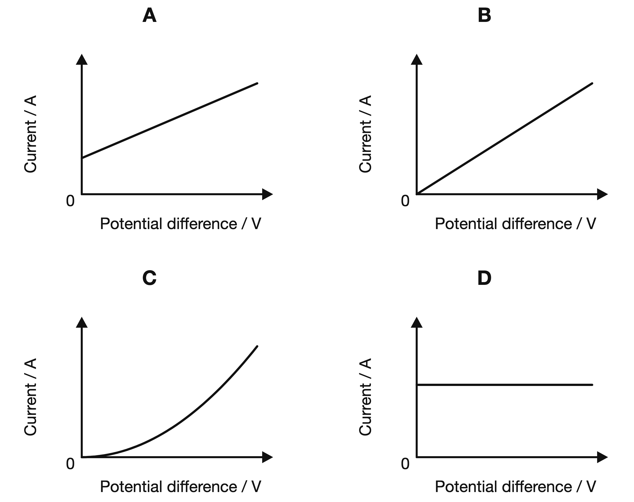
(1 mark)
7. A student rubs two different insulating materials together. Both materials become charged.
What has moved from one material to the other?
A atoms
B neutrons
C electrons
D protons
(1 mark)
8. The same small potential difference is applied to a diode in each direction. It is large enough for the diode to conduct in the forward direction. Which comparison is correct?
 | Forward-direction resistance | Reverse-direction resistance
A | high | high
B | low | high
C | high | low
D | low | low

(1 mark)
9. Which is the smallest suitable full-scale range for the ammeter?
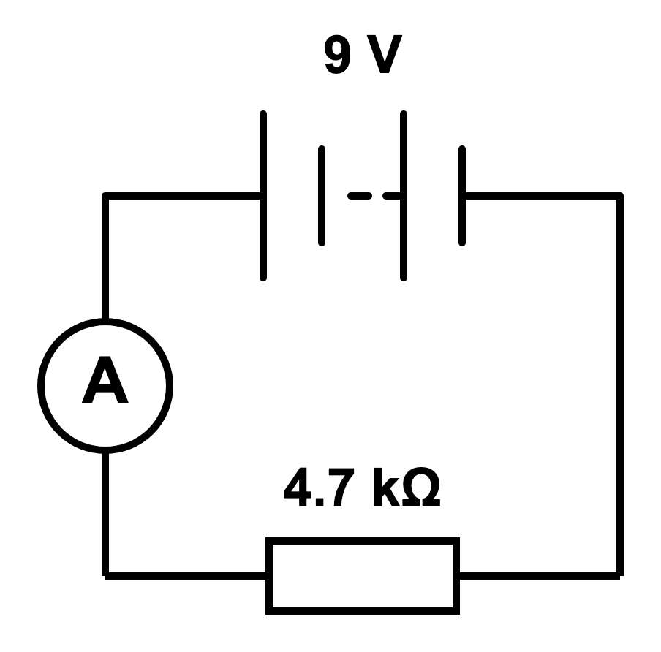
A 0 to 10 mA
B 0 to 1 mA
C 0 to 1 A
D 0 to 10 A
(1 mark)
10. The potential difference across a filament lamp is increased, causing a larger current. Why does the lamp's resistance increase?
A The filament becomes brighter, so its resistance must decrease.
B The filament becomes hotter, increasing its resistance.
C The filament obeys Ohm's law, so its resistance stays constant.
D The current passes through without transferring energy to the filament.
(1 mark)
11. A component is kept at constant temperature. Which set of measurements shows that the component obeys Ohm's law?
 | Potential difference readings / V | Current readings / A
A | 1.0, 2.0, 3.0 | 0.20, 0.30, 0.40
B | 1.0, 2.0, 3.0 | 0.20, 0.40, 0.80
C | 1.0, 2.0, 3.0 | 0.20, 0.40, 0.60
D | 1.0, 2.0, 3.0 | 0.60, 0.40, 0.20

(1 mark)
12. A metal wire is connected in a complete circuit to a cell.
Which row gives the directions of conventional current and electron movement in the external circuit?
 | Conventional current | Electron movement
A | negative to positive | negative to positive
B | positive to negative | positive to negative
C | negative to positive | positive to negative
D | positive to negative | negative to positive

(1 mark)
13. Record the current shown by the ammeter.
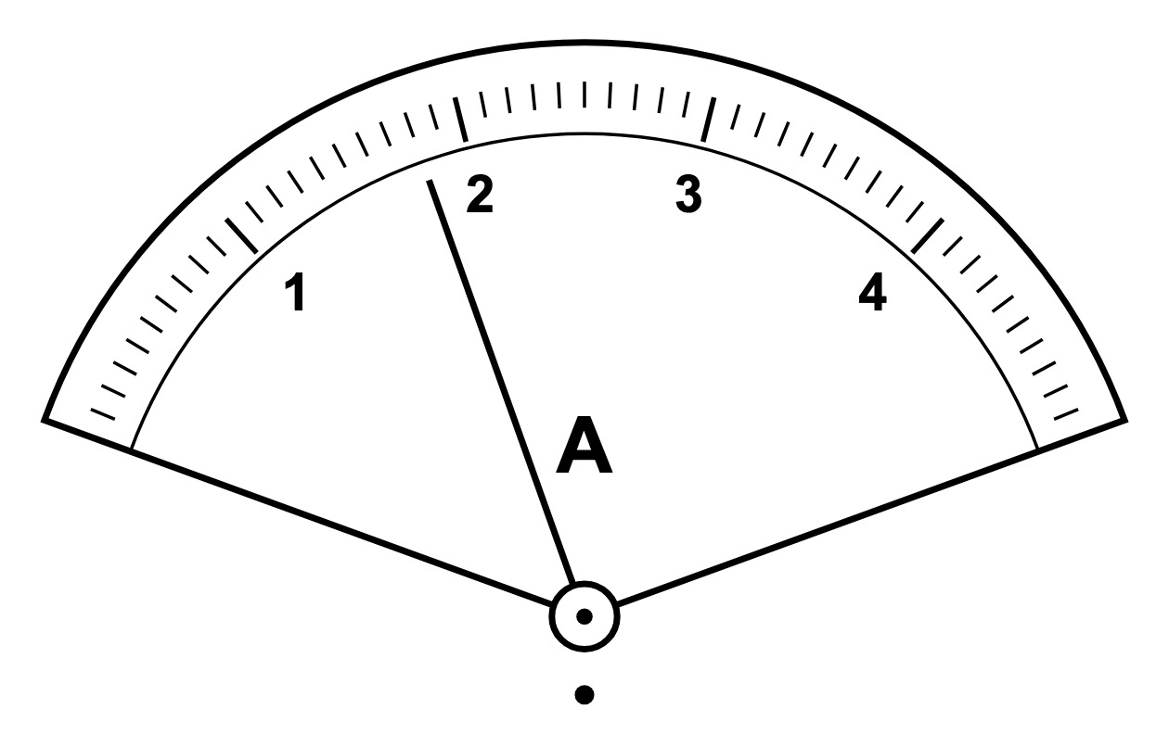
.....................................................................................................
.....................................................................................................
(1 mark)
14. Two devices are shown in separate branches. Name the device that transfers energy mainly to light and the device that transfers energy mainly to kinetic energy.
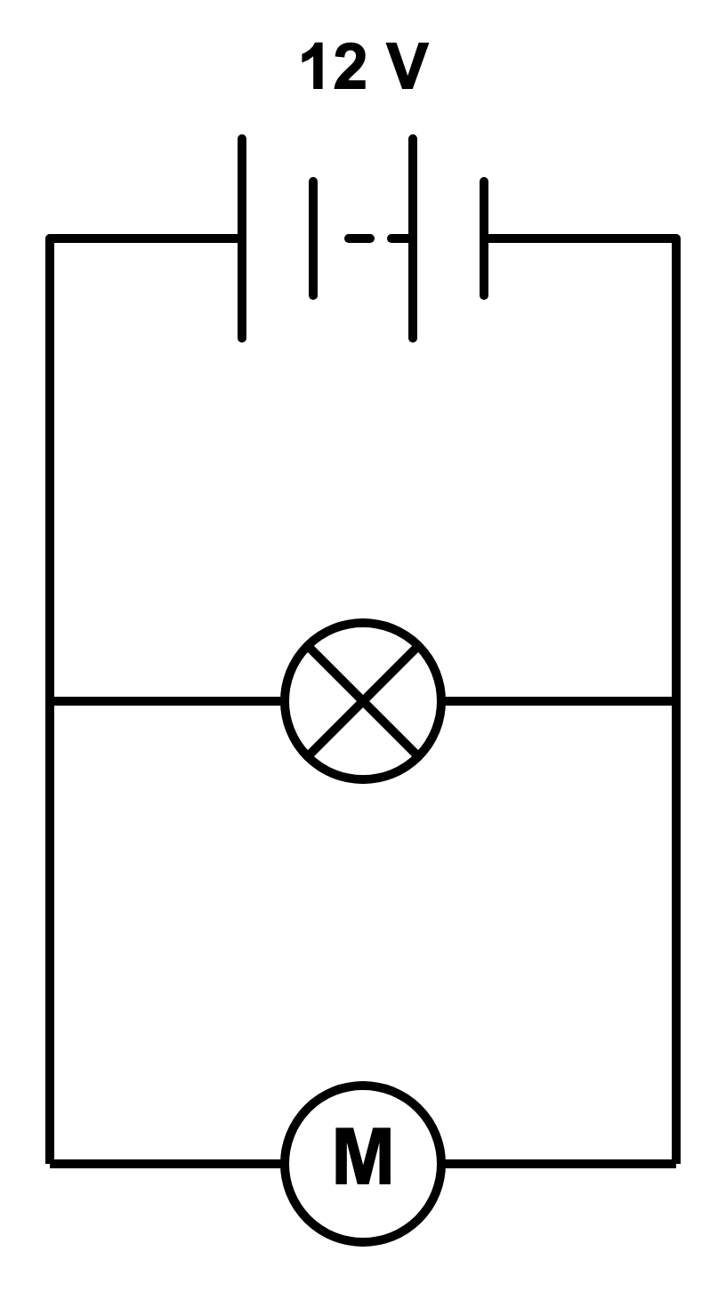
.....................................................................................................
.....................................................................................................
.....................................................................................................
.....................................................................................................
(2 marks)
15. State the resolution of the voltmeter scale.
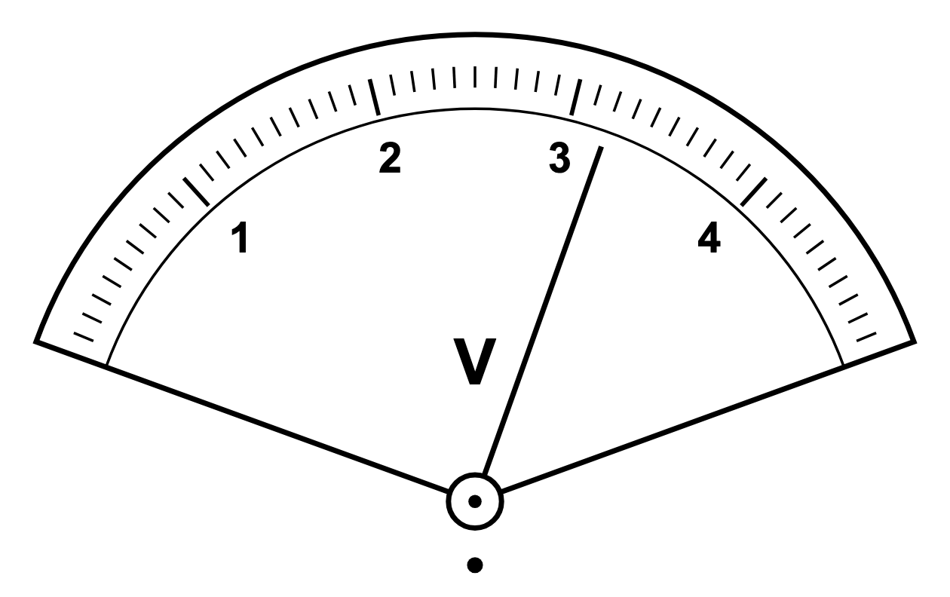
.....................................................................................................
.....................................................................................................
(1 mark)
16. The electric field points upwards. State the direction of the force on the particle and give the reason for your answer.
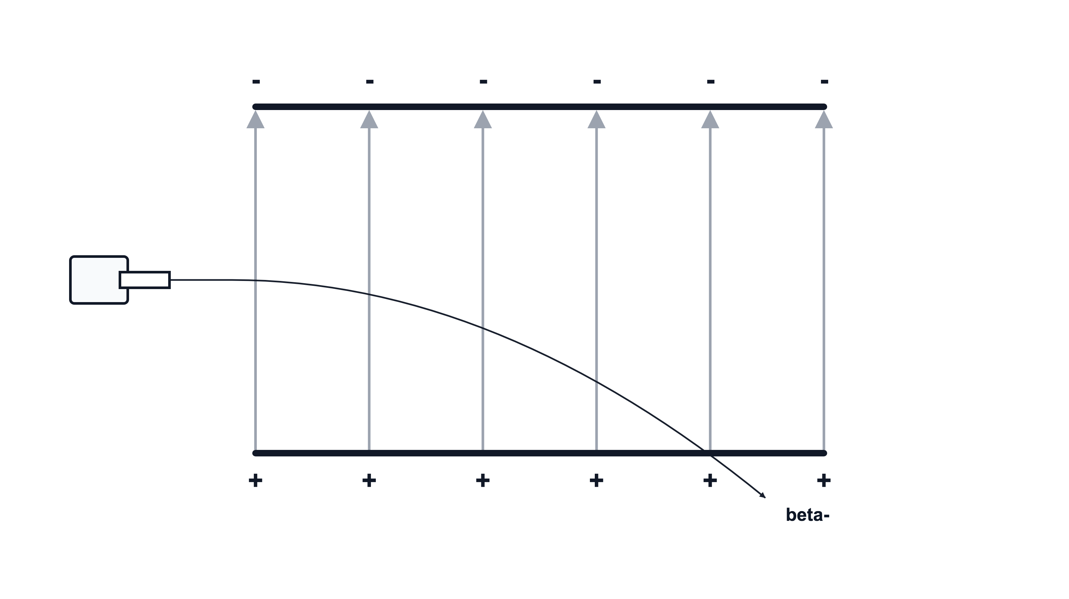
.....................................................................................................
.....................................................................................................
.....................................................................................................
.....................................................................................................
(2 marks)
17. Use both meter readings to determine the energy transferred by the heating element in 50 s.
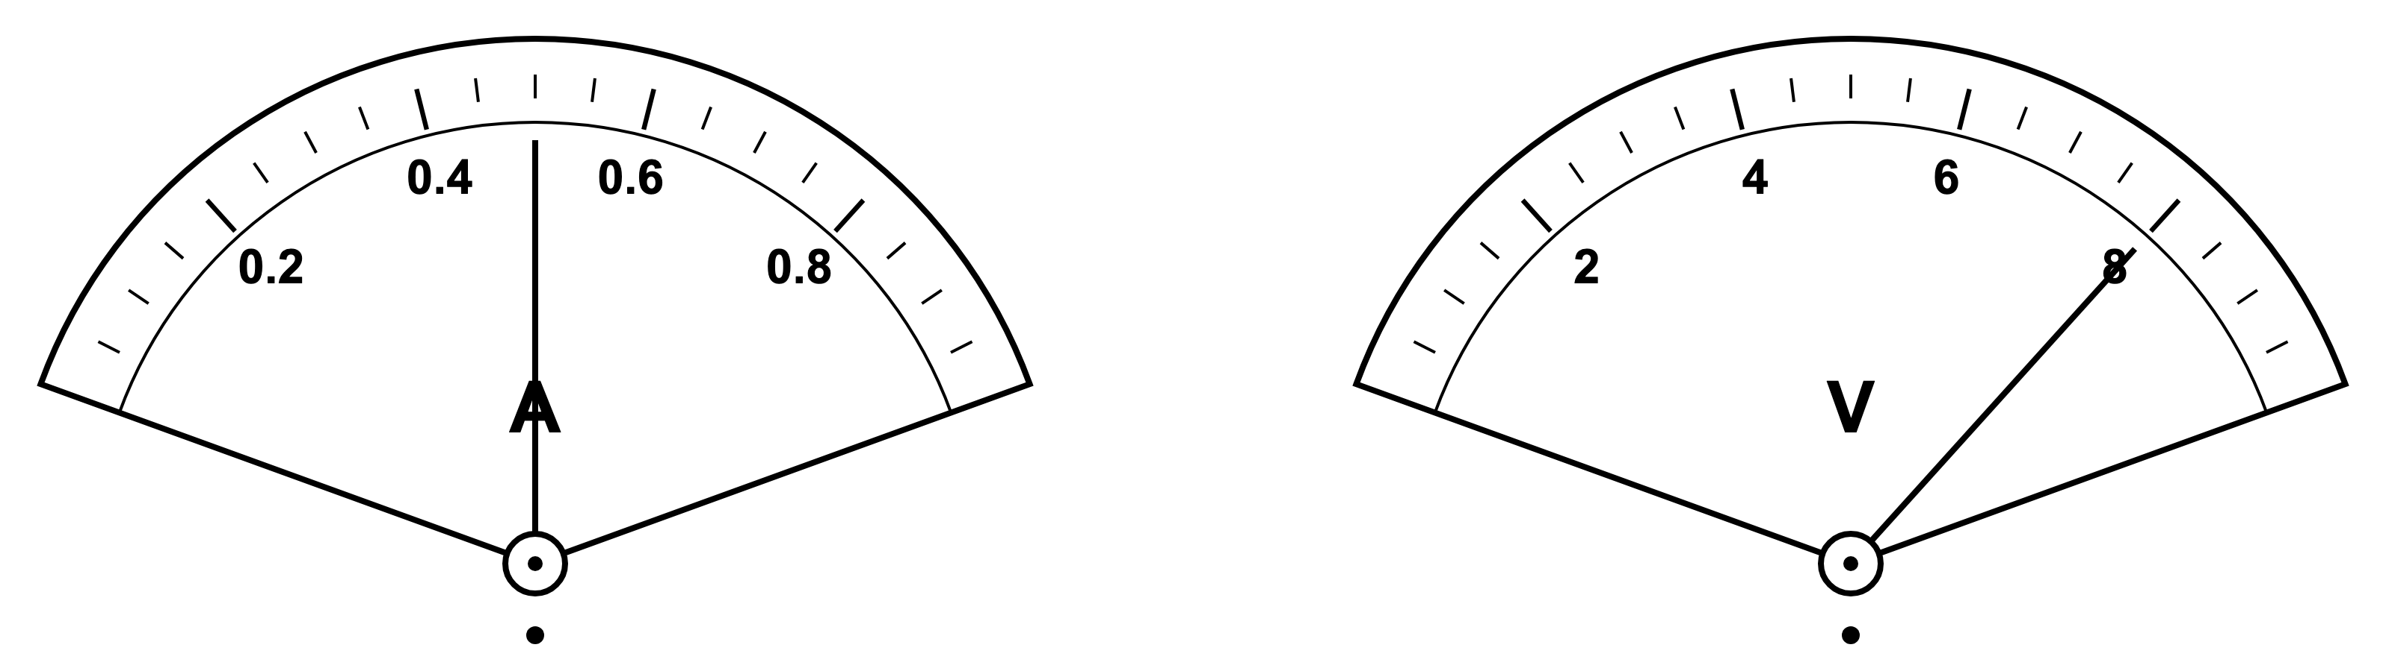
.....................................................................................................
.....................................................................................................
.....................................................................................................
.....................................................................................................
(2 marks)
18. Name the circuit component shown and state its main useful energy transfer.
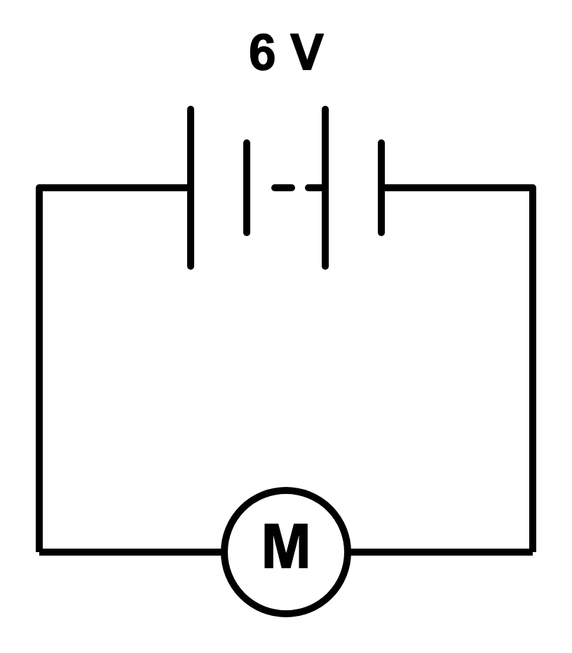
.....................................................................................................
.....................................................................................................
.....................................................................................................
.....................................................................................................
(2 marks)
19. The ammeter shows the current in a wire. Calculate the charge that flows through the wire in 25 s.
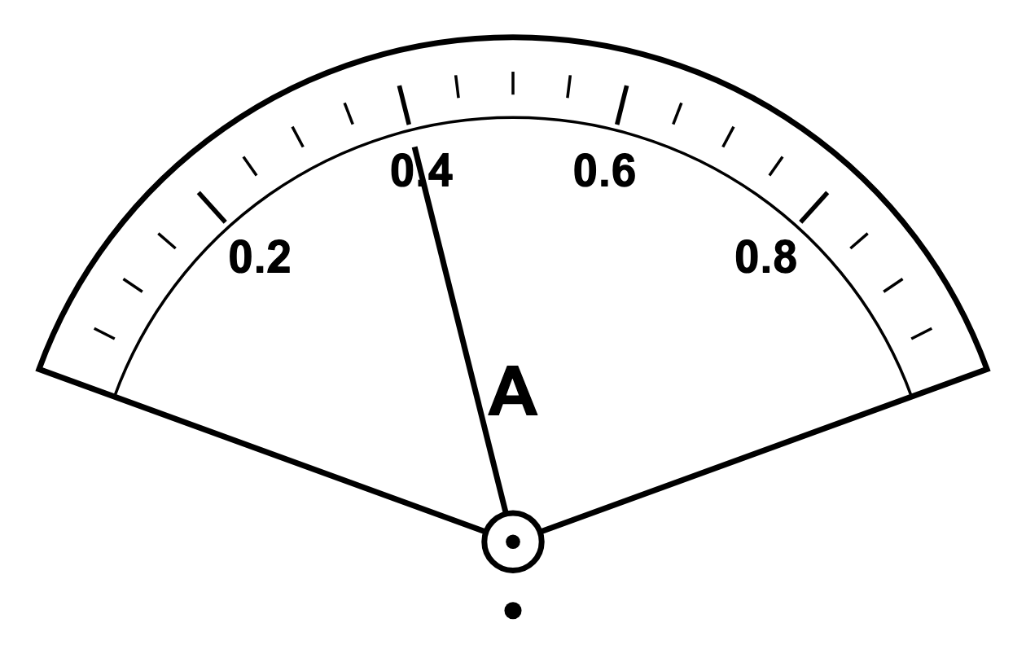
.....................................................................................................
.....................................................................................................
.....................................................................................................
.....................................................................................................
(2 marks)
20. State the direction of conventional current in a metal wire. State the direction in which its free electrons move.
.....................................................................................................
.....................................................................................................
.....................................................................................................
.....................................................................................................
(2 marks)
21. State the two types of electric charge.
.....................................................................................................
.....................................................................................................
(1 mark)
22. A student says, "Adding another resistor in parallel must increase the total resistance, because there is another resistor in the circuit."
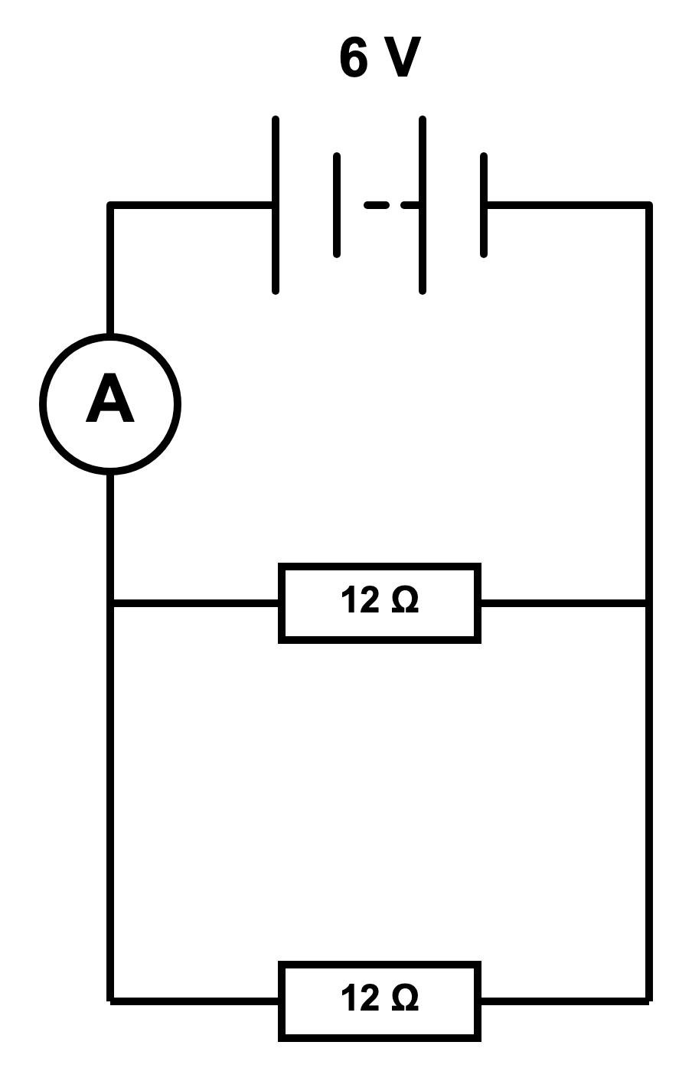
(a) Calculate the current from the battery if only one resistor is connected.
.....................................................................................................
.....................................................................................................
.....................................................................................................
.....................................................................................................
(2 marks)
(b) Calculate the combined resistance when both resistors are connected in parallel.
.....................................................................................................
.....................................................................................................
.....................................................................................................
.....................................................................................................
.....................................................................................................
(3 marks)
(c) Calculate the total current from the battery when both resistors are connected.
.....................................................................................................
.....................................................................................................
.....................................................................................................
.....................................................................................................
(2 marks)
(d) Explain why the student's statement is wrong.
.....................................................................................................
.....................................................................................................
.....................................................................................................
.....................................................................................................
(2 marks)
23. A 6.0 V power pack is connected in series with a lamp and a resistor. The potential difference across the lamp is 2.2 V. The potential difference across the resistor is 3.8 V.
During one test, 360 C of charge passes through the power pack in 3.0 minutes.
(a) Define electromotive force, e.m.f.
.....................................................................................................
.....................................................................................................
.....................................................................................................
.....................................................................................................
(2 marks)
(b) Define potential difference, p.d., across a component.
.....................................................................................................
.....................................................................................................
(1 mark)
(c) Calculate the current in the circuit during the test.
.....................................................................................................
.....................................................................................................
.....................................................................................................
.....................................................................................................
.....................................................................................................
(3 marks)
(d) Calculate the energy transferred by the power pack to the charges during the test.
.....................................................................................................
.....................................................................................................
.....................................................................................................
.....................................................................................................
.....................................................................................................
(3 marks)
(e) Calculate the energy transferred by the charge in the lamp and in the resistor. Then use your answers to check that energy is conserved in this circuit.
.....................................................................................................
.....................................................................................................
.....................................................................................................
.....................................................................................................
.....................................................................................................
(4 marks)
(f) Explain why the same value of charge, 360 C, can be used for both the lamp and the resistor.
.....................................................................................................
.....................................................................................................
(1 mark)

