4.3 Electric circuits: Cambridge IGCSE Physics worksheet
1. Two identical lamps are connected in parallel across a battery. One lamp breaks and stops conducting.
What happens to the other lamp?
A It goes out because the whole circuit is broken.
B It stays lit with the same brightness.
C It becomes dimmer because the battery potential difference halves.
D It becomes brighter because it receives the broken lamp's current.
(1 mark)
2. A second resistor is added in parallel with a resistor connected to a fixed-voltage supply.
What happens to the total resistance and the total current from the supply?
 | Total resistance | Total current
A | increases | decreases
B | increases | increases
C | decreases | decreases
D | decreases | increases

(1 mark)
3. Three identical resistors are connected in series across a 12 V supply.
What is the potential difference across one resistor?
A 2 V
B 3 V
C 4 V
D 12 V
(1 mark)
4. Three 1.5 V cells are connected in series, all in the same direction.
What is the total potential difference?
A 0.5 V
B 1.5 V
C 3.0 V
D 4.5 V
(1 mark)
5. The battery and meters are ideal. What is the reading on the voltmeter?
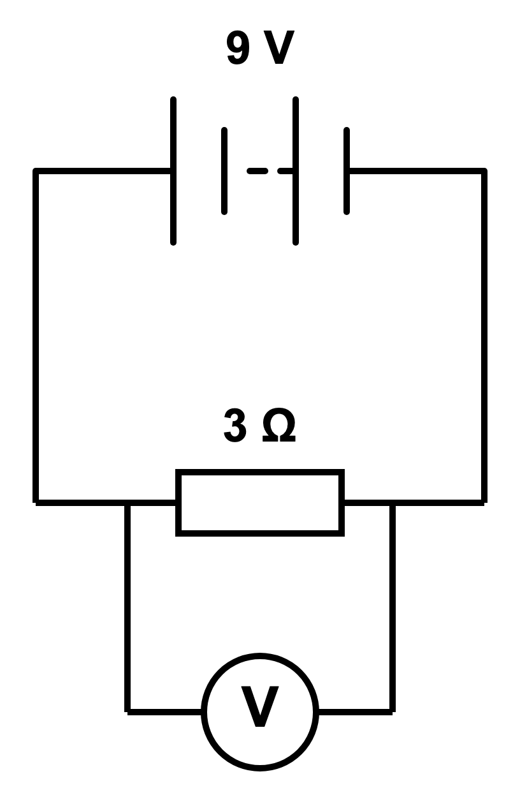
A 0 V
B 3 V
C 6 V
D 9 V
(1 mark)
6. Which row gives one correct rule for a series circuit and one correct rule for a parallel circuit?
 | Series circuit | Parallel circuit
A | current divides between components | current is the same everywhere
B | potential difference is the same across every component | branch potential differences add to the supply
C | current is the same at every point | potential difference is the same across each branch
D | total resistance is less than the smallest resistance | resistances add to give the total

(1 mark)
7. Currents of 0.25 A and 0.35 A leave a junction along two branches.
What current enters the junction?
A 0.60 A
B 0.10 A
C 0.30 A
D 1.40 A
(1 mark)
8. A 4 Ω resistor is connected in series with two 4 Ω resistors connected in parallel.
What is the total resistance of the network?
A 2 Ω
B 6 Ω
C 8 Ω
D 12 Ω
(1 mark)
9. The ammeter reads 1.0 A. What are the readings on V₁ and V₂?
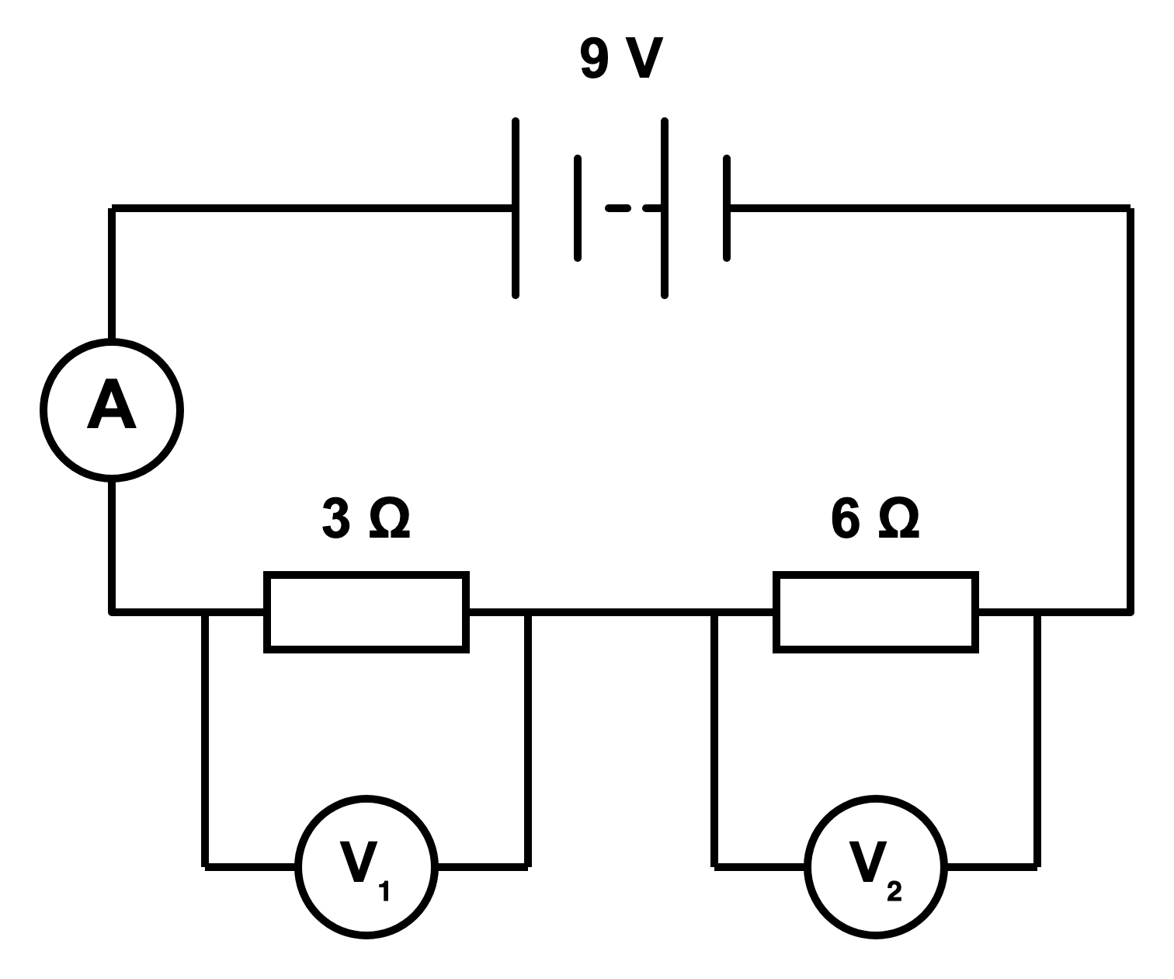
 | V₁ reading / V | V₂ reading / V
A | 3.0 | 6.0
B | 6.0 | 3.0
C | 9.0 | 9.0
D | 2.0 | 1.0

(1 mark)
10. A 3 Ω resistor and a 7 Ω resistor are connected in series.
What is their combined resistance?
A 10 Ω
B 4 Ω
C 21 Ω
D 2.1 Ω
(1 mark)
11. Use the branch resistance values shown. How does the reading on A₁ compare with the reading on A₂?
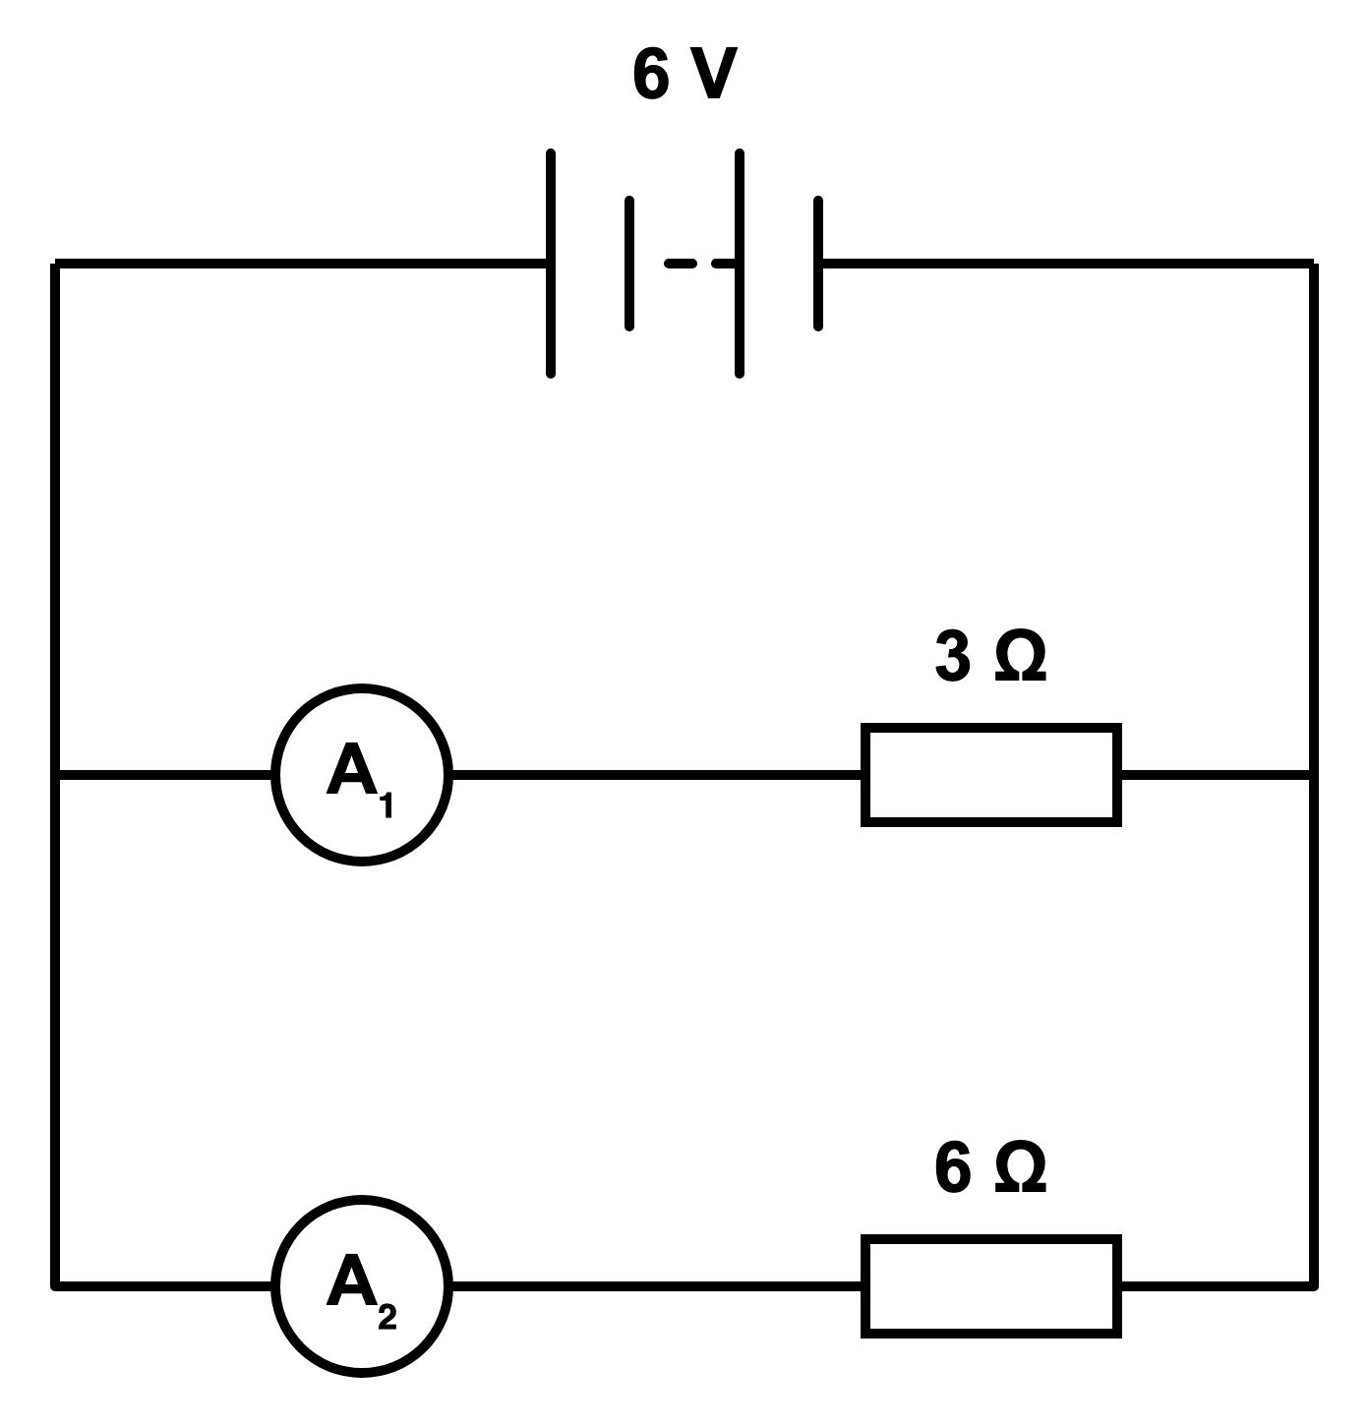
A A₁ is half A₂.
B A₁ is equal to A₂.
C A₁ is twice A₂.
D A₁ is four times A₂.
(1 mark)
12. The thermistor is warmed while the supply remains unchanged. What happens to the reading on the main ammeter?
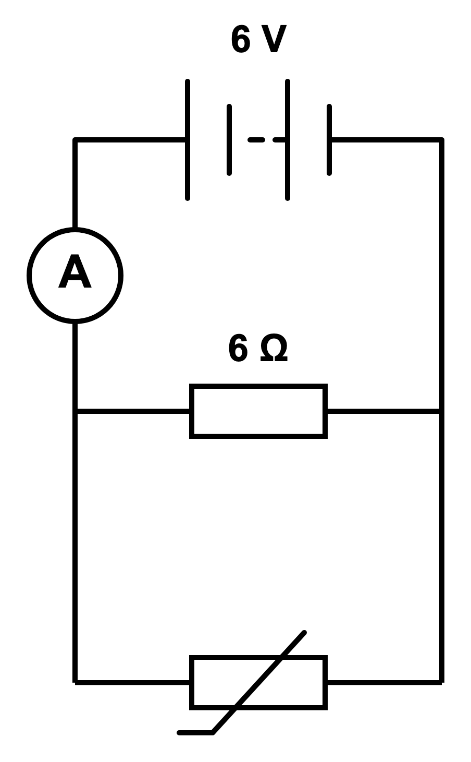
A It decreases.
B It increases.
C It remains constant.
D It becomes zero.
(1 mark)
13. Use the circuit shown. State what the ammeter measures and how its reading is related to the two branch currents.
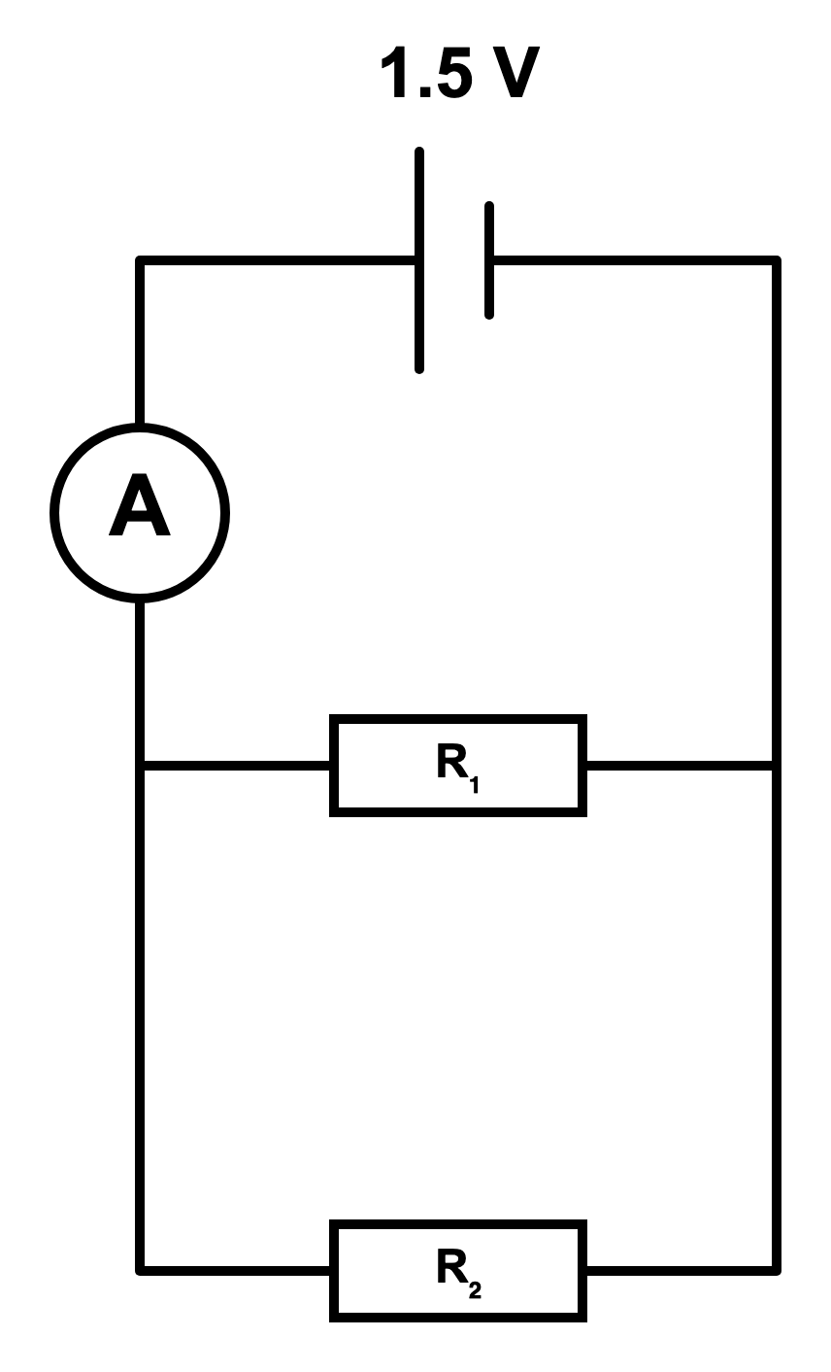
.....................................................................................................
.....................................................................................................
.....................................................................................................
.....................................................................................................
(2 marks)
14. The two labelled resistors form one loop in the circuit shown. Calculate their combined resistance.
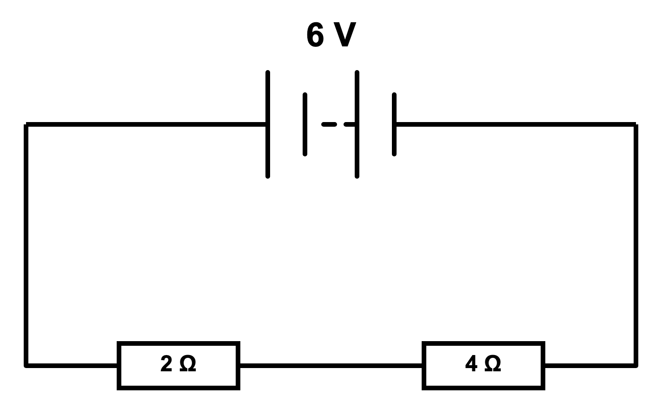
.....................................................................................................
.....................................................................................................
.....................................................................................................
.....................................................................................................
(2 marks)
15. State how the current through components connected in series compares at different points in the circuit.
.....................................................................................................
.....................................................................................................
(1 mark)
16. The circuit shown contains a single conducting loop. Name the arrangement of the lamps and compare their currents.
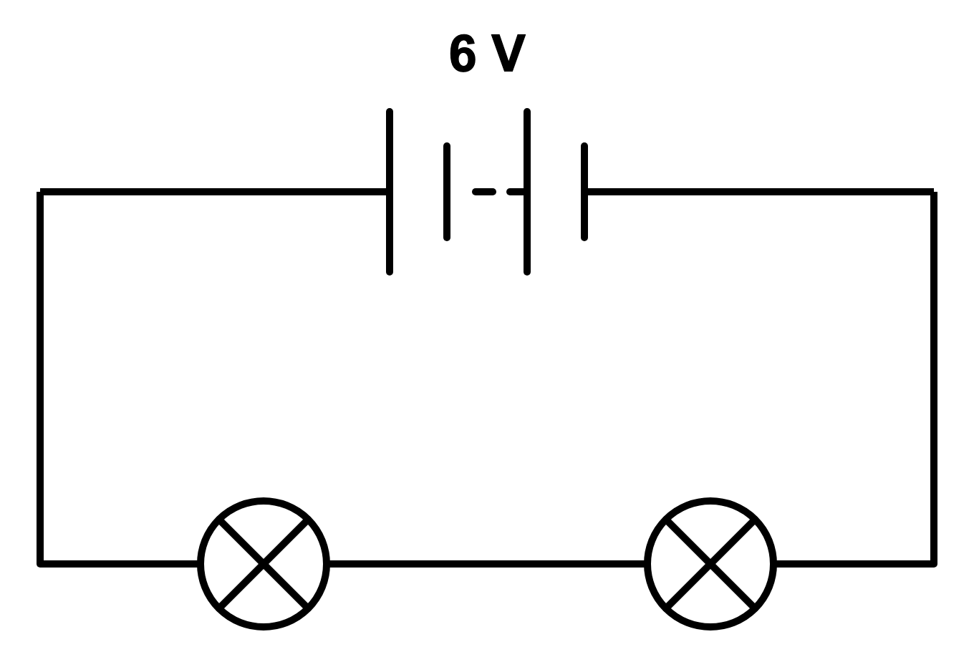
.....................................................................................................
.....................................................................................................
.....................................................................................................
.....................................................................................................
(2 marks)
17. The ammeter shows the current in one branch of a parallel circuit. A second branch carries 0.25 A. Calculate the current supplied to the two branches.
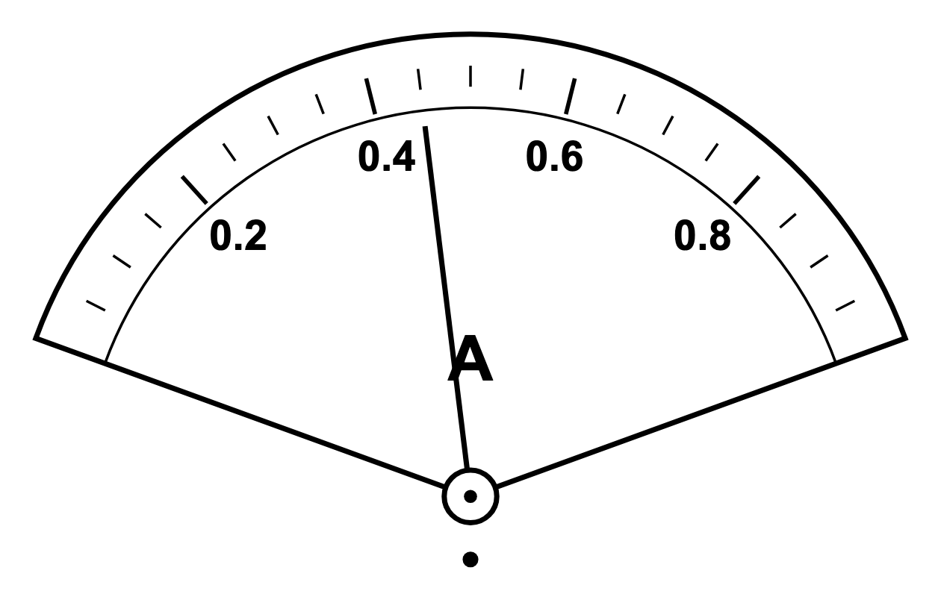
.....................................................................................................
.....................................................................................................
.....................................................................................................
.....................................................................................................
(2 marks)
18. A circuit has separate branches connected between two junctions. Name this circuit arrangement.
.....................................................................................................
.....................................................................................................
(1 mark)
19. In a series circuit, does charge have one path or more than one path?
.....................................................................................................
.....................................................................................................
(1 mark)
20. State which ammeter measures the total current and which ammeter measures the current in the upper branch.
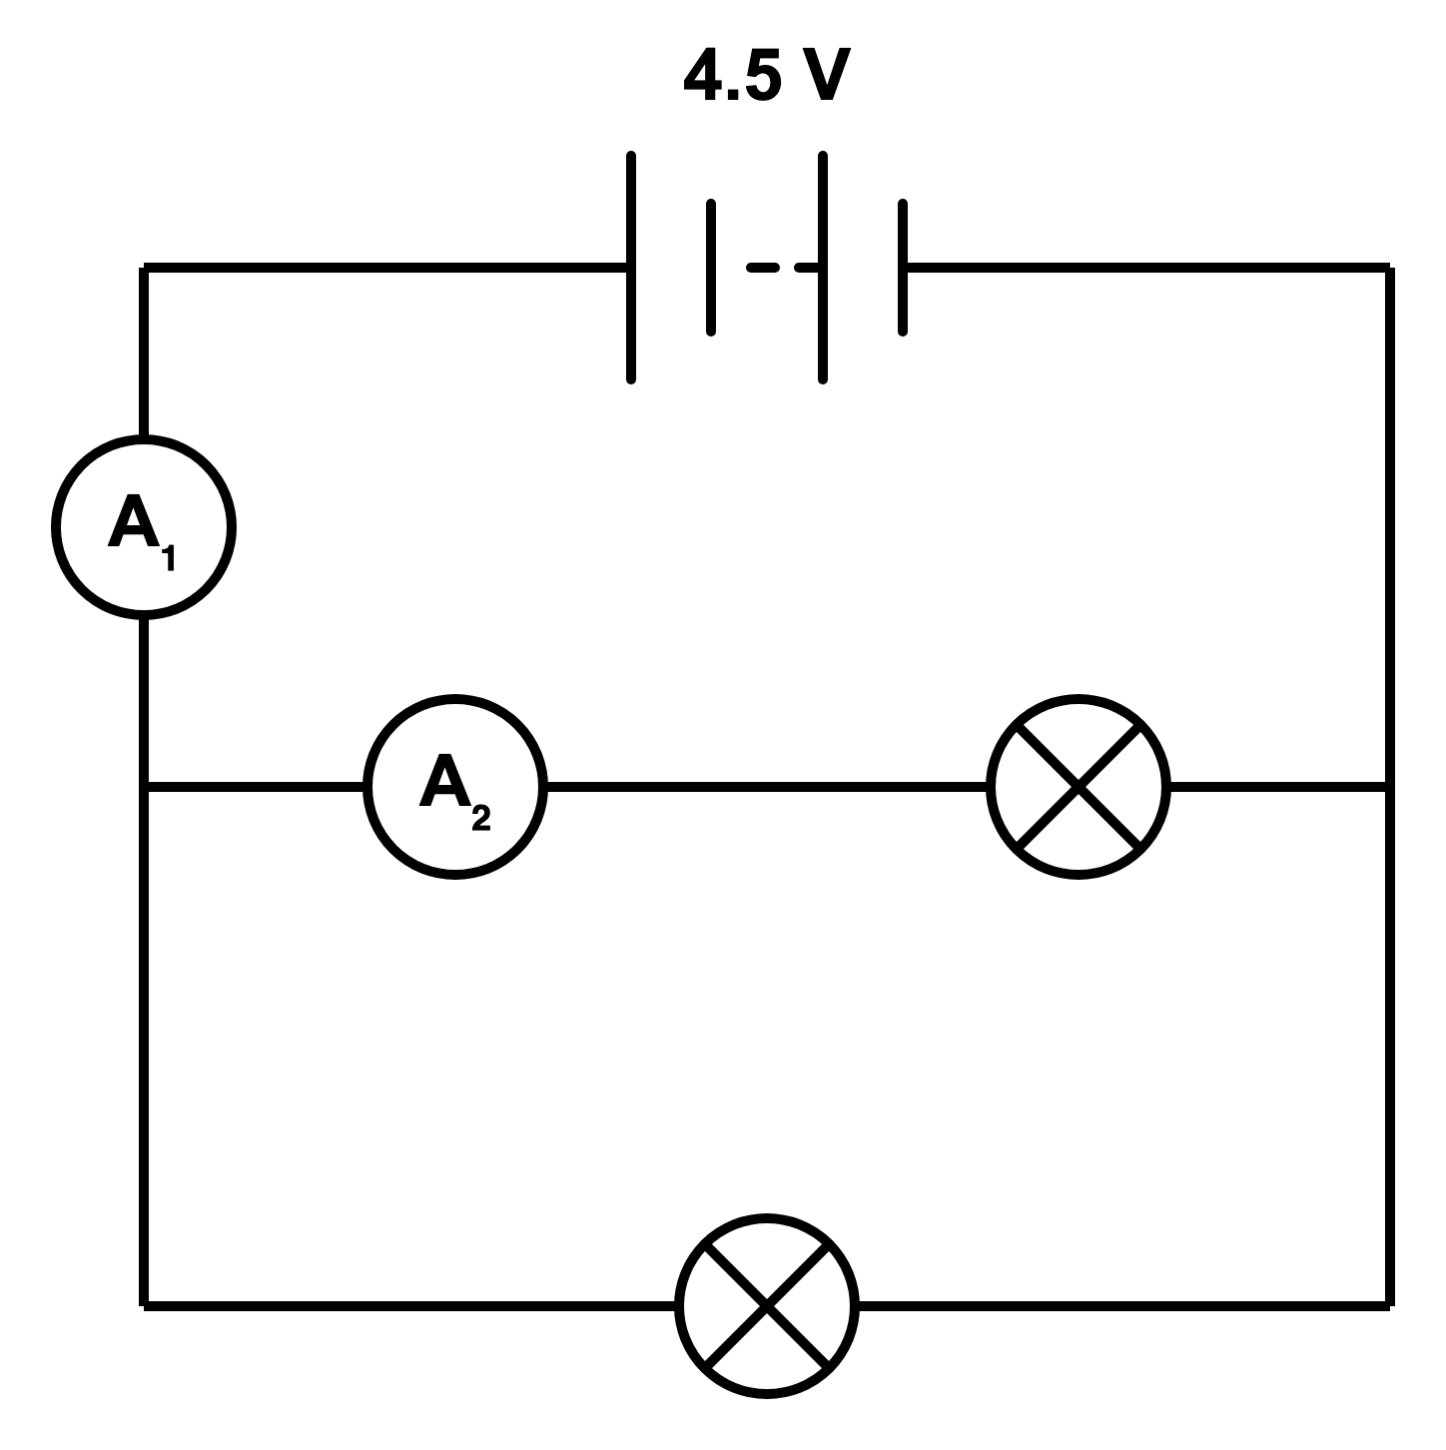
.....................................................................................................
.....................................................................................................
.....................................................................................................
.....................................................................................................
(2 marks)
21. The two ammeters are placed at different points in the same series circuit. Use the readings shown to identify why they cannot both be correct.
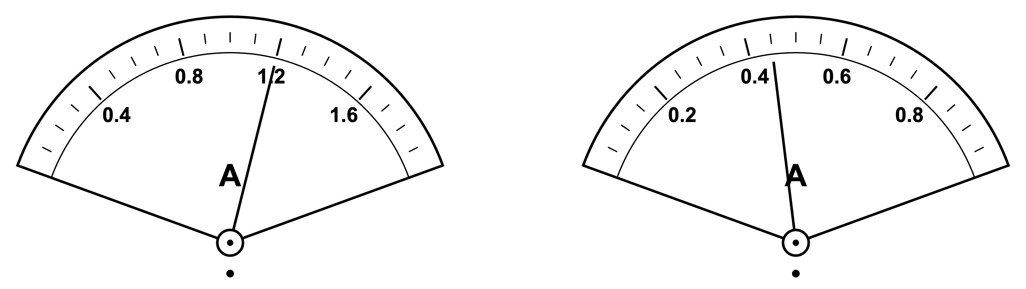
.....................................................................................................
.....................................................................................................
.....................................................................................................
.....................................................................................................
(2 marks)
22. The diagram below shows a potential divider made from two resistors in series: R₁ = 3 kΩ and R₂ = 9 kΩ. The voltmeter measures the output potential difference across R₂.
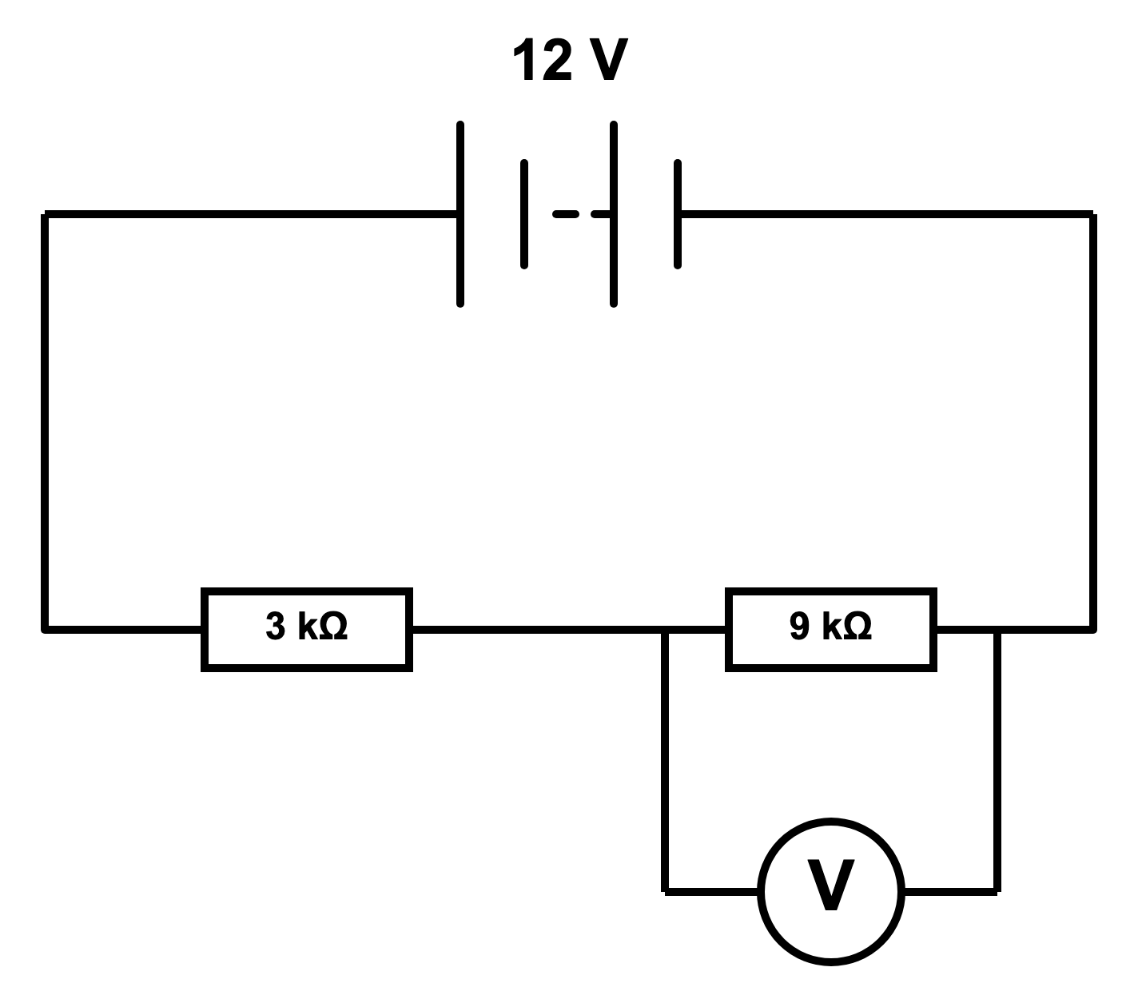
(a) State what a potential divider does.
.....................................................................................................
.....................................................................................................
(1 mark)
(b) Calculate the total resistance of the circuit.
.....................................................................................................
.....................................................................................................
(1 mark)
(c) Calculate the current in the circuit. Give your answer in mA.
.....................................................................................................
.....................................................................................................
.....................................................................................................
.....................................................................................................
(2 marks)
(d) Calculate the output potential difference across R₂.
.....................................................................................................
.....................................................................................................
.....................................................................................................
.....................................................................................................
(2 marks)
(e) Explain why the output p.d. is greater than the p.d. across R₁.
.....................................................................................................
.....................................................................................................
.....................................................................................................
.....................................................................................................
(2 marks)
23. The circuit has two parallel branches. Branch 1 contains R₁ = 6 Ω only. Branch 2 contains R₂ = 4 Ω and R₃ = 8 Ω in series.
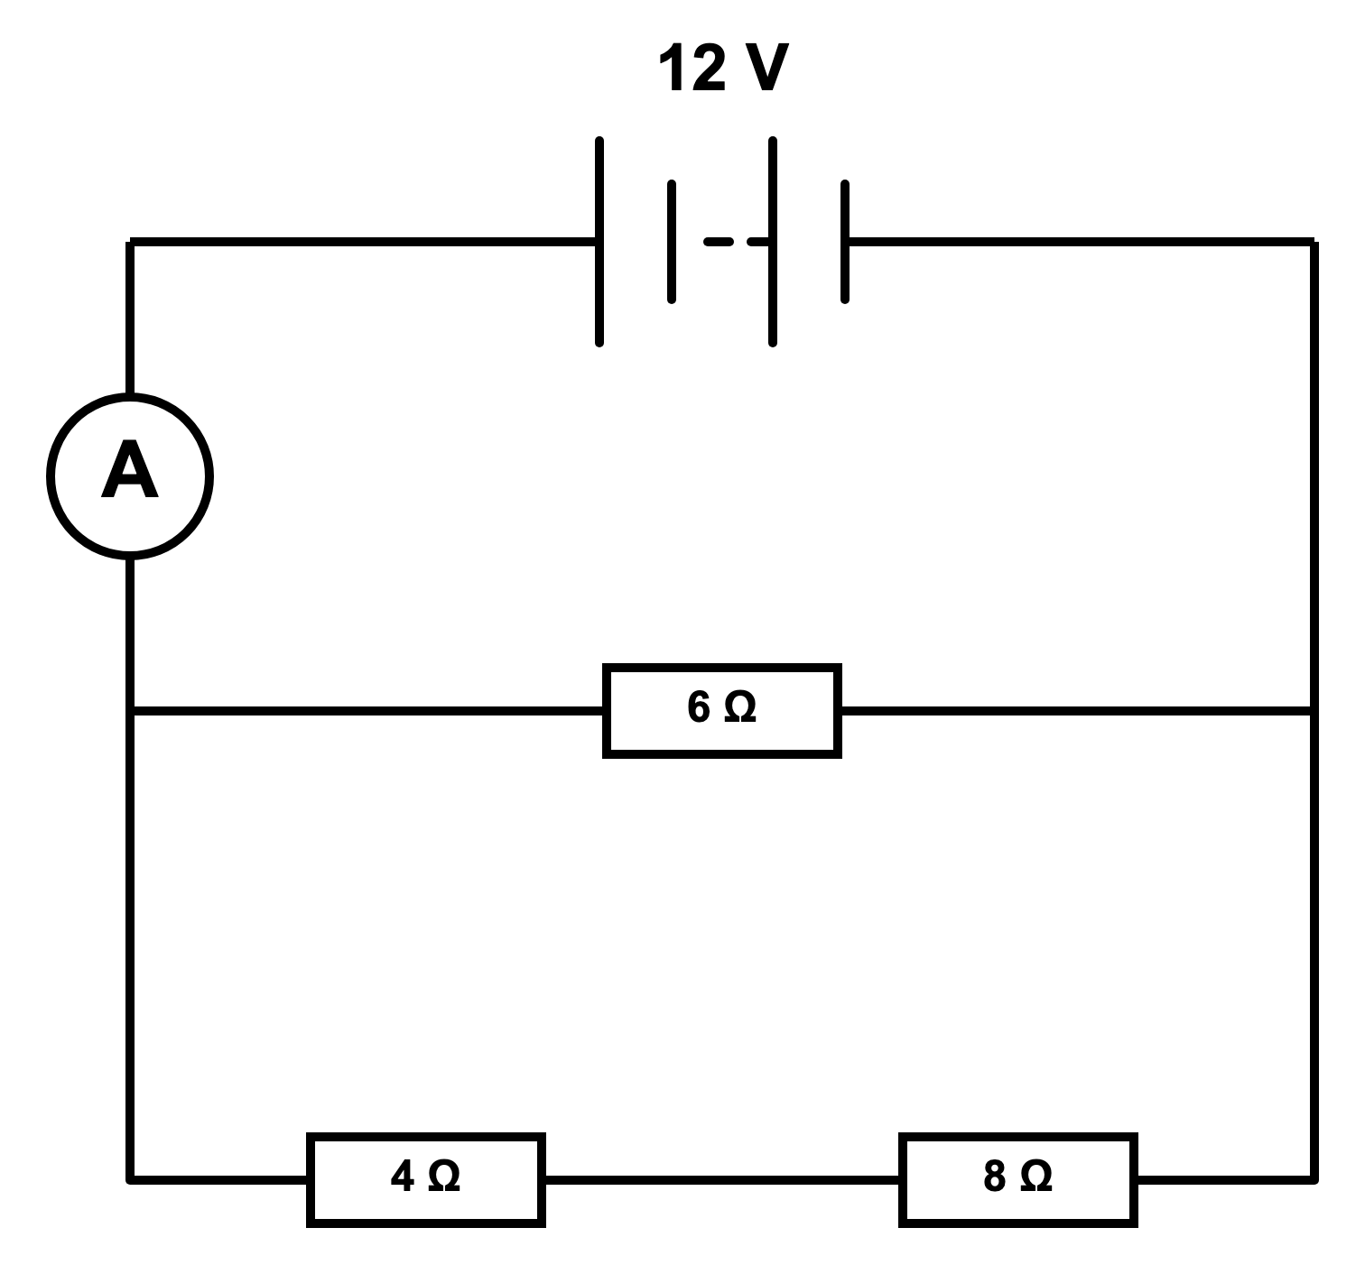
(a) State the potential difference across each branch.
.....................................................................................................
.....................................................................................................
(1 mark)
(b) Calculate the total resistance of branch 2.
.....................................................................................................
.....................................................................................................
.....................................................................................................
.....................................................................................................
(2 marks)
(c) Calculate the current through R₁.
.....................................................................................................
.....................................................................................................
.....................................................................................................
.....................................................................................................
(2 marks)
(d) Calculate the current through branch 2.
.....................................................................................................
.....................................................................................................
.....................................................................................................
.....................................................................................................
(2 marks)
(e) Calculate the total current from the battery.
.....................................................................................................
.....................................................................................................
.....................................................................................................
.....................................................................................................
(2 marks)
(f) Calculate the total resistance of the whole circuit.
.....................................................................................................
.....................................................................................................
.....................................................................................................
.....................................................................................................
(2 marks)
(g) Calculate the potential difference across R₂ and the potential difference across R₃.
.....................................................................................................
.....................................................................................................
.....................................................................................................
.....................................................................................................
.....................................................................................................
(4 marks)

