4.5 Electromagnetic effects: Cambridge IGCSE Physics worksheet
1. State the function of the split-ring commutator in a simple d.c. motor.
.....................................................................................................
.....................................................................................................
.....................................................................................................
.....................................................................................................
(2 marks)
2. The current in a conductor is increased while the magnetic field is unchanged. State the effect on the force on the conductor.
.....................................................................................................
.....................................................................................................
(1 mark)
3. In a motor-effect experiment, give one change that reverses the motion of the conductor without moving the magnet.
.....................................................................................................
.....................................................................................................
(1 mark)
4. State the direction of the force on a current-carrying wire relative to the current and the magnetic field.
.....................................................................................................
.....................................................................................................
.....................................................................................................
.....................................................................................................
(2 marks)
5. A magnet is pulled out of a coil instead of being pushed into it. State how the direction of the induced current changes.
.....................................................................................................
.....................................................................................................
(1 mark)
6. The arrows on the diagram show the magnetic field direction. State whether the conventional current in the vertical wire is upwards or downwards.
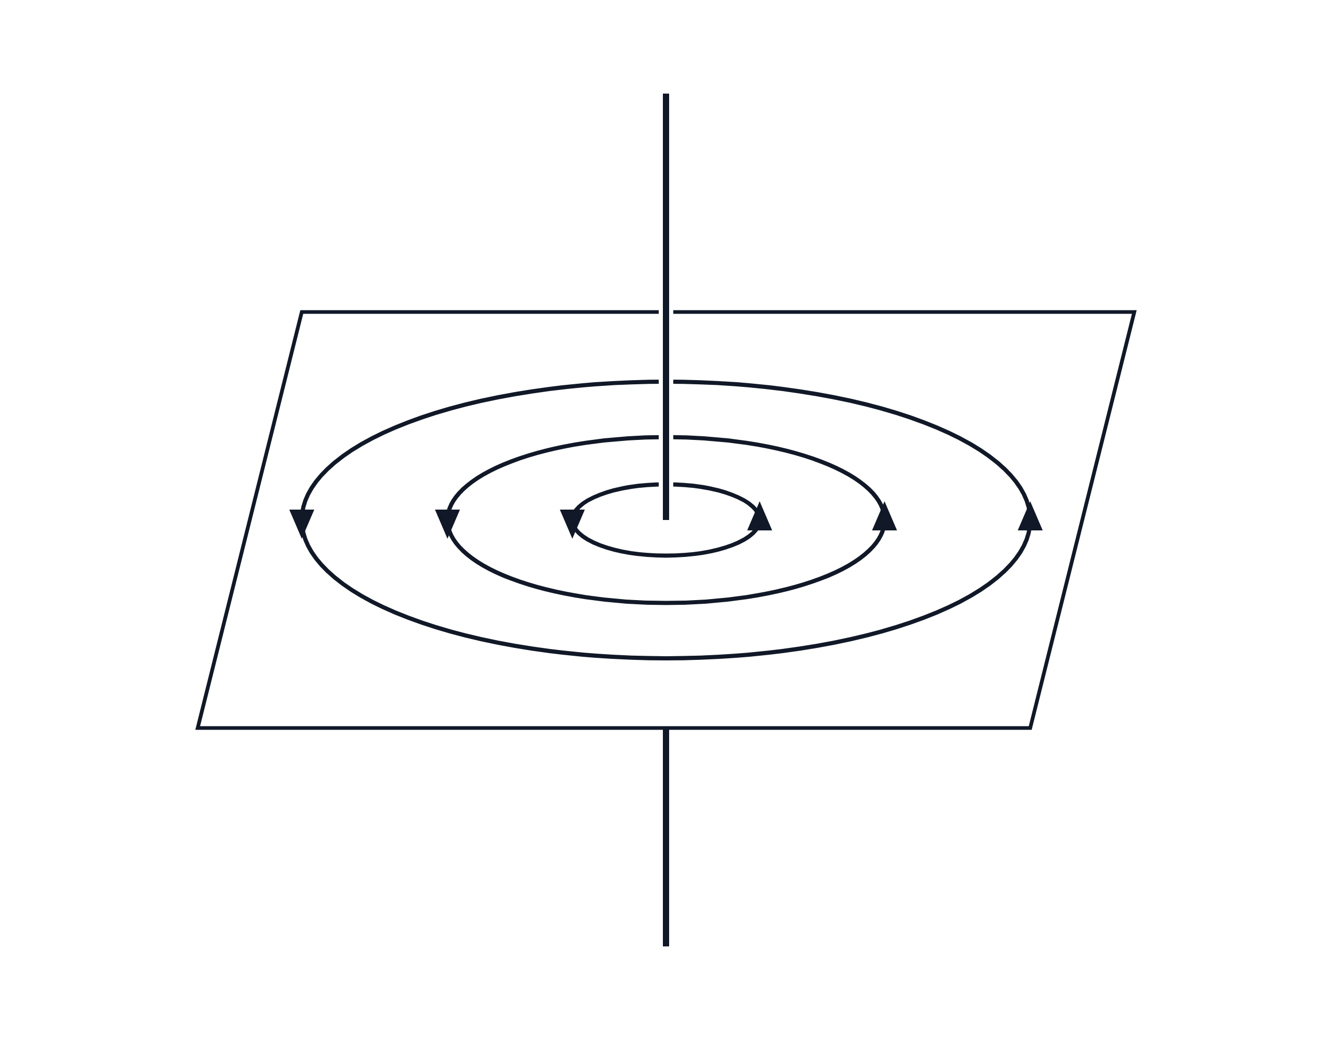
.....................................................................................................
.....................................................................................................
(1 mark)
7. State the direction of the magnetic field outside the electromagnet, immediately above its centre.
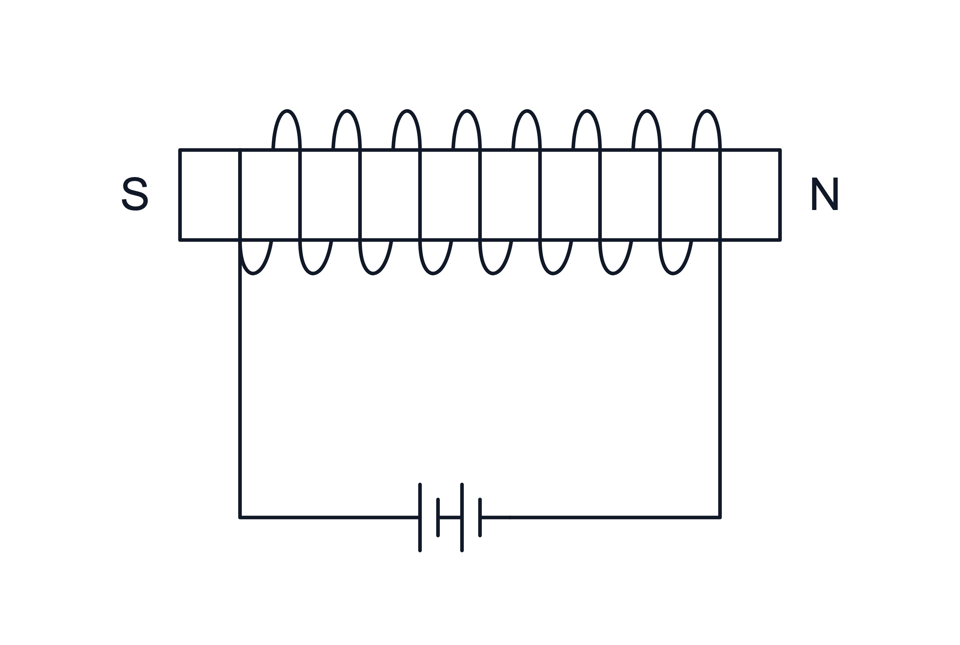
.....................................................................................................
.....................................................................................................
(1 mark)
8. Deduce the magnetic pole at the left-hand end of the electromagnet shown.
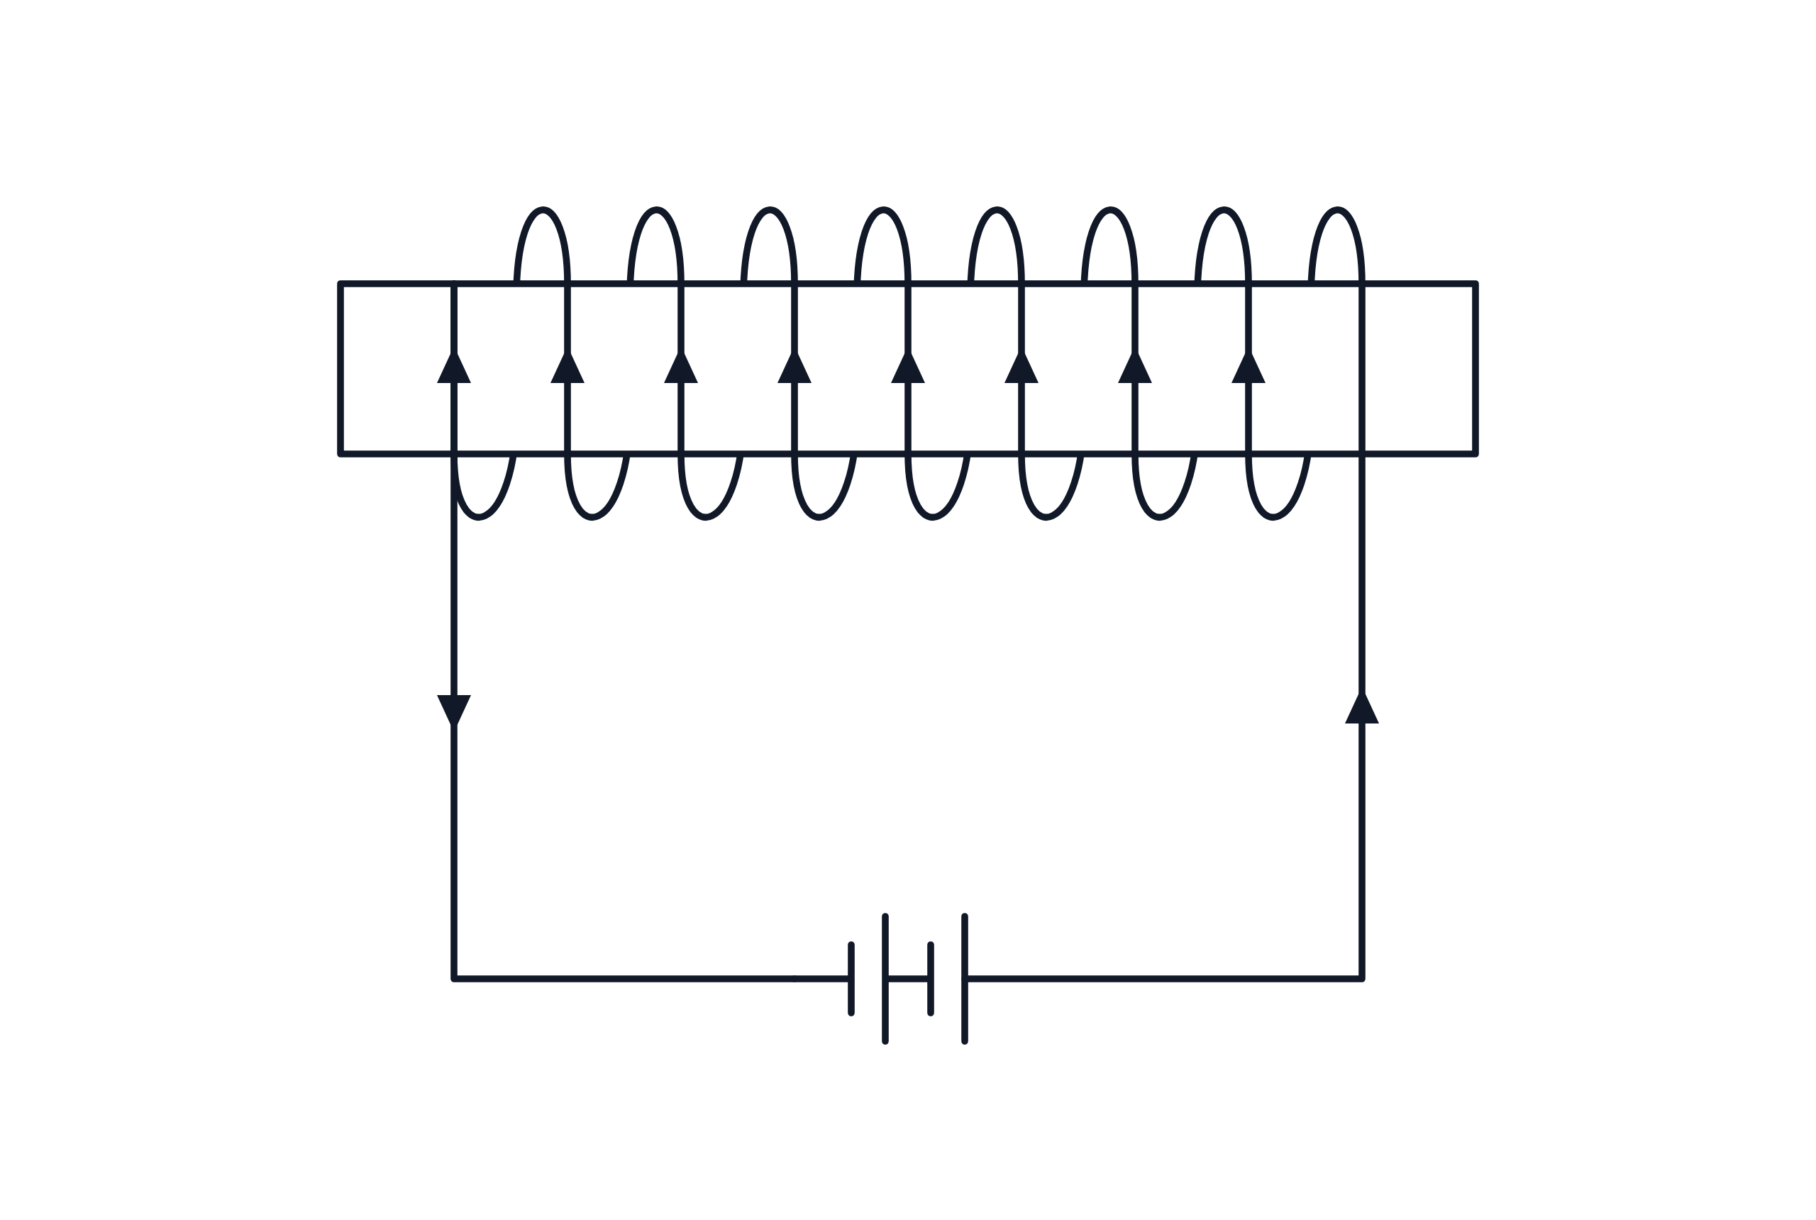
.....................................................................................................
.....................................................................................................
(1 mark)
9. State why a transformer requires an alternating current in its primary coil.
.....................................................................................................
.....................................................................................................
.....................................................................................................
.....................................................................................................
(2 marks)
10. Calculate the secondary potential difference for the transformer shown.
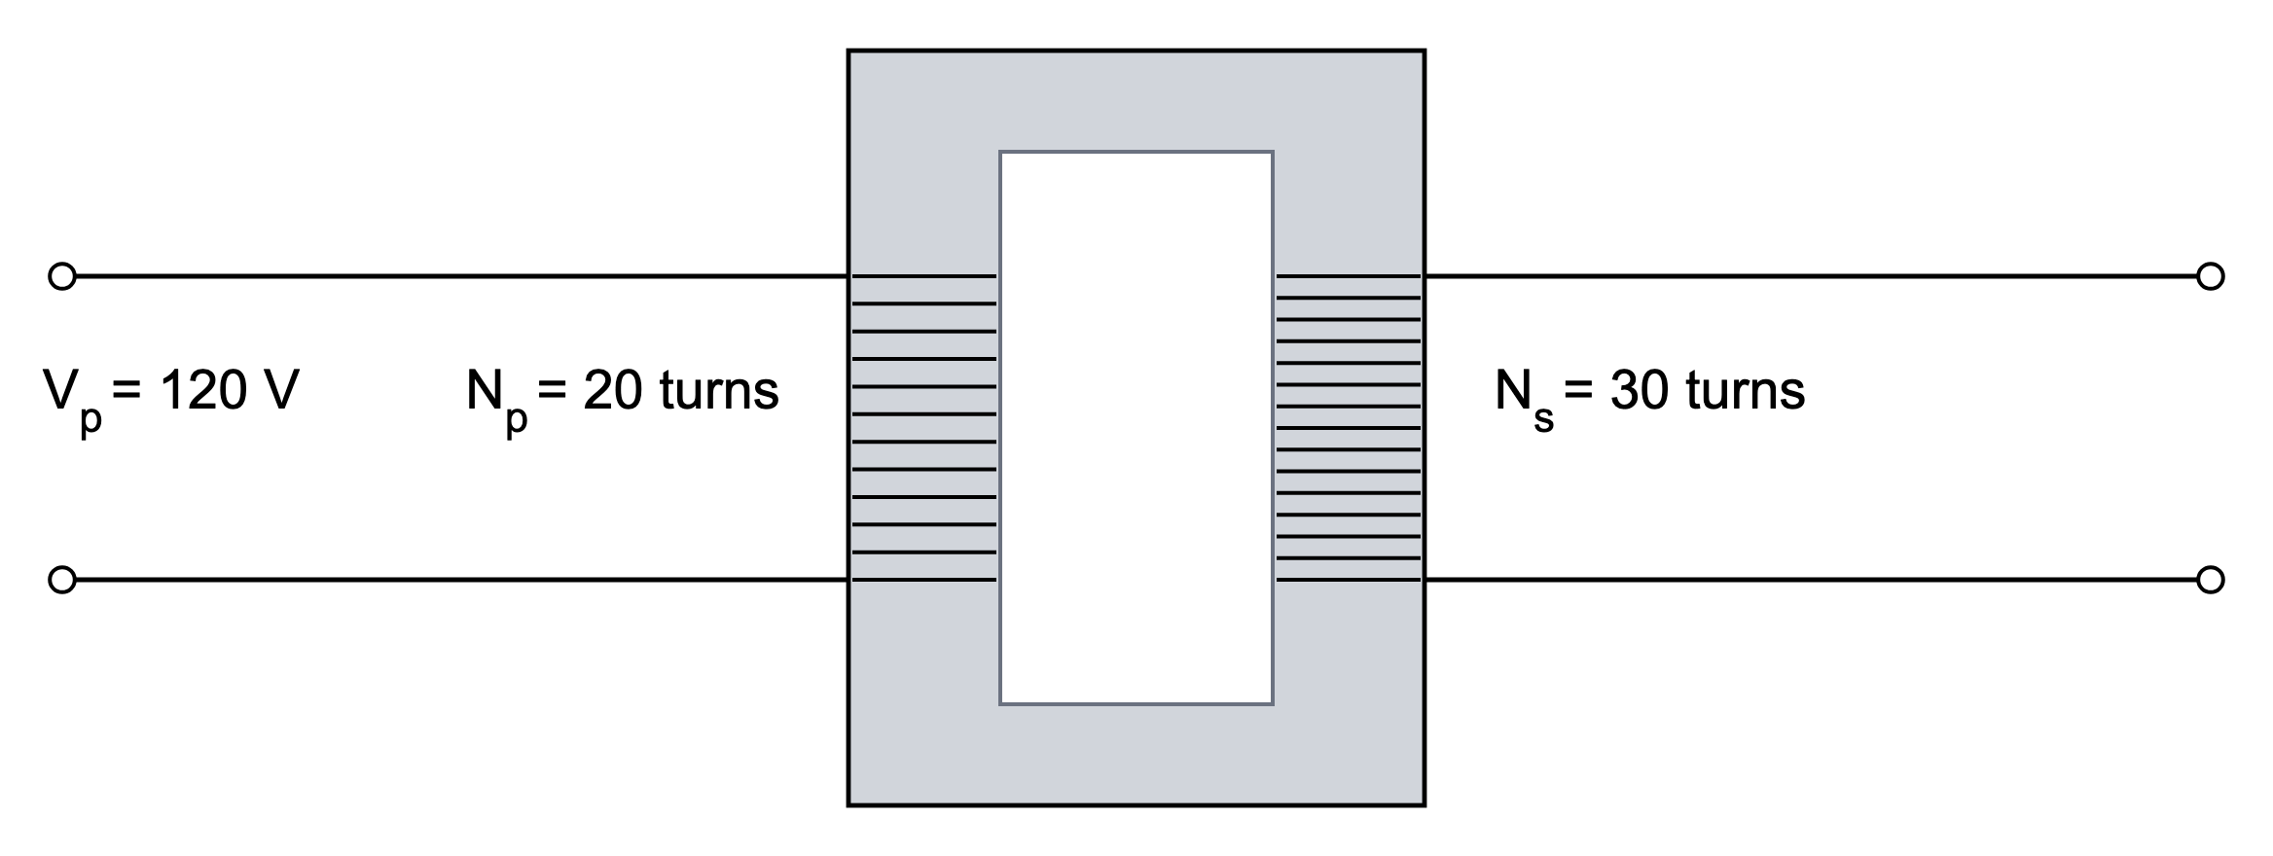
.....................................................................................................
.....................................................................................................
.....................................................................................................
.....................................................................................................
(2 marks)
11. Explain why electrical energy is transmitted at a high potential difference.
.....................................................................................................
.....................................................................................................
.....................................................................................................
.....................................................................................................
(2 marks)
12. The current around one end of a solenoid is anticlockwise when viewed from that end. Identify the magnetic pole at that end and state the direction of the field inside the solenoid.
.....................................................................................................
.....................................................................................................
.....................................................................................................
.....................................................................................................
(2 marks)
13. Use the transformer diagram to determine the number of turns on the secondary coil.
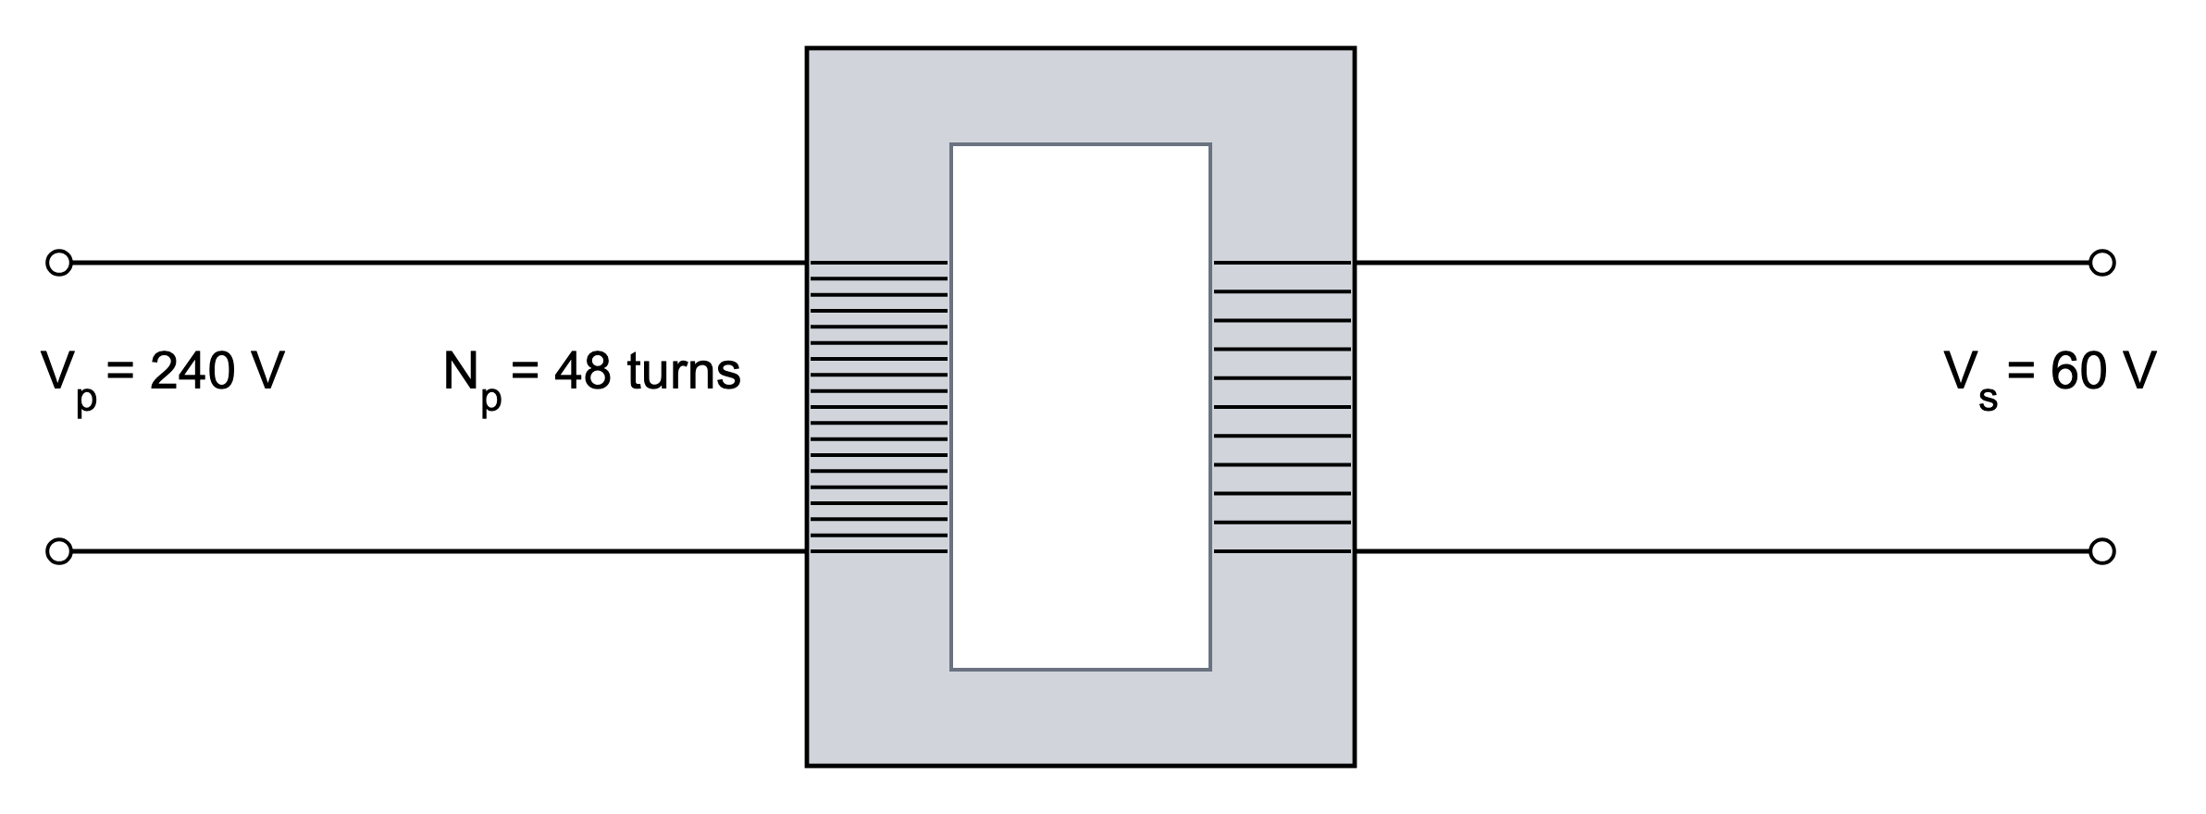
.....................................................................................................
.....................................................................................................
.....................................................................................................
.....................................................................................................
(2 marks)
14. The diagram below shows a transformer.
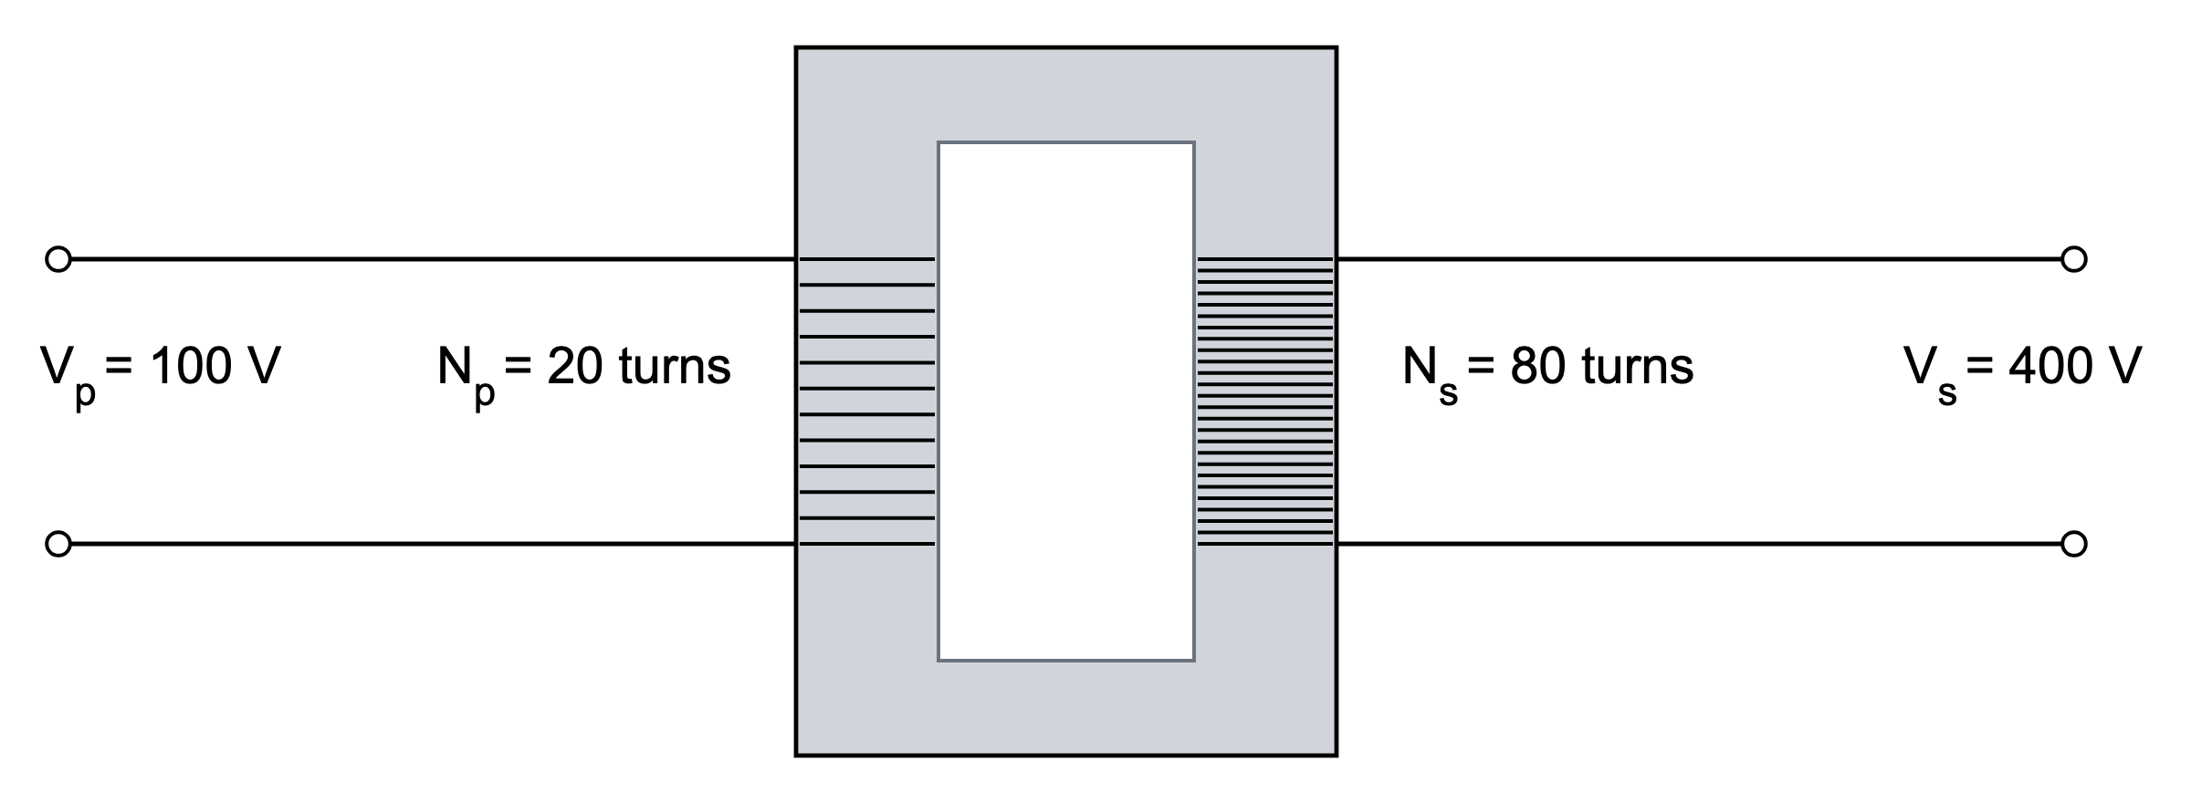
(a) Show that the turns ratio of the transformer is consistent with the voltage ratio shown in the diagram.
(2 marks)
(b) State whether this transformer is step-up or step-down. Give a reason for your answer.
.....................................................................................................
.....................................................................................................
.....................................................................................................
.....................................................................................................
(2 marks)
(c) Step-up transformers are used on the National Grid. Explain why the voltage is increased before electricity is transmitted over long distances.
.....................................................................................................
.....................................................................................................
.....................................................................................................
.....................................................................................................
.....................................................................................................
(3 marks)
(d) Describe how the alternating current in the primary coil of a transformer causes a voltage to be induced in the secondary coil.
.....................................................................................................
.....................................................................................................
.....................................................................................................
.....................................................................................................
.....................................................................................................
(4 marks)
15. A teacher gives a student a bar magnet, a coil of wire and a galvanometer.
(a) Describe how the student can use the equipment to demonstrate electromagnetic induction.
.....................................................................................................
.....................................................................................................
.....................................................................................................
.....................................................................................................
.....................................................................................................
(3 marks)
(b) Describe the galvanometer readings when the north pole of the magnet is pushed into the coil, pulled back out of the coil, and then held still inside the coil.
.....................................................................................................
.....................................................................................................
.....................................................................................................
.....................................................................................................
.....................................................................................................
(3 marks)
(c) Explain why a galvanometer is more useful than an ordinary ammeter in this experiment.
.....................................................................................................
.....................................................................................................
(1 mark)
16. The diagram shows a simple motor-effect setup. A conductor is placed between the poles of a magnet and connected to a d.c. supply.
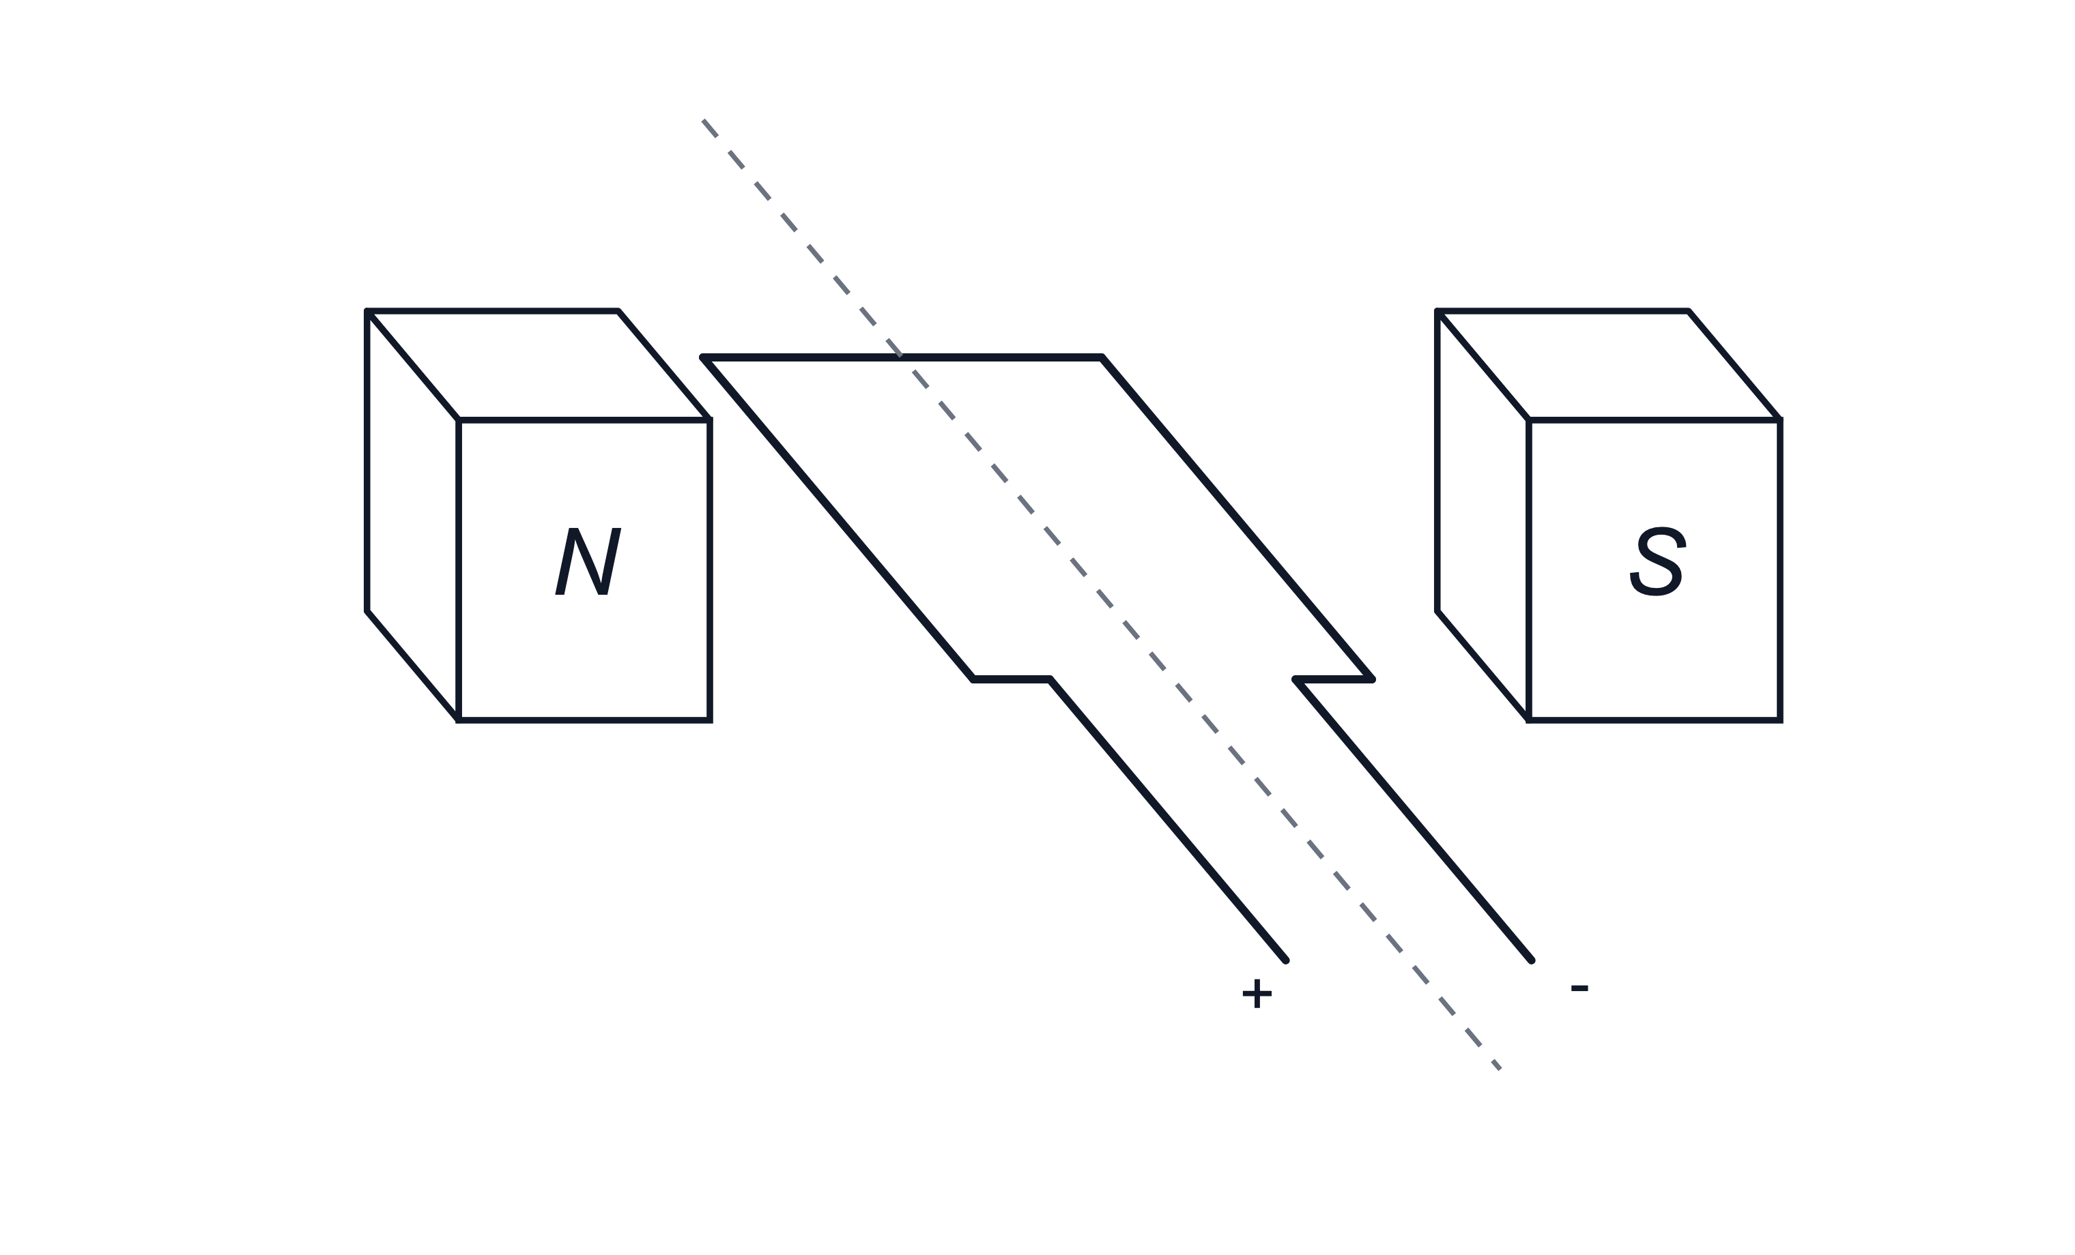
(a) State what is meant by the motor effect.
.....................................................................................................
.....................................................................................................
(1 mark)
(b) State two separate changes that would reverse the direction of the force on the conductor.
.....................................................................................................
.....................................................................................................
.....................................................................................................
.....................................................................................................
(2 marks)
(c) Explain why the conductor would not move if the circuit were open.
.....................................................................................................
.....................................................................................................
.....................................................................................................
.....................................................................................................
(2 marks)
17. A student pushes a bar magnet towards a coil of wire connected to a sensitive voltmeter. The voltmeter needle deflects while the magnet is moving.
(a) State what is meant by an induced e.m.f.
.....................................................................................................
.....................................................................................................
.....................................................................................................
.....................................................................................................
(2 marks)
(b) The student holds the magnet still inside the coil. State and explain what happens to the reading on the voltmeter.
.....................................................................................................
.....................................................................................................
.....................................................................................................
.....................................................................................................
(2 marks)
(c) State two changes that could make a larger e.m.f. appear on the voltmeter.
.....................................................................................................
.....................................................................................................
.....................................................................................................
.....................................................................................................
(2 marks)

