5.1 The nuclear model of the atom: Cambridge IGCSE Physics worksheet
1. Which statement describes nuclear fission?
A A nucleus emits an electron.
B Two light nuclei join to form a heavier nucleus.
C A heavy nucleus splits into two lighter nuclei.
D An atom loses an outer electron.
(1 mark)
2. An ion contains 12 protons, 12 neutrons and 10 electrons.
What is the charge on the ion?
A −2
B 0
C +2
D +12
(1 mark)
3. Which condition causes the number of fission events in successive generations to increase rapidly?
A No neutrons from fission reach another fuel nucleus.
B Exactly one neutron from each fission causes another fission.
C All neutrons are absorbed by the control rods.
D More than one neutron from each fission causes another fission.
(1 mark)
4. What happens first when a ${}_{92}^{235}U$ nucleus undergoes induced fission?
A It absorbs an electron.
B It emits all its protons.
C It joins with another ${}_{92}^{235}U$ nucleus.
D It absorbs a neutron.
(1 mark)
5. Which row describes the products of a typical fission event?
 | Nuclei formed | Neutrons emitted | Energy released
A | one heavier nucleus | none | yes
B | two lighter nuclei | two or three | yes
C | two lighter nuclei | none | no
D | one unchanged nucleus | two or three | no

(1 mark)
6. Which statement about energy release in fission and fusion is correct?
A Fission releases energy, but fusion always absorbs energy.
B Both processes can release large amounts of energy from a small amount of fuel.
C Fusion releases energy, but fission always absorbs energy.
D Neither process releases more energy than a chemical reaction.
(1 mark)
7. In a scattering experiment, most alpha particles pass straight through a very thin metal foil.
What does this observation suggest about atoms?
A Atoms contain no charged particles.
B Atomic nuclei have negative charge.
C Most of an atom is empty space.
D Electrons contain nearly all the atomic mass.
(1 mark)
8. A phosphorus nucleus has proton number 15 and nucleon number 31.
How many neutrons are in the nucleus?
A 15
B 31
C 16
D 46
(1 mark)
9. A reactor operates at a steady power. On average, what happens to the neutrons released by each fission event?
A One neutron causes another fission event.
B No neutrons cause another fission event.
C Every neutron causes another fission event.
D All neutrons remain inside the original nucleus.
(1 mark)
10. A neutral atom contains 12 protons.
How many electrons does it contain?
A 12
B 6
C 13
D 24
(1 mark)
11. Why do neutral isotopes of the same element have the same chemical properties?
A They have the same electron arrangement.
B They have the same neutron number.
C They have the same nucleon number.
D They have nuclei with the same mass.
(1 mark)
12. Each fission event releases two neutrons, and each neutron causes one new fission event. One fission event occurs first.
How many fission events occur in total in the next two generations?
A 2
B 4
C 6
D 8
(1 mark)
13. How many more neutrons than protons are shown in this nucleus?
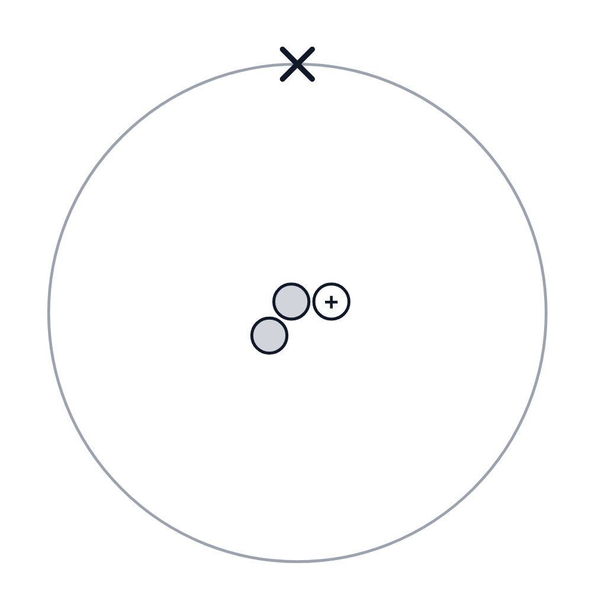
.....................................................................................................
.....................................................................................................
(1 mark)
14. Define nuclear fission.
.....................................................................................................
.....................................................................................................
.....................................................................................................
.....................................................................................................
(2 marks)
15. State the particle that is usually absorbed by a uranium-235 nucleus before it undergoes fission.
.....................................................................................................
.....................................................................................................
(1 mark)
16. Explain what is meant by isotopes of the same element.
.....................................................................................................
.....................................................................................................
.....................................................................................................
.....................................................................................................
(2 marks)
17. Define proton number.
.....................................................................................................
.....................................................................................................
(1 mark)
18. Define the nucleon number of a nucleus.
.....................................................................................................
.....................................................................................................
(1 mark)
19. State the relative mass of a proton and the relative mass of a neutron.
.....................................................................................................
.....................................................................................................
.....................................................................................................
.....................................................................................................
(2 marks)
20. What subatomic particle is marked B in the model shown? Include its relative charge.
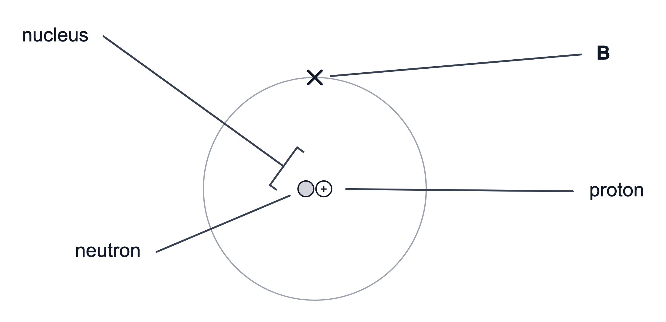
.....................................................................................................
.....................................................................................................
.....................................................................................................
.....................................................................................................
(2 marks)
21. State what the proton number identifies about a nucleus.
.....................................................................................................
.....................................................................................................
(1 mark)
22. Mara says every particle visible in this nucleus is positive. Use the model to correct her statement.
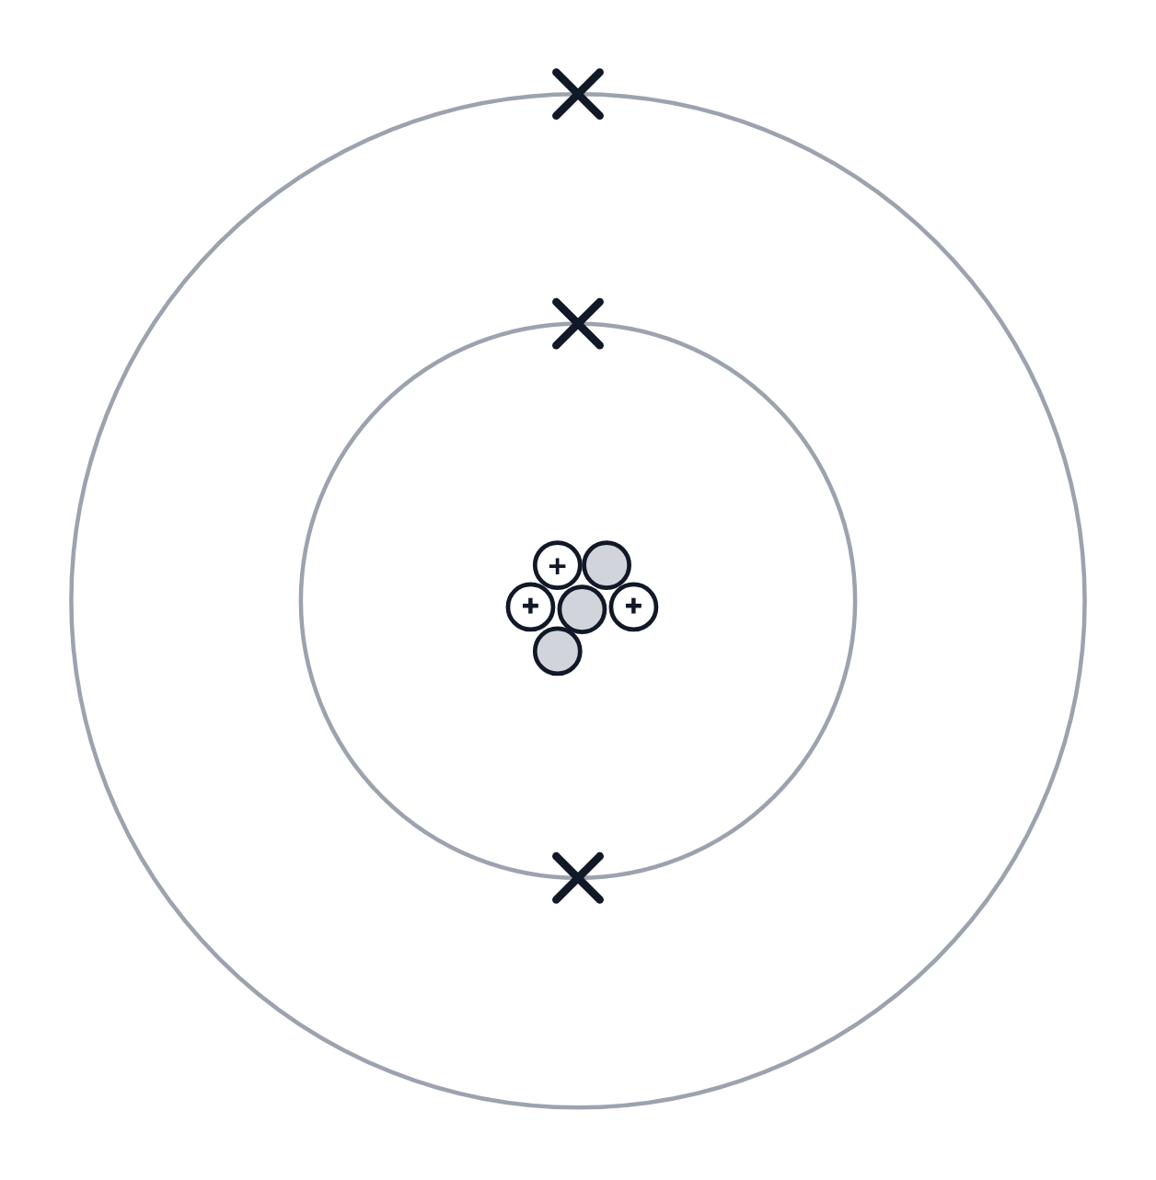
.....................................................................................................
.....................................................................................................
.....................................................................................................
.....................................................................................................
(2 marks)
23. A nuclear reaction involving uranium-235 is represented by the incomplete equation ${}_{92}^{235}U+_{0}^{1}n→_{56}^{A}Ba+_{Z}^{92}Kr+3 {}_{0}^{1}n$.
(a) State why a neutron is written with proton number 0.
.....................................................................................................
.....................................................................................................
(1 mark)
(b) Determine the values of A and Z in the equation.
.....................................................................................................
.....................................................................................................
.....................................................................................................
.....................................................................................................
.....................................................................................................
(4 marks)
(c) Describe the nuclear process shown by this equation.
.....................................................................................................
.....................................................................................................
.....................................................................................................
.....................................................................................................
.....................................................................................................
(3 marks)
(d) Explain the energy transfer to the fission products.
.....................................................................................................
.....................................................................................................
.....................................................................................................
.....................................................................................................
(2 marks)
24. In a nuclear fission reaction, a uranium-235 nucleus absorbs a neutron and splits into two daughter nuclei, releasing two or three neutrons. The total mass of the products is compared with the total mass of the reactants.
(a) State whether the products have greater mass, smaller mass or the same mass as the reactants.
.....................................................................................................
.....................................................................................................
(1 mark)
(b) Describe why the nucleon number can still be conserved in the reaction.
.....................................................................................................
.....................................................................................................
.....................................................................................................
.....................................................................................................
(2 marks)
(c) Explain why energy is released.
.....................................................................................................
.....................................................................................................
(1 mark)
(d) State the main energy store gained by the moving fission products.
.....................................................................................................
.....................................................................................................
(1 mark)
25. A neutral chromium atom is represented as ${}_{24}^{52}Cr$.
(a) State the number of protons in the nucleus.
.....................................................................................................
.....................................................................................................
(1 mark)
(b) Calculate the number of neutrons in the nucleus.
.....................................................................................................
.....................................................................................................
.....................................................................................................
.....................................................................................................
(2 marks)
(c) Determine the relative charge of the chromium nucleus.
.....................................................................................................
.....................................................................................................
.....................................................................................................
.....................................................................................................
(2 marks)
(d) Determine the relative mass of the chromium nucleus and explain why electron mass is ignored.
.....................................................................................................
.....................................................................................................
.....................................................................................................
.....................................................................................................
.....................................................................................................
(3 marks)

