5.2 Radioactivity: Cambridge IGCSE Physics worksheet
1. What is an alpha particle?
A a helium nucleus containing two protons and two neutrons
B a high-speed electron
C an electromagnetic wave
D a single neutron
(1 mark)
2. Which row gives the nucleon number and proton number of a beta-minus particle?
 | Nucleon number | Proton number
A | 4 | 2
B | 0 | 0
C | 1 | 0
D | 0 | −1

(1 mark)
3. A sample initially contains 6400 undecayed nuclei of a radioactive isotope.
How many of these nuclei are expected to remain undecayed after three half-lives?
A 800
B 1600
C 3200
D 5600
(1 mark)
4. A student must move a sealed radioactive source a short distance in a laboratory.
Which action reduces the radiation dose to the student's hands?
A holding the source directly and moving it slowly
B using tongs and completing the move promptly
C holding the source closer to make it easier to see
D removing the source from its container long before it is needed
(1 mark)
5. The activity of a radioactive sample decreases from 960 Bq to 120 Bq in 18 hours.
What is the half-life of the isotope?
A 3 hours
B 6 hours
C 9 hours
D 12 hours
(1 mark)
6. A narrow beam of gamma radiation enters a magnetic field.
What happens to the beam?
A It follows a circular path through the field.
B It spirals because the field steadily removes its energy.
C It continues without being deflected.
D It stops immediately at the edge of the field.
(1 mark)
7. What must be true for a nuclear equation to be balanced?
A The same number of nuclei must appear on both sides.
B The same element symbol must appear on both sides.
C Every number on the left must equal the number directly opposite it.
D The total nucleon number and total proton number must each be the same on both sides.
(1 mark)
8. A radioactive tracer moves through a thick steel pipe. A detector outside the pipe must detect the radiation from the tracer.
Which type of radiation is most suitable?
A alpha, because it is the most ionising
B beta, because it is always stopped by air
C gamma, because it can penetrate the pipe wall
D alpha, because it has the shortest range
(1 mark)
9. The activity of a sample is 45 Bq after three half-lives.
What was its initial activity?
A 135 Bq
B 360 Bq
C 180 Bq
D 5.625 Bq
(1 mark)
10. A detector records 860 counts/min from a source and the background together. The background count rate is 60 counts/min.
What count rate will the detector record after one half-life?
A 400 counts/min
B 430 counts/min
C 800 counts/min
D 460 counts/min
(1 mark)
11. An old sample and an equal mass of recently living material contain the same radioactive isotope. Their corrected count rates are 80 counts/min and 640 counts/min respectively. The half-life of the isotope is 6000 years.
What is the age of the old sample?
A 6000 years
B 12 000 years
C 18 000 years
D 24 000 years
(1 mark)
12. Which particle completes the nuclear equation?
${}_{6}^{14}C→{}_{7}^{14}N$ + ?
A ${}_{2}^{4}He$
B ${}_{−1}^{0}e$
C ${}_{0}^{1}n$
D ${}_{0}^{0}γ$
(1 mark)
13. State one property of the two smaller nuclei produced by the fission of uranium-235.
.....................................................................................................
.....................................................................................................
(1 mark)
14. In the equation ${}_{19}^{40}K→_{□}^{□}Ca+_{−1}^{0}e$, determine the missing upper and lower numbers.
.....................................................................................................
.....................................................................................................
.....................................................................................................
.....................................................................................................
(2 marks)
15. On the diagram, draw the paths of alpha and beta particles after entering the magnetic field.
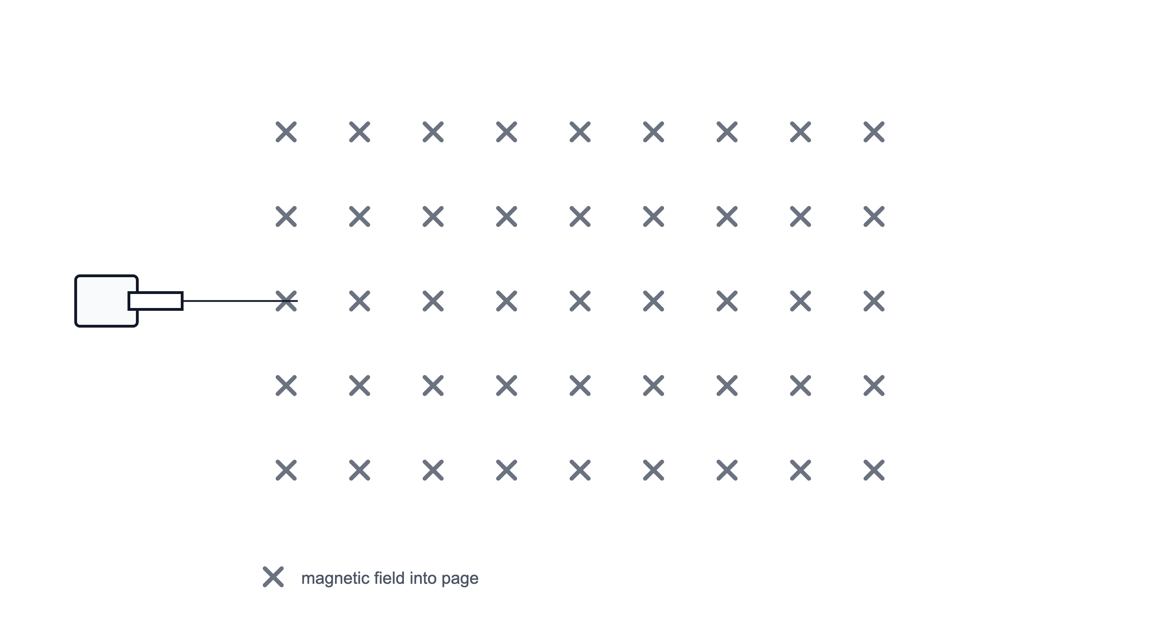
(2 marks)
16. State the meaning of an activity of 350 Bq.
.....................................................................................................
.....................................................................................................
(1 mark)
17. Use the paths labelled P, Q and R. Identify the beta path, the gamma path and the alpha path.
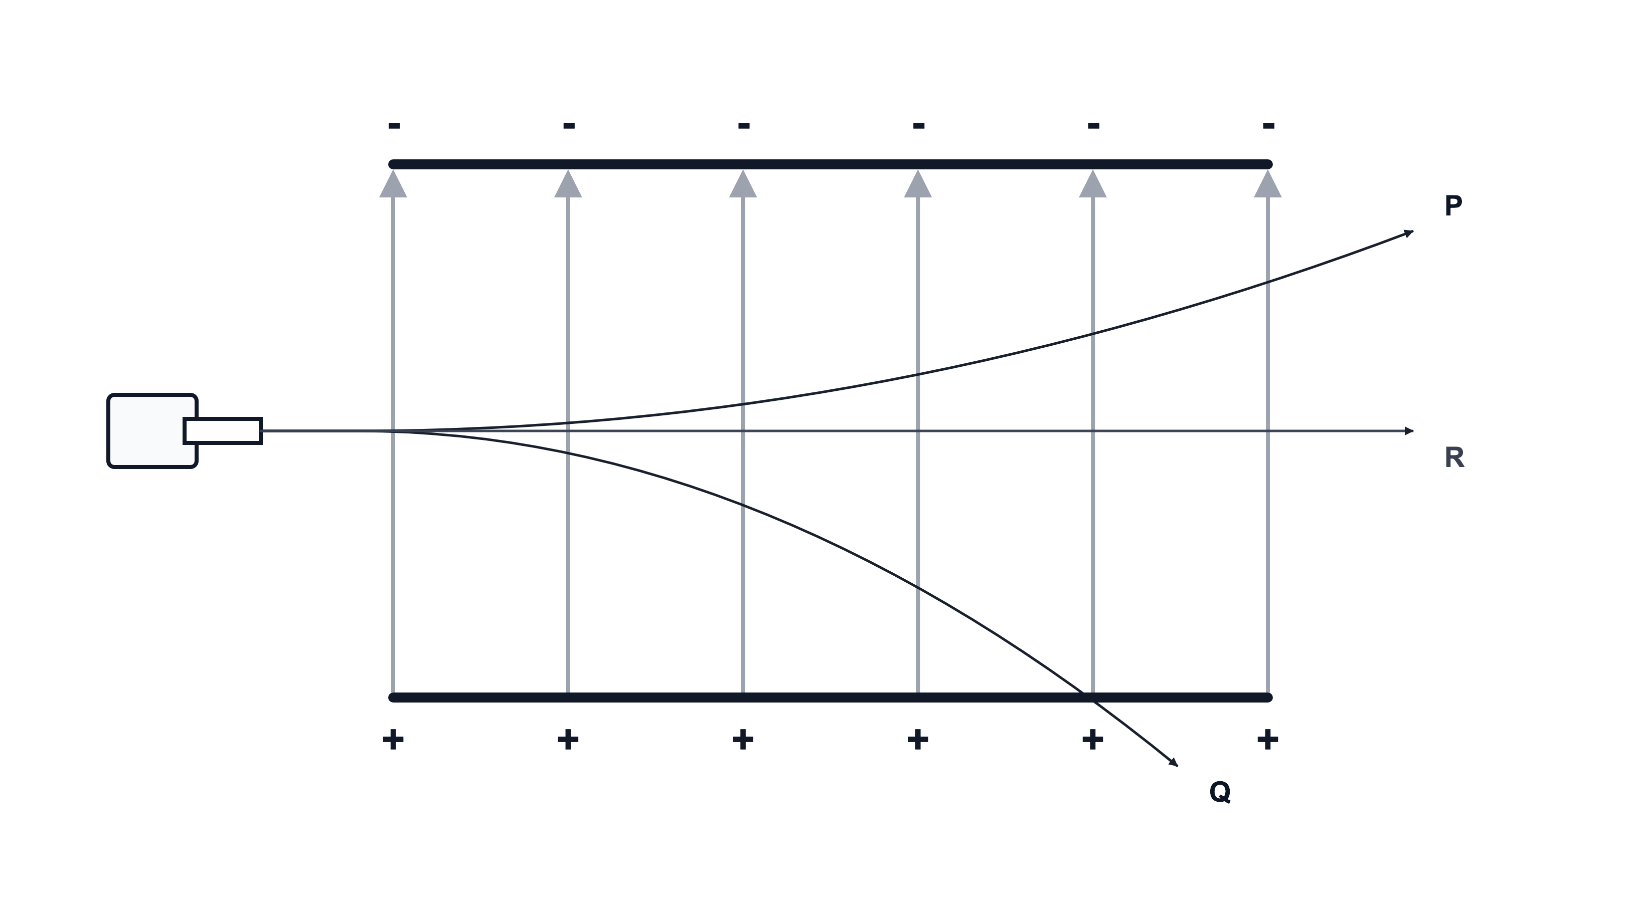
.....................................................................................................
.....................................................................................................
.....................................................................................................
.....................................................................................................
(2 marks)
18. Put alpha, beta and gamma radiation in order from most ionising to least ionising.
.....................................................................................................
.....................................................................................................
.....................................................................................................
.....................................................................................................
(2 marks)
19. Identify beta and alpha particles in the diagram below. Compare the amount of deflection of beta radiation with alpha radiation. Give one reason for the difference.
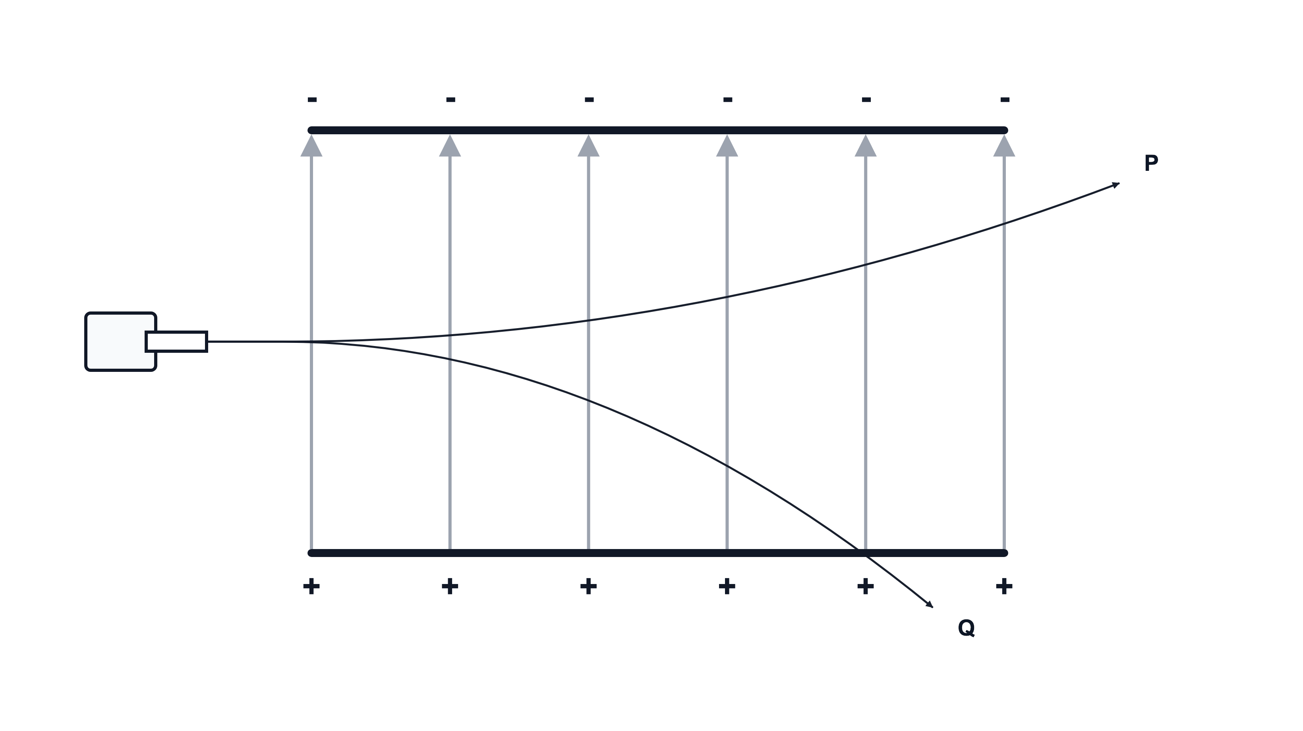
.....................................................................................................
.....................................................................................................
.....................................................................................................
.....................................................................................................
.....................................................................................................
(3 marks)
20. Alpha, beta and gamma radiation pass through the electric field shown. Identify the radiation that is not deflected and explain why it follows a straight path.
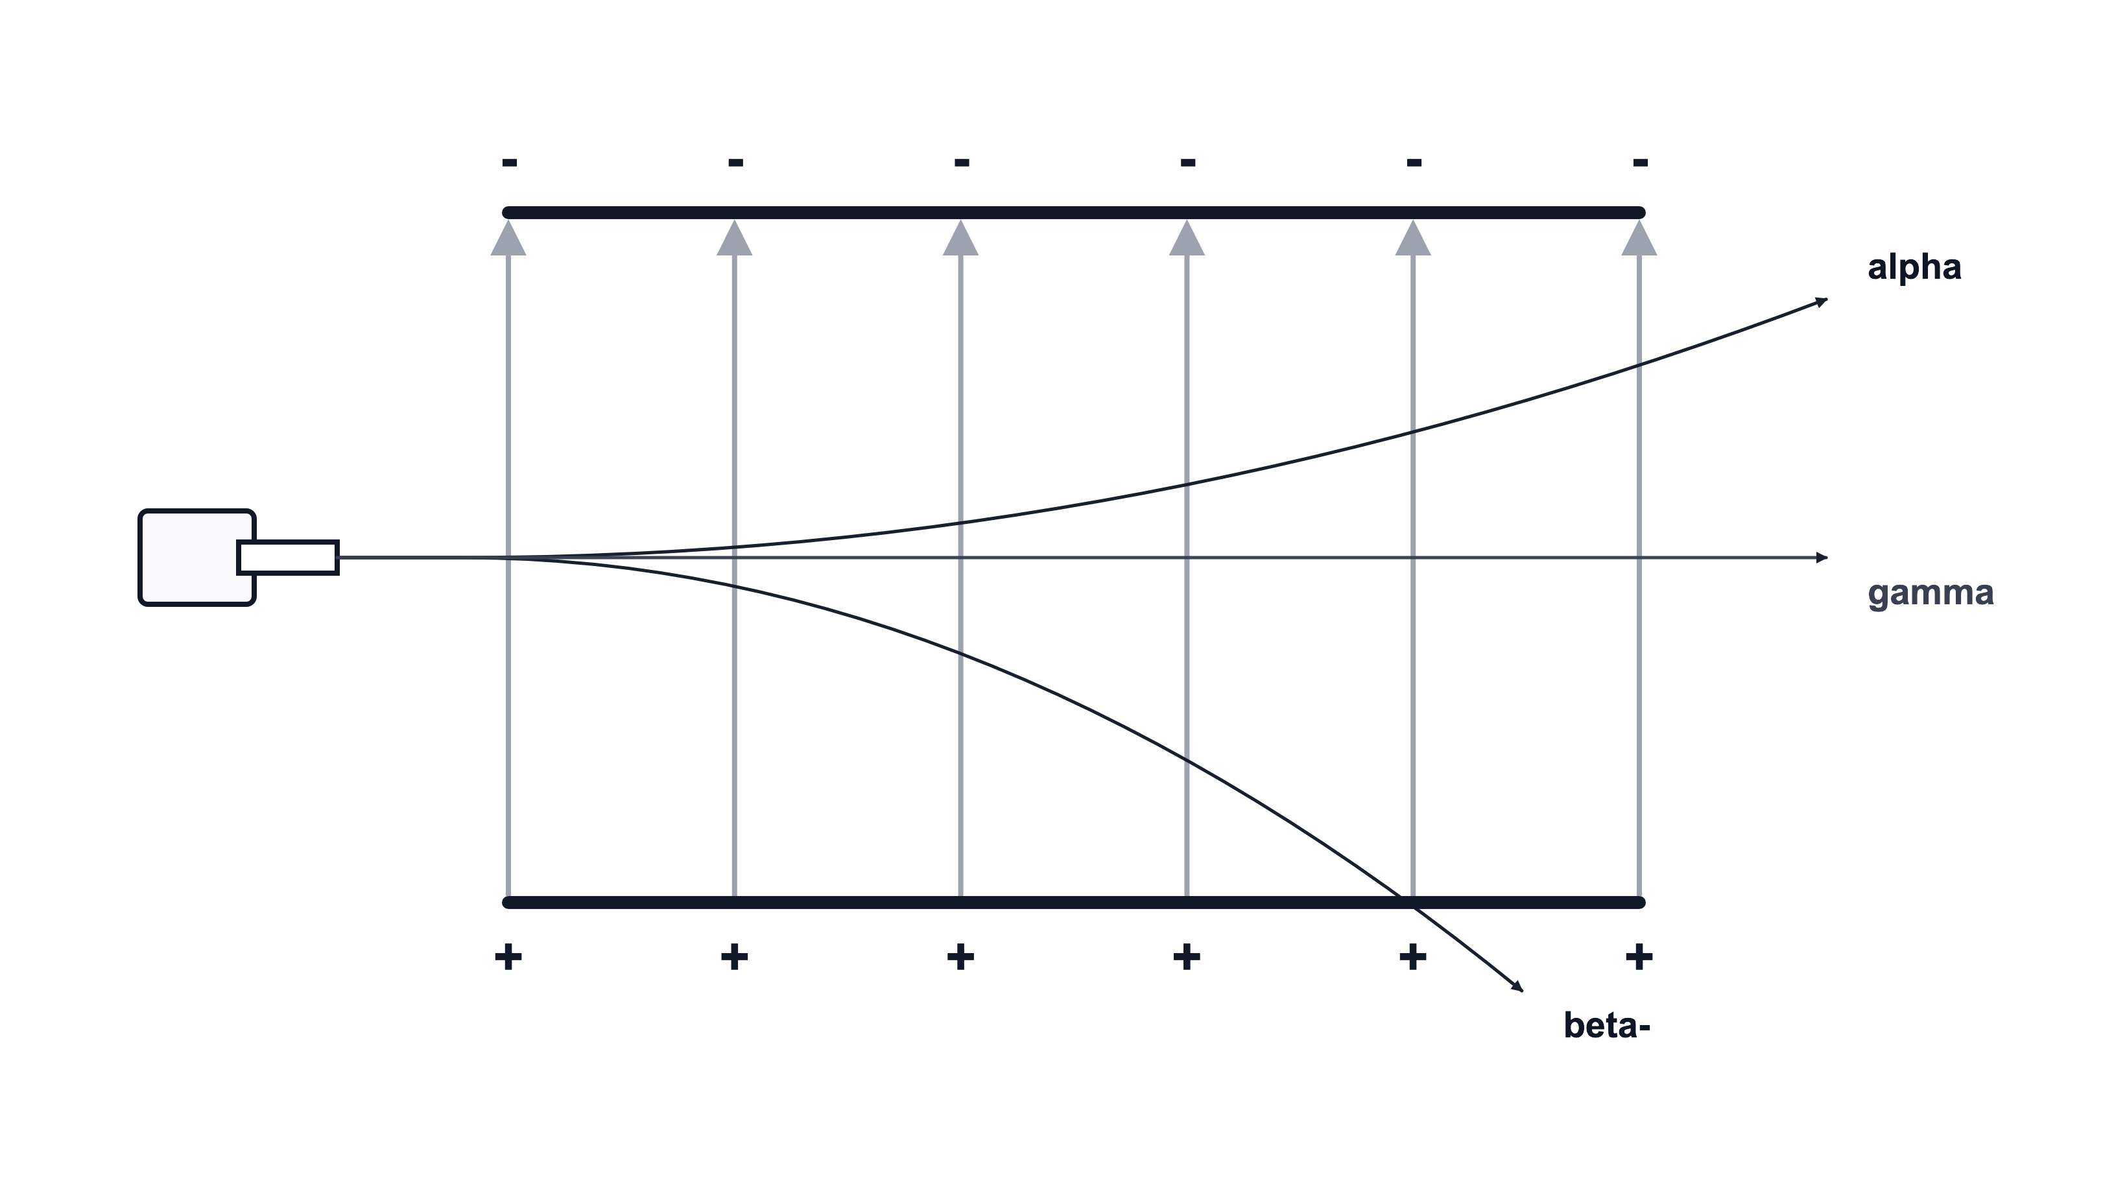
.....................................................................................................
.....................................................................................................
.....................................................................................................
.....................................................................................................
(2 marks)
21. An animal bone found in a cave gives a carbon-14 activity of 10 counts/min. Fresh bone containing an equal mass of carbon would give 160 counts/min. The half-life of carbon-14 is 5700 years. Background has already been subtracted.
(a) Calculate the fraction of the original carbon-14 activity remaining in the cave bone.
.....................................................................................................
.....................................................................................................
.....................................................................................................
.....................................................................................................
(2 marks)
(b) Calculate the age of the cave bone.
.....................................................................................................
.....................................................................................................
.....................................................................................................
.....................................................................................................
.....................................................................................................
(3 marks)
(c) Explain why the cave bone has a lower carbon-14 activity than fresh bone.
.....................................................................................................
.....................................................................................................
.....................................................................................................
.....................................................................................................
(2 marks)
22. A beam of alpha, beta and gamma radiation passes between charged plates. The electric field is directed downwards.
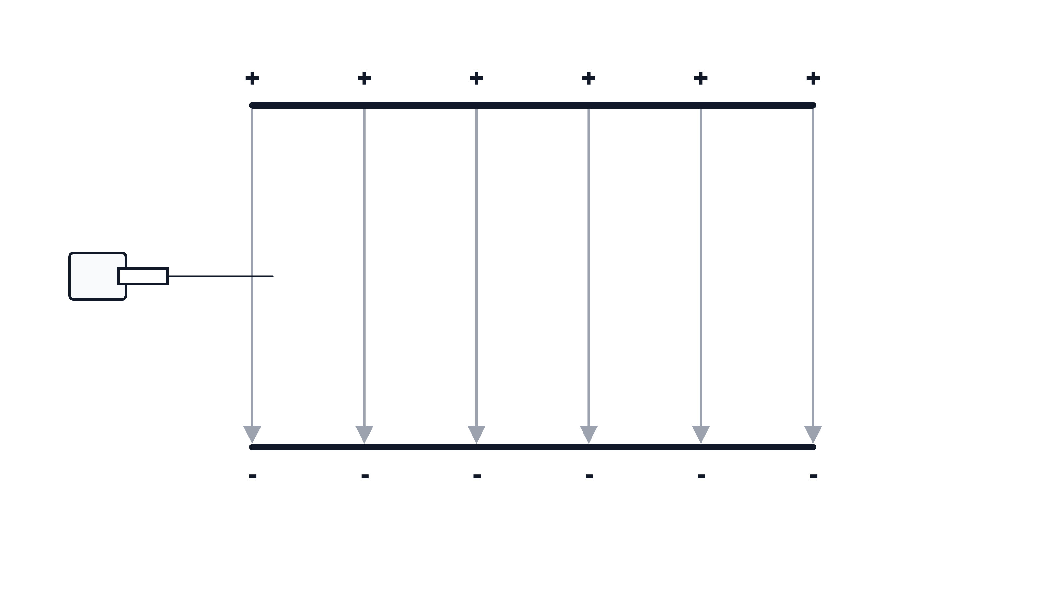
(a) Draw on the diagram the paths followed by alpha radiation, beta radiation and gamma radiation. Add labels to your paths.
(3 marks)
(b) Explain why gamma radiation is not deflected by the electric field.
.....................................................................................................
.....................................................................................................
.....................................................................................................
.....................................................................................................
.....................................................................................................
(3 marks)
(c) Suggest how the paths would change if the plates were connected the opposite way round.
.....................................................................................................
.....................................................................................................
.....................................................................................................
.....................................................................................................
(2 marks)
23. Uranium-235 can decay by emitting radiation. The nuclear equation has missing values.
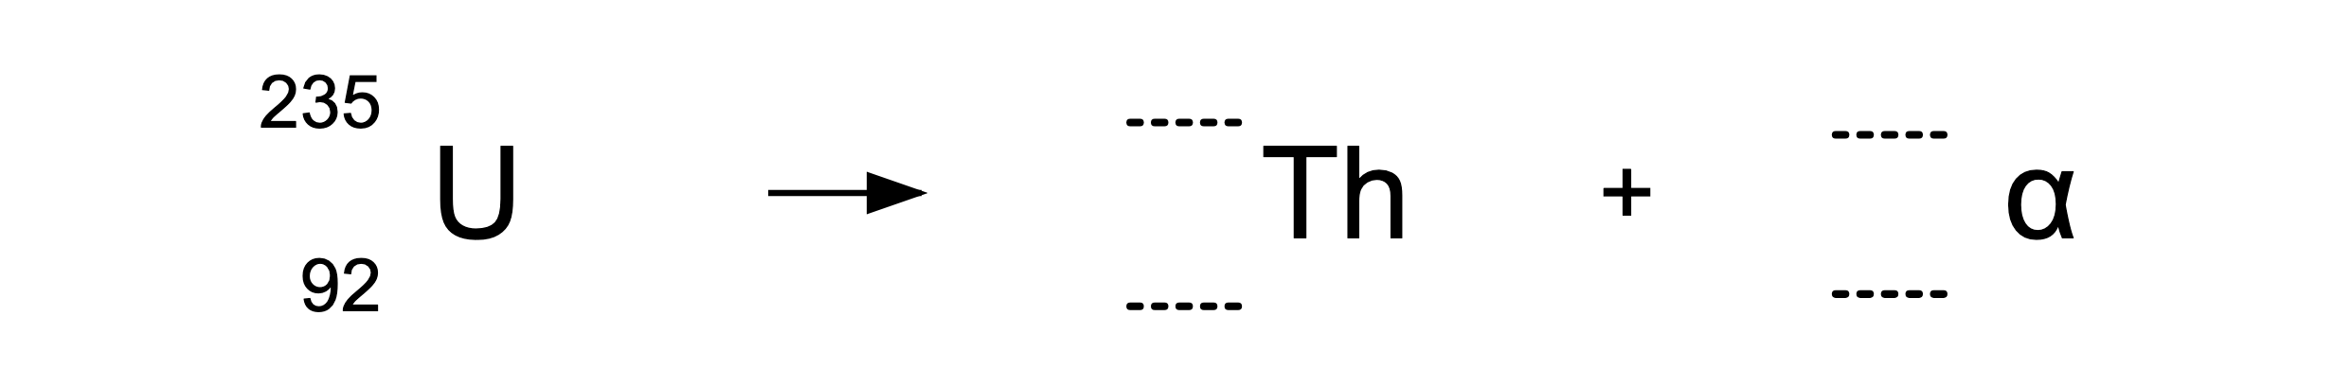
(a) Complete the missing values in the decay equation.
.....................................................................................................
.....................................................................................................
.....................................................................................................
.....................................................................................................
(2 marks)
(b) Name the daughter element.
.....................................................................................................
.....................................................................................................
(1 mark)
(c) Explain why the mass number decreases by 4 in this decay.
.....................................................................................................
.....................................................................................................
(1 mark)
24. A sealed xenon source is used to check a detector. Its activity falls from 640 Bq to 80 Bq in 15 days.
(a) Determine the number of half-lives that have passed in 15 days.
.....................................................................................................
.....................................................................................................
.....................................................................................................
.....................................................................................................
(2 marks)
(b) Calculate the half-life of the xenon source. ​
.....................................................................................................
.....................................................................................................
.....................................................................................................
.....................................................................................................
(2 marks)

