6.1 Earth and the Solar System: Cambridge IGCSE Physics worksheet
1. Which row correctly states how visible light from the Sun and from a planet reaches an observer?
 | Sun | Planet
A | only reflects light | produces its own visible light
B | only reflects light | only reflects light
C | produces visible light | reflects sunlight
D | produces visible light | produces its own visible light

(1 mark)
2. A planet follows an approximately circular orbit of radius $r$ with orbital period $T$. Which equation gives its average orbital speed $v$?
A $v=\frac{T}{2πr}$
B $v=\frac{r}{T}$
C $v=\frac{2πr}{T}$
D $v=2πrT$
(1 mark)
3. Which sequence shows the four inner planets in order of increasing distance from the Sun?
A Venus, Mercury, Earth, Mars
B Mercury, Earth, Venus, Mars
C Mars, Earth, Venus, Mercury
D Mercury, Venus, Earth, Mars
(1 mark)
4. Which motion of Earth defines the length of one year?
A one rotation of Earth about its axis
B one complete orbit of Earth around the Sun
C one complete orbit of the Moon around Earth
D one rotation of the Sun about its axis
(1 mark)
5. Which force provides the inward resultant force that keeps a moon in a circular orbit around a planet?
A gravitational force
B magnetic force
C electrostatic force
D frictional force
(1 mark)
6. Which statement about the Sun is correct?
A It is a planet slightly larger than Earth.
B It is a moon that orbits the centre of the Solar System.
C It is a star much larger than any planet.
D It is a galaxy containing all the Solar System's planets.
(1 mark)
7. Which row gives approximate times for the motions of Earth and the Moon?
 | Earth orbiting the Sun | Moon orbiting Earth
A | one day | one year
B | one month | one day
C | one year | one month
D | one year | one day

(1 mark)
8. Which description best explains how the planets formed around the young Sun?
A They were captured as fully formed planets from other stars.
B They separated from the Sun after nuclear reactions began.
C They appeared when the Sun's light cooled empty space.
D Gravity brought material together in a rotating disc around the young Sun.
(1 mark)
9. A moon moves at constant speed in a circular orbit around a planet. Which statement is correct?
A Its velocity changes because its direction changes.
B Its velocity is constant because its speed is constant.
C Its acceleration is zero because its speed is constant.
D Its gravitational force acts along the tangent to the orbit.
(1 mark)
10. Which process caused material in a cloud of gas and dust to gather together during the formation of the Sun?
A gravitational attraction between particles
B friction between the cloud and empty space
C electrostatic repulsion between particles
D magnetic repulsion from nearby planets
(1 mark)
11. Which description identifies a comet?
A a large spherical body that has cleared most objects from its orbit
B a small icy body that can develop a tail when it approaches the Sun
C a natural object that orbits a planet
D a rocky planet located between Mars and Jupiter
(1 mark)
12. A comet follows a highly elliptical orbit around the Sun. At which position is the comet moving fastest?
A when it is furthest from the Sun
B when its gravitational attraction to the Sun is weakest
C when it is closest to the Sun
D when it crosses the orbit of any planet
(1 mark)
13. Satellite P travels in a circular orbit of radius 8.0 × 10⁶ m in 4.0 × 10⁴ s. Satellite Q travels in a circular orbit of radius 1.2 × 10⁷ m in 8.0 × 10⁴ s. Which comparison of their average orbital speeds is correct?
A P and Q have the same average orbital speed.
B Q is 1.5 times as fast as P.
C Q is 2.0 times as fast as P.
D P is 1.3 times as fast as Q.
(1 mark)
14. Name the force shown in the diagram and state which body provides it.
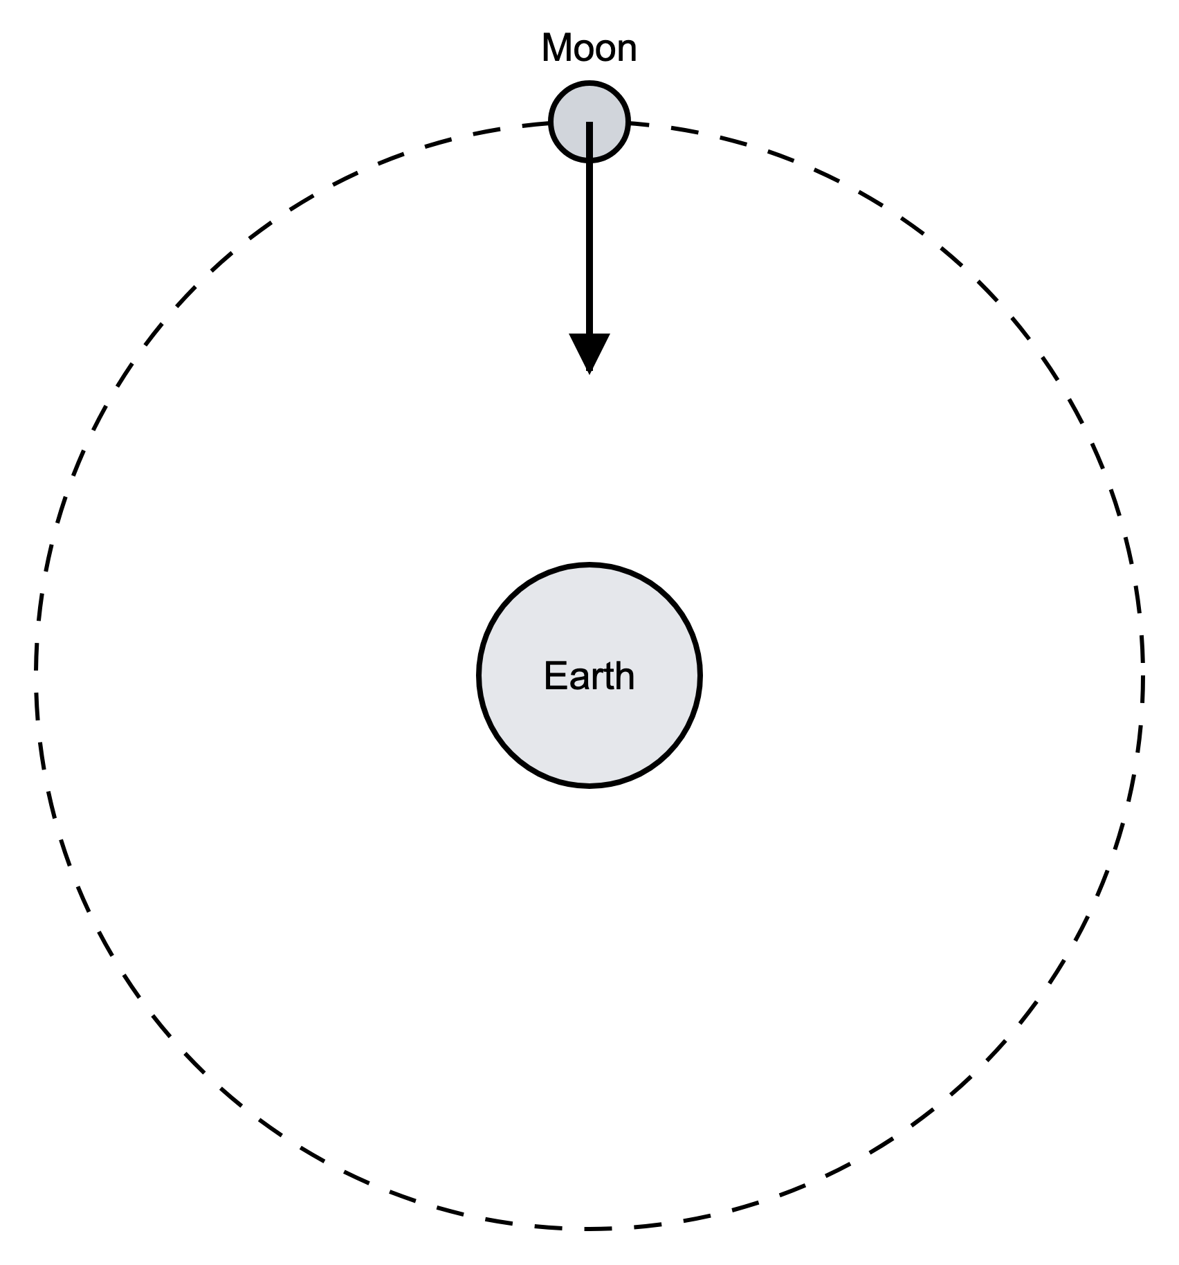
.....................................................................................................
.....................................................................................................
.....................................................................................................
.....................................................................................................
(2 marks)
15. State the number of stars and the number of planets in the Solar System.
.....................................................................................................
.....................................................................................................
.....................................................................................................
.....................................................................................................
(2 marks)
16. Name the planet closest to the Sun and name the planet furthest from the Sun.
.....................................................................................................
.....................................................................................................
.....................................................................................................
.....................................................................................................
(2 marks)
17. The Earth is 1.5 × 10¹¹ m from the Sun. Calculate the time taken for light to travel this distance at 3.0 × 10⁸ m/s.
.....................................................................................................
.....................................................................................................
.....................................................................................................
.....................................................................................................
(2 marks)
18. As a planet's distance from the Sun increases, state how the Sun's gravitational field strength and the planet's orbital speed change.
.....................................................................................................
.....................................................................................................
.....................................................................................................
.....................................................................................................
(2 marks)
19. Give one typical property of the four inner planets and one typical property of the four outer planets.
.....................................................................................................
.....................................................................................................
.....................................................................................................
.....................................................................................................
(2 marks)
20. The Sun and planets formed from a cloud of gas and dust about 4.5 billion years ago.
(a) Name the cloud of gas and dust from which the Solar System formed.
.....................................................................................................
.....................................................................................................
(1 mark)
(b) Describe how gravity helped the Sun and planets to form from this cloud.
.....................................................................................................
.....................................................................................................
.....................................................................................................
.....................................................................................................
.....................................................................................................
(3 marks)
(c) Explain why the four planets nearest the Sun are rocky and relatively small.
.....................................................................................................
.....................................................................................................
.....................................................................................................
.....................................................................................................
.....................................................................................................
(4 marks)
(d) Explain why the four planets furthest from the Sun are large gas giants.
.....................................................................................................
.....................................................................................................
.....................................................................................................
.....................................................................................................
.....................................................................................................
(3 marks)
21. The Solar System contains the Sun, planets and several smaller bodies.
(a) State the type of object that the Sun is.
.....................................................................................................
.....................................................................................................
(1 mark)
(b) Give the names of the four planets nearest to the Sun.
.....................................................................................................
.....................................................................................................
.....................................................................................................
.....................................................................................................
(2 marks)
(c) Compare asteroids and comets.
.....................................................................................................
.....................................................................................................
.....................................................................................................
.....................................................................................................
.....................................................................................................
(3 marks)
(d) To be classed as a planet, an object orbiting the Sun must have cleared other objects out of the region around its orbit. Pluto shares its region of space with many other icy objects, so it is classed as a dwarf planet. Suggest why Pluto has not cleared these objects out of the region around its orbit.
.....................................................................................................
.....................................................................................................
(1 mark)
22. A comet travels around the Sun in a highly elliptical orbit.
(a) State what is meant by an elliptical orbit.
.....................................................................................................
.....................................................................................................
(1 mark)
(b) State where the Sun is positioned in a highly elliptical comet orbit.
.....................................................................................................
.....................................................................................................
(1 mark)
(c) Describe how the speed of the comet changes as it moves closer to the Sun and then further away.
.....................................................................................................
.....................................................................................................
.....................................................................................................
.....................................................................................................
(2 marks)
(d) Explain the energy changes as the comet moves closer to the Sun.
.....................................................................................................
.....................................................................................................
.....................................................................................................
.....................................................................................................
(2 marks)
(e) Compare the orbit of a comet with the orbit of a planet such as Earth.
.....................................................................................................
.....................................................................................................
.....................................................................................................
.....................................................................................................
.....................................................................................................
(3 marks)

