6.2 Stars and the Universe: Cambridge IGCSE Physics worksheet
1. Astronomers observe a galaxy that is millions of light-years away.
Why does the observation show the galaxy as it was in the past?
A The galaxy stops changing while its light travels.
B Light takes time to travel from the galaxy to Earth.
C Redshift makes every distant galaxy appear younger.
D Telescopes store the light for millions of years before detection.
(1 mark)
2. What is cosmic microwave background radiation?
A Visible light emitted only by nearby stars.
B Radio waves produced only by communication satellites.
C Microwave radiation arriving from all directions as a remnant of the hot early Universe.
D Infrared radiation emitted only by cool planets.
(1 mark)
3. If the expansion of the Universe is traced backwards, which description applies to the very early Universe?
A Matter was closer together, and the Universe was hotter and denser.
B Matter was farther apart, and the Universe was cooler and less dense.
C Matter had the same separation, but all galaxies were brighter.
D There was no matter, radiation or energy.
(1 mark)
4. Which sketch represents Hubble's law for distant galaxies?
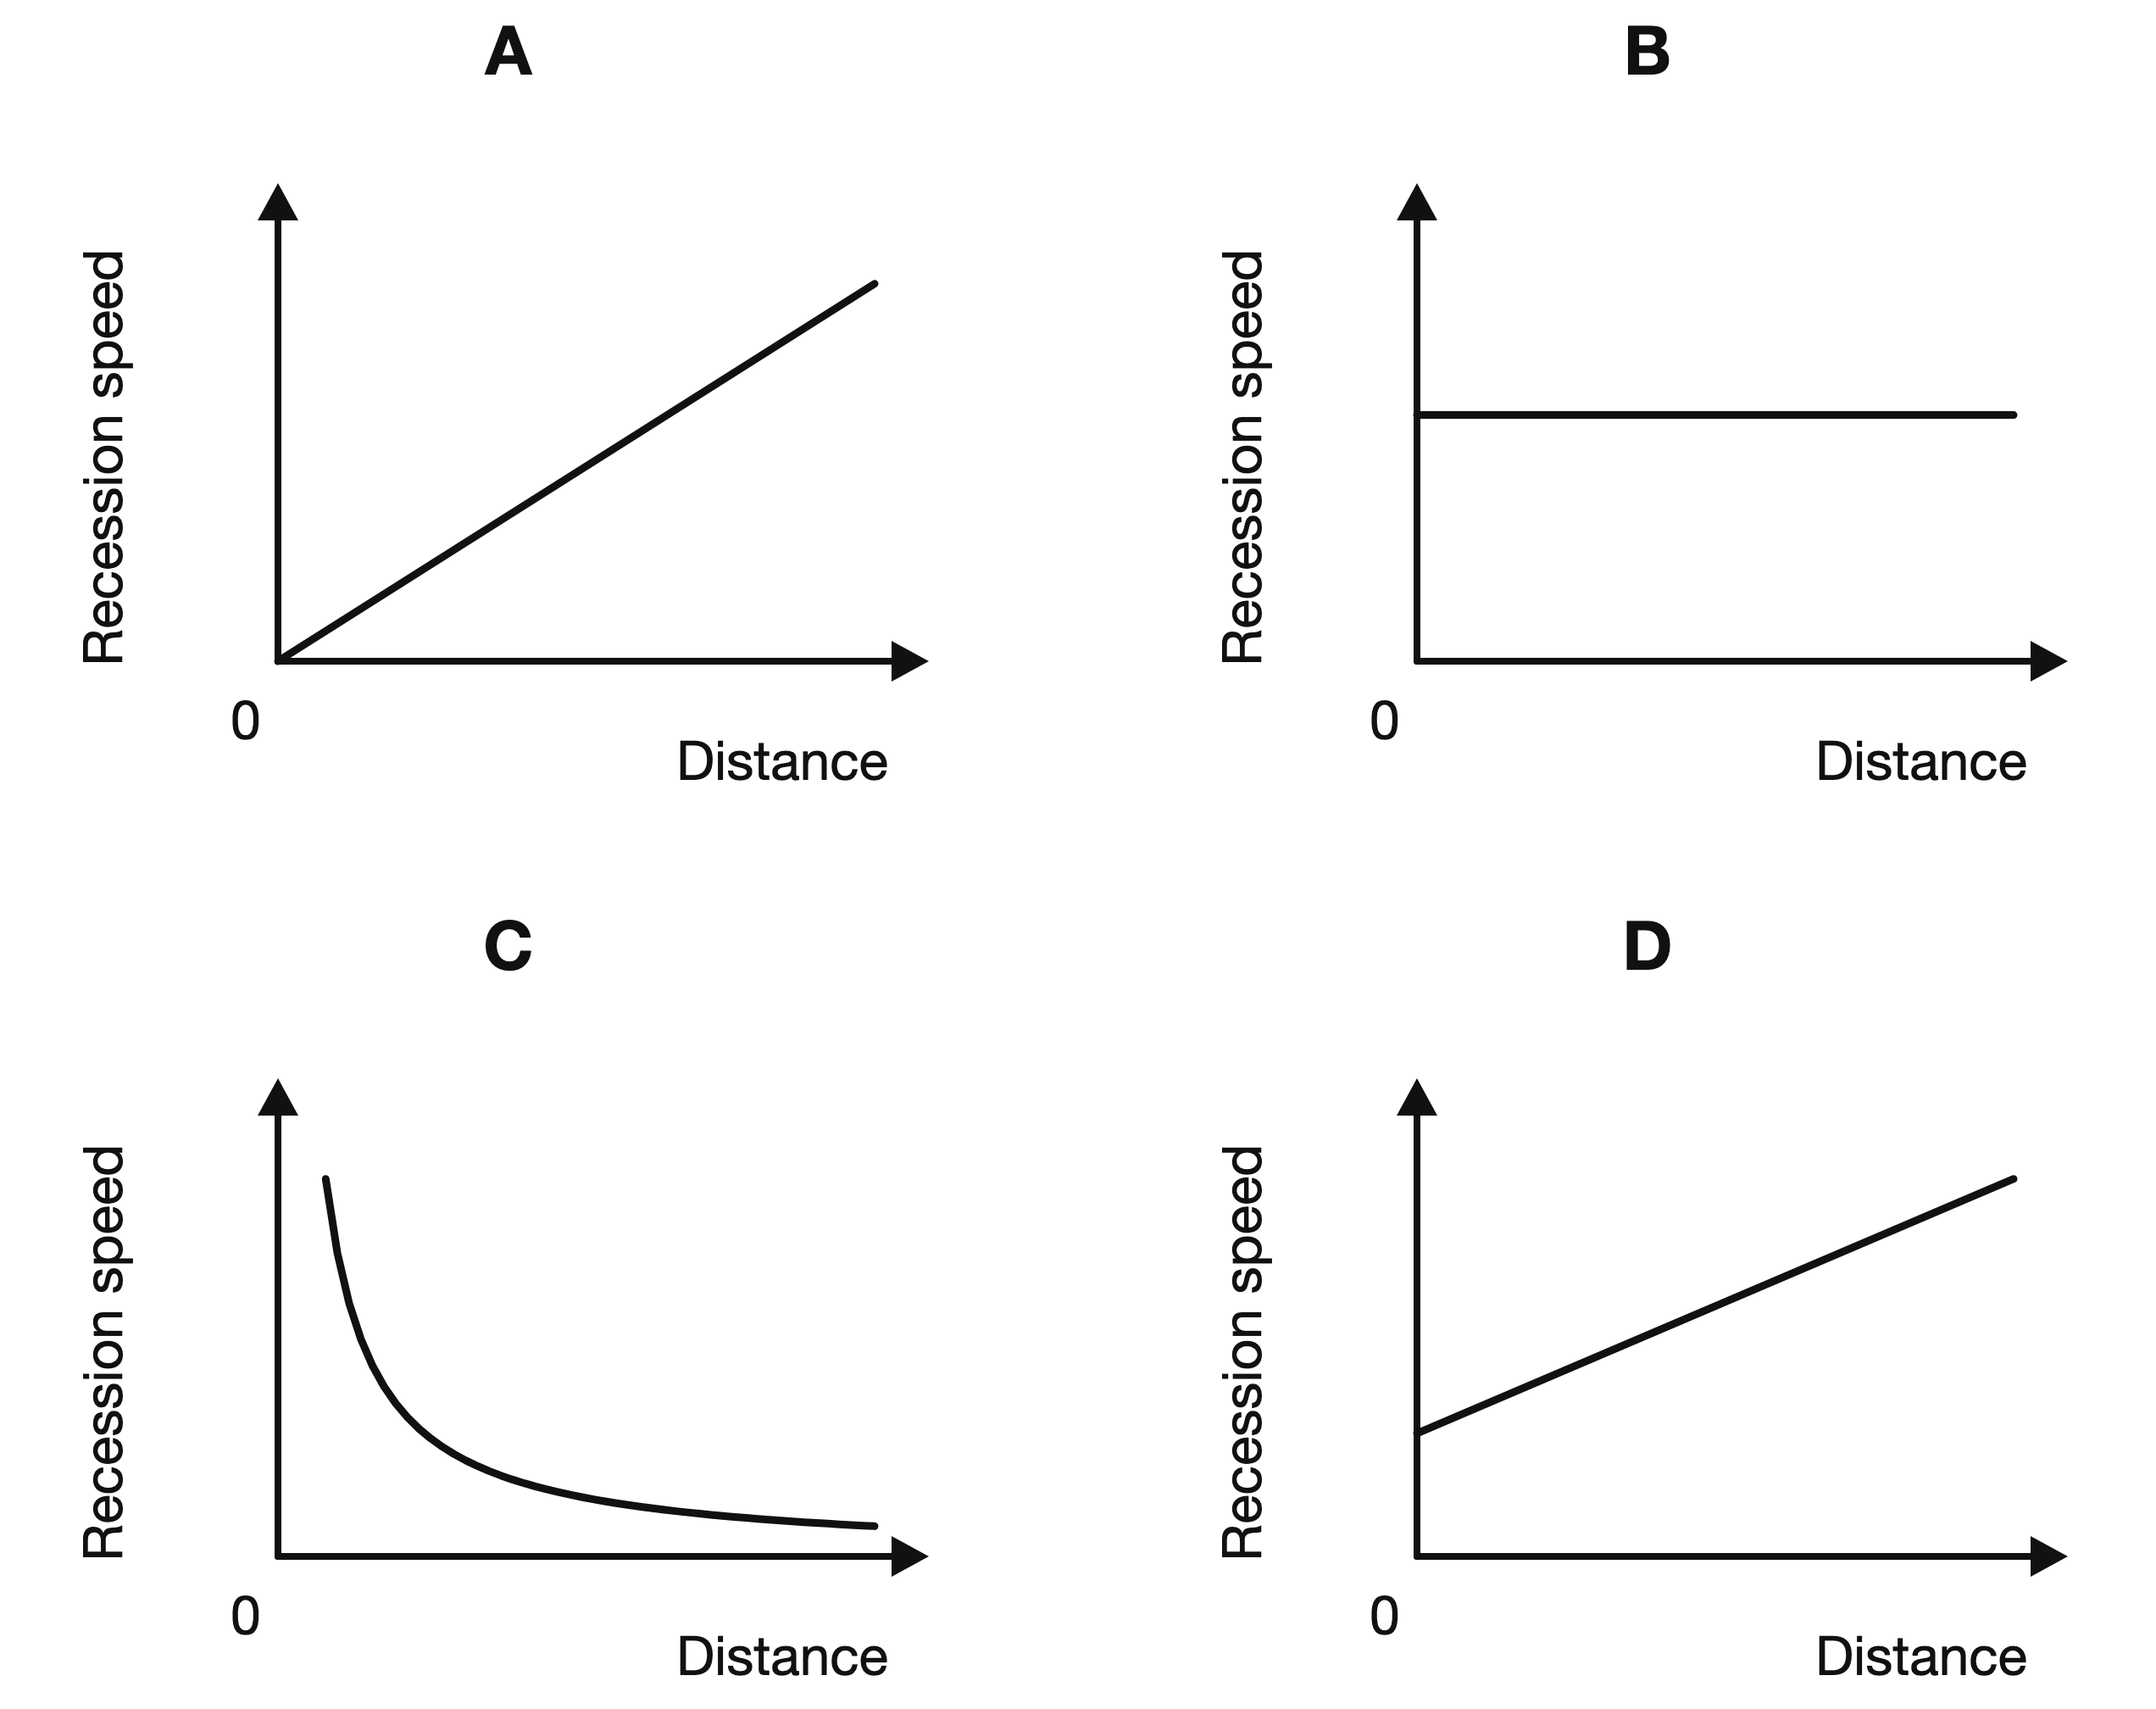
(1 mark)
5. The Hubble constant is 70 km/s per Mpc. A galaxy is 80 Mpc from Earth.
Using $v=H_{0}d$, what is the recession speed of the galaxy?
A 0.875 km/s
B 150 km/s
C 5600 km/s
D 56000 km/s
(1 mark)
6. What change is seen when light from a distant galaxy is redshifted?
A Its spectral lines are observed at longer wavelengths.
B Its spectral lines are observed at shorter wavelengths.
C Its spectral lines become brighter without changing wavelength.
D Its spectral lines disappear from the spectrum.
(1 mark)
7. Which expression gives an estimate of the age of the Universe from the Hubble constant $H_{0}$?
A $H_{0}$
B $\frac{d}{H_{0}}$
C $\frac{1}{H_{0}}$
D $H_{0}d$
(1 mark)
8. Which observation provides evidence that the Universe is expanding?
A Most distant galaxies are blueshifted, with nearby galaxies moving fastest.
B All galaxies have identical spectra and remain at fixed distances.
C Only nearby stars are redshifted, and the shift is unrelated to distance.
D Most distant galaxies are redshifted, and more distant galaxies generally recede faster.
(1 mark)
9. The Hubble constant has the value 2.0 × 10⁻¹⁸ s⁻¹.
Using $t=\frac{1}{H_{0}}$, what is the estimated age of the Universe?
A 5.0 × 10¹⁷ s
B 2.0 × 10¹⁸ s
C 5.0 × 10⁻¹⁹ s
D 2.0 × 10⁻¹⁸ s
(1 mark)
10. For a galaxy moving at speed $v$, $\frac{v}{c}=\frac{λ_{observed}−λ_{laboratory}}{λ_{laboratory}}$.
A line with a laboratory wavelength of 600 nm is observed at 606 nm. The speed of light $c$ is 3.0 × 10⁸ m/s. What is $v$?
A 0.010 m/s
B 3.0 × 10⁵ m/s
C 3.03 × 10⁸ m/s
D 3.0 × 10⁶ m/s
(1 mark)
11. The table gives data for three galaxies.
What value of the Hubble constant is supported by all three galaxies?
Galaxy | Distance  (Mpc) | Recession speed  (km/s)
X | 50 | 3400
Y | 100 | 6800
Z | 150 | 10200

A 0.0147 Mpc per km/s
B 50 km/s per Mpc
C 68 km/s per Mpc
D 6800 km/s per Mpc
(1 mark)
12. Why is remnant radiation from the hot early Universe now detected mainly at microwave wavelengths?
A Dust has reflected all the radiation towards Earth.
B Expansion has stretched the radiation to longer wavelengths as the Universe cooled.
C Gravity has changed every photon into a radio wave.
D Stars have absorbed all wavelengths except microwaves.
(1 mark)
13. According to the Big Bang theory, describe the initial state of the Universe using two properties.
.....................................................................................................
.....................................................................................................
.....................................................................................................
.....................................................................................................
(2 marks)
14. The Sun emits most of its energy in three regions of the electromagnetic spectrum. Give any two of these regions.
.....................................................................................................
.....................................................................................................
.....................................................................................................
.....................................................................................................
(2 marks)
15. A galaxy recedes at 1.1 × 10⁷ m/s. Calculate the distance of the galaxy from the Earth.
.....................................................................................................
.....................................................................................................
.....................................................................................................
.....................................................................................................
(2 marks)
16. A hydrogen line has a wavelength of 486.1 nm in a laboratory and 493.4 nm in light from a distant galaxy. Describe the change in wavelength and name the effect.
.....................................................................................................
.....................................................................................................
.....................................................................................................
.....................................................................................................
(2 marks)
17. Read the lettered diagram for a star much more massive than the Sun. Name stages D and E.
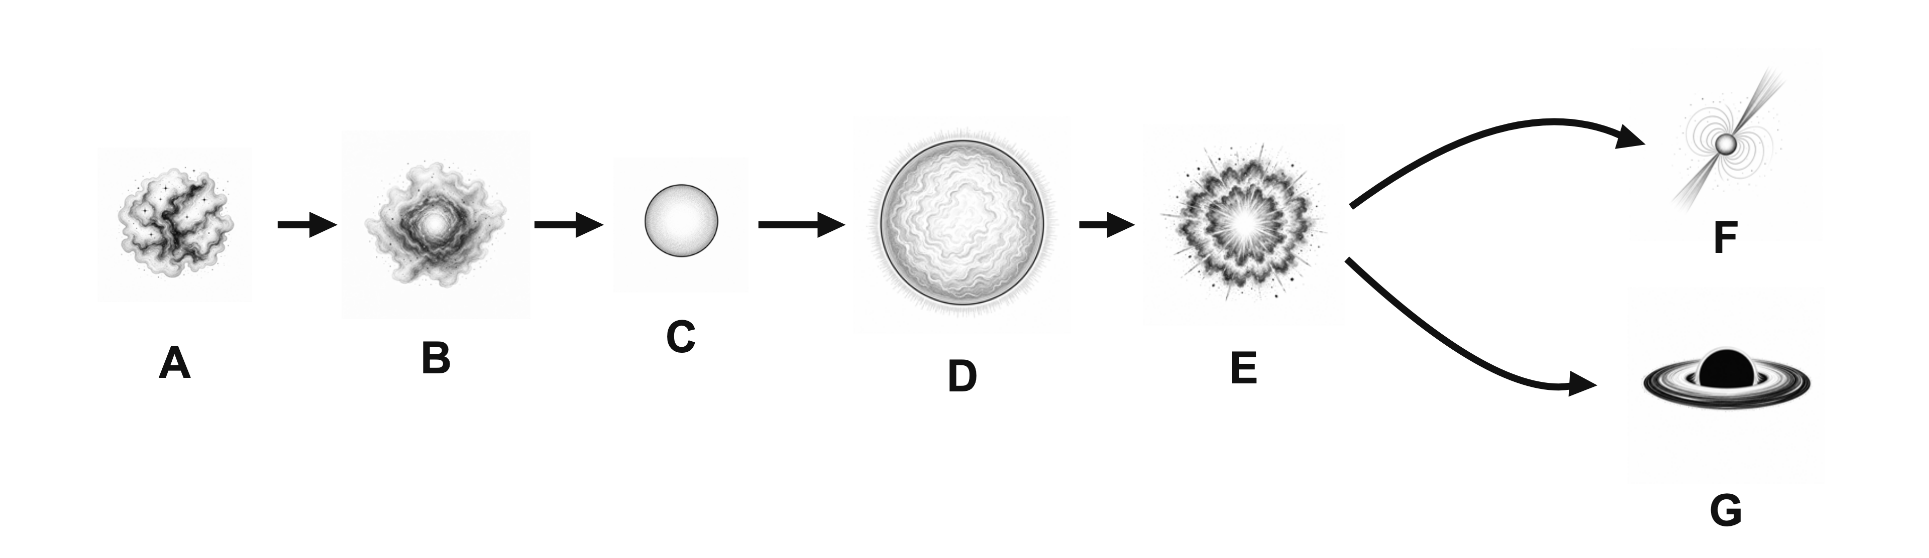
.....................................................................................................
.....................................................................................................
.....................................................................................................
.....................................................................................................
(2 marks)
18. Give two types of matter found in the nebula produced by a supernova.
.....................................................................................................
.....................................................................................................
.....................................................................................................
.....................................................................................................
(2 marks)
19. Name the cloud of gas and dust from which a star forms and state one element it contains.
.....................................................................................................
.....................................................................................................
.....................................................................................................
.....................................................................................................
(2 marks)
20. Name one astronomical object whose known brightness can be used to find the distance of a far galaxy.
.....................................................................................................
.....................................................................................................
(1 mark)
21. The diagram below follows the life-cycle of a star with a mass similar to the Sun.
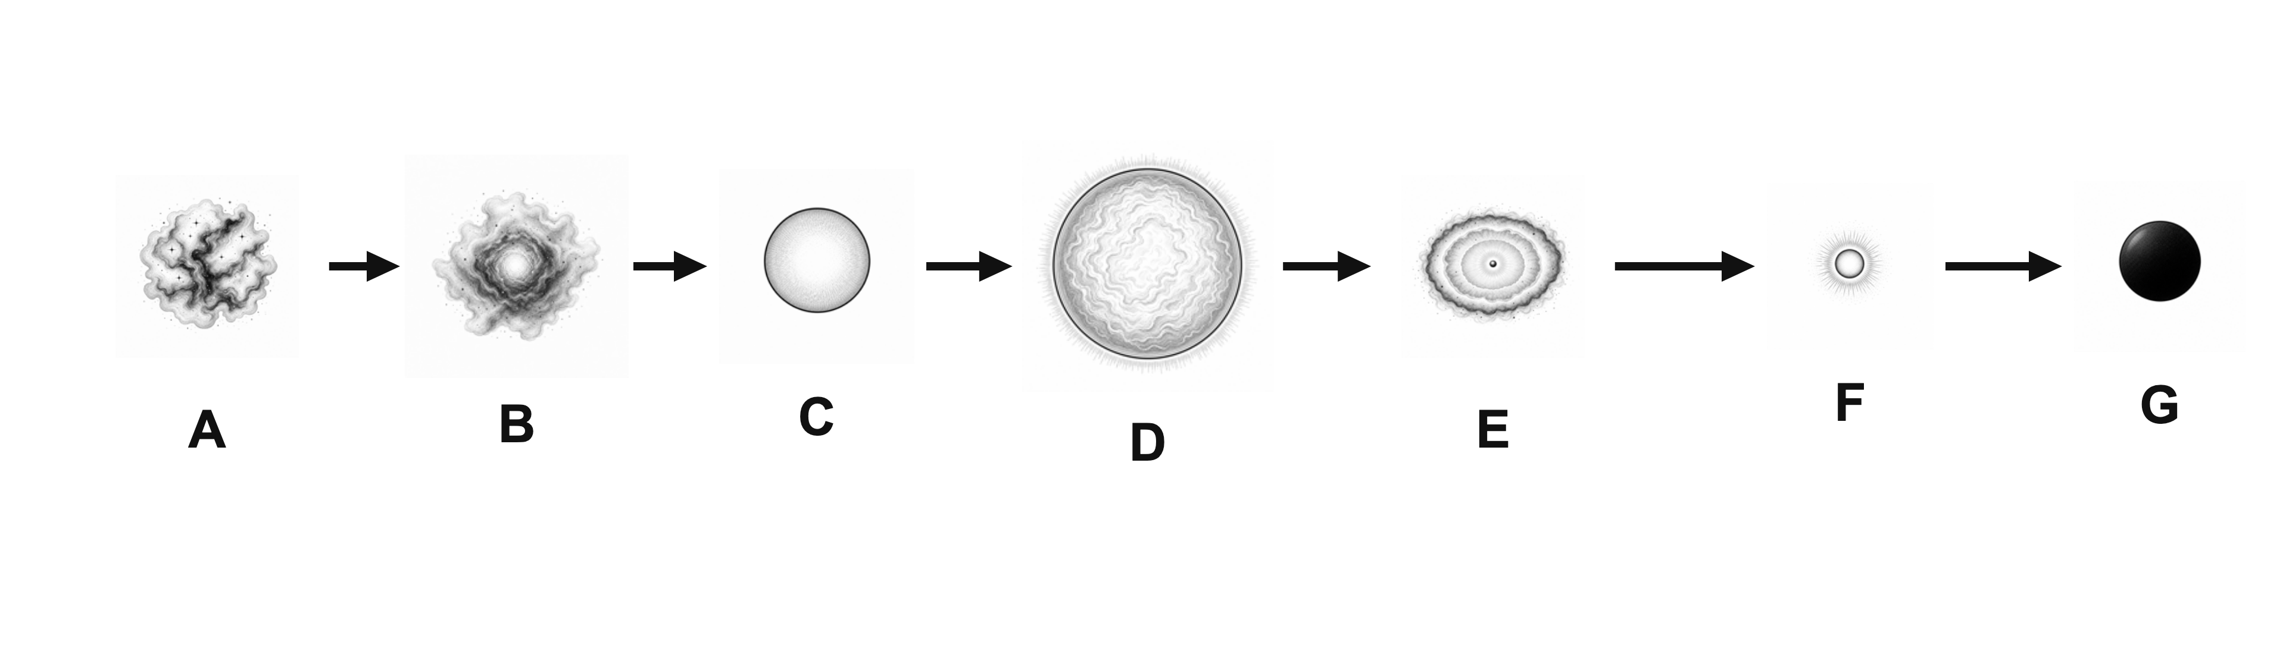
(a) State the stage represented by C.
.....................................................................................................
.....................................................................................................
(1 mark)
(b) Identify stages E and F.
.....................................................................................................
.....................................................................................................
.....................................................................................................
.....................................................................................................
(2 marks)
(c) Describe what happens between C and E. ​
.....................................................................................................
.....................................................................................................
.....................................................................................................
.....................................................................................................
.....................................................................................................
(3 marks)
22. The Sun is a stable star of medium size that consists mostly of hydrogen and helium.
(a) Name the process that releases energy in the Sun.
.....................................................................................................
.....................................................................................................
(1 mark)
(b) Describe what happens after most of the hydrogen in the centre of the Sun has been fused into helium. ​
.....................................................................................................
.....................................................................................................
.....................................................................................................
.....................................................................................................
(2 marks)
(c) Explain why the Sun is not expected to leave a neutron star or a black hole.
.....................................................................................................
.....................................................................................................
.....................................................................................................
.....................................................................................................
(2 marks)
23. The table gives measurements for seven galaxies.
Distance from the Earth  (10²⁴ m) | Recession speed  (10⁶ m/s)
1.0 | 2.3
2.0 | 4.2
3.0 | 6.7
4.0 | 8.6
5.0 | 11.2
6.0 | 13.0
7.0 | 15.6


(a) Plot a graph of recession speed against distance. Label both axes, choose suitable linear scales, plot all seven points and draw a line of best fit.
(4 marks)
(b) Use the gradient of your line to determine the Hubble constant.
.....................................................................................................
.....................................................................................................
.....................................................................................................
.....................................................................................................
.....................................................................................................
(3 marks)
(c) State why the line of best fit does not need to pass through every plotted point.
.....................................................................................................
.....................................................................................................
(1 mark)
24. The table gives the wavelengths of four hydrogen absorption lines measured in a laboratory and in the light from two galaxies.
Laboratory wavelength  (nm) | Wavelength from galaxy A  (nm) | Wavelength from galaxy B  (nm)
410.2 | 414.3 | 418.4
434.0 | 438.3 | 442.7
486.1 | 491.0 | 495.8
656.3 | 662.9 | 669.4

(a) Describe how the table shows that the light from both galaxies is redshifted.
.....................................................................................................
.....................................................................................................
.....................................................................................................
.....................................................................................................
(2 marks)
(b) Identify the galaxy that is moving away from the Earth at the greater speed. Explain your answer.
.....................................................................................................
.....................................................................................................
.....................................................................................................
.....................................................................................................
(2 marks)
(c) Explain why redshift from distant galaxies supports the idea that the Universe is expanding.
.....................................................................................................
.....................................................................................................
.....................................................................................................
.....................................................................................................
(2 marks)

