Equivalent Resistance and Ohm's Law: skills worksheet
1. State the equation linking resistance, potential difference and current. State the unit of resistance.
.....................................................................................................
.....................................................................................................
.....................................................................................................
.....................................................................................................
(2 marks)
2. A potential difference of 12 V produces a current of 0.40 A in a resistor. Calculate the resistance.
.....................................................................................................
.....................................................................................................
.....................................................................................................
.....................................................................................................
(2 marks)
3. The voltmeter shows the potential difference across a 16 Ω resistor. Calculate the current through the resistor.
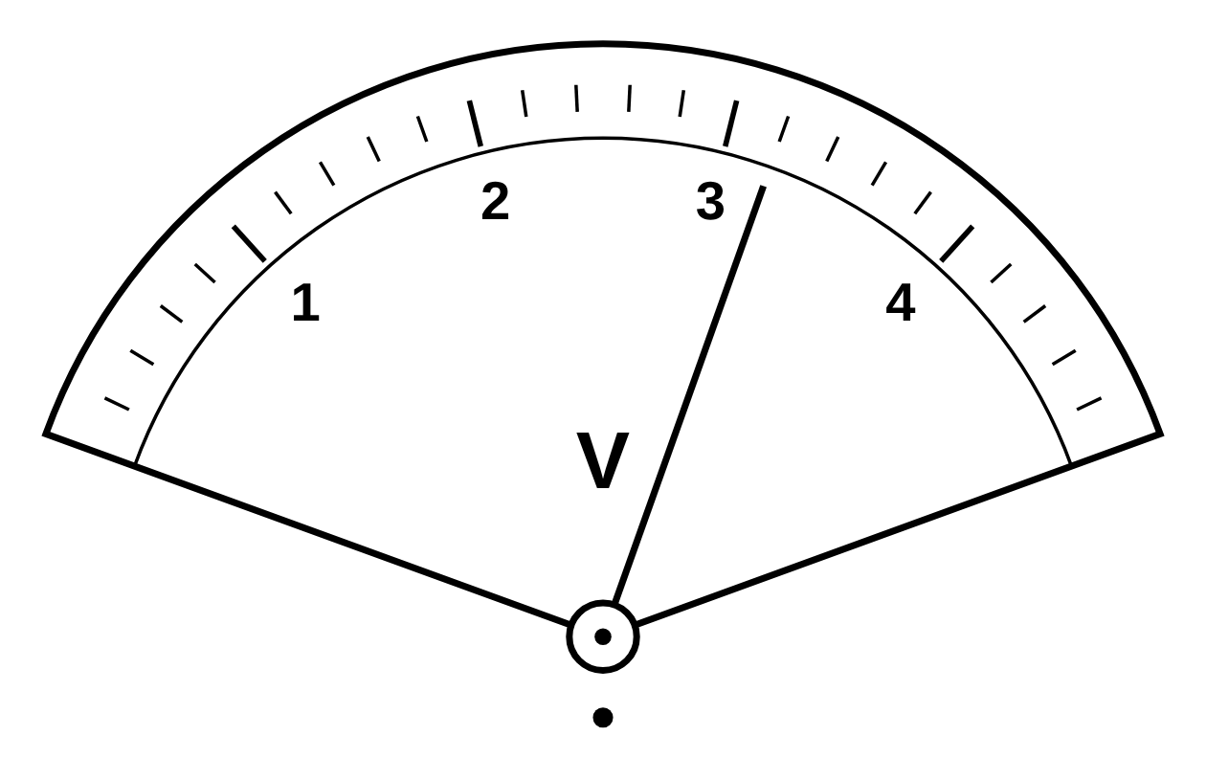
.....................................................................................................
.....................................................................................................
.....................................................................................................
.....................................................................................................
(2 marks)
4. A current of 4.0 mA flows through a 1.5 kΩ resistor. Calculate the potential difference across the resistor.
.....................................................................................................
.....................................................................................................
.....................................................................................................
.....................................................................................................
(2 marks)
5. Two resistors of resistance 7 Ω and 13 Ω are connected in series. Calculate their total resistance.
.....................................................................................................
.....................................................................................................
.....................................................................................................
.....................................................................................................
(2 marks)
6. Calculate the reading on the ammeter.
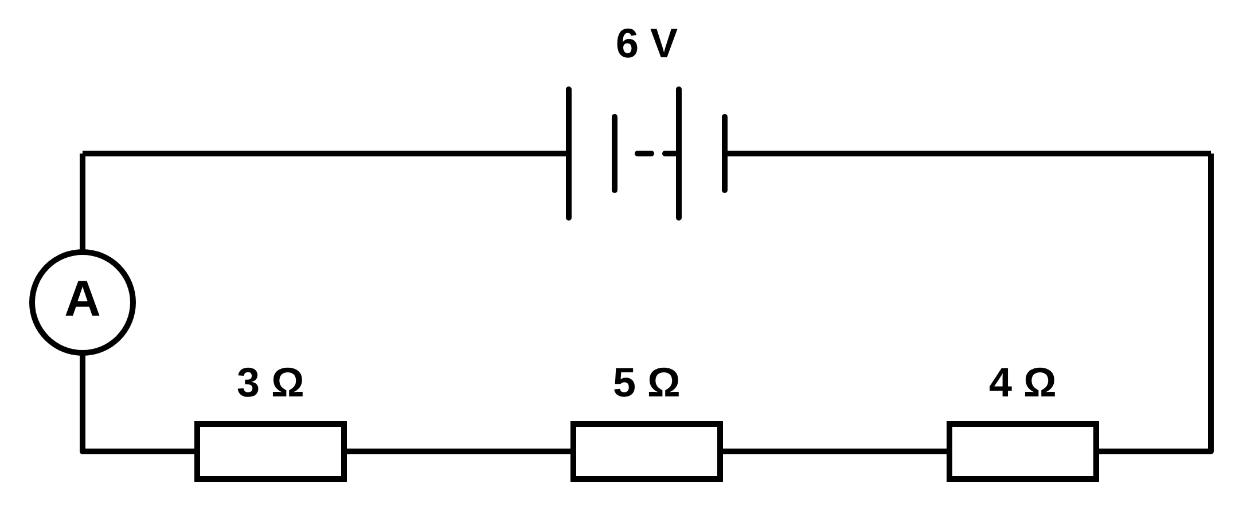
.....................................................................................................
.....................................................................................................
.....................................................................................................
.....................................................................................................
(2 marks)
7. Calculate the reading on the voltmeter.
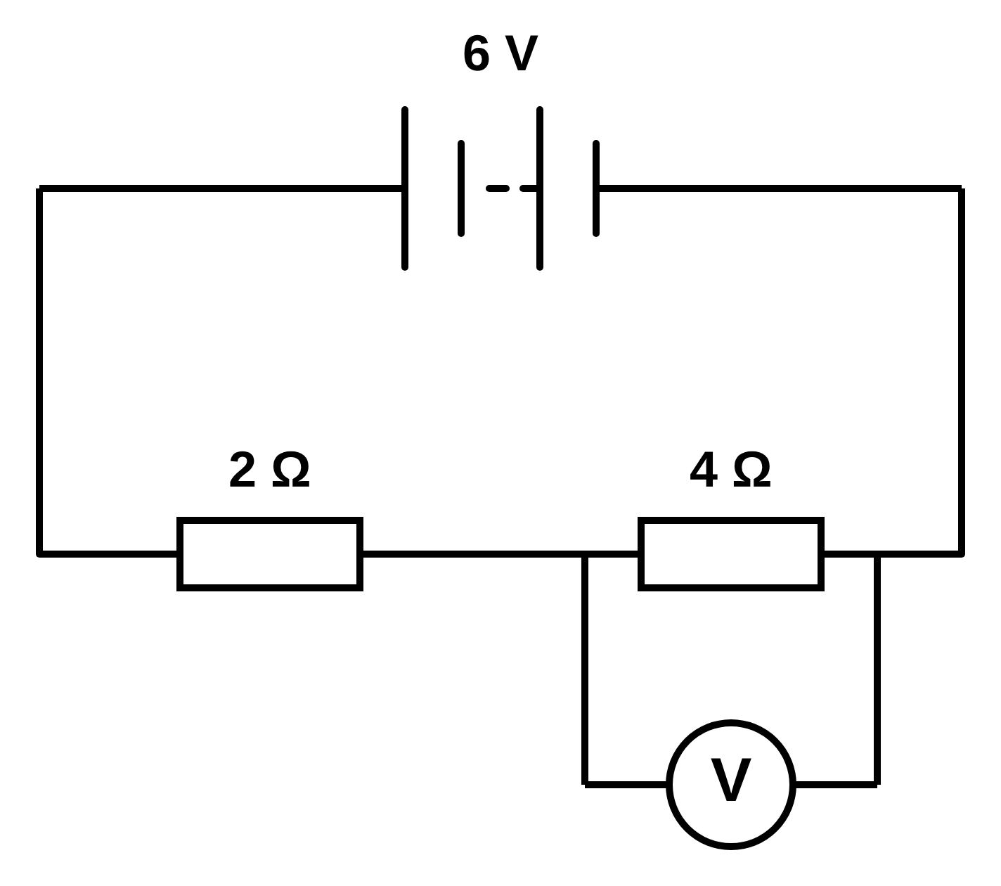
.....................................................................................................
.....................................................................................................
.....................................................................................................
.....................................................................................................
(2 marks)
8. The ammeter reads 0.30 A. Calculate the resistance of R.
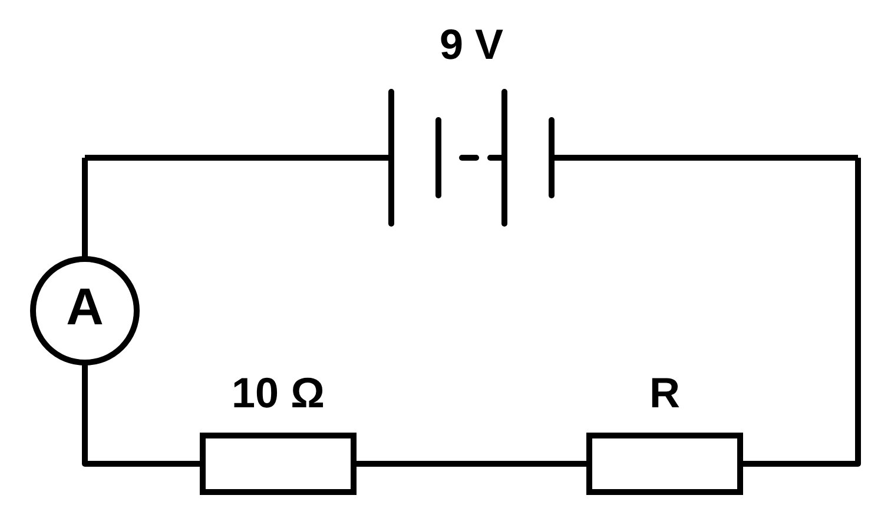
.....................................................................................................
.....................................................................................................
.....................................................................................................
.....................................................................................................
(2 marks)
9. Two identical 10 Ω resistors are connected in parallel. State their combined resistance.
.....................................................................................................
.....................................................................................................
(1 mark)
10. Calculate the reading on the ammeter.
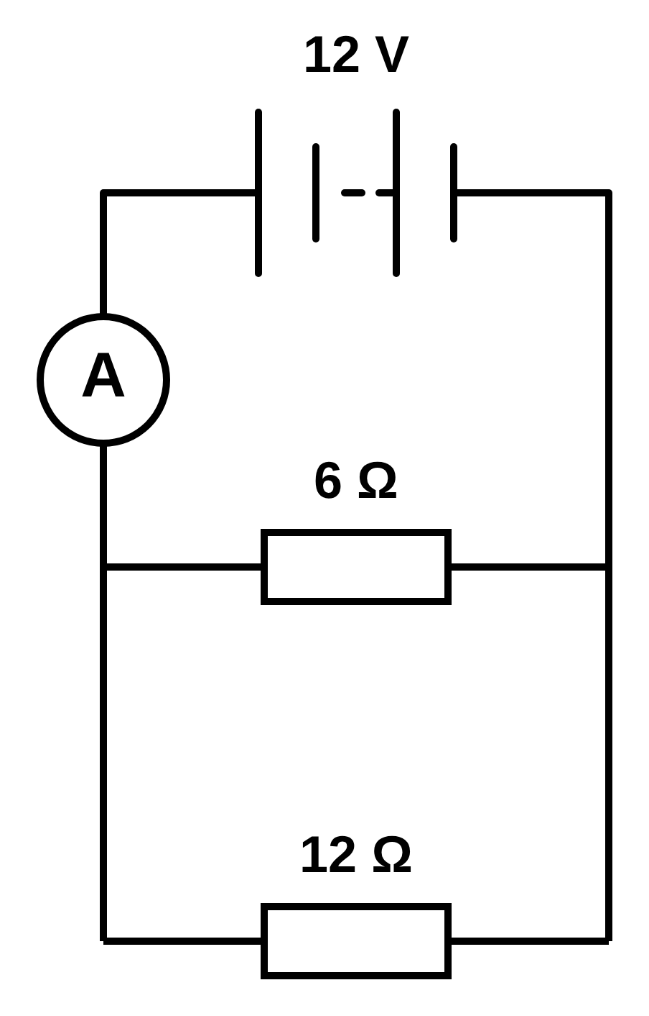
.....................................................................................................
.....................................................................................................
.....................................................................................................
.....................................................................................................
(2 marks)
11. Calculate the combined resistance of the two resistors in the circuit shown.
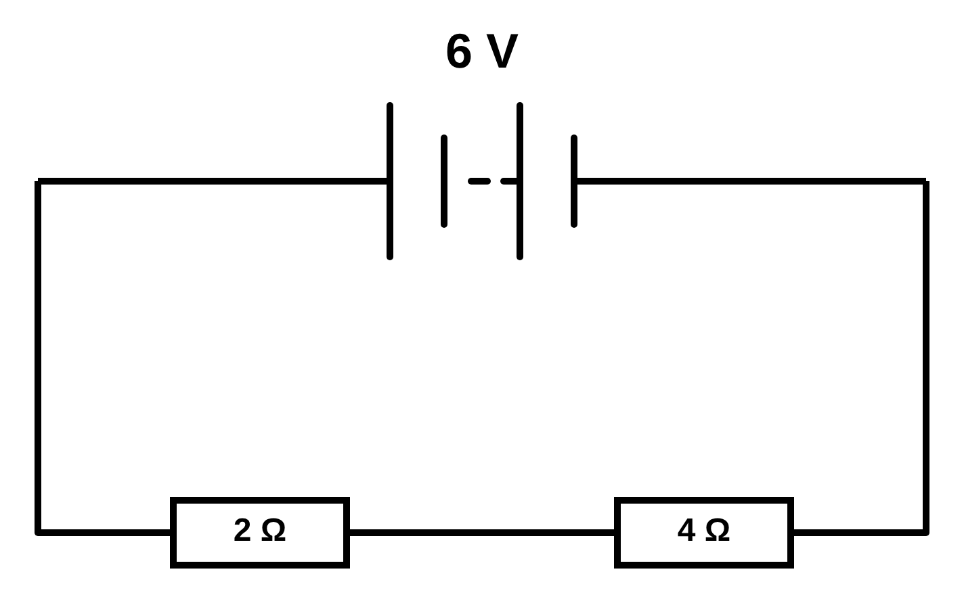
.....................................................................................................
.....................................................................................................
.....................................................................................................
.....................................................................................................
(2 marks)
12. The ammeter reads 0.60 A. Calculate the resistance of R.
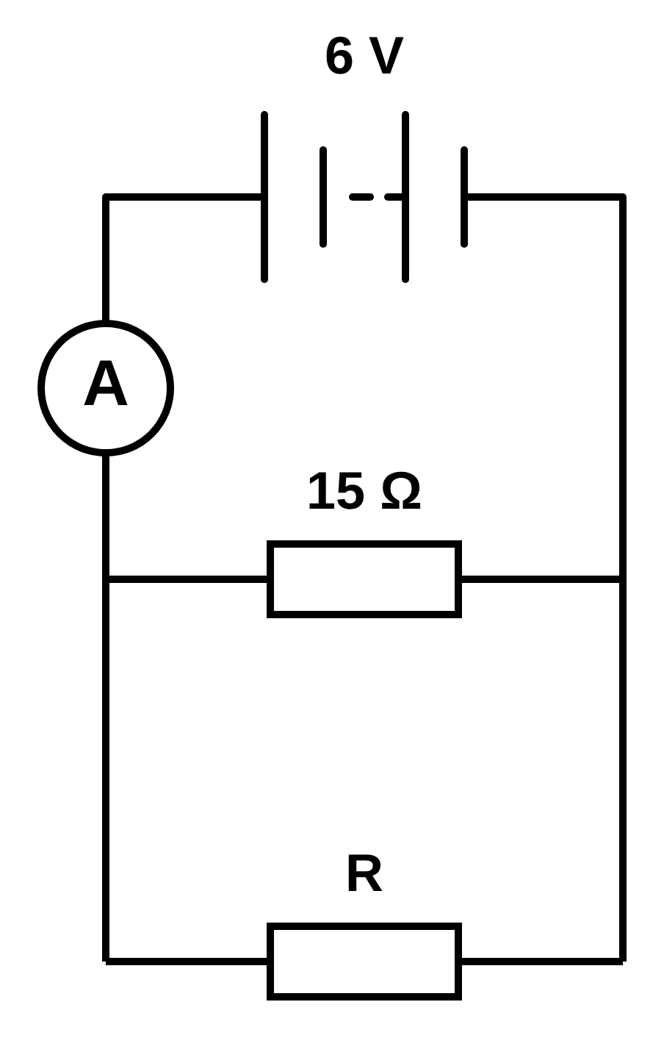
.....................................................................................................
.....................................................................................................
.....................................................................................................
.....................................................................................................
(2 marks)
13. Calculate the combined resistance of the resistors in the circuit shown.
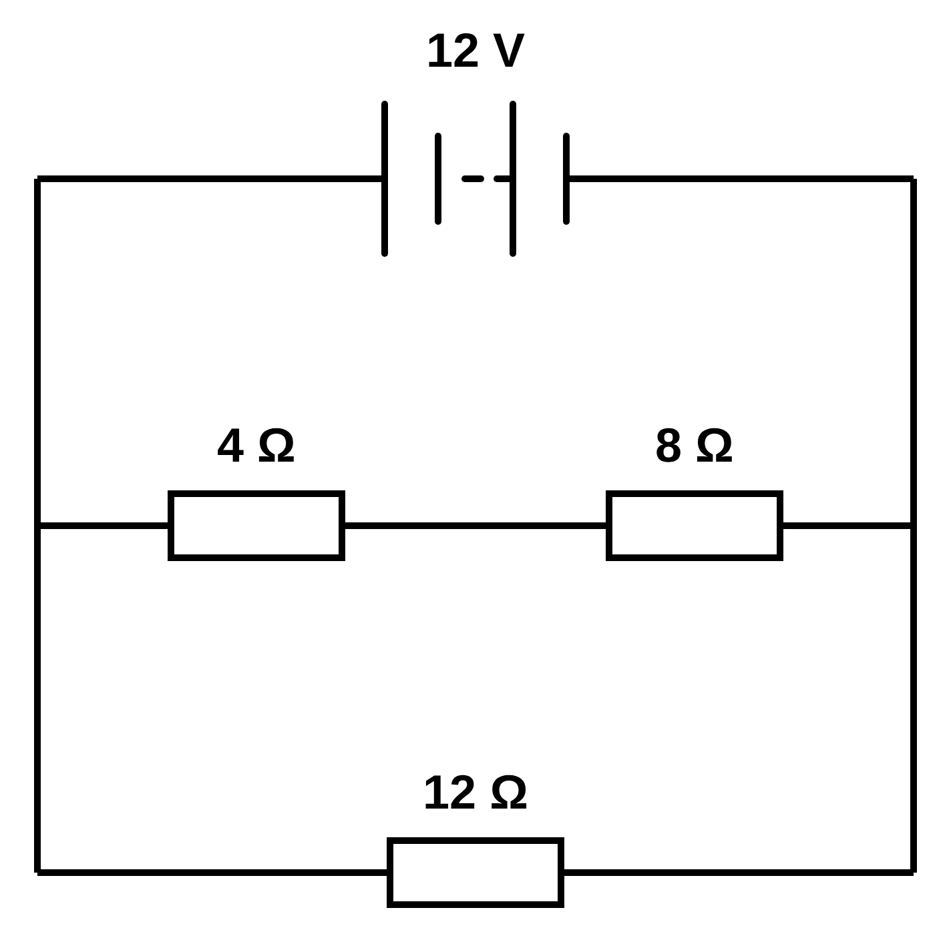
.....................................................................................................
.....................................................................................................
.....................................................................................................
.....................................................................................................
(2 marks)
14. In the circuit shown, the 4 Ω resistor is in series with the 6 Ω and 12 Ω resistors, which are connected in parallel with each other.
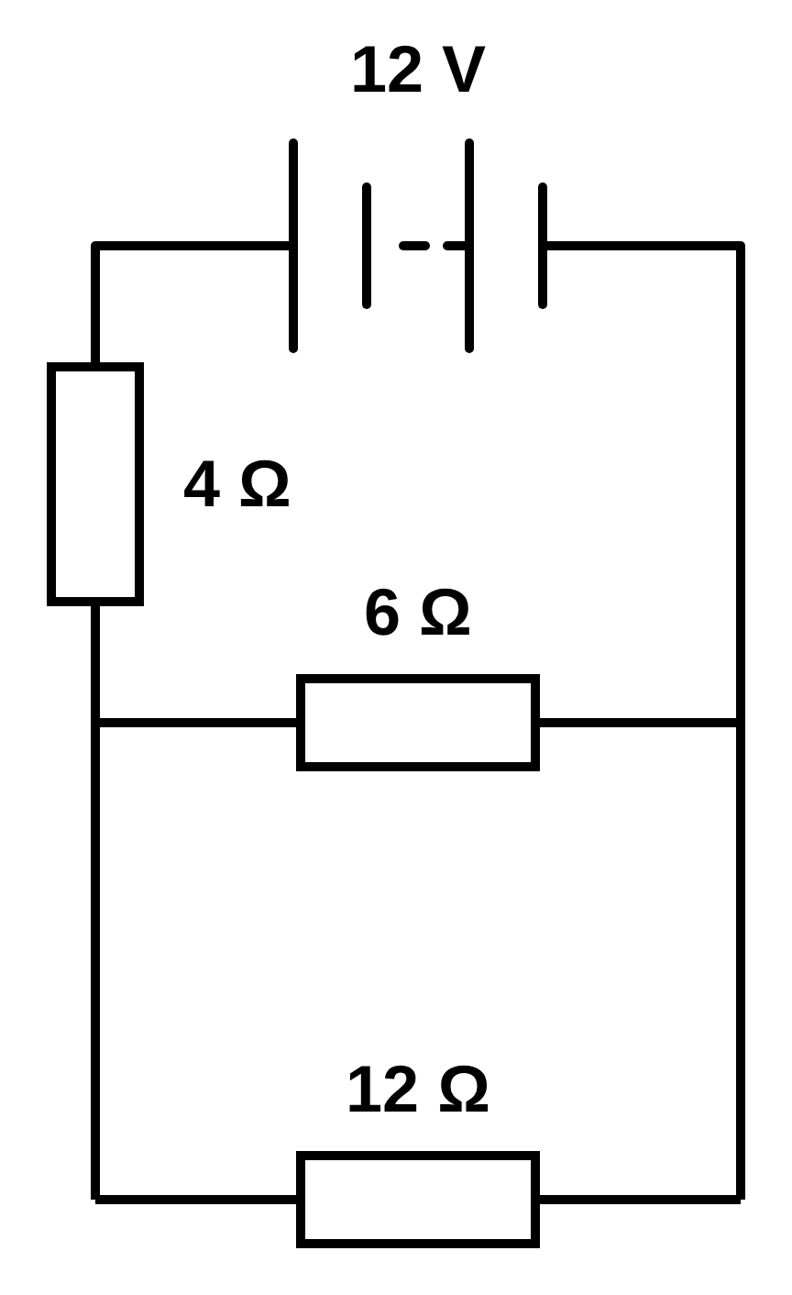
(a) Calculate the combined resistance of the 6 Ω and 12 Ω resistors.
.....................................................................................................
.....................................................................................................
.....................................................................................................
.....................................................................................................
(2 marks)
(b) Calculate the total resistance of the circuit.
.....................................................................................................
.....................................................................................................
(1 mark)
(c) Calculate the current from the battery.
.....................................................................................................
.....................................................................................................
.....................................................................................................
.....................................................................................................
(2 marks)
(d) Calculate the potential difference across the 4 Ω resistor.
.....................................................................................................
.....................................................................................................
.....................................................................................................
.....................................................................................................
(2 marks)
(e) Calculate the current through the 12 Ω resistor.
.....................................................................................................
.....................................................................................................
.....................................................................................................
.....................................................................................................
(2 marks)
(f) The 12 Ω resistor is disconnected, leaving the 4 Ω and 6 Ω resistors in series. Calculate the new current from the battery.
.....................................................................................................
.....................................................................................................
.....................................................................................................
.....................................................................................................
(2 marks)
15. A student has three identical resistors. Each resistor has a resistance of 12 Ω. The student connects all three resistors to a 12 V battery in four different ways, P, Q, R and S.
(a) The circuit diagram shows arrangement P. Calculate the total resistance of the circuit.
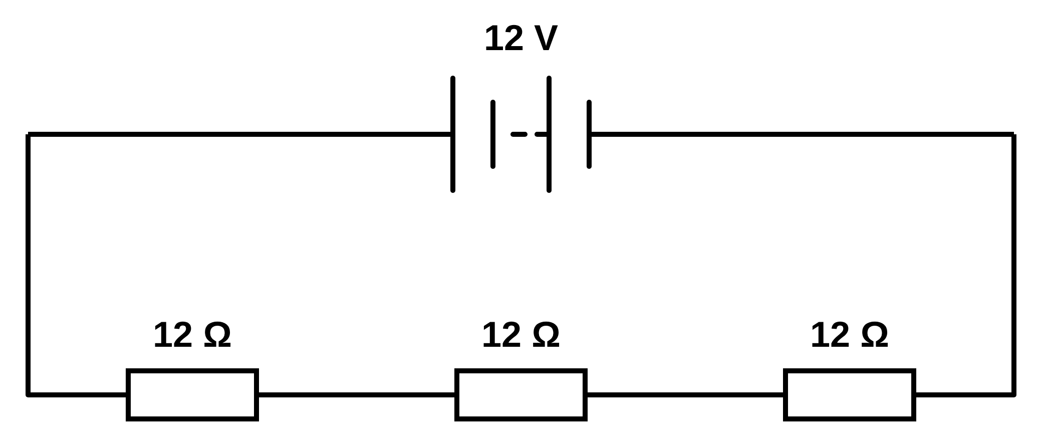
.....................................................................................................
.....................................................................................................
(1 mark)
(b) The circuit diagram shows arrangement Q. Calculate the total resistance of the circuit.
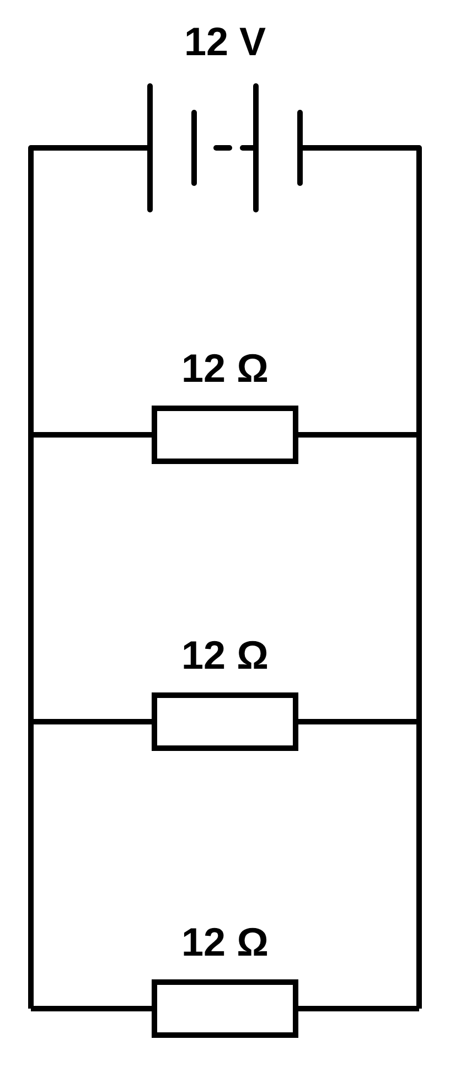
.....................................................................................................
.....................................................................................................
.....................................................................................................
.....................................................................................................
(2 marks)
(c) The circuit diagram shows arrangement R. Calculate the total resistance of the circuit.
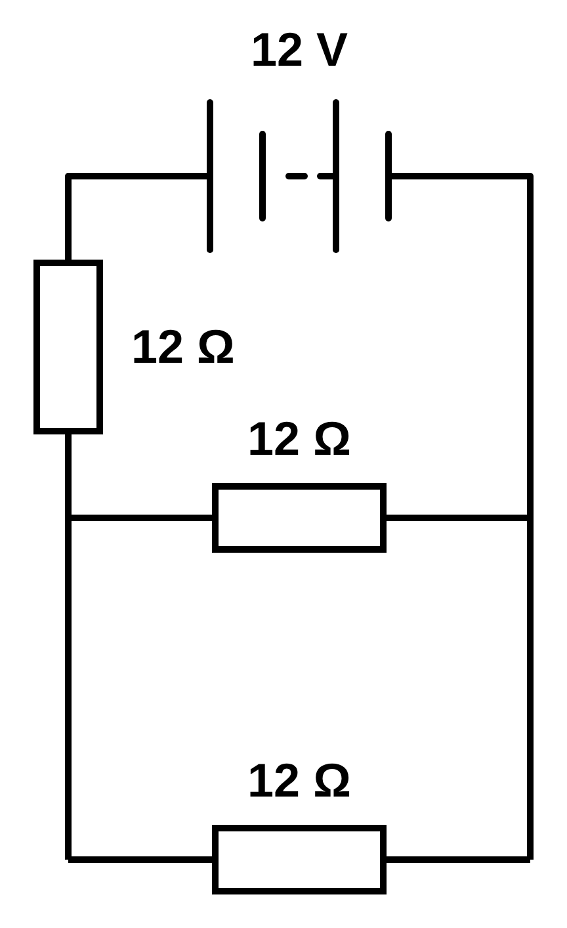
.....................................................................................................
.....................................................................................................
.....................................................................................................
.....................................................................................................
(2 marks)
(d) The circuit diagram shows arrangement S. Calculate the total resistance of the circuit.
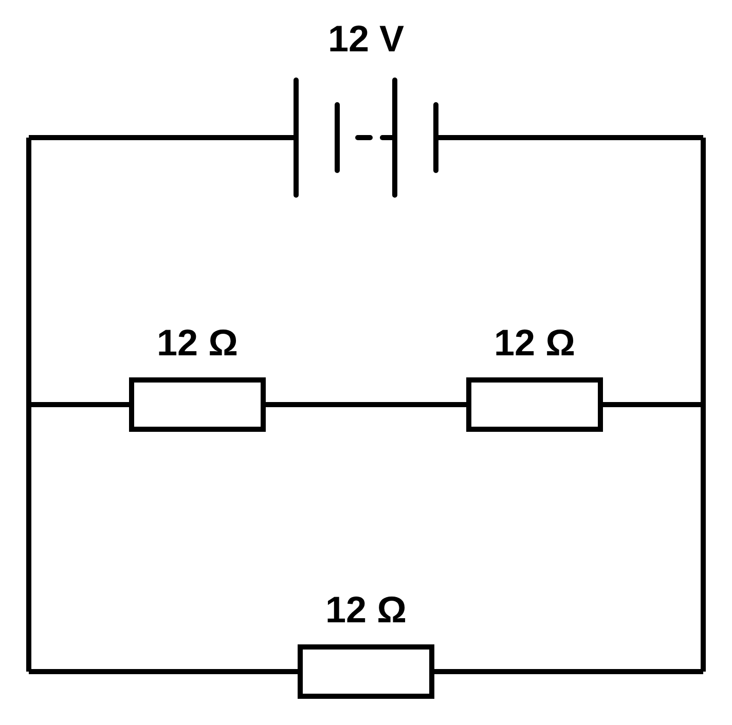
.....................................................................................................
.....................................................................................................
.....................................................................................................
.....................................................................................................
(2 marks)
(e) In one of the arrangements the current from the battery is 1.5 A. Identify the arrangement. Show how you decide.
.....................................................................................................
.....................................................................................................
.....................................................................................................
.....................................................................................................
(2 marks)

