Using the SUVAT Equations: skills worksheet
1. The equations of motion use the symbols s, u, v, a and t. State the quantity that each symbol represents.
.....................................................................................................
.....................................................................................................
.....................................................................................................
.....................................................................................................
(2 marks)
2. State the condition that the motion of an object must meet for the equations of motion to be used.
.....................................................................................................
.....................................................................................................
(1 mark)
3. The velocity–time graph shows a car accelerating uniformly. Calculate the acceleration of the car.
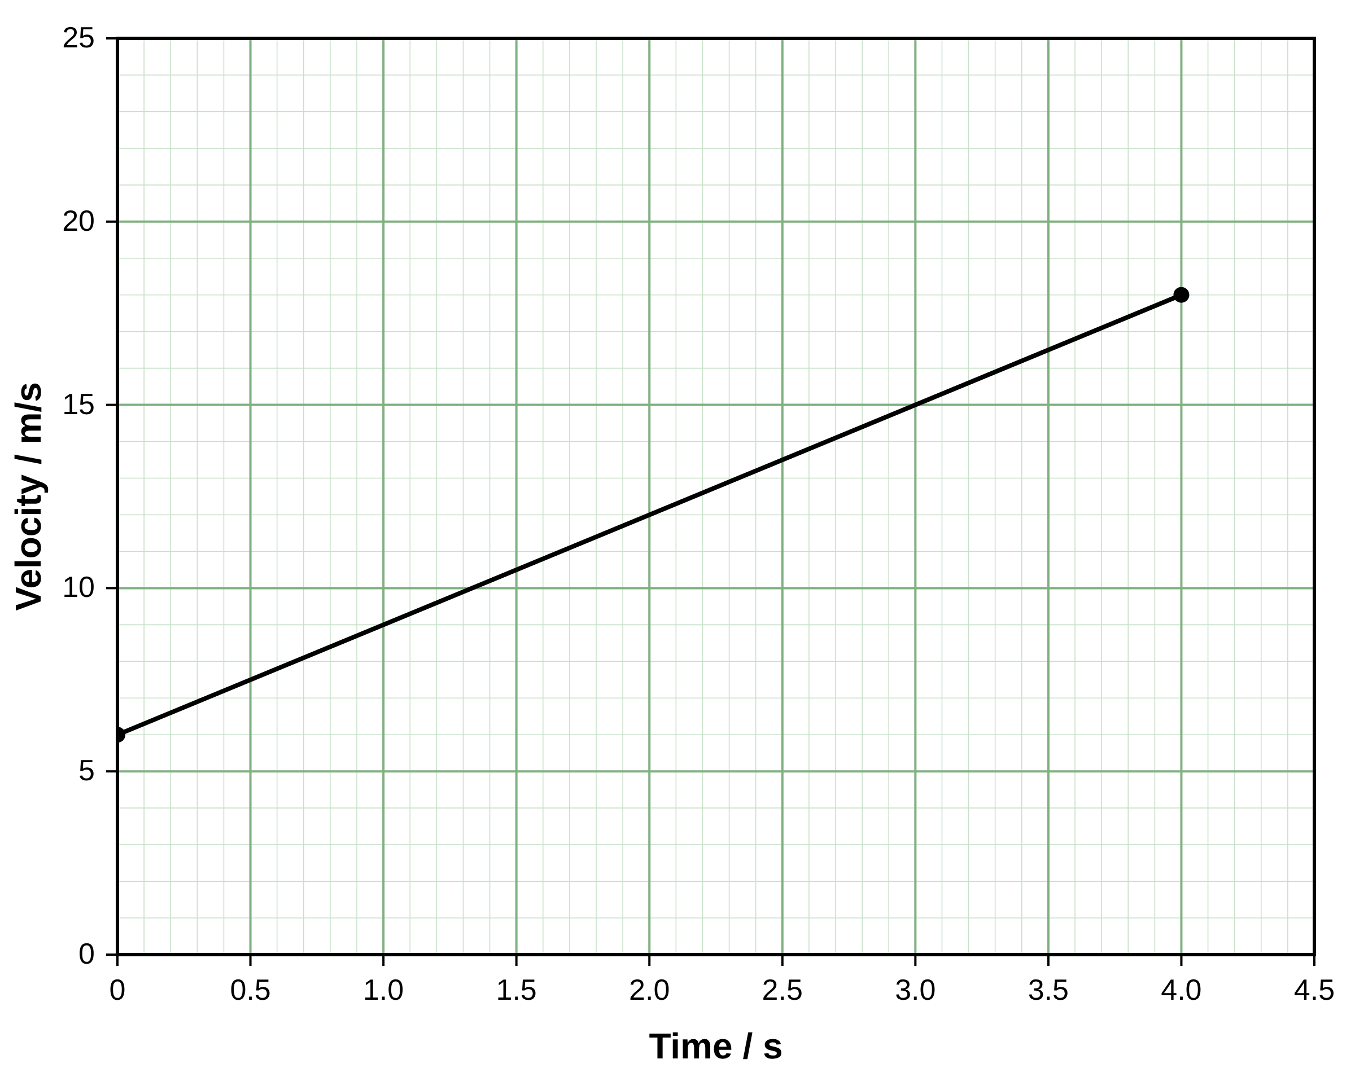
.....................................................................................................
.....................................................................................................
.....................................................................................................
.....................................................................................................
(2 marks)
4. A cyclist starts from rest and accelerates uniformly at 1.5 m/s² for 6.0 s. Calculate the final velocity of the cyclist.
.....................................................................................................
.....................................................................................................
.....................................................................................................
.....................................................................................................
(2 marks)
5. A train slows down uniformly from 30 m/s to 12 m/s in 20 s. Calculate the distance the train travels while it slows down.
.....................................................................................................
.....................................................................................................
.....................................................................................................
.....................................................................................................
(2 marks)
6. The velocity–time graph shows a van accelerating uniformly. Calculate the displacement of the van during the 6.0 s shown.
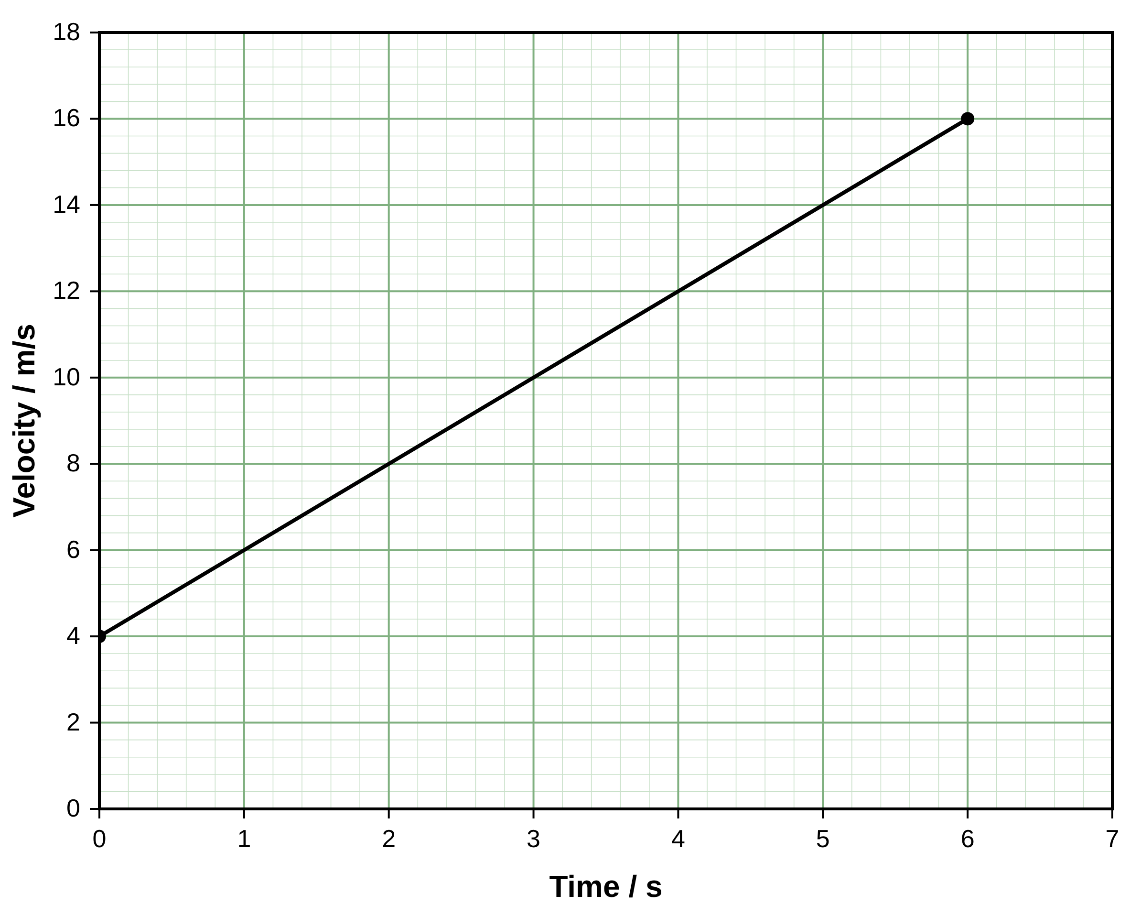
.....................................................................................................
.....................................................................................................
.....................................................................................................
.....................................................................................................
(2 marks)
7. A cyclist travelling at 6.0 m/s accelerates uniformly at 0.50 m/s² for 8.0 s. Calculate the distance travelled in this time.
.....................................................................................................
.....................................................................................................
.....................................................................................................
.....................................................................................................
(2 marks)
8. A ball is dropped from rest. Air resistance is negligible. Calculate the distance the ball falls in the first 1.5 s. Take the acceleration of free fall as 9.81 m/s².
.....................................................................................................
.....................................................................................................
.....................................................................................................
.....................................................................................................
(2 marks)
9. A runner starts from rest and accelerates uniformly. She covers 25 m in 5.0 s. Calculate her acceleration.
.....................................................................................................
.....................................................................................................
.....................................................................................................
.....................................................................................................
(2 marks)
10. A skateboarder moving at 2.0 m/s accelerates uniformly at 0.80 m/s² over a distance of 15 m. Calculate the final speed of the skateboarder.
.....................................................................................................
.....................................................................................................
.....................................................................................................
.....................................................................................................
(2 marks)
11. A car travelling at 24 m/s brakes uniformly and stops in a distance of 36 m. Calculate the deceleration of the car.
.....................................................................................................
.....................................................................................................
.....................................................................................................
.....................................................................................................
(2 marks)
12. A stone is thrown vertically upwards at 14 m/s. Air resistance is negligible. Calculate the maximum height the stone reaches above the point of release. Take the acceleration of free fall as 9.81 m/s².
.....................................................................................................
.....................................................................................................
.....................................................................................................
.....................................................................................................
(2 marks)
13. The velocity–time graph shows a scooter that accelerates uniformly from rest and then moves at a constant velocity. Calculate the total displacement of the scooter in the 10 s shown.
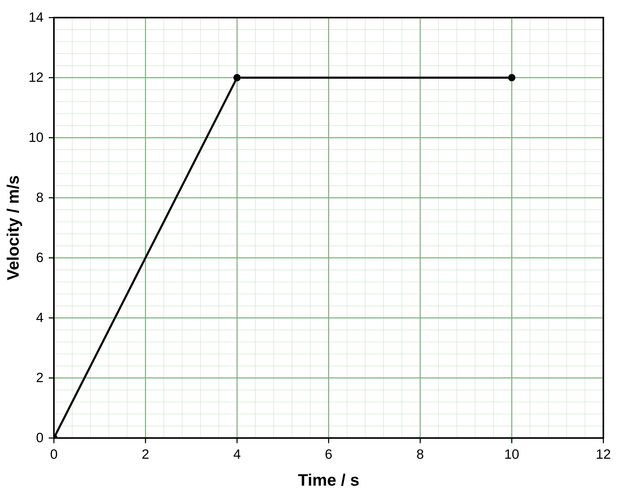
.....................................................................................................
.....................................................................................................
.....................................................................................................
.....................................................................................................
(2 marks)
14. A ball is rolled up a slope. It slows down, stops and rolls back down with the same constant acceleration. The velocity–time graph shows its motion, with up the slope as positive. State the time at which the ball is momentarily at rest.
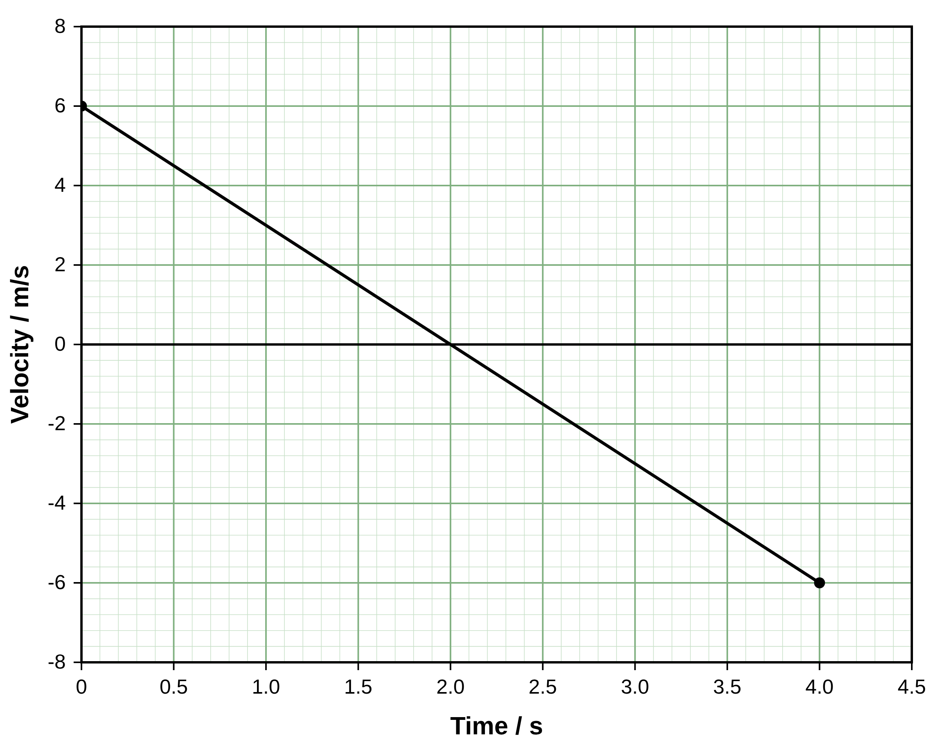
.....................................................................................................
.....................................................................................................
(1 mark)
15. A driver travelling at a constant velocity sees a hazard. After a reaction time, the driver brakes and the car decelerates uniformly to rest. The velocity–time graph shows the motion of the car from the moment the driver sees the hazard.
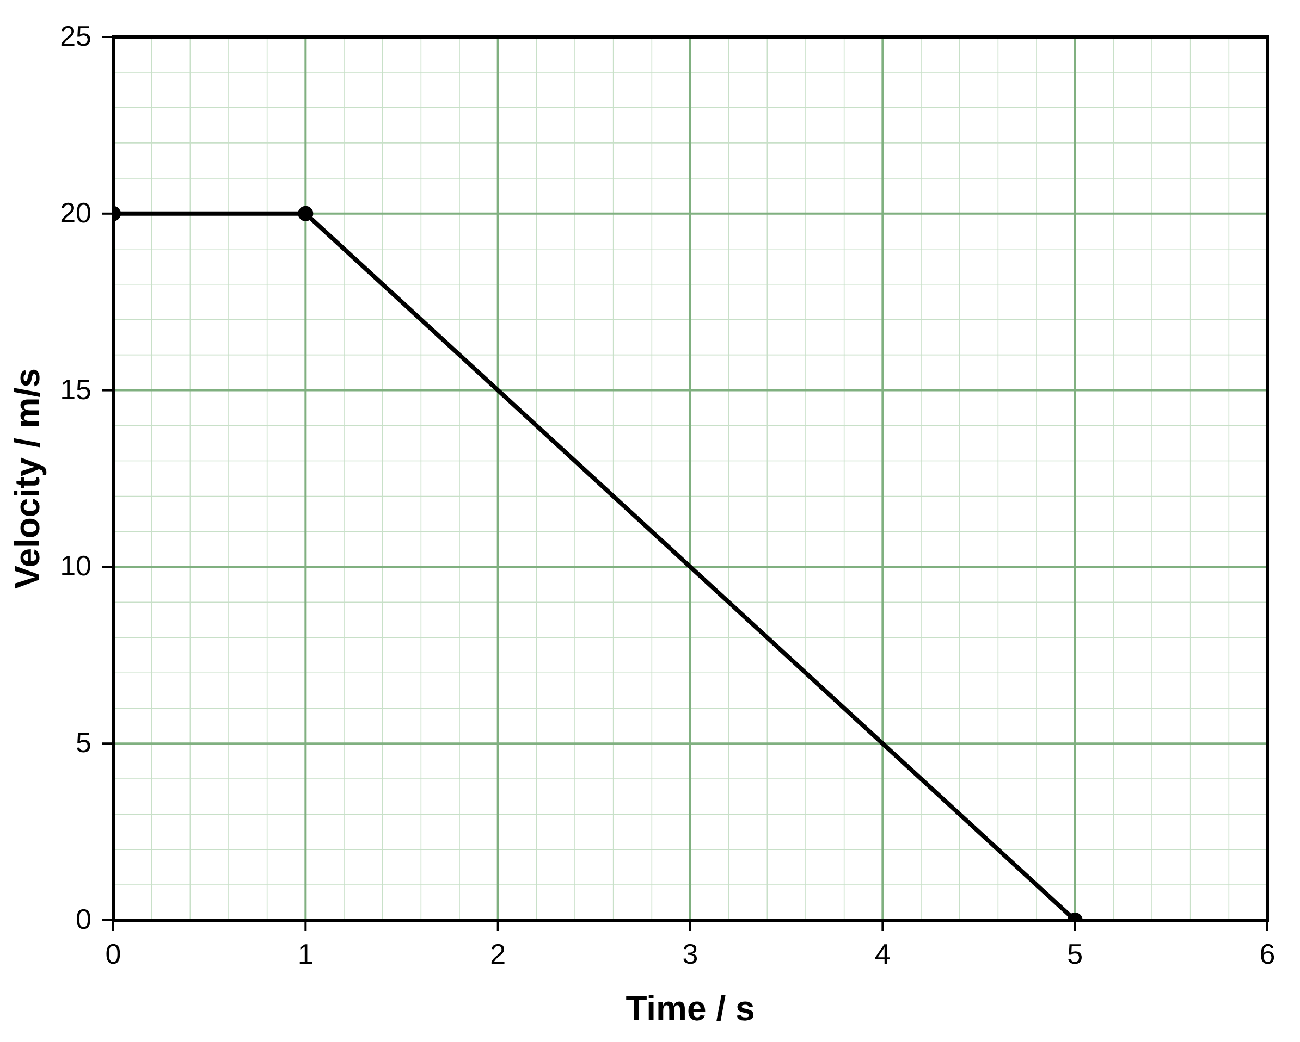
(a) State the reaction time of the driver.
.....................................................................................................
.....................................................................................................
(1 mark)
(b) Calculate the distance the car travels during the reaction time.
.....................................................................................................
.....................................................................................................
(1 mark)
(c) Calculate the deceleration of the car while it brakes.
.....................................................................................................
.....................................................................................................
.....................................................................................................
.....................................................................................................
(2 marks)
(d) Use an equation of motion to calculate the braking distance of the car.
.....................................................................................................
.....................................................................................................
.....................................................................................................
.....................................................................................................
(2 marks)
(e) The same driver later travels at 30 m/s. The reaction time and the deceleration are the same as before. Calculate the total stopping distance of the car.
.....................................................................................................
.....................................................................................................
.....................................................................................................
.....................................................................................................
.....................................................................................................
(3 marks)
16. A student throws a ball vertically upwards at 12 m/s from the edge of a cliff. The ball rises, then falls past the edge of the cliff and lands in the sea 20 m below the point of release. Air resistance is negligible. Take the acceleration of free fall as 9.81 m/s².
(a) Calculate the time the ball takes to reach its maximum height.
.....................................................................................................
.....................................................................................................
.....................................................................................................
.....................................................................................................
(2 marks)
(b) Calculate the maximum height of the ball above the point of release.
.....................................................................................................
.....................................................................................................
.....................................................................................................
.....................................................................................................
(2 marks)
(c) State the velocity of the ball as it falls past the point of release.
.....................................................................................................
.....................................................................................................
(1 mark)
(d) Calculate the speed of the ball as it reaches the sea.
.....................................................................................................
.....................................................................................................
.....................................................................................................
.....................................................................................................
(2 marks)
(e) Calculate the total time from the moment the ball is thrown until it reaches the sea.
.....................................................................................................
.....................................................................................................
.....................................................................................................
.....................................................................................................
(2 marks)

